The 2022 Pharmacy access scheme (PhAS): contractor guidance on submitting an eligibility review application – distance grounds only.

The Pharmacy Access Scheme (PhAS)
The 2022 PhAS will apply from 1 January 2022 and will run until the next PhAS review. The first payment of the 2022 PhAS will be part of the January reconciliation payment on 1 April 2022. The published guidance and list of eligible contractors can be found here.

Who can submit a review via the portal
As with previous PhAS processes, the 2022 PhAS retains a review process to allow for consideration of extenuating circumstances which may mean that access is not being protected in the way intended by the scheme. Broadly, this means that contractors meeting all other eligibility requirements except the distance criteria can submit a review application via the portal if any of the following apply:
- Inaccuracy: the contractor’s pharmacy site address, used for the distance calculation, is incorrect and the correct location would mean the contractor was eligible for PhAS.
- Inaccuracy: the address of the contractors next nearest pharmacy, used for the distance calculation, is incorrect and the correct location would mean the contractor was eligible for PhAS.
- Physical feature anomaly: For example, a semi-permanent roadblock means the nearest pharmacy is more than 1 mile away by the most practicable route means the contractor was eligible for PhAS.

Appropriate review processes will be adopted for relevant pharmacies with LPS contracts that return to the pharmaceutical list whilst this scheme is in place.

Timeframe for review
The window for contractors to submit review applications is between 4 January 2022 and 4 February 2022, inclusive of both days. The review portal will close at midnight (23:59) on the 4 February 2022. Subject to the overall number of applications received, it is envisaged that all contractors will have been informed about the outcome of their review by the end of May 2022. Your regional pharmacy contract management team will provide updates on any changes.

Submitting a review application via the portal
The review portal can be accessed here https://survey123.arcgis.com/share/40cfaa4346d04fb2a0cfef7eece2e0ec
Important information to read before you start your review application
The portal uses the same login details issued to contractors for the PhAS online distance mapping portal. This unique identifier consists of your ODS code plus another 5 digits e.g. F1234-W6789. Your unique identifier should have been sent to you with this guidance. If you have not received this, please contact your regional pharmacy contract management team.
Please note: each unique access code can only be used to submit a review application once, and you cannot access or amend your review application once it has been submitted.
You cannot save an in-progress application to return to later and all data entered will be lost on exiting an unsubmitted form.
After you have submitted an application, the confirmation screen will have a link to a site where you have an opportunity to upload additional documents to support your application. You can only upload documents immediately after you have submitted your application. (The application and supporting document upload systems are different so that there is no limit to the number or size of documents you can upload to support your application).
Therefore:
You should ensure that you have all supporting evidentiary documentation ready to upload before proceeding with this form, as you will only get one opportunity to submit this form and any supporting documents, such as PDFs, in this one session.

Making your application
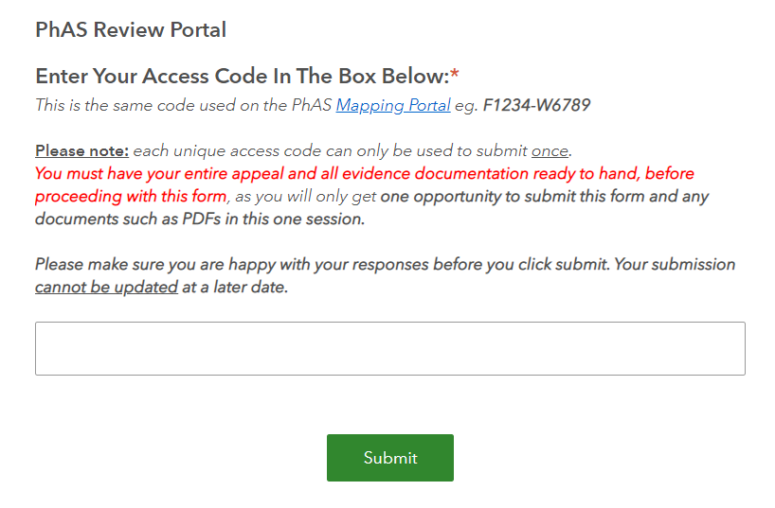
- Please enter your unique access code. This will enable the portal to check your eligibility for review and populate the form with your pharmacy site and distance mapping details. Please check these are correct. If these details are not correct please contact your regional pharmacy contract team.

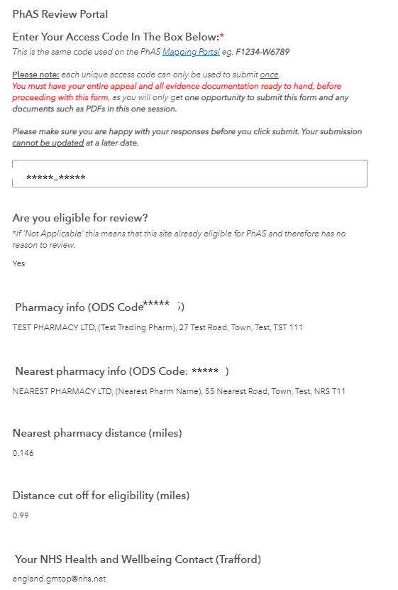

- Please enter your pharmacy premises specific nhsmail address.

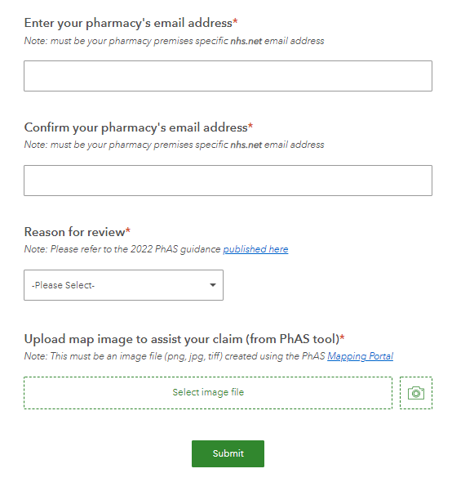

- Please select your reason for review

- Inaccuracies in pharmacy premises location e.g. the mapped location of your pharmacy or next nearest pharmacy is incorrect
- Route or physical feature anomalies – that make the mapped route inaccessible to customers
- Other distance-based reason (inaccuracy or physical feature anomaly)
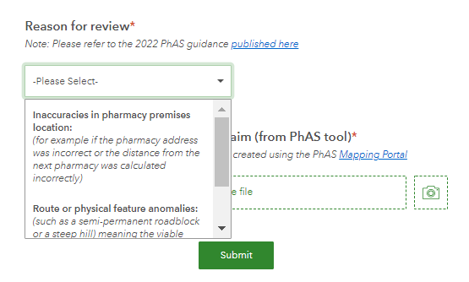

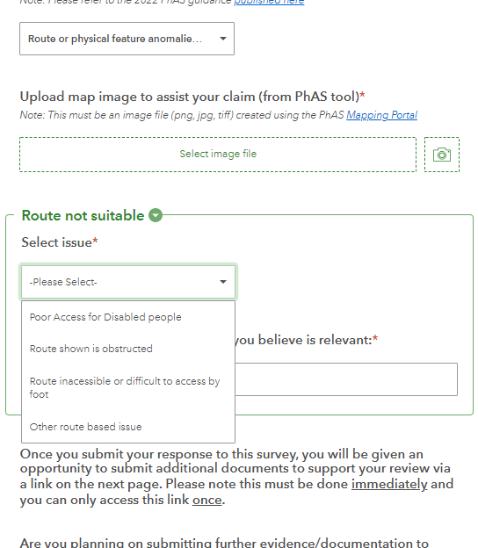

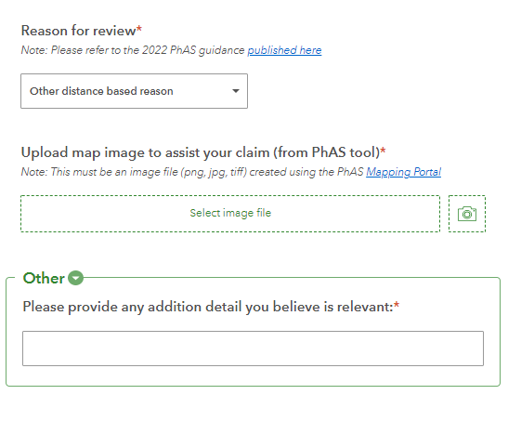

- Please complete the requested details on the reason for your review application – upload map image from PhAS tool and adding any additional text-based information.
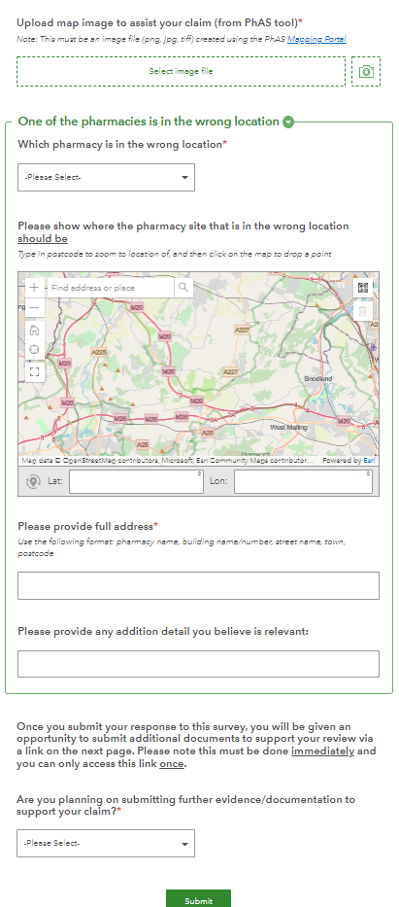

- Please select Yes or No to identify if you will be submitting further evidence/documentation, such as letters, photographs etc to support your claim. Once you submit your review application you will be provided with a link to the document upload site to add your supporting evidence.

If you selected No, any uploaded documents will not be linked to your application and will not be considered with your application.
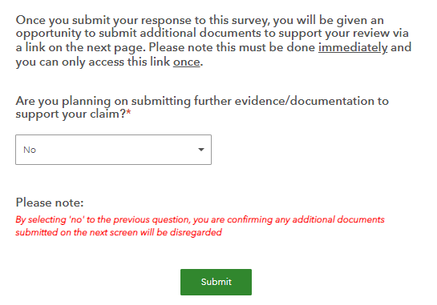If you have selected Yes, your evidence must be uploaded straight away via the link provided on the next screen.
Please see the section below ‘Submitting supporting evidence’. Your submission may not proceed until you have provided this additional evidence.
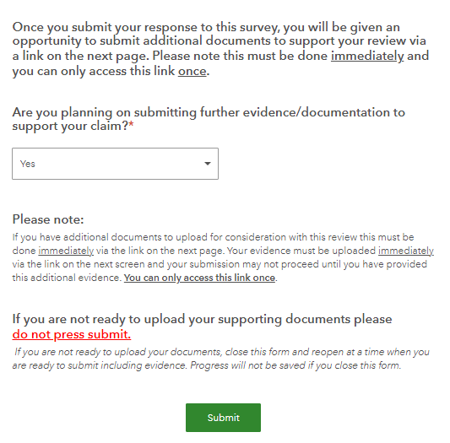

- Once you have completed the application form please click the submit button. If you require a record of your submission please take a screen shot as there is no download facility.

Submitting supporting evidence
Once you have submitted your review application there is a confirmation screen which contains a link to the site for you to upload your supporting evidence – only upload supporting documents if you selected the Yes option in your application form to state you would be doing this.
You must upload your supporting documentation straight away as there will be no further opportunity to return to this upload site at a later date. It is recommended that this is done within fifteen minutes of accessing the link.
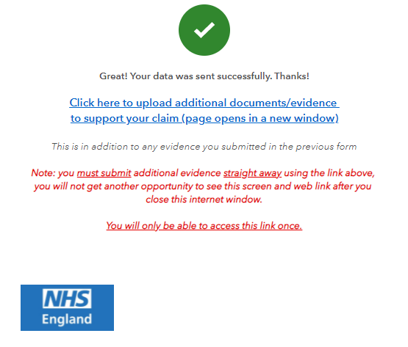
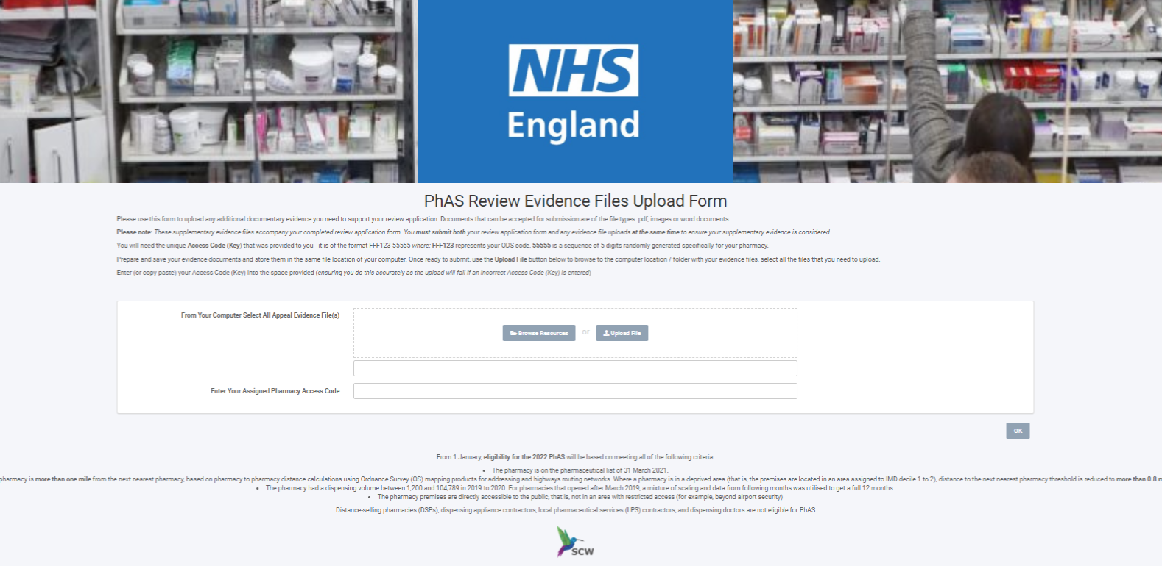

How a decision will be made
Completed applications will be reviewed by the relevant NHSE&I regional pharmacy contract team who manage the pharmaceutical list for the Health and Wellbeing Board area where the submitting pharmacy premises are listed.
Review applicants may be asked to provide further clarification on their application to support this process.
The outcome of the review will be determined by the relevant Pharmaceutical Services Regulations Committee (PSRC).

Communicating the decision
NHSE&I regional pharmacy contract teams will communicate the outcome of the review to the applicants. Contractors who are deemed to be eligible for the 2022 PhAS will be added to the scheme and payments will be backdated to 1 January 2022.
Please note: A condition for PhAS payment is that contractors must be registered on the Manage Your Service (MYS) platform to provide the Community Pharmacist Consultation Service (CPCS). For the first payment – for January 2022 – registration for CPCS must be by 31 December 2021. For subsequent months they must have been registered on the MYS platform to deliver CPCS for greater than or equal to half of the number of full days in the relevant month.

Help with using the portal
If you require any further support in accessing the portal or have any problems completing your review application, please contact your NHSEI regional pharmacy contract management team. Contact details are available at https://www.england.nhs.uk/primary-care/pharmacy/pharmacy-contract-teams/
You may also want to contact PSNC at info@psnc.org.uk

