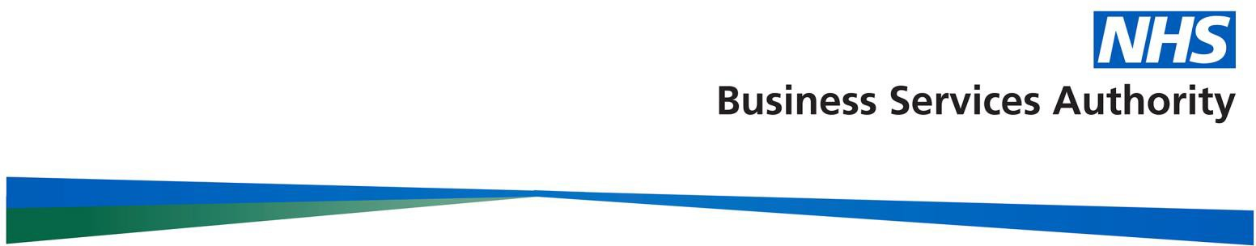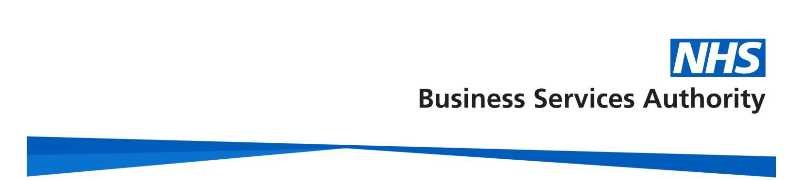

NHS Prescription Services
Bridge House 152 Pilgrim Street Newcastle upon Tyne
NE1 6SN

Tel: 0845 850 0001
Email:nhsbsa.prescriptionservices@nhs.net
Website: www.nhsbsa.nhs.uk

3 January 2022

GTIN

03/01/2022 Version 1.0.0
There are no updates on the GTIN Transfer Tracking Log this week. Regards,

dm+d authoring team

