|  |  |
| --- | --- |
|  | **NHS Prescription Services**  Bridge House  152 Pilgrim Street  Newcastle upon Tyne  NE1 6SN  0845 850 0001  nhsbsa.prescriptionservices@nhs.net  [www.nhsbsa.nhs.uk](http://www.nhsbsa.nhs.uk)  27 June 2022 |
|  |

VERSION 6.3.0

Dear dm+d User,

**PROPOSED VMP SNOMED CODE CHANGES**

As part of the routine review of SNOMED codes in dm+d, we propose to carry out the SNOMED code changes below to the VMP concepts listed. The changes will appear in the files published on the 8th August 2022.

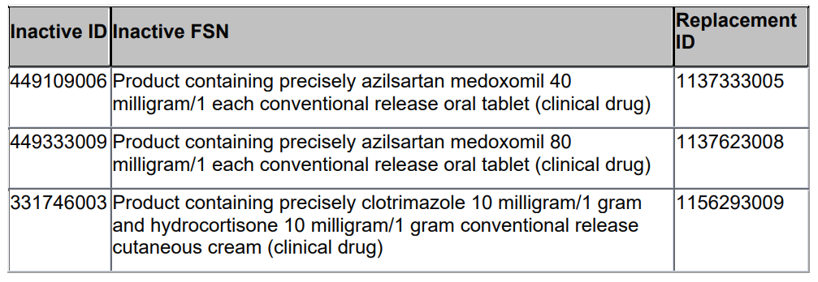

**Workpackage to Support Advisory Committee on Borderline Substances (ACBS) dietician experts and Impacts on SNOMED codes**

This is advanced notice that over the course of the next few months, in the region of 400 to 450 food substance AMPs will be invalidated and moved to different VMPs.

The NHSBSA is supporting an initiative by Advisory Committee on Borderline Substances (ACBS) dietician experts to improve the clinical categorisation / classification of food substances.

We are mindful that where new SNOMED codes are used that this can add challenges to EPS until prescribing and dispensing systems are aligned. We will therefore try to communicate changes as best we can but this will also need yourselves as dm+d users to please monitor this weekly communication and for system suppliers to please refresh and update your drug dictionary data with the most recent version of the dm+d files available.

More information will be communicated over the forthcoming weeks. In the meanwhile if you have any further questions, please email [nhsbsa.dmdenquiries@nhs.net](mailto:nhsbsa.dmdenquiries@nhs.net)

|  |
| --- |
|  |

**Sanofi Range of Clexane solution for injection pre-filled syringes**

We understand that the Sanofi Clexane product packs may either have the *Eris needle guard safety system OR the Preventis needle guard safety system.*

This information is not distinguished in Part 1 of the Sanofi SmPCs but to support these product packs in dm+d we have added both of the GTINs against the existing AMPP listings.

We trust this communication insight may be of help to dm+d users.

**DHSC require these concepts to be made available and visible (similar to licensed medicines) in prescribing and dispensing systems for the time being.**

|  |  |  |  |
| --- | --- | --- | --- |
| **Specials/Imports added at request of DHSC to mitigate shortages in the supply chain** | | | |
| **AMP Name** | **AMP SNOMED Code** | **Import/Special** | **dm+d extract date** |
| Desmopressin 150micrograms/dose nasal spray | 38955011000001100 | Imported | 14/09/2020 |
| Desmopressin 150micrograms/dose nasal spray | 38996011000001101 | Special Order | 21/09/2020 |
| Cloral betaine 707mg tablets | 39069011000001104 | Imported | 12/10/2020 |
| Chloral hydrate 143.3mg/5ml oral solution BP | 39517711000001107 | Special Order | 12/04/2021 |
| Gynokadin 0.06% gel | 40714711000001102 | Imported (Germany) | 13/06/2022 |
| Oestraclin 0.06% gel | 40714911000001100 | Imported (Spain) | 13/06/2022 |
| Sandrena 1mg gel sachets | 40715411000001109 | Imported (Italy) | 13/06/2022 |
| Lenzetto 1.53mg/dose transdermal spray | 40715811000001106 | Imported (Poland) | 13/06/2022 |
| Ovestin 1mg cream | 40716111000001105 | Imported (Germany) | 13/06/2022 |

**Invalidations**

None

**Advance Notice of Invalidations**

The following concept will be invalidated mid-July. Product added in error no replacement concept required.

|  |  |
| --- | --- |
| **Concept to be made Invalid** | **Replacement concepts** |
| **VMP** N/A | **VMP** N/A |
| **VMP SNOMED ID** N/A | **VMP SNOMED ID** N/A |
| **VMPP** N/A | **VMPP** N/A |
| **VMPP SNOMED ID** N/A | **VMPP SNOMED ID** N/A |
| **AMP** Bimatroprost 300mg/ml / Timolol 5mg/ml eye drops preservative free | **AMP** N/A |
| **AMP SNOMED ID** 39881111000001103 | **AMP SNOMED ID** N/A |
| **AMPP** 3ml | **AMPP** N/A |
| **AMPP SNOMED ID** 39881211000001109 | **AMPP SNOMED ID** N/A |

The following concept will be invalidated mid-Aug. Product authored incorrectly reauthored under a new VMP.

|  |  |
| --- | --- |
| **Concept to be made Invalid** | **Replacement concepts** |
| **VMP** N/A | **VMP**  Teicoplanin 200mg powder for solution for injection vials |
| **VMP SNOMED ID** N/A | **VMP SNOMED ID** 766184003 |
| **VMPP** N/A | **VMPP** 1 vial |
| **VMPP SNOMED ID** N/A | **VMPP SNOMED ID** 40739711000001109 |
| **AMP** Teicoplanin 200mg powder and solvent for solution for injection vials (Consilient Health Ltd) | **AMP** Teicoplanin 200mg powder for solution for injection(Consilient Health Ltd) |
| **AMP SNOMED ID** 40541411000001101 | **AMP SNOMED ID** 40739811000001101 |
| **AMPP** 1 Vial | **AMPP** 1 Vial |
| **AMPP SNOMED ID** 40541711000001107 | **AMPP SNOMED ID** 40740011000001100 |

The following concept will be invalidated mid-Aug. Product authored incorrectly reauthored under a new VMP.

|  |  |
| --- | --- |
| **Concept to be made Invalid** | **Replacement concepts** |
| **VMP** N/A | **VMP**  Teicoplanin 400mg powder for solution for injection vials |
| **VMP SNOMED ID** N/A | **VMP SNOMED ID** 766185002 |
| **VMPP** N/A | **VMPP** 1 vial |
| **VMPP SNOMED ID** N/A | **VMPP SNOMED ID** 40740511000001108 |
| **AMP** Teicoplanin 400mg powder and solvent for solution for injection vials (Consilient Health Ltd) | **AMP** Teicoplanin 400mg powder for solution for injection(Consilient Health Ltd) |
| **AMP SNOMED ID** 40542711000001100 | **AMP SNOMED ID** 40740711000001103 |
| **AMPP** 1 Vial | **AMPP** 1 Vial |
| **AMPP SNOMED ID** 40542811000001108 | **AMPP SNOMED ID** 40740811000001106 |

Kind regards

dm+d Authoring Team