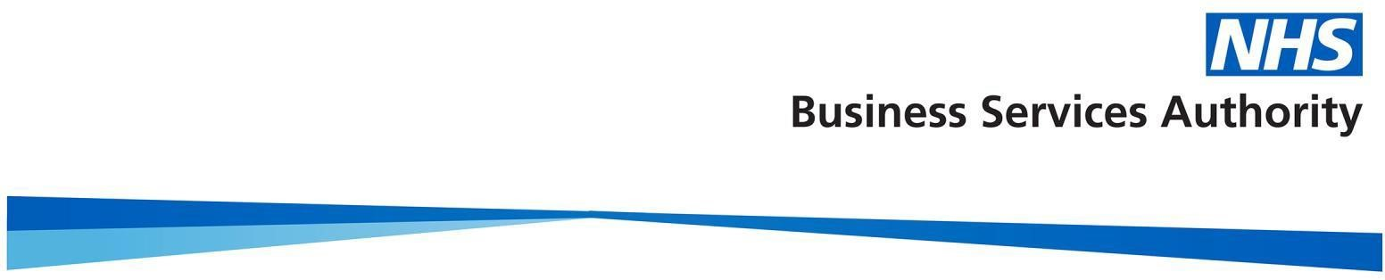
Naming Convention Changes in ePACT2 Dashboards, Reports and Bespoke Analysis
From the 1st of July the naming convention for certain organisations within the ePACT2 system will be changing. Headings in the dashboards and reports will be amended to fit the new naming convention.
STP’s (Sustainability and Transformation Partnerships) will be renamed as ICB’s (Integrated Care Boards) e.g. W YORKSHIRE & HARROGATE H&C P/SHIP STP will be changing to NHS WEST YORKSHIRE INTEGRATED CARE BOARD
CCG’s (Clinical Commissioning Groups) will be renamed as SICBL’s (Sub Integrated Care Board Locations) e.g. KIRKLEES CCG will be changing to SICBL of NHS WEST YORKSHIRE ICB X2C4Y.
Organisation codes are not changed, and you will need to be aware of codes when running both ICB and SICBL data.
This will be the only reporting structure within the current and historical view unless the CCG has closed prior to 1 July 2022, in which case it will reflect the closed CCG name.
Similar 10 views will continue to be reflected in our dashboards and reporting up to and including Jun22 data, however NHS RightCare are no longer maintaining a Similar 10 profile and no Similar 10 views will apply to our data from July 22 data onwards.
From 1 July 2022 the system will continue to reflect the STP/CCG structure until the boundary changes for these new organisations comes into effect once July 2022 dispensing data is published.

CCG Flag within ePACT2
CCG Flags and HS CCG Flags will be renamed to SICBL and HS SICBL effective 1 July 2022 to reflect the change from CCGs to SICBL’s.
These flags are in the following subject areas within the ePACT2 analysis tool
· All Prescribing Organisations, Organisation Attributes
· England Prescribing Organisations, England Prescribing Organisation Attributes
· HS All Prescribing, HS Organisations Attributes
· HS England Prescribing Organisations, HS England Prescribing Organisation Attributes

Effective Date of Boundary Changes
The boundary changes will be applied to the new organisational structure within the system in the upload of July 2022 prescribing data. This refresh will take place approximately 2 weeks into September 2022 as is the usual timeframe (generally 6 weeks after the end of the prescribing/dispensing month).
Therefore, any reporting undertaken for July 2022 prescribing data and onwards will reflect the new ICB’s (Integrated Care Boards – formally STPs) within their new boundaries, as well as the new SICBL’S (Sub Integrated Care Board Locations – formally CCGs) within their new boundaries.

Access Changes to a Users Organisation
With the upcoming changes to the NHS structure and the introduction of ICBs, the organisation that users are registered under may be changing and access rights will need to be considered.
If the organisation you work for is changing, please get in touch with our registration team to ensure you are registered for access to ePACT2 under the correct organisation.
If for any reason your email address is also changing, please don't forget to let the registration team know.
The registration team can be contacted at DataServicesSupport@nhsbsa.nhs.uk.

Bespoke Analysis
The change to the organisational structure means that columns and filters using the old naming convention within ePACT2 will have to be replaced in all bespoke analysis.
To assist with the changes, we will be giving users a three-month period from 1 July – 1 October 2022 to change the columns and filters in their saved analysis. During this time, the columns and filters using the old naming convention will continue to work but will need to be replaced by 1 October 2022.
Please be aware that any saved analysis or filters within the shared area of ePACT2 will also need to be updated within this period.
If you require any assistance or have any questions, please get in touch with us at DataServicesSupport@nhsbsa.nhs.uk.

