Using eOPSv3 – with Performer Level Data dashboard

Interactive Contents
Use this interactive contents list to jump straight to the content you want to see. Just click the titles below to go directly to that section:
Contents
Accessing and navigating eOPSv3 dashboard 1
Accessing the eOPSv3 – with Performer Level Data dashboard 1
Navigating the landing page 2
Accessing your reports 3
Filtering the dashboard to select criteria 5
Expanding individual views 8
Exporting the data 9
Getting more help 14

Accessing and navigating eOPSv3 dashboard

Accessing the eOPSv3 – with Performer Level Data dashboard
To log in to use the ‘eOPSv3 – with Performer Level Data’ dashboard, firstly access the eOPS webpage www.nhsbsa.nhs.uk/access-our-data-products/eops
Next, click the ‘Log in to eOPS’ button
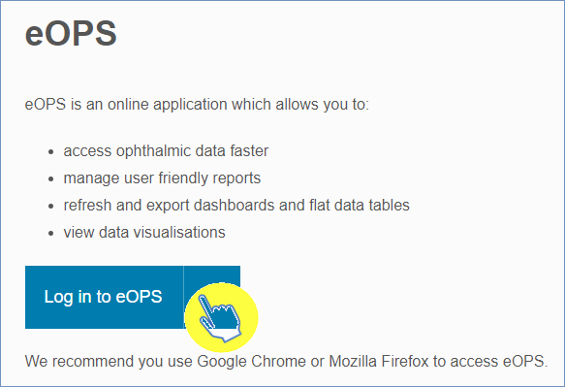
This will access the sign in page:
- Enter the email address that you used to register for eOPS in the ‘User Name’ box

- Enter your password in the ‘Password’ box

- Click the ‘Sign In’ button

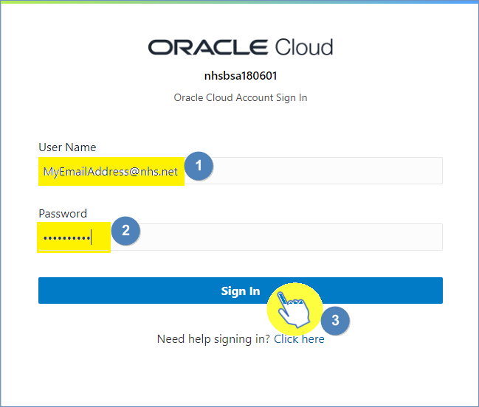
Once logged in this will take you to the eOPS landing page.

Navigating the landing page
When you sign into eOPS you will come to the landing page, it is split into four sections:
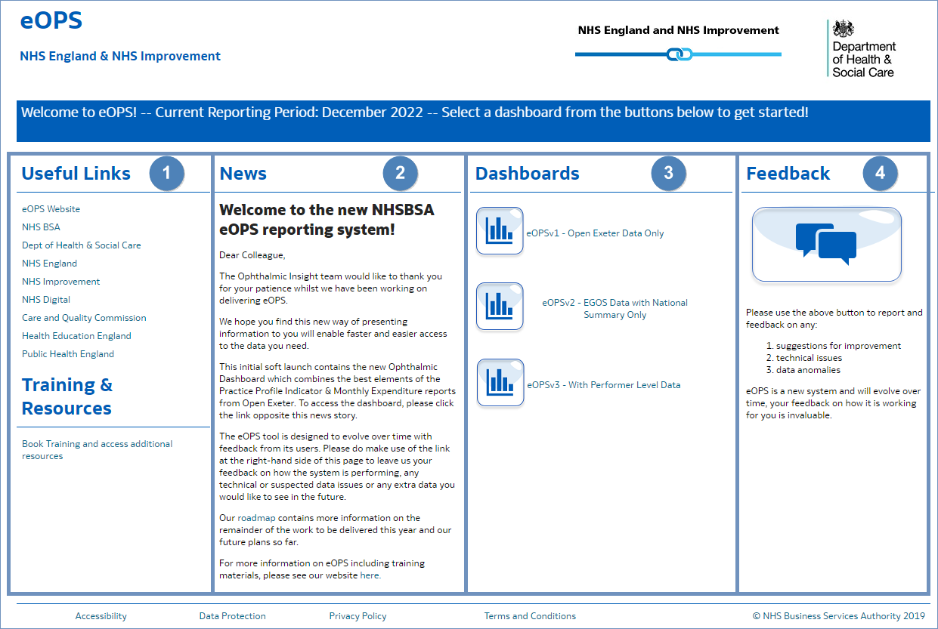
- Useful Links - From here users can select a hyperlink to useful content external from the eOPS system
- News - Important information regarding the system such as any planned downtime or updates will be displayed here
- Dashboards – here you will see all the available eOPS commissioner dashboards, as an England Commissioner you will be able to select the ‘eOPSv1’ dashboard, ‘eOPSv2’ dashboard and the new the ‘eOPSv3’ dashboard which includes ‘Performer Level’ data
- Feedback – here you can click on the feedback button to give your feedback on the system and its reports.

Accessing your reports
To open the ‘eOPSv3 – with Performer Level Data’ dashboard:
- From the ‘Dashboards’ section of the landing page, select the ‘eOPSv3 – with Performer Level Data’ dashboard link
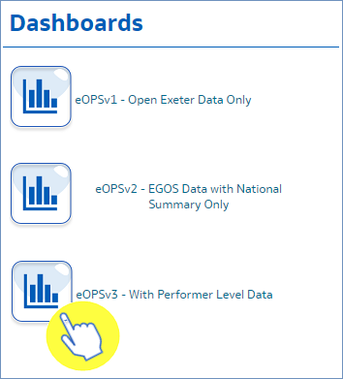

- The ‘eOPSv3 – with Performer Level Data’ dashboard will open and default to the ‘NHS Sight Tests Summary’ page
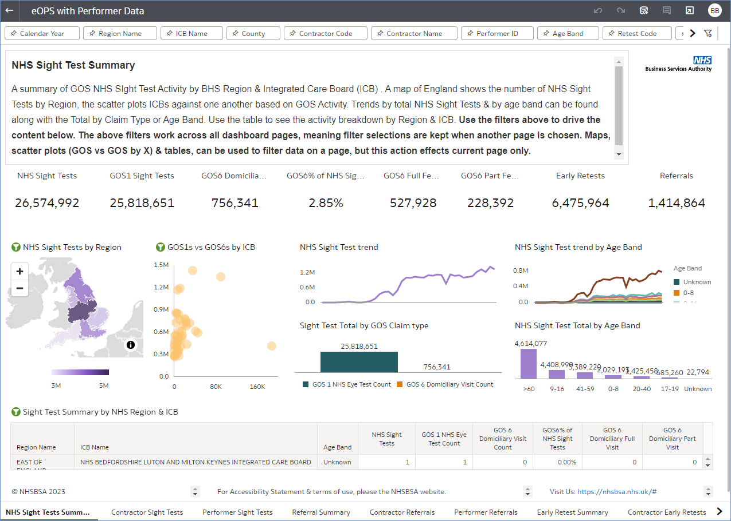

- To select any of the other pages in the eOPSv3 – with Performer Level Data dashboard (for instance - the ‘Performer Sight Tests’ page), then simply select the required page from the page options located at the bottom of the dashboard (highlighted red below)
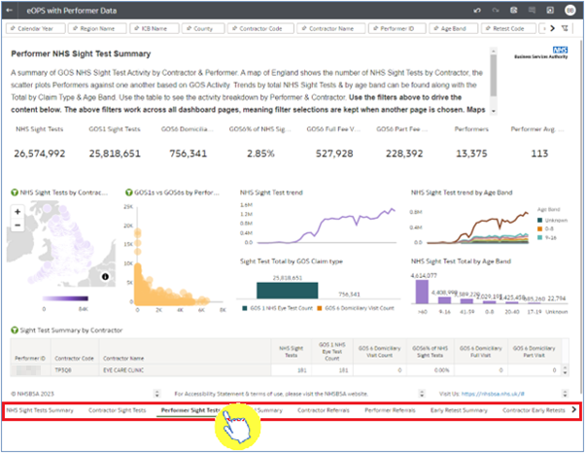

Please note: For detailed guidance regarding each of the views on the ‘eOPSv3 – with Performer Level Data’ dashboard pages, visit the eOPS training hub and access the ‘eOPS dashboard guidance’ user guide.

Filtering the dashboard to select criteria
When the ‘eOPSv3 – with Performer Level Data’ dashboard is initially opened, it will default to the ‘NHS Sight Tests Summary’ page and will show ALL DATA NATIONALLY FOR ALL TIME PERIODS AVAILABLE within the different views of the page that is selected.
The dashboard can be filtered to return specific data (for a time period, ICB, contractor etc.) by using the filter options located at the top of the dashboard page (highlighted red below):
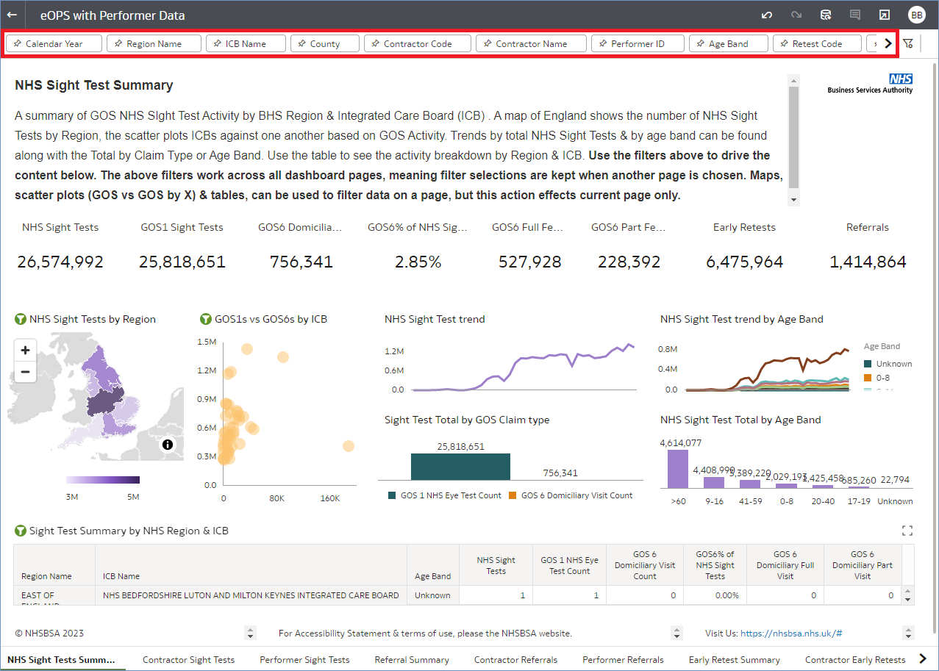
The filter options will allow users of the eOPSv3 dashboard the ability to filter for:
- Calendar Year
- Region
- ICB (Integrated Care Board)
- County
- Contractor Code
- Contractor Name
- Performer ID
- Age Band
- Retest Code
- Retest Description
- Patient referred to GP or Hospital
To filter the dashboard for the criteria you require follow the example below:
In this case, we will be filtering for the ‘Calendar Year’ to return only 2022 data:
- Select the filtering option at the top of the dashboard page that you would like to place a filter on
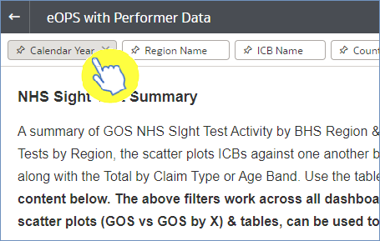

- This will then expand the filter pane, in this case for ‘Calendar Year’, to show the options which you can filter the dashboard for

- Then, select the criteria you wish filter for by clicking on the option(s) you want to select, in this case I am filtering for 2022 data
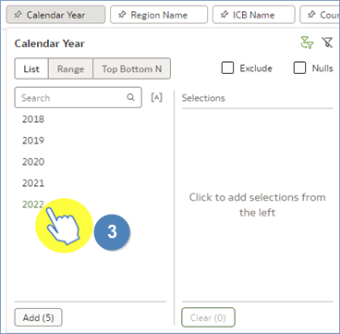

- Once the selection(s) has been made, in this case 2022, it will populate in the ‘Selections’ area of the filter pane to reflect the criteria the filter is applying to the dashboard
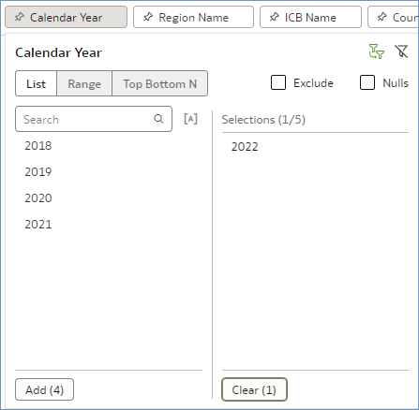

The data in the dashboard will automatically update when a selection has been made.
Once all the selections have been made, simply click anywhere on the screen (other than the filter pane) to close the filter pane.

Please note: Once a filter has been applied to the dashboard using the filtering options detailed above, then the filter selected will be applied across all of the dashboard’s pages.

Expanding individual views
When looking at a page in the dashboard, such as the ‘Contractor Sight Tests’ page, you can see that this page is made up of a number of individual views/data tables that have been grouped together to form one dashboard page.
If you want to expand out an individual view, in each of the views there is a symbol which will appear when you hover over the view (see below):
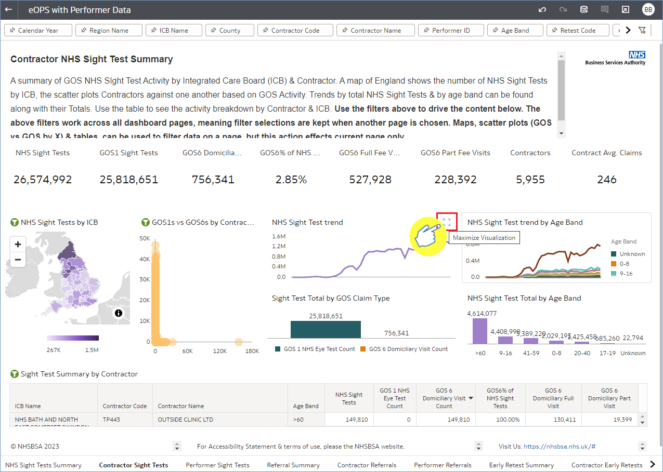
Clicking this icon will then expand the individual view and resize it to your screen. To close the expanded view down, simply click the ‘X’ icon (shown below):
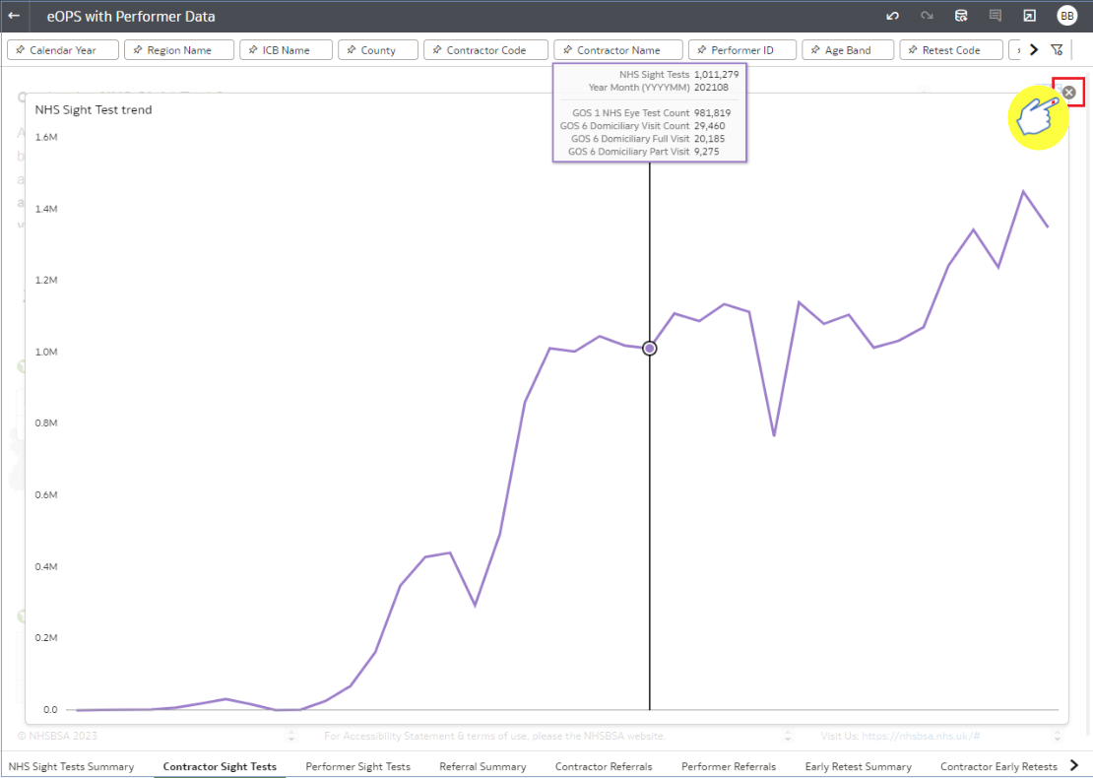

Exporting the data
Users of the ‘eOPSv3 - with Performer Level Data’ dashboard have the ability to export the data out of the dashboard into various formats. Here we show you how you can export a dashboard page as a whole, or export an individual analysis from the dashboard page selected.

Exporting the full dashboard page
In this example we shall be exporting the full ‘NHS Sight Tests Summary’ page. To export the full page from the dashboard:
- Select the export symbol located in the black task bar that runs across the top of the dashboard page (highlighted red below)
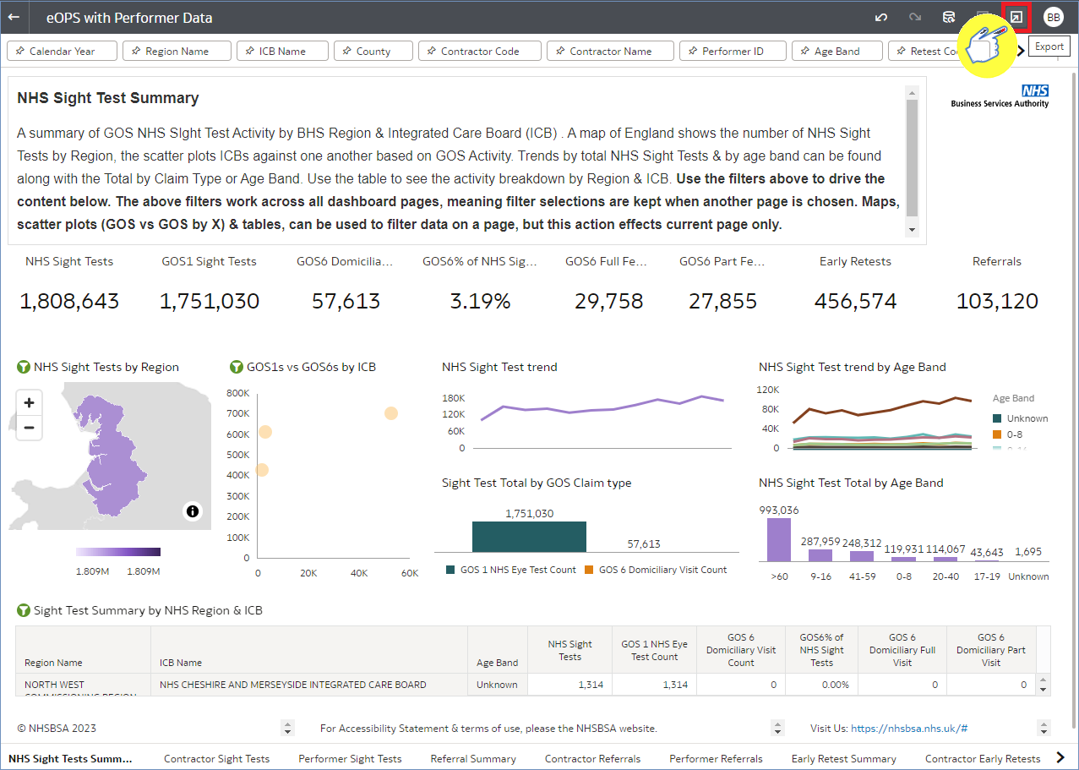
- Once selected, the export function will give you 2 options – ‘File’ or ‘Print’.
‘File’ will export the data out of the system. ‘Print’ will send the data to your connected printer to print a copy.
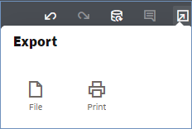
- Select the ‘File’ option to export the full dashboard page, this will bring up the ‘File’ pane
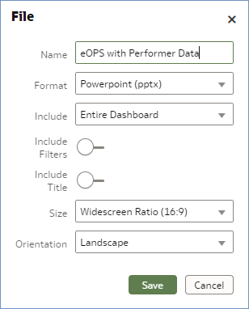

Once the ‘File’ pane has opened there are a number of variables for the user to select.
- In this example I shall rename the file as ‘NHS Sight Test Summary - National’

- I will select the Powerpoint option from the ‘Format’ drop-down list as the requested method of exporting this dashboard page

- Then, select ‘Save’ to export the dashboard page to the designated file format
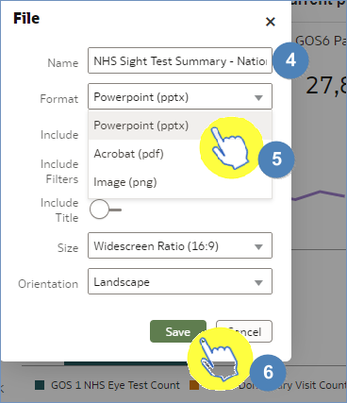
Once the export has successfully downloaded, the data will be presented in the format selected, in this example as a Powerpoint file document:
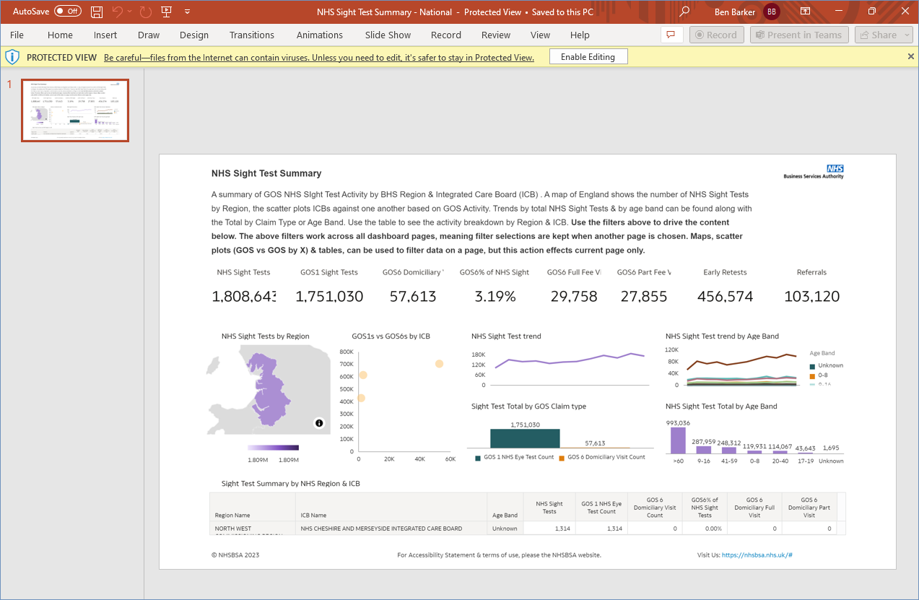

Exporting an individual view
In this example we shall be exporting the individual ‘NHS Sight Test trend by Age Band’ view from the NHS Sight Test Summary dashboard page.
- Expand out the individual view by selecting the icon on the view
- Once expanded, select the export icon and select the ‘File’ option
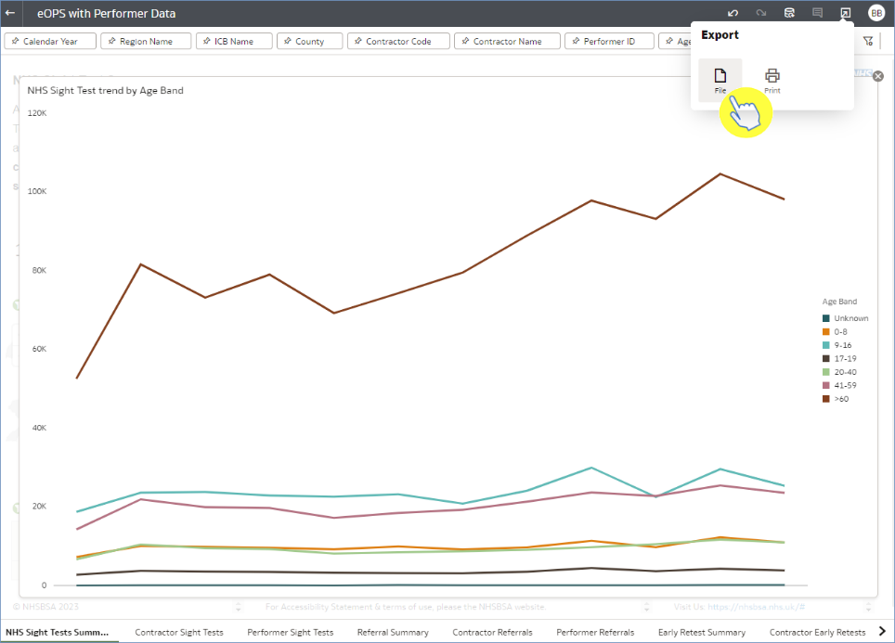
- Once the ‘File’ pane has opened, select the ‘Active Visual’ option from the ‘Include’ drop-down prompt
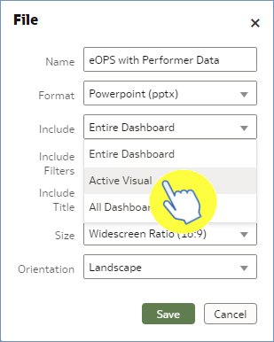

- Then, select the format you wish to export the individual view from the ‘Format’ drop-down prompt.

When exporting an individual view, as well as having the ability to export the view itself you also have the option to export the raw data which makes up the view by selecting the ‘Data (csv)’ option
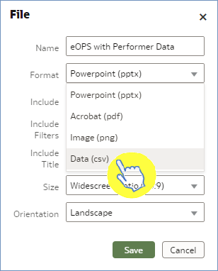

- Once the format option has been selected for the individual view export, in this case ‘Data (csv)’, select ‘Save’ to export the data
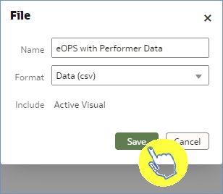

You will have now exported the data for the individual view selected:
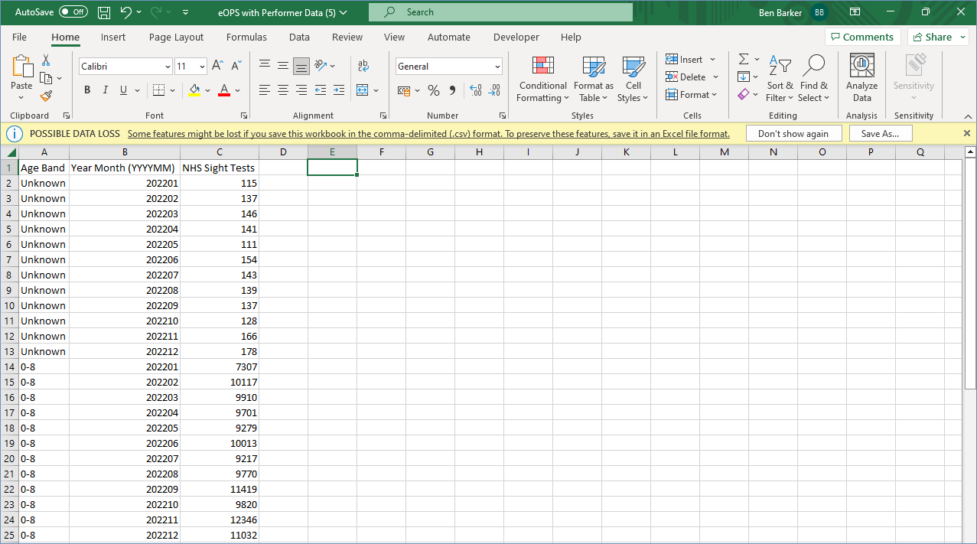

If you wish to export the image of the individual view then select one of the other ‘Format’ options when exporting, such as the ‘Powerpoint (pptx)’ option.

Getting more help

Additional training material and user guides
The eOPS training team has developed several how to guides to help you get the best out of eOPS. These can be found on our eOPS training hub
Webinar sessions
We offer a free, personalised webinar training service to all our users and you can book as many as you need.
You can let us know if you have any specific topics or reports you’d like to cover or if you would prefer an introductory tour. You can take part wherever you are as long as you can get online.
You can find our more and book your webinar by going to our eOPS training hub

