eOPS v1 dashboard guidance

Interactive Contents
Use these interactive contents list to jump straight to the content you want to see.
Just click the titles below to go directly to that section:
eOPS - NHS England Ophthalmic Dashboard v1
Sight Tests
Vouchers
Supplements
Repairs, Replacements & Small Glasses
Finance
Benchmarking
Average Contractor

eOPS - NHS England Ophthalmic Dashboard v1

Dashboard Name
NHS England Ophthalmic Dashboard v1
This is also referred to as eOPS.
This section is designed to complement the NHSBSA eOPS Dashboard to provide context on the different types of analyses & information presented.
- The Practice Profile Report (PPR) & Monthly Expenditure Report by Practice (MERP) are extracted once a month from Open Exeter & both are used to drive the content within eOPS.
- Any activity analysis is solely derived from the Practice Profile Report & the Finance data comes from the Monthly Expenditure Report by Practice (MERP) only.
- There is reference to the old Primary Care Trusts (PCTs) in the dashboard tool. The reason for this is because this is how the data is structured currently in Open Exeter.
- There are two views available for most of the graphs – a graph view or a table view. Use the drop down immediately above a graph to switch between these views.
- All references to Year refer to Financial Year and NOT Calendar Year.
- Any item labelled with * means that this is a mandatory field & the User must choose a value or no results will be displayed.
- Do make use of the hover text inside of graphs and other analysis. These can be useful to identify exactly each data point and other related information.
- This guidance doesn’t display every graphic or analysis available within eOPS, for instance GOS 4 Repairs have been described but additional graphs & tables for GOS 4 Replacements and GOS 4 Small Glasses have been omitted. The logic applied to one can apply to all similar graphs.
For further help and guidance, you can contact the NHSBSA Ophthalmic Insight team at: eopssupport@nhsbsa.nhs.uk

Sight Tests
Analysis Name | Analysis Description | Image
Total Contracts | The total count of NHS GOS Contracts where NHS Sight Test count > 0, for the Organisation level and FY selected. | 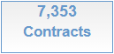
Total Sight Tests | Total count of all NHS Sight Tests, for the Organisation level and FY selected. | 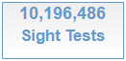
Total Sight Test Bar Graph | A graph showing the count of total NHS Sight Tests by Month, for the FY selected. | 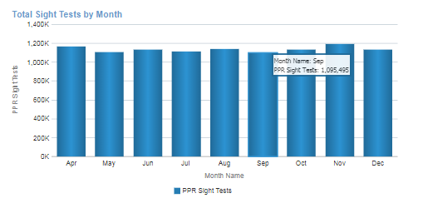
Total Sight Test Pivot Table | A table of values showing the total count of NHS Sight Tests by month, for the FY selected. | 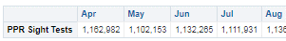
Contract Count Line Graph | A line graph showing the count of contracts by month providing NHS Sight Tests by month, for the FY selected. | 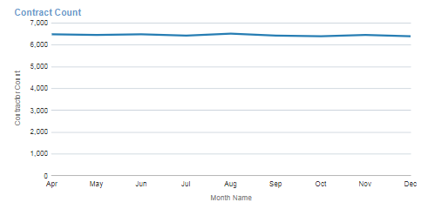
Contract Count Pivot Table | A table of values showing the count of contracts per month, which provided an NHS Sight Test for the FY selected. | 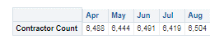
Total Contract Count | Total contract count where at least 1 domiciliary visit has been recorded | 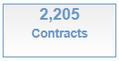
Total Visits | Total count of visits for the FY selected. | 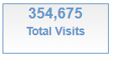
Total Full Visits | Total count of FULL visits, for FY selected. | 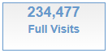
Total Part Visits | Total count of PART visits, for FY selected. | 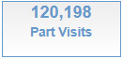
Total Domiciliary Visit Graph | Total count of all Domiciliary Visits by month, for the FY selected. | 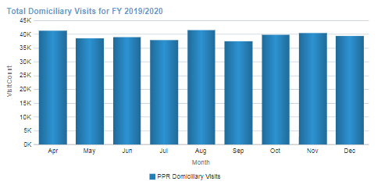
Total Domiciliary Visit Table | Total count of all Domiciliary Visits by month, for the FY selected. | 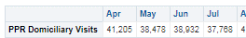
Domiciliary Visit by Type Graph | A line graph which plots the count of visit type by month, for the FY selected. | 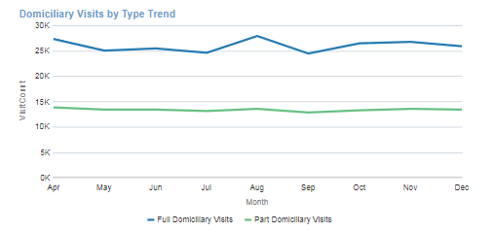
Domiciliary Visit by Type Table | A table showing the values of the visit types by month, for the FY selected. | 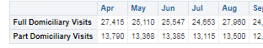

Vouchers
Total Vouchers | Shows the count of ALL vouchers issued for the Organisation level for FY selected. | 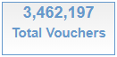
Voucher A-D | Shows the total count of vouchers A-D, for FY selected. | 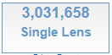
Voucher E-H | Shows the total count of vouchers E-H, for the FY selected. | 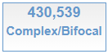
Total Vouchers Graph | A graph showing the total count of ALL vouchers by month, for the FY selected. | 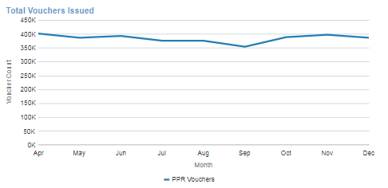
Total Vouchers Table | A table showing the total count of all vouchers, by month for the FY selected. | 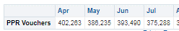
Voucher A-D Graph | A graph showing the count of vouchers A-D by month for the FY selected | 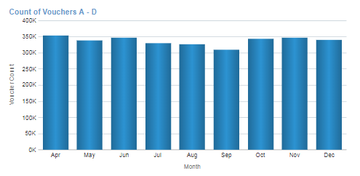
Voucher A-D Table | A table of values detailing the total count of voucher A-D, by month for the FY selected | 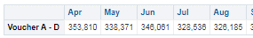
Voucher E-H Graph | A graph showing the total voucher E-H count, for the FY selected. | 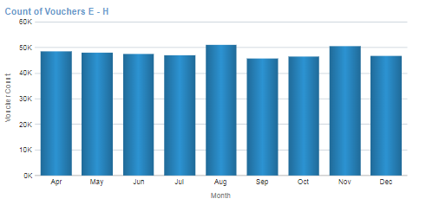
Voucher E-H Table | A table showing the total voucher E-H count, for the FY selected. | 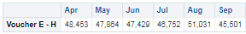
Volume of A Voucher Graph | A graph allowing the user to choose an individual voucher to view the voucher count by month, for the FY selected. | 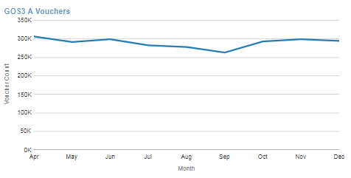
Voucher Table | A table of values that gives a total count by month, for each voucher type for the FY selected. | 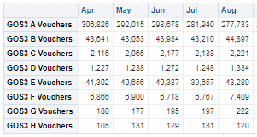
% of Vouchers by Type  Graph | A graph visualising the % of all vouchers issued per month (e.g., 76.27% of Vouchers issued in April, were for A Vouchers). | 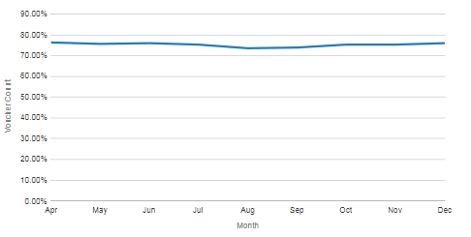
% of Vouchers by Type  Table | A table of values showing the proportion of voucher issues for all voucher types | 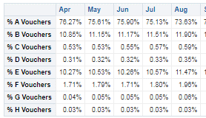
% Sight Test per Voucher Type Graph | A line graph showing the % of total NHS Sight Tests that generated a voucher type (e.g., 26.38% of Sight Tests generated an A Voucher in April). | 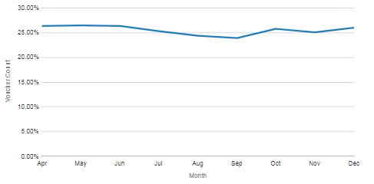
% Sight Test per Voucher Type Table | A table of values showing the proportion of voucher issues for all sight tests | 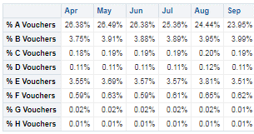

Supplements
Total Supplements | The total count of all supplements, for the Organisation level or FY selected. | 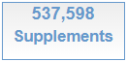
Total Tints | Shows the count of all Tints for the FY selected. | 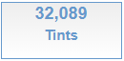
Total Prisms | Shows the count of all Prisms for the FY selected. | 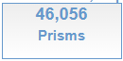
Total Second Pairs | Shows the count of Second Pairs for the FY selected. | 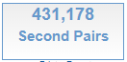
Total Single Complex | Shows the count of Single Complex lenses for the FY selected. | 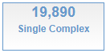
Total Complex Bifocals | Shows the count of Complex Bifocals for the FY selected. | 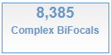
Supplement Quantity Graph | A bar graph (histogram) that shows the total count by supplement for the FY selected. | 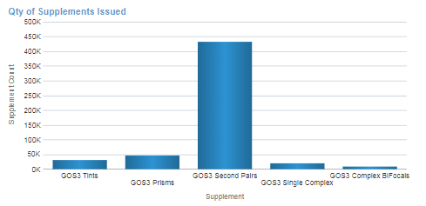
Supplement Qty Table | A table of values that provides the count by supplement, for the FY selected. | 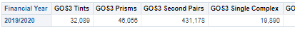
Supplement % Graph | A pie chart showing the % of all supplements claimed, for FY selected (e.g., 80.20% of supplements were 2nd pairs in 2019/20). | 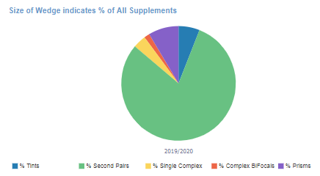
Supplement % Table | A table of values with the supplement % breakdown | 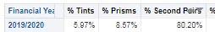
Heat Map Tints | A heat map showing the volume of supplement by month – the darker the colour, the greater the volume. | 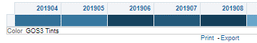
Tint and Prism Graph – Quantity | A graph which visualises the quantity of supplement issued by month | 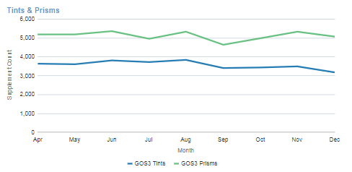
Tint and Prism Table – Quantity | A table of values for the quantity of supplement issued by month for the selected FY. | 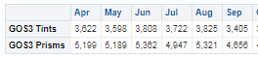
% Supplement to Vouchers Issued Graph | The % of Vouchers where a supplement was issued (e.g., in August, 1.01% of vouchers had a tint supplement). | 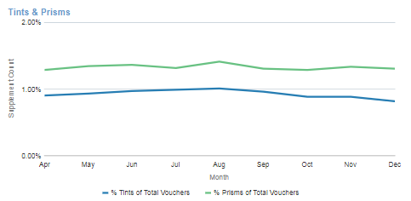
% Supplement to Vouchers Issued Table | The above analysis, but in tabular form | 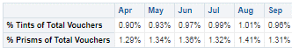

Repairs, Replacements & Small Glasses
Total Repairs | Shows the total count of Repairs claimed. | 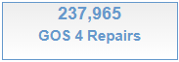
Total Replacements | Shows the total count of Replacements claimed. | 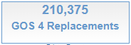
Total Small Glasses | Shows the total count of Small Glasses claimed. | 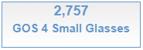
Repair Graph - Quantity | A graph showing the count of chosen supplement, by month for the FY selected. | 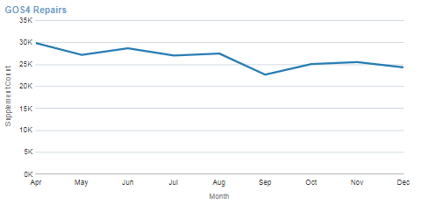
Repair Table – Quantity | A table of values describing the counts of each supplement by month, for the FY selected. | 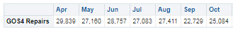
Repairs Graph - % | % of all repairs issued, by month for the FY selected. | 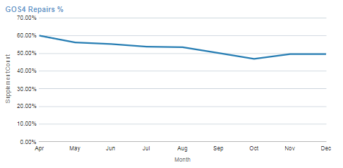
Repair Table - % | A table of values describing the % of all repairs claimed in month, for the FY selected. | 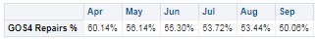

Finance
OMP Sight Tests. | A graph showing the value to the Contract for the selected metric. | 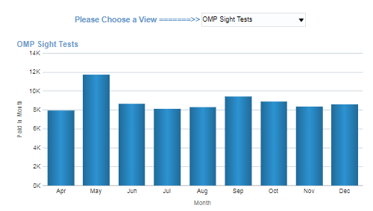
Financial Summary. | A table to reflect the information found in the original MERP report and shows the financial summaries. | 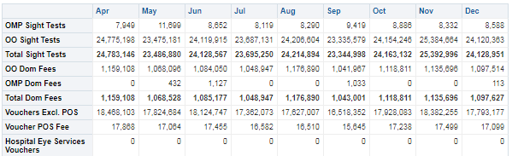

Benchmarking
This section provides some benchmarking at Regional or Commissioner Level depending on the page you select.
Total NHS Sight Tests Bar Graph | This shows the total count of NHS Sight Tests, by RT/AT or by Year. | 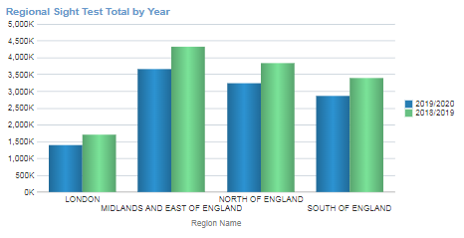
Total Sight Test Bubble Graph | This shows the total NHS Sight Tests by RT/AT & the % of the National Total for each. | 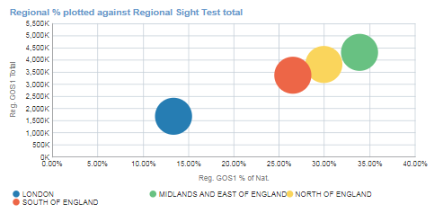
Total Sight Test Table | This provides an at-a-view glance of the above two analysis | 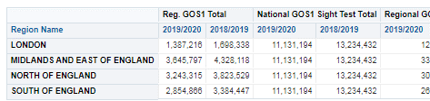
Total Visit Bar Graph | This shows the total count of Domiciliary Visits by RT/AT & by FY. | 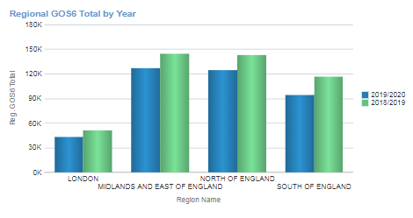
Total Domiciliary Visit Bubble Graph | This shows the total count of Domiciliary Visits by RT, plotted against the % of National Total. | 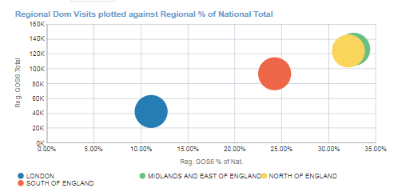
Total Domiciliary Visit Table | This is the table of values for the prior two graphs. | 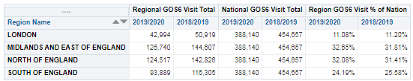
Total Voucher Bar Graph | This shows the total count of Vouchers claimed by RT/AT and Year | 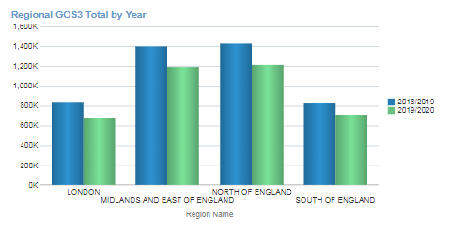
Total Voucher Bubble Graph | This shows the total count of Vouchers claimed by RT/AT by Year, plotted against the % of All Vouchers | 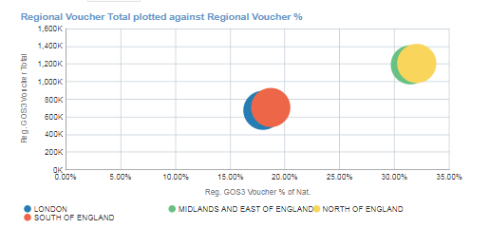
Total Voucher Table | This is the table of values for the preceding two graphs | 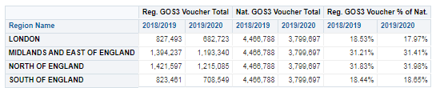
Total Supplements Bar Graph | This shows the total Supplements* by RT/AT & Year. | 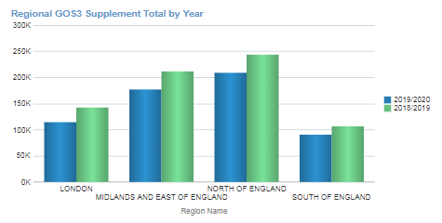
Total Supplements Bubble Graph | This shows the total Supplements* by RT/AT & Year plotted against the % of National Total | 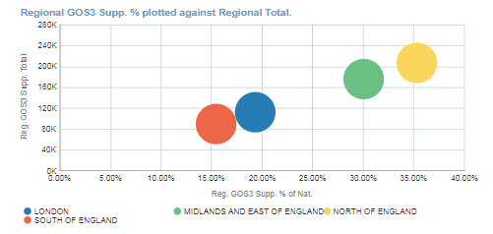
Total Supplements  Table | A table of values for the preceding two graphs. | 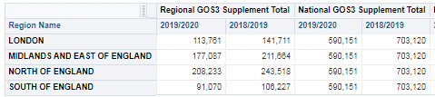
Total Repairs/  Replace & Small Glasses Bar Graph | This shows the total count of all claimed by RT/AT & FY selected. | 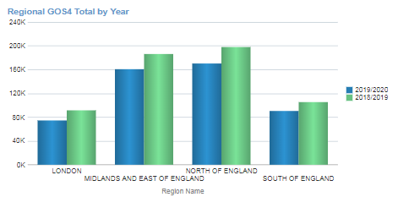
Total Repairs/  Replace & Small Glasses Bubble Graph | This shows the total count of all claimed by RT/AT & FY selected. This also plots each Region/AT against the National Total for GOS 4 Repairs, Replacements etc. | 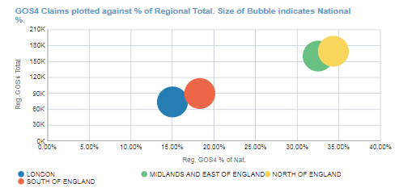
Total Repairs/  Replace & Small Glasses  Table | This is a table of values for the prior two graphs. | 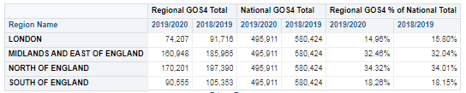

Average Contractor
This section splits out at varying Organisation levels; however, these are just the mean values for each of the reported indicators. This does tell you useful anecdotal facts about the GOS landscape, such as the average cost of a Sight Test by Region or the Average number of Sight Tests per Voucher.
Average Claim by Contract | This is the average financial claim for a theoretical Contract for the Organisation Level selected. | 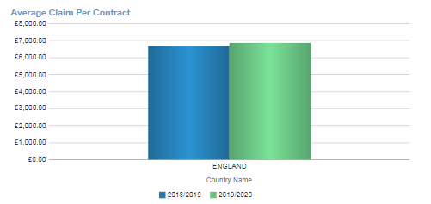
Average Cost Per Sight Test | This is the Average cost of a Sight Test for the Organisation Level selected. | 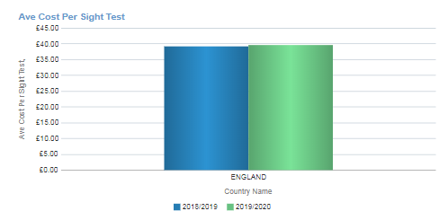
Average Sight Test Count Per Contract | This shows the Average number of NHS Sight Tests claimed by a Contract at the Organisation Level selected. | 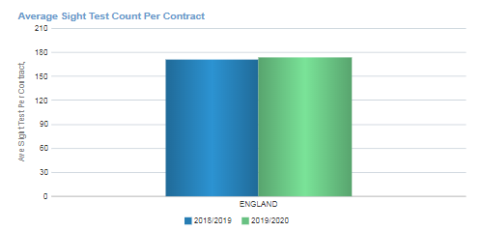
Monthly Average Sight Test Count by Contract | This shows the average number of NHS Sight Tests performed by a Contract at the Organisation Level selected. | 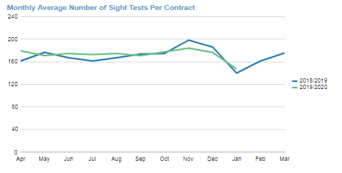
Average number of Sight Tests per Voucher | This shows the average number of NHS Sight Tests performed, before a voucher is issued. | 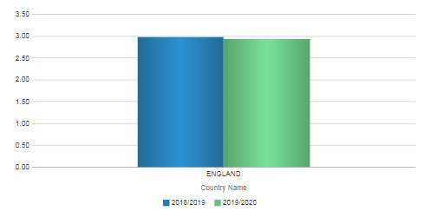
Average number of Sight Tests per Voucher by Month. | This shows the analysis immediately above, but by month | 