Annual GOS Complaints Submission
National Briefing – April 2023

Dear Colleague

As you will be aware it is a contractual requirement to confirm the number of written NHS complaints received for GOS in your practice. Following last year’s successful collection of GOS complaints we are writing to confirm the dates and process for this year’s collection.

The online data collection will be open between Monday 17th April 2023 to Friday 26th May 2023. Access to the survey will require the input of your ODS code. If you are unsure of your code, you can look up your practice using the following link to the NHS Digital ODS Portal: https://odsportal.digital.nhs.uk/.

The submission window will reopen on Saturday 1 July 2023 and close on Monday 31 July 2023 for non-responders to complete their submission.

Access to the collection is via the following link and detail regarding complaints received within 2021/2022 financial year is only required. Timescales for 2022/2023 financial year will be provided at a later stage.

https://online1.snapsurveys.com/NHS_Ophthalmic_Complaints You can also access the form by scanning the QR code:

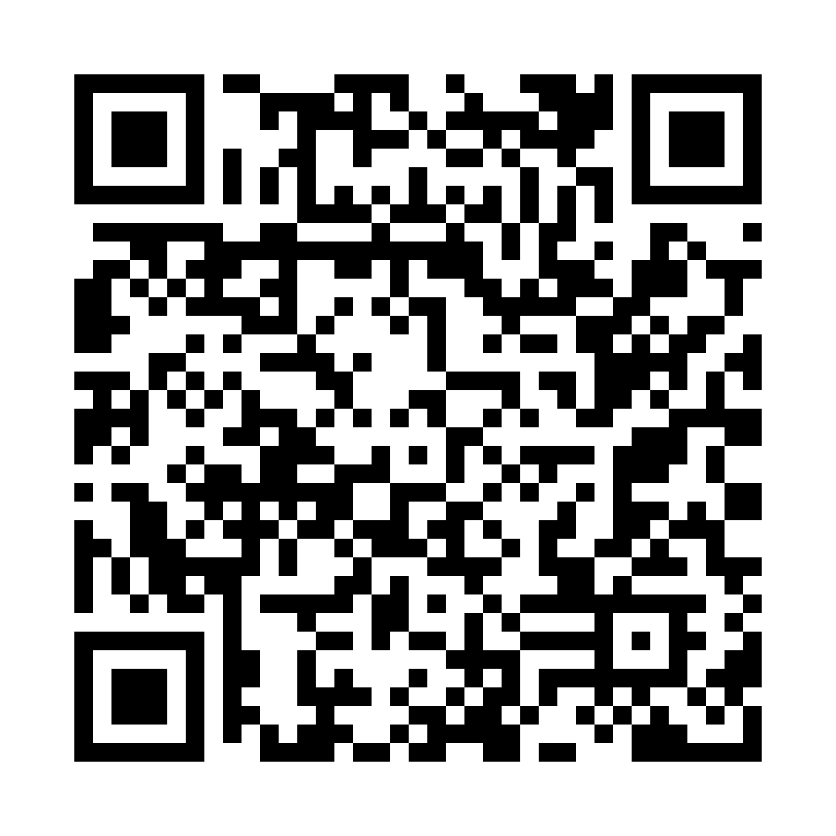

Alternatively, the collection can be accessed on the Provider Assurance Ophthalmic website via the following link: https://www.nhsbsa.nhs.uk/provider-assurance-ophthalmic

Once you have accessed the survey the first task you will be required to complete is to confirm the name and email address of the person completing the form. Stage two will then be to enter the number of complaints received. In the case that a practice has received no complaints please enter ‘0’ within the capture field. Prior to submitting your completed response, you will be taken to a review page in order that you may check the information entered.

Your response will be collated along with responses from fellow GOS contractors and shared with NHS England, relevant ICB and commissioning team.

Many thanks in advance of completion and should you have any queries, please contact the Provider Assurance Ophthalmic team via e-mail at: pao@nhsbsa.nhs.uk.

Our core opening hours are Monday to Friday, 8.00am – 4.30pm.

