Potential Generic Savings

Version: July 2023

Dashboard Overview and Specifications

Contents

Overview 3
Interpretation of the reports 3
Data source 4
Data owner & contact details 4
Timeframe 4
Data quality assurance 4
Data restrictions 4
Alternative potential generic saving reports 5
Prescribing Reports – Prescribing Comparators – Potential Generic Savings (PG1) 5
Premium Priced Generics 5
Dashboard Operation: Navigation 6
Dashboard Operation: Criteria Selection 6
Dashboard Section: Overview 6
Dashboard Section: SICBL Summary 7
Dashboard Section: Practice Summary 8
Dashboard Section: Organisation Summary 9
Dashboard Section: Datasets 10
Dashboard Section: Supplementary Information 10
Appendix 1: Terminology used and calculations 12
Appendix 2: Visualisation Examples 15
Summary of potential savings 15
Potential savings on net ingredient cost 15
Proprietary Prescribing – Monthly Trend 15
Current prescribing 15

Overview
In England, 81% of all drugs in primary care are already prescribed generically, generating significant savings for the NHS. This percentage is impressive, but the variation in generic prescribing rates between GP practices suggests there are still opportunities for some prescribers to deliver even better value care.

The Potential Generic Savings dashboard is designed to provide insight into the savings that could be achieved by changing from proprietary to generic prescribing for the 20 drugs identified at a national level as having the greatest potential to release additional resources through increased generic prescribing.

The dashboard presents data across a range of reporting levels from National to Practice level to show how the savings relate to individual organisations.

Interpretation of the reports

The reports show the current prescribing of the proprietary products alongside the potential savings if these items were prescribed generically. The price used in the potential cost calculation is the latest held in the NHSBSA database at the time the dashboard is produced and may change. The current overall prescribing of the generic products is also displayed to show how often these items are already being prescribed generically.

The dashboard is a cost-based analysis and the drug list used has not been reviewed from a clinical perspective. The data should be considered a suggestion of where potential savings could be found.

It is still possible that patients will express a preference for the branded version of a particular medicine. Such preferences should be dealt with on a case-by-case basis.

For medicines with relatively low current levels of generic prescribing in their locality, SICBLs may wish to consider notifying community pharmacies of their intention to increase generic prescribing, so they can plan accordingly.

The number of patients has been included to give an idea of the number of patients that would be impacted by any changes and to allow resources to be targeted cost-effectively.

Please note that patients may appear in the counts for multiple different medicines.

Data source
NHS Business Services Authority - based on data from the NHSBSA’s Information Services Data Warehouse which contains all NHS prescription data, with the exception of prescriptions which are dispensed in prisons, hospitals and private prescriptions.

Analysis is based only on prescriptions that were prescribed from within a SICBL environment, including any prescribing from practices within the SICBL organisation structure. This will exclude any prescribing from outside of the SICBL environment, including hospital trusts.

Data owner & contact details
DataServicesSupport@nhsbsa.nhs.uk

Timeframe
Each quarter a new iteration of the dashboard will be produced to highlight the top 20 switches (at a national level) for that quarter. However, previous iterations of the dashboard will remain accessible for a period of a year.

Data quality assurance
NHS Prescription Services have their own internal quality process to assure the data they provide matches what was originally submitted as part of the prescription processing activity. Some processes are complex and manual therefore there may be random inaccuracies in capturing prescription information which are then reflected in the data but checks are in place to reduce the chance of issues occurring. The processes operate to a number of key performance indicators, one of which is the percentage Prescription Information Accuracy, the target being 99.8% and as at Mar 2023 the accuracy level achieved over the latest 12 month rolling period was 99.91%.

Data restrictions
In addition to the results only being presented for the top 20 potential switches nationally there are a couple of additional restrictions that have been applied to the data:
- Data is limited to SICBL prescribing data
  - As this dashboard focuses on SICBL prescribing there is no data included from other commissioner/providers. For example, practice level information is only available for practices assigned to a SICBL and the national (or region etc.) level figures are only based on an aggregation of the SICBL data.
- Data excludes items dispensed in Scotland (prescribed in England)
  - Due to the way the NHSBSA systems capture this information, no pack level data is captured making it difficult to accurately identify potential generic costs and therefore this information has been excluded. For English prescribing data, Scottish dispensing only accounts for around 0.003% of prescription items per month.
- Some restrictions to drugs are applied. The dashboard will exclude any products which are in Drug Tariff Category C. Any drugs in BNF Section 0802 – Drugs affecting the immune response, BNF 040801 – Control of epilepsy and any appliances in BNF chapters 20-23 are all excluded from the drug list.

Please take these restrictions into account when trying to consolidate any figures from the dashboard with other reports or data sets.

Alternative potential generic saving reports
In addition to this dashboard there are another couple of other resources in ePACT2 related to potential generic savings and these can be accessed via the “Supplementary Information” link on the dashboard (in addition to being available via the standard menu route).

Prescribing Reports – Prescribing Comparators – Potential Generic Savings (PG1)
This report provides details of the top 40 generic saving switches for a selected organisation.

The main difference between this report and the dashboard is that the identified savings from the report are bespoke to the selected organisation. Therefore, using this report at the SICBL level will show the top 40 savings identified for the selected practice.

Please note, this report includes information for all commissioner/providers (SICBL, Trust etc.) and therefore the national figures reported may be higher than those displayed in the dashboard which is just based on SICBL prescribing data.

Premium Priced Generics
This dashboard focuses on the prescribing where a generic product has been prescribed along with a brand/supplier.

When using computerised systems a prescriber may intend to simply prescribe a generic product but when selecting the drug from the system they may select a specific brand/supplier version from the list of available products.

In situations where this occurs the drug costs charged to the prescriber’s budget and reimbursed to the community pharmacy or dispensing practice will be that of the list price of the branded medicine or the specified supplier.

This dashboard is designed to help identify where this type of prescribing is taking place and the potential savings if the true generic version was prescribed.

Dashboard Operation: Navigation
Along the top of each dashboard page there are a series of links which can be used to navigate throughout the dashboard:

Within each of these headings there may be an additional list of menus to allow the selection of a subpage within the selected section.

Dashboard Operation: Criteria Selection
Within each of the dashboard pages there is a “Criteria Selection” box which can be used to select what information should be displayed on the current dashboard page:

The selection boxes will list the available options for the currently displayed dashboard and any selections will not take effect until the “Apply” button is pressed.

Dashboard Section: Overview
The overview page within the dashboard provides a high level summary of the available information. The data included within the page shows the overall figures for each of the potential brand to generic switches.

For each potential drug switch the current spend is shown to identify what the existing spend was during the reporting period for the proprietary presentation. The potential spend shows what cost could potentially have been had all of the proprietary prescribing switched to the generic presentation. The potential saving shows the difference between these two figures, identifying how much money could potentially have been saved.

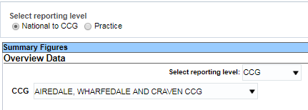
Results within the table can be displayed at different levels using a combination of controls on the dashboard:

- There is an option to switch between viewing data from National down to SICBL level or to view practice level.
- When viewing National to SICBL level data there is an additional selection box to select which of these levels to view.
- Finally, when looking at any level other than National, there are additional options available to select which single organisation to view.

Dashboard Section: SICBL Summary
The SICBL summary dashboard pages allow the figures to be viewed for a single selected SICBL compared against other SICBLs within the selected grouping level.

From the dashboard page menu, when selecting “SICBL Summary” there are a number of pages available to select which dictate which SICBLs are displayed for comparison:
- SICBLs within National
- SICBLs within AHSN
- SICBLs within ICB
- SICBLs within Region

Within each of the available pages, an individual potential generic switch can be viewed in isolation by selecting the proprietary medicine from a selection list. The dashboard page will show, for the selected SICBL and medicine, what the current prescribing details are for the proprietary item and the potential figures if all prescribing was switched to the generic equivalent.

The “Summary of potential savings” section (see appendix 2 for example) at the top of the page will show a summary of the current proprietary prescribing and the potential figures if prescribing was switched to the generic equivalent product.

The “Potential savings on net ingredient cost” section (see appendix 2 for example) includes a chart to show the potential saving highlighting the selected SICBL against all of the other SICBLs within the relevant SICBL group for the selected page.

The “Proprietary Prescribing – Monthly Trend” section (see appendix 2 for example) includes charts to show the prescribing (items and net ingredient cost) on a monthly basis. This section of the dashboard shows figures for all months following the reported quarter to allow monitoring of performance against the identified proprietary to generic switch.

For both of the charts mentioned above there is the functionality to switch to view the underlying data.

The “Current prescribing” section (see appendix 2 for example) at the bottom of the dashboard includes a table showing the current prescribing of both the proprietary and the associated generic medicines. This table can be used to help identify the levels of prescribing that are already being completed using the generic medicine and the current scope for improvement.

Please note the figures included for the number of identified patients receiving prescriptions are only representative of the patients who could be identified during the prescription processing activities and therefore may not account for all of the items included in the report. In general patients can only be identified for around 91% of prescription items, although this figure will vary based on drug, prescribing organisation etc.

Dashboard Section: Practice Summary
The practice summary dashboard pages allow the figures to be viewed for a single selected practice compared against other practices within a selected SICBL.

From the dashboard page menu when selecting “Practice Summary” there are two pages available to select, which dictate whether the dashboard will only concentrate on GP practices or also include all other practices (Out of Hours, Walk in Centres etc.):
- GP practices within SICBL
- All practices within SICBL

Within each of the available pages, an individual potential generic switch can be viewed in isolation by selecting the proprietary medicine from a selection list. The dashboard page will show, for the selected practice and medicine, what the current prescribing details are for the proprietary item and the potential figures if all prescribing was switched to the generic equivalent.

Please note, due to the lower levels of prescribing associated with practices it is possible that there may not have been any prescribing for a selected proprietary medicine. In these circumstances the dashboard results may be blank to signify there are no figures to display. In addition, the selected practice will also not be displayed in the charts within the dashboard as there will be no potential savings available to display.

The “Summary of potential savings” section (see appendix 2 for example) at the top of the page will show a summary of the current proprietary prescribing and the potential figures if prescribing was switched to the generic equivalent product.

The “Potential savings on net ingredient cost” section (see appendix 2 for example) includes a chart to show the potential saving highlighting the selected practice against all of the other practices within the selected SICBL.

The “Proprietary Prescribing – Monthly Trend” section (see appendix 2 for example) includes charts to show the prescribing (items and net ingredient cost) on a monthly basis. This section of the dashboard shows figures for all months following the reported quarter to allow monitoring of performance against the identified proprietary to generic switch.

For both of the charts mentioned above there is the functionality to switch to view the underlying data.

The “Current prescribing” section (see appendix 2 for example) at the bottom of the dashboard includes a table showing the current prescribing of both the proprietary and the associated generic medicines. This table can be used to help identify the levels of prescribing that are already being completed using the generic medicine and the current scope for improvement.

Please note the figures included for the number of identified patients receiving prescriptions are only representative of the patients who could be identified during the prescription processing activities and therefore may not account for all of the items included in the report. In general patients can only be identified for around 91% of prescription items, although this figure will vary based on drug, prescribing organisation etc.

Dashboard Section: Organisation Summary
The organisation summary dashboard pages allow the figures to be viewed at various grouping levels encompassing multiple SICBLs.

From the dashboard page menu, when selecting “Organisation Summary” there are a number of pages available to select which dictate which organisation groups are displayed for comparison:
- AHSN Summary
- ICB Summary
- Region Summary

Within each of the available pages, an individual potential generic switch can be viewed in isolation by selecting the proprietary medicine from a selection list. The dashboard page will show, for the selected organisation (e.g. AHSN, Cluster etc.) and medicine, what the current prescribing details are for the proprietary item and the potential figures if all prescribing was switched to the generic equivalent.

The “Summary of potential savings” section (see appendix 2 for example) at the top of the page will show a summary of the current proprietary prescribing and the potential figures if prescribing was switched to the generic equivalent product.

The “Potential savings on net ingredient cost” section (see appendix 2 for example) includes a chart to show the potential saving highlighting the selected organisation against all of the other related organisations.

The “Proprietary Prescribing – Monthly Trend” section (see appendix 2 for example) includes charts to show the prescribing (items and net ingredient cost) on a monthly basis. This section of the dashboard shows figures for all months following the reported quarter to allow monitoring of performance against the identified proprietary to generic switch.

For both of the charts mentioned above there is the functionality to switch to view the underlying data.

The “Current prescribing” section (see appendix 2 for example) at the bottom of the dashboard includes a table showing the current prescribing of both the proprietary and the associated generic medicines. This table can be used to help identify the levels of prescribing that are already being completed using the generic medicine and the current scope for improvement.

Please note the figures included for the number of identified patients receiving prescriptions are only representative of the patients who could be identified during the prescription processing activities and therefore may not account for all of the items included in the report. In general patients can only be identified for around 91% of prescription items, although this figure will vary based on drug, prescribing organisation etc.

Dashboard Section: Datasets
The dataset dashboard pages allow access to the full datasets which underpin the other dashboard pages.

From the dashboard page menu, when selecting “Datasets” there are a number of pages available to select which dictate at which organisation level the data will be presented:
- Data by SICBL
- Data by Practice
- Data by AHSN
- Data by ICB
- Data by Region

Each subpage in this section will list all the data for a selected proprietary to generic switch, with the data being grouped by the selected organisation level.

For each entry the current prescribing details are included for both the generic and proprietary medicines. In addition, the potential savings are included to show what the potential savings were had all prescribing of the proprietary medicine been completed using the generic equivalent.

The datasets do not hold any information in addition to what is available throughout the rest of the dashboard pages. However, these datasets may be useful if the data needs to be exported to external products for analysis.

Please note the figures included for the number of identified patients receiving prescriptions are only representative of the patients who could be identified during the prescription processing activities and therefore may not account for all of the items included in the report. In general patients can only be identified for around 91% of prescription items, although this figure will vary based on drug, prescribing organisation etc.

Dashboard Section: Supplementary Information
This section contains links to additional information or related reports that may be useful or of interest:
- Glossary
  - This provides a glossary of the terms and calculations used throughout the dashboard. The glossary has also been included within Appendix 1 of this document
- Generic Unit Cost Reference
  - The potential cost and savings have been calculated using the unit cost of the generic equivalent product and this section of the dashboard provides an example of the calculation and details of the unit costs that have been applied
- [Link] Prescribing Report – Potential Generic Savings (PG1)
  - Provides a link to the ePACT2 report
- [Link] Premium Priced Generics
  - Provides a link to the ePACT2 dashboard
Appendix 1: Terminology used and calculations

AHSN
Academic Health Science Network: There are 15 Academic Health Science Networks (AHSNs) across England, established by NHS England in 2013 to spread innovation at pace and scale – improving health and generating economic growth. Each AHSN works across a distinct geography serving a different population in each region.

ICB
Geographical grouping used to group SICBLs according to 27 areas. These areas correspond with the historic NHS Area Teams.

SICBL
Sub-ICB Locations (previously known as CCGs) are NHS organisations that organise the delivery of NHS services in England. They are clinically led groups that include all of the GP groups in their geographical area.

Current Cost (£)
Value showing the current cost of items that are currently prescribed using the proprietary medicine.

Current Items
Value showing the number of items that are currently prescribed using the proprietary medicine.

Generic Medicine
The scientific or generic name for a medicinal product (i.e. Ibuprofen)

Identified Patients
The number of unique patients, who can be identified, based on NHS number. During prescription processing activities not all patient details can be captured and therefore the patient's NHS number will only be available for a proportion of prescriptions (circa 91% of all prescriptions). Care should be exercised when reporting patient numbers and these values should not be combined as this could lead to double counting of patients.

Items
Number of prescribed items. For example, if four prescription items each have a quantity of 28 the total items will be 4.

NIC
Net Ingredient cost (NIC) is the basic price of a drug as stated in Part II Clause 8 of the Drug Tariff.

Potential Cost (£)
Value showing the potential cost that would apply if the current prescribing of the proprietary medicine was switched to the generic product. Potential costs are calculated by multiplying the paid quantity of the proprietary product by a unit cost for associated generic product. The unit cost for the generic product is based on the reimbursement price divided by the pack size (or container size for special container items), with the reimbursement price being the latest price available when the data was loaded into our data warehouse system (typically around 6 weeks following the end of the reporting period).

For example:
- we have a branded product “BRAND A” where a total of 100 tablets has been dispensed.
- the generic equivalent product “GENERIC A” has a reimbursement price of £1.00 for a pack of 50 tablets.
- the unit cost for “GENERIC A” would be £0.02 (this is the cost per individual tablet).
- therefore the potential cost is calculated by multiplying the quantity of “BRAND A” (100) by the unit cost of “GENERIC A” (£0.02) to get a potential cost of £2.00.

Potential Saving (£)
Value showing the potential saving that could be achieved if all of the current prescribing of the proprietary medicine was switched to the generic product. Savings are calculated by identifying the difference between the current cost and the potential cost.
Calculation: Potential Saving (£) = Current Cost (£) - Potential Cost (£)

Practice
The name of the individual practice to which prescribing can be attributed. Separate reports have been included to allow comparison of GP practices in isolation or combined with all other practices (i.e. Walk in Centres, Out of Hours services etc.)

Proprietary Medicine
The brand name as given to a medicine by the pharmaceutical company it is developed by (i.e. Nurofen).

Quantity x Items
Total quantity for the number of prescribed items. For example, if four prescription items each have a quantity of 28 the total quantity x items will be 112.

Region
Four regional teams regions cover healthcare commissioning and delivery in their area and provide professional leadership on finance, nursing, medical, specialised commissioning, patients and information, human resources, organisational development, assurance and delivery.

Saving on Presentation (%)
Value showing the potential saving that could be achieved as a percentage of the current net ingredient cost spend for the individual item.
Calculation: Saving on Total NIC (%) = (Potential Saving (£) / Current Cost (£))*100

Saving on Total NIC (%)
Value showing the potential saving that could be achieved as a percentage of the total net ingredient cost spend. The total spend covers all prescribing activity for the organisation and time period in question.
Calculation: Saving on Total NIC (%) = (Potential Saving (£) / Total NIC Spend)*100

Appendix 2: Visualisation Examples

Summary of potential savings
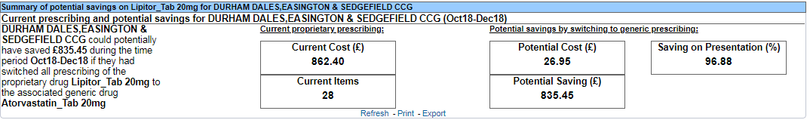
This section shows a high level summary of the proprietary prescribing and the potential cost/savings. Please note, this section may be blank where the selected organisation did not have any applicable prescribing of the selected proprietary drug presentation.

Potential savings on net ingredient cost
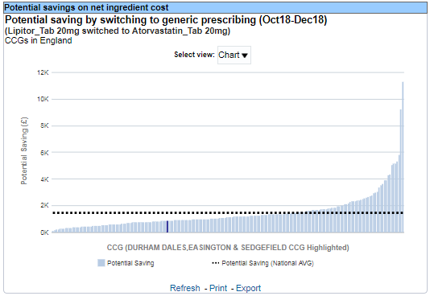
This section charts the potential saving for the selected organisation against other peer organisations.

For the SICBL summary pages the peers will be restricted to the relevant selected grouping (e.g. SICBLs in AHSN etc.).

The highlighted bar will represent the selected organisation and the dotted line will represent the average figure.

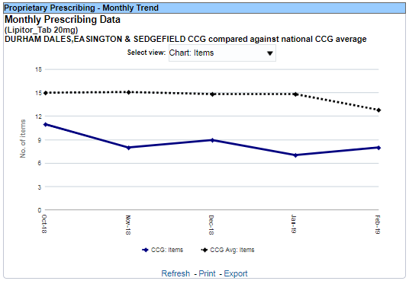
Proprietary Prescribing – Monthly Trend
This section shows the monthly items or net ingredient cost (NIC) for the selected organisation and medicine.

This trend will extend each month as new prescribing data becomes available and can be used to track if prescribing of the identified medicine is decreasing over time.

The solid line represents the selected organisation and the dotted line represents the average figure.

Current prescribing
This section shows the prescribing of both the proprietary and generic medicines over the reported period. This can be used to identify how prescribing is currently split between the identified products.
