2015 Scheme GP tiered contributions: Guidance notes for use of the annualisation calculator for year 2022/23
Background
From 1 April 2022 as all members are in the 2015 Scheme, the tiered employee contribution rate for a medical practitioner is based on their global and annualised income, for example, GP practice plus self-employed OOHs plus self-employed ICB.
All breaks in pensionable service in year 2022/23 must be accounted for irrespective of the type of GP or length of the break. A GP is not regarded as being in continuous pensionable service during a break.
To assist GPs, NHS Pensions has developed a 2022/23 annualisation calculator, in which the GP enters details of their GP work and income to determine the correct tiered employee contribution rate(s).
Special provision for 2022/2023 year due to mid-year tiered employee contribution rate change
NHS Pension Regulations were modified from 1 April 2023 in respect of annualising during the scheme year 2022/2023 to account for a mid-year tiered employee contribution rate change. The Regulations refer to two relevant periods, which are 1 April 2022 to 30 September 2022 and 1 October 2022 to 31 March 2023
They specify how annualised pay is calculated under two different methods depending on the type of membership.
For Type 1 GP’s, as pensionable earnings are determined by practice profits and therefore do not apply to a specific date of work, the total pensionable pay is apportioned between the two relevant periods based on the number of pensionable days. The annualised pay is then calculated for each relevant period based on the apportioned pensionable pay and pensionable pays in each period. Where a member only has a Type 1 post during 2022/23, the annualised pay for each relevant period will be the same amount.
For Type 2 GPs and Locum GPs, as the actual pensionable pay for each period of work is known, the annualised pay is based on the actual pensionable pay earned and the number of pensionable days in each relevant period.
This method of annualising for 2022/23 is different to the examples previously provided in the 2022/23 SOLO and Locum form guidance, which were based on the understanding that following the mid-year tiered employee contribution rate change with effect from 1 October 2023, the tier rates would be determined by annualising the pensionable pay for the whole scheme year for all types of practitioner posts.
This may result in more contribution adjustments than previous years following the submission of the 2022/23 Annual Certificates/Forms.
Therefore the annualisation calculator has been updated for the 2022/23 scheme year to calculate the annualised pay for each relevant period and determine the correct tiered employee contribution rate for each relevant period.

General guidance for using the 2022/23 calculator
When using the calculator it is important to enter the type of GP work undertaken. The calculator recognises three different types of work, which each contribute to the total GP income used to set the tiered employee contribution rate.

Type 1 GP
A Type 1 GP is a GP who is partner, shareholder, or single-hander.
Please enter the dates and income for each period of work as a Type 1 GP.
For example:
A Type 1 GP who worked from 1 May 2022 – 31 March 2023 should enter the pensionable profit figure for the whole period of work and the calculator will apportion the profit between the two relevant periods.
Calculator inputs:
1 May 2022 – 31 March 2023
Pay = pensionable profit for the whole period i.e. 1 May 2022 – 31 March 2023

Type 2 GP
A Type 2 GP is:
• A salaried GP formally employed by a GP practice, APMS contractor or a LHB;
• a long term fee based/self-employed GP who works for a GP practice, APMS contractor, or LHB, for a period of, generally, six months or more and elects to be a Type 2;
• a GP who works solely on a self-employed basis for an Out of Hours Provider that is an NHS Pension Scheme Employing Authority.

Please enter the dates and pensionable income for each period of work as a Type 2 GP. Where a post spans 1 October 2022, the post should be split between pre and post 1 October 2022.
For example:
A salaried GP who worked from 1 July 2022 – 31 October 2022 should enter two periods of Type 2 work.
Calculator input:
- 1 July 2022 – 30 September 2022
Pay = actual pensionable pay for this period

- 1 October 2022 – 31 October 2022
Pay = actual pensionable for this period

Self-employed freelance Locum GP
Only enter the actual dates worked and income pensioned via the 2022/23 GP locum forms. Where a post spans 1 October 2022, the post should be entered into the calculator for the split between pre and post 1 October 2022 as advised on the GP locum forms.
Non-working days must not be declared on the forms or the calculator.
Remember that a freelance GP locum has up to 10 weeks to pension their income.

GP SOLO (e.g. ad hoc) income
Where a Type 1 or 2 GP also performs SOLO work (e.g. self-employed OOHs, appraisals, etc) in addition to their ongoing main Type 1 or Type 2 post, it must not be entered in the calculator as a separate post.
The SOLO income is not annualised separately, even if the SOLO work is irregular, provided that the GP also has an ongoing Type 1 or Type 2 post.
Instead, the SOLO income is added to the Type 1 or Type 2 income before annualising occurs. This means that if the GP did not work a full 365 days in the year the SOLO income will form part of the annualised income.

Where a GP only performs SOLO work and does not have an ongoing Type 1 or Type 2 practitioner post, their pensionable membership is determined by their contract for service arrangement.
- A GP who has a continuous contract for service arrangement with the OOH’s provider has continuous pensionable service for the duration of the contract for service arrangement.

Please enter the dates and pensionable income for the duration of the contracted period during the 2022/23 year. Where the period spans 1 October 2022, the period should be split between pre and post 1 October 2022.

- A GP who has individual contract for services arrangements on each occasion they work for the OOH’s provider has pensionable membership for the actual days of work only.

Please enter the dates and pensionable income for each period of OOH work during the 2022/23 year. Where a post spans 1 October 2022, the post should be split between pre and post 1 October 2022.

CCG/ICB work
Although a CCG/ICB may put a self-employed GP ‘on the payroll’ so that tax and NI is paid at source they are still a practitioner in NHS Pension Scheme terms and the SOLO form must be used. The CCG/ICG must not create an officer post.
A GP who is formally employed by a CCG/ICB under a contract of service (i.e. contract of employment) is not a practitioner in NHS Pension Scheme terms; they are an officer.
Officer work must not be entered on the calculator because the tiered employee contribution rate is determined separately.

Breaks in service
From 1 April 2019 all breaks, irrespective of their length, must be accounted for when annualising pensionable income. A GP is not regarded as being in continuous pensionable service during a break.

Using the calculator to set the tiered contribution rate(s)
Please take care when entering details in the calculator as errors may result in incorrect tiered rate(s).

Step 1: Select the Period (YE) from the dropdown menu. 2023 should be selected.
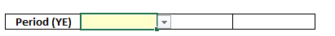
Step 2: Under the heading Type, select the type of work from the dropdown menu.
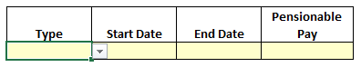

Step 3: Enter the period of employment and pay for that post. (Freelance GP locums must only enter actual working days that have been pensioned via 2022/23 Locum forms).
Step 4: Click on add row and repeat the above steps for any other employments.
Step 5: When all employments for the year have been entered click calculate. The calculator will display the annualised pay and the employee tiered contribution rate for each of the two relevant periods : 1 April 2022 – 30 September 2022 and 1 October 2022 – 31 March 2023.
Step 6: Apply the same tiered employee contribution rate to all actual GP pensionable income in each relevant period when completing the annual certificate / self-assessment forms.
Step 7: If a copy of the results is required, click on the Print button.
Step 8: The form must be cleared before beginning any new or revised calculation.

Examples:
- Type 1 GP post only

1 June 2022 – 31 March 2023
Pensionable Profit = £55,000.00

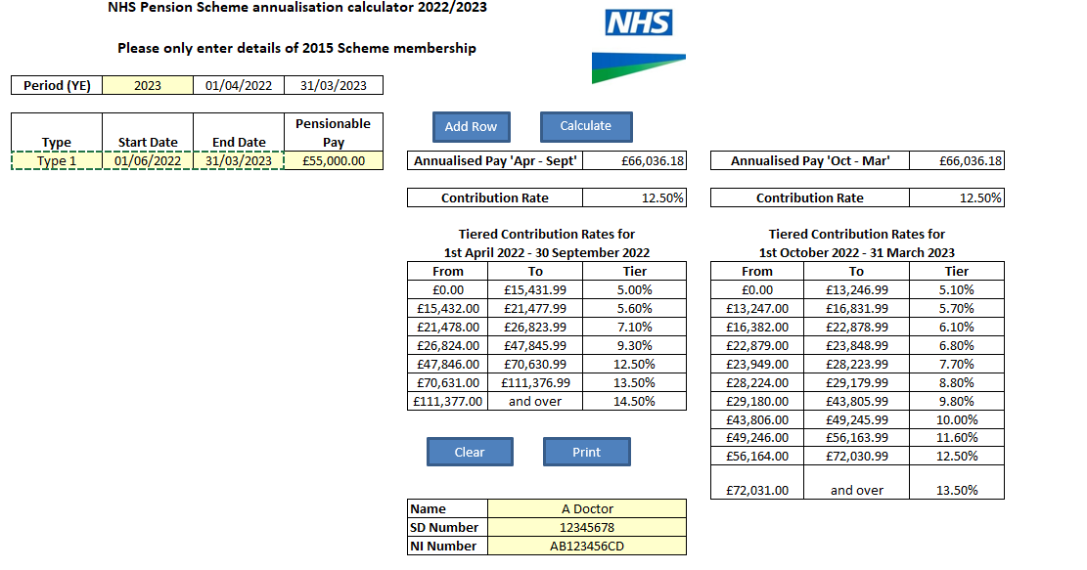
Annualised pay for April - September = £66,036.18
Tiered contribution rate for April to September = 12.50 %

Annualised pay for October - March = £66,036.18
Tiered contribution rate for October - March = 12.50 %

As stated earlier in this guidance where a GP only has a Type 1 post in 2022/23 with no other types of practitioner membership, the annualised pay for each relevant period will be the same amount.

- Type 2 post only

1 July 2022 – 28 February 2023
Actual pensionable pay for 1 July 2022 – 30 September 2022 = £15,000.00
Actual pensionable pay for 1 October 2022 – 28 February 2022 = £32,500.00

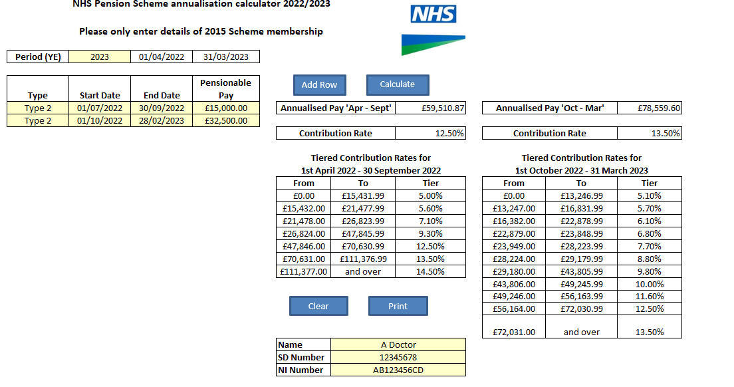
Annualised pay for April - September = £59,510.87
Tiered contribution rate for April to September = 12.50 %

Annualised pay for October - March = £78,559.60
Tiered contribution rate for October - March = 13.50 %

- Type 2 and Locum

Type 2: 1 April 2022 – 31 October 2022
Actual pensionable pay for 1 April 2022 – 30 September 2022 = £25,000.00
Actual pensionable pay for 1 October 2022 – 31 October 2022 = £5,000.00

Locum: 7 June 2022 – 10 June 2022
Actual Pensionable Pay = £1,400.00

22 November 2022 – 24 November 2022
Actual pensionable pay = £950.00
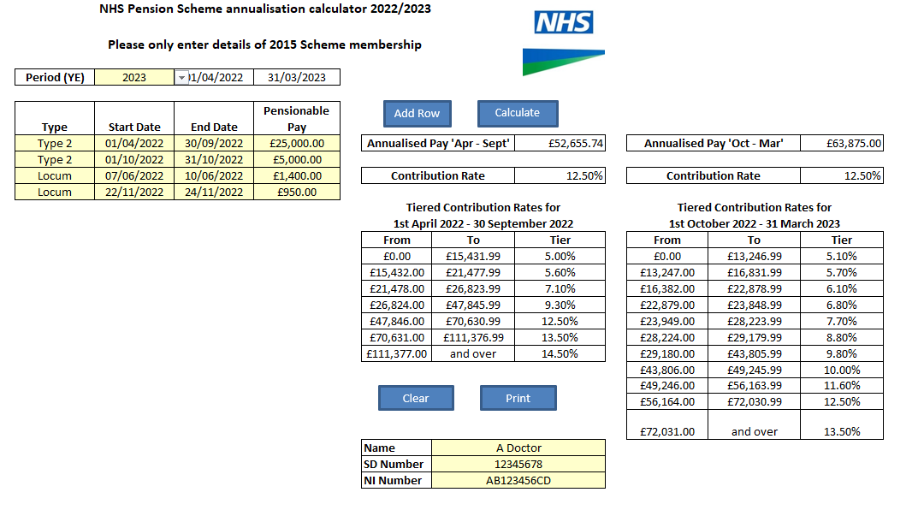
Annualised pay for April - September = £52,655.74
Tiered contribution rate for April to September = 12.50 %

Annualised pay for October - March = £63,875.00
Tiered contribution rate for October - March = 12.50 %
- Multiple posts: Type 2, Locum, & Type 1

Type 2: 1 April 2022 – 31 May 2022
Actual pensionable pay = £9,000.00

Locum: 13 June 2022 – 17 June 2022
Actual pensionable pay = £2,000.00

Type 1: 1 July 2022 – 31 March 2023
Pensionable Profit = £75,000.00
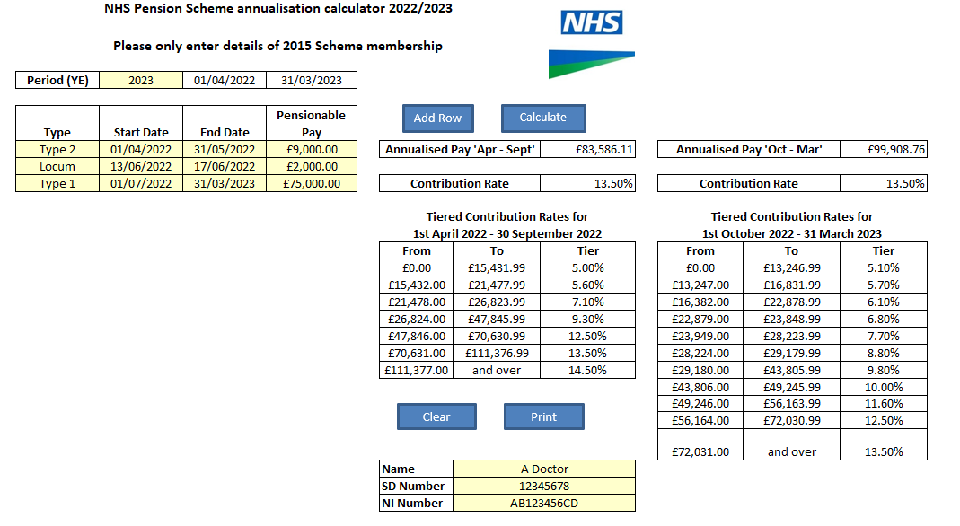

Annualised pay for April - September = £83,586.11
Tiered contribution rate for April to September = 13.50 %

Annualised pay for October - March = £99,908.76
Tiered contribution rate for October - March = 13.50 %

