directionS
social care, england
The NHS Business Services Authority (Awdurdod Gwasanaethau Busnes y GIG) (Training Funds Reimbursement Scheme) Directions 2023
The Secretary of State for Health and Social Care, in exercise of the powers conferred by section 153(2) of the Health and Social Care Act 2008(), gives the following Directions.
Citation, commencement, extent, application, and interpretation
- — These Directions may be cited as the NHS Business Services Authority (Awdurdod Gwasanaethau Busnes y GIG) (Training Funds Reimbursement Scheme) Directions 2023.
- These Directions come into force on the day after the day on which they are signed.
- These Directions extend to England and Wales and apply in relation to England.
- In these Directions—
″the Authority″ means the NHS Business Services Authority (Awdurdod Gwasanaethau Busnes y GIG) (); and
″the Scheme″ means the Training Funds Reimbursement Scheme to be established pursuant to section 149(1A) of the Health and Social Care Act 2008.
Direction to build a digital platform
- The Secretary of State directs the Authority to exercise the function of building a digital platform for the purpose of administering reimbursement payments under the Scheme to adult social care employers in relation to qualifying training, skills and qualifications for the social care workforce.
Policies and advice
- — In exercising the function in paragraph 2, the Authority must act in accordance with such policies or advice, and have regard to such guidance, as the Secretary of State may notify in writing to the Authority.
(2) Upon request by the Secretary of State, the Authority must provide advice or other information to the Secretary of State in relation to the building of the digital platform.

Signed by authority of the Secretary of State for Health and Social Care.
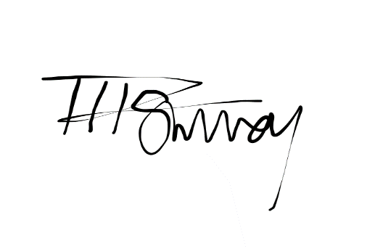

Tom Surrey
Director, Adult Social Care Policy

Member of the Senior Civil Service
Date: 27.09.23 Department of Health and Social Care

(?) 2008 c. 14.
(?) Established by S.I. 2005/2414.

