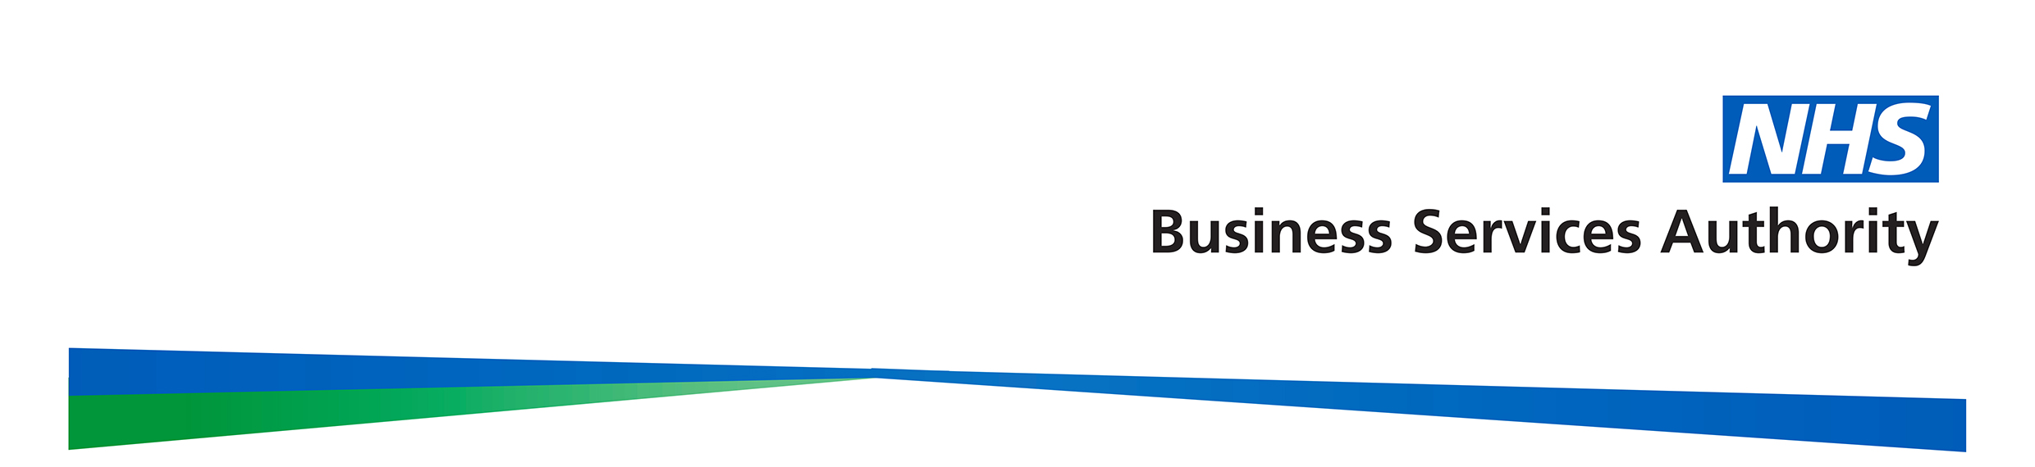
NHS Pensions - Payment of your pension abroad

If you decide not to maintain a bank account in the UK, we can make payments direct to your bank account, held in the country specified on the bank mandate, in local currency. Before we can do this, we will need the mandate completing and returning to us. Once we receive the form we will calculate and process your pension and any lump sum entitlement.

The overseas bank mandate forms are available to download from the NHS Pensions website under Members Hub, Applying for your pension.

Please note that direct credit payments abroad take a little longer to process than payments to a UK bank account and your pension will arrive a few days after your usual payment date. However, because your pension will be readily available on the day your account is credited, you should receive the benefit of your pension earlier. A small processing fee will be collected from each net payment to facilitate conversion to local currency and onward transmission overseas.

We will inform you when we make the first payment to your account abroad and when your account is due for credit. Your bank statement will show subsequent payments, the value of which will vary because of fluctuating exchange rates.

We will send you an advice of payment every time there is a change in the GB Pound amount of your annual pension rate or in the PAYE tax code notified by HM Revenue & Customs (HMRC). Please address any enquiries about your income tax to: Pay As You Earn and Self Assessment, HM Revenue and Customs, BX9 1AS, quoting their reference 948/401 and your National Insurance number.

Important: We will make payment to your bank account on the understanding that any pension payments issued after a change in your pension entitlement or death must be repaid. If you have a joint bank account, it is important that you tell the other account holder of this condition. Once the payment has been returned we will be able to calculate any balance still due.

You will receive any public sector pension increases while you are abroad. You should let us know immediately of any changes to your address or bank account details, otherwise payments may be delayed or misdirected.

NHS Pensions contact details are:

NHS Pensions
PO Box 683
Unit 5
Newcastle Upon Tyne
NE5 9EE

Our telephone number is 0345 121 2522. From abroad 0044 191 283 0303.

