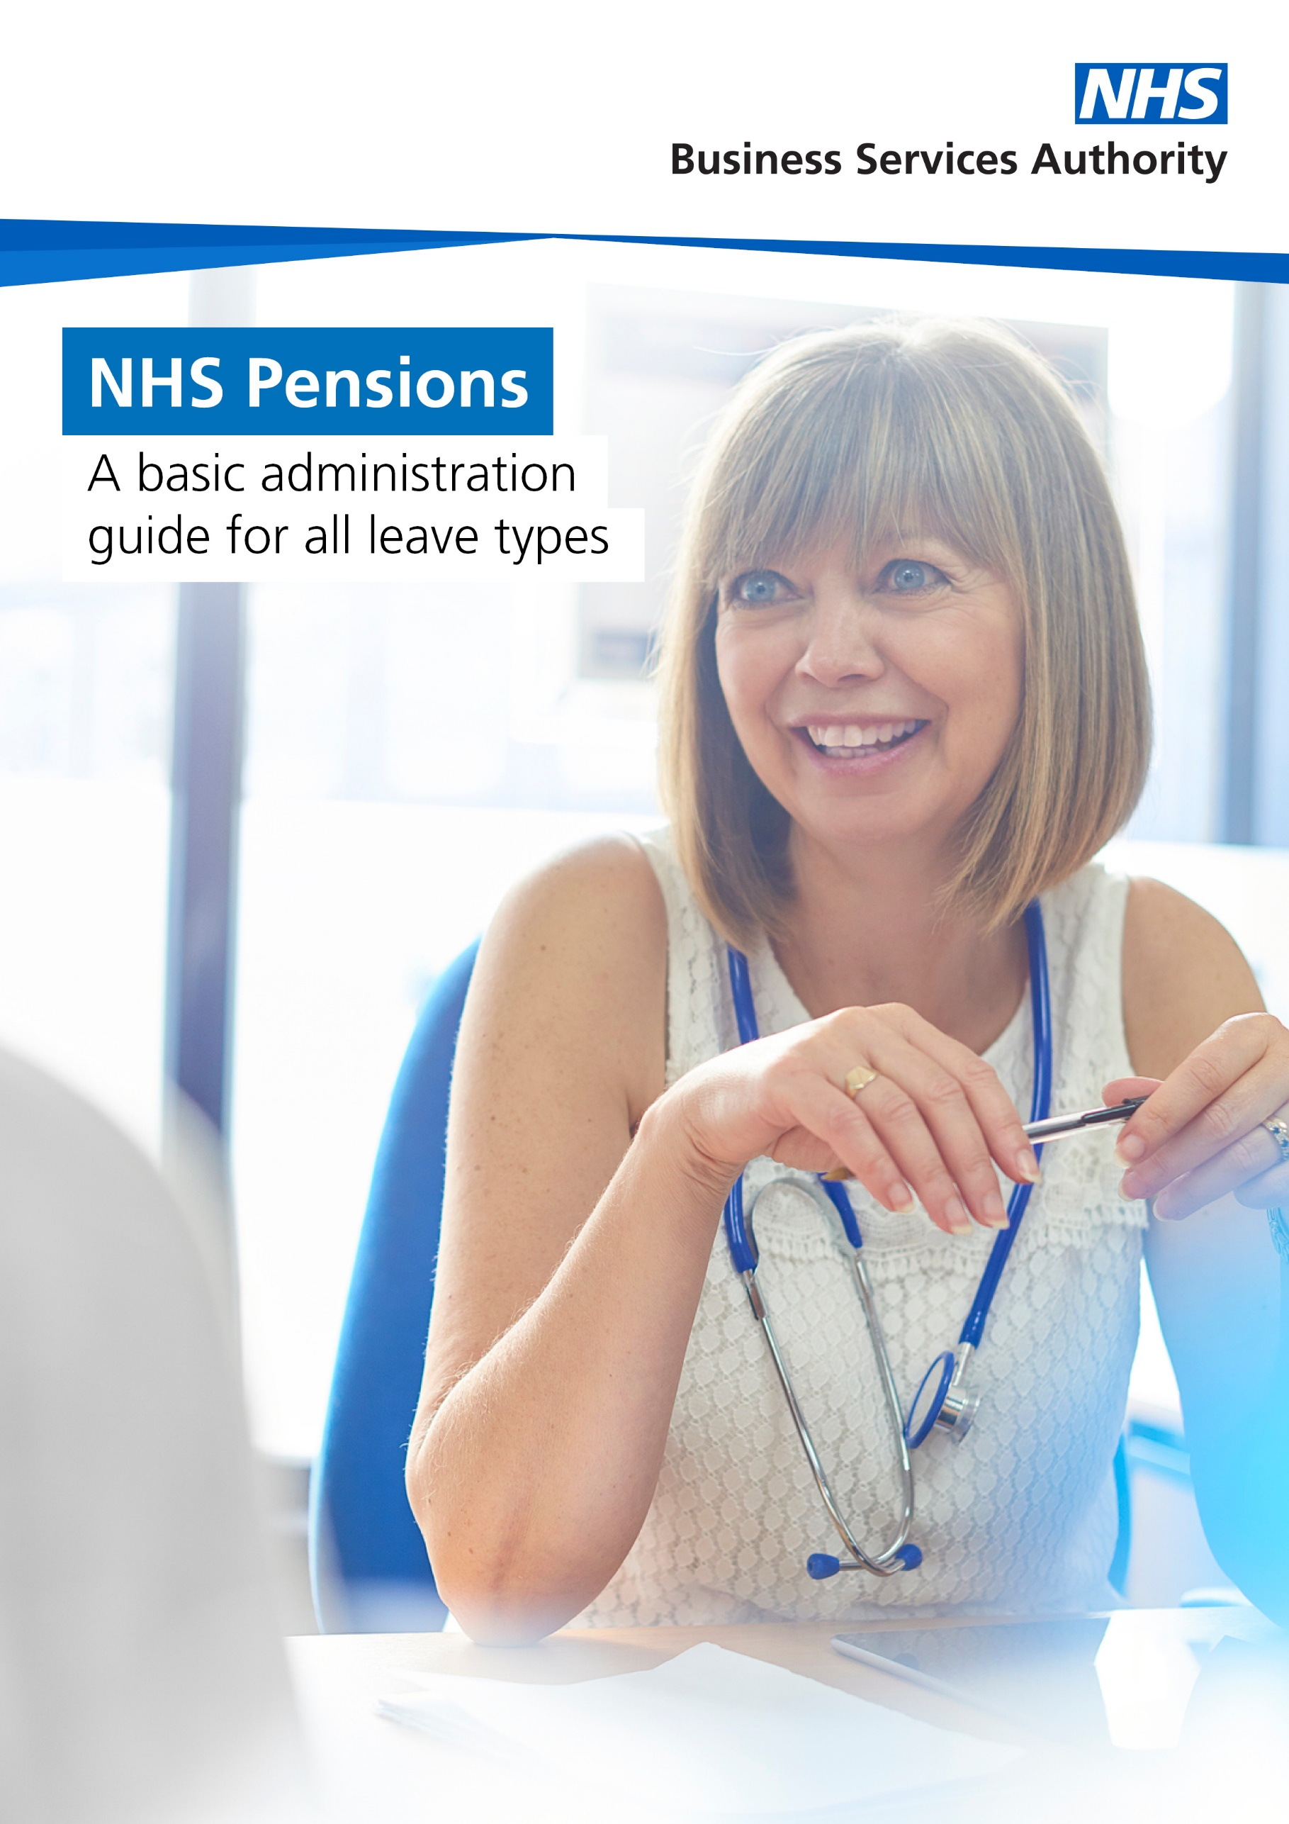

Disclaimer

The information contained in this guide has been prepared by the Stakeholder Engagement Team at NHS Pensions.

It represents the relevant NHS Pension Scheme Regulations and should not be treated as a complete and authoritative statement of the law.

No responsibility whatsoever will be assumed by the NHSBSA for any direct or consequential loss, financial or otherwise, damage or inconvenience, or any other obligation or liability incurred by readers relying on information contained in this guide.

Whilst every attempt is made to ensure the accuracy of the guide, it would be helpful if employers could bring to our attention any perceived errors or omissions using the Stakeholder Engagement email address at: stakeholderengagement@nhsbsa.nhs.uk

Contact details

You can contact us by calling:

Member helpline: 0300 330 1346
Employer helpline: 0300 330 1353

Opening times: 08:00 to 18:00 – Monday to Friday

Postal address:

NHS Pensions PO Box 683
Newcastle Upon Tyne
NE5 9EE

All contact information can also be located on our website.

Contents

Disclaimer 2
Contact details 2
Contents 3
Sick leave 5
Added Years/Additional Pension/Early Reduction Retirement Buy Out (ERRBO) 5
Full pay 5
Reduced or suspended pay with entitlement to statutory sick pay 5
Reduced pay with no entitlement to statutory sick pay 5
Statutory sick pay only 5
No pay 5
Locum GPs 6
Bank staff 6
Maternity, paternity, shared parental and adoption leave 7
Contributions 7
Full pay 7
Half pay 7
Statutory pay only (for example statutory maternity pay, statutory adoption pay) 7
Bank staff / Locum GPs 7
Added Years/Additional Pension/Early Reduction Retirement Buy Out (ERRBO) 8
Members that decide not to return to work 8
Annual leave 8
Keep in Touch days 8
Maternity leave flexibilities 8
Authorised leave of absence 9
Additional information 10
Maternity, paternity, shared parental, and adoption 10
Reassessing member contribution tiers 10
Bank staff 10
Terms of contract 10
Refunds 10
Moving employers 10
Joining the Scheme during absence 11
Salaried GPs 11
Authorised leave of absence 11
Granting an authorised leave of absence 11
Pensioning an authorised leave of absence 11
Continuing to pay employer contributions after six months 11
Scheme Administration Charge (employer levy) 11
Leave of absence exceeding two years 11
Entitlement to life assurance and family benefits during an authorised leave of absence 12
Added Years, Additional Pension and ERRBO contracts 12

Sick leave

Both employer and member contributions are payable during a period of paid sick leave. If a member is on no pay sick leave, no contributions are payable and the period of membership is regarded as disallowed days and is not counted as qualifying or reckonable membership.

Added Years/Additional Pension/Early Reduction Retirement Buy Out (ERRBO)
Added Years, Additional Pension and ERRBO contributions remain deductible on the member’s full pay throughout the period of sick leave. However, the contributions cease if the member has a period of no pay sick leave.

Full pay
If a member is absent because of illness but is in receipt of ‘full pay’, all contributions continue to be payable as normal.

Scheme membership continues to be reckonable in accordance with the member’s contract of employment (for example full or part time).

Reduced or suspended pay with entitlement to statutory sick pay
Members – Contributions are payable on actual reduced pay and statutory sick pay only.

Employers – Contributions are payable on the member’s unreduced pay immediately before the reduction.

Membership – Continues to build up as per the member’s contract of employment.

Reduced pay with no entitlement to statutory sick pay
Members – Contributions are based on actual reduced pay only.

Employers – Contributions are payable on the member’s unreduced pay immediately before the reduction.

Membership – Continues to build up as per the member’s contract of employment.

Statutory sick pay only
Members – Contributions are payable on statutory sick pay only.

Employers – Contributions are payable on the member’s unreduced pay immediately before the reduction.

Membership – Continues to build up as per the member’s contract of employment.

No pay
Members – No contributions are payable.

Employers – No contributions are payable.

Membership – Stops building from the last day of pay/statutory sick pay. As soon as all pay including statutory sick pay ceases, all membership (reckonable and qualifying) stops building up and the no pay period should be recorded as disallowed days.

If a member is on no pay sick leave and their contract of employment has not been terminated, they remain covered for ‘in service’ death benefits.

Locum GPs
Locum GPs are not entitled to sick pay as they are ‘self-employed’, they therefore cannot continue to pay into the NHS Pension Scheme while they are absent from work.

Bank staff
Normally bank staff are not entitled to sick pay and as such do not pay pension contributions whilst they are on sick leave.

Their pension record will remain open until three months have passed since their last day of work. Their pension record should then be closed down retrospectively from the last day that the bank staff worked.

Maternity, paternity, shared parental and adoption leave

A member can continue to be pensionable throughout any period of absence for maternity, paternity, parental or adoption leave purposes.

Contributions
Pension contributions remain payable during a period of maternity, paternity, shared parental or adoption leave unless the member opts out.

Full pay
Member and employer contributions are payable as normal based on the pay the member would have received if there was no reduction for maternity, paternity, shared parental or adoption leave. It is understood that even during a period of basic full pay maternity, paternity or adoption leave, employer contributions could be higher than employee pension contributions because a member’s enhancements may not be included in their pay.

Half pay

Members – Contributions are payable on the reduced pay.

Employers – Contributions are payable on the members unreduced pay (see full pay above).

Statutory pay only (for example statutory maternity pay, statutory adoption pay)

Members – Contributions are payable on the amount of statutory pay received. Employers – Contributions payable on the member’s unreduced pay (see full pay above).

No pay

Members – Contributions are payable on the amount of pay immediately before the period of unpaid leave begins.

Employers – Contributions are payable on the member’s unreduced pay.

Where shared parental leave is being taken as separate ‘blocks’ of leave, contributions payable in each period should be assessed separately.

Bank staff / Locum GPs

Bank staff and Locum GPs are not entitled to maternity/paternity/adoption leave pay and as such cannot pay pension contributions whilst they are on maternity, paternity, shared parental or adoption leave.

If the member is entitled to statutory pay, then the contributions are calculated as above.

Added Years/Additional Pension/Early Reduction Retirement Buy Out (ERRBO)
Additional contributions continue to be payable on the reckonable pay/pensionable earnings the member was receiving prior to any period of maternity, paternity or adoption leave.

Members that decide not to return to work
If a member initially intends to return to work and has already paid some contributions during the period of leave and then decided not to return to work, the last day of membership will be treated as the last day up to which the contributions were last paid.

If the member does not intend to return to work, they are still entitled to pay pension contributions during the period of statutory leave.

Annual leave
If the member has any untaken annual leave, then the date of leaving must be extended to include this, and pension contributions must be paid until this date.

Keep in Touch days
Keep in Touch (KIT) days are where a member carries out up to 10 days work during the maternity, paternity or adoption leave period.

For pension purposes, Keep in Touch days do not break the period of leave. The member will pay contributions for the KIT days; however, these will be based on the reduced earnings for the period of leave. Any additional pay received during the KIT days will be excluded.

Maternity leave flexibilities
By prior agreement with the employer, Occupational Maternity Pay may be paid as a combination of full pay and half pay or a fixed amount spread equally over the maternity leave period.

Where a member has six months paid and six months unpaid leave, but the pensionable/reckonable pay/pensionable earnings is averaged out over the 12 month period, contributions will be deducted based on the underlying entitlement.

Authorised leave of absence

From 1 October 2008, the NHS Pension Scheme Regulations changed to allow a member who is on a leave of absence for reasons other than sick, maternity, paternity, shared parental or adoption leave, and who has already paid contributions continuously during the first six months, to continue to pension the leave for a further period of up to 18 months.

Where pensionable pay is reduced or suspended, member and employer pension contributions are based on the member’s pensionable pay immediately prior to the break starting.

It is not compulsory for a member to pay pension contributions during this type of leave period.

If a member decides not to pay pension contributions, their pension record should be closed down the day before the leave commences.

Should the member wish to continue contributing to the Scheme during the additional period, they will be responsible for both the member and employer pension contributions. Employers are responsible for ensuring that both member and employer pension contributions are collected continuously throughout the leave and paid monthly to NHS Pensions.

Arrears cannot be allowed to accumulate and payment made on returning to the Scheme.
If pension contributions are not paid for the first six months, the member does not have the option to continue to be pensionable for the further period of up to 18 months.

The facility to pension authorised leave does not apply to Locum Practitioners.

Additional information

Maternity, paternity, shared parental, and adoption

Reassessing member contribution tiers

If a member goes onto reduced pay due to reduced maternity leave, paternity leave etc. then their contribution rate should be reassessed.

For example, if on 1st November a member goes on reduced pay e.g. reduced maternity leave, paternity leave etc. and the member was on an actual annual salary of £40,000, paying a contribution rate of 9.8%; and their pay then reduces to £20,000, their contribution rate reduces to 6.5% from 1st December. On return to actual pay of £40,000 their contribution rate returns to 9.8% the following month.

Paying pension contributions whilst on unpaid leave
Arrears of pension contributions built up during a period of unpaid leave can be collected when the member returns to work providing they are collected within a reasonable amount of time. This should be agreed between the employer and the member.

Bank staff
As bank staff do not have a contract of employment, if a member working on the bank does not qualify for maternity leave, they cannot accrue arrears and repay on return.

Terms of contract
If a member returns to work after their leave, the terms of the member’s contract are between the employer and the employee.

Refunds
If contributions have been correctly paid on any part of the period of leave, whether paid or unpaid, they cannot be refunded (unless the member subsequently leaves the Scheme with entitlement to a refund of contributions).

Moving employers
If a member moves to another Employing Authority before they start their leave of absence, the situation of statutory maternity pay (SMP) being paid by the previous employer and occupational maternity pay (OMP) being paid by the new employer is most likely to arise with Junior Doctors who change contracts.

Although the SMP is being paid by the previous employer, it is in respect of a period of later maternity leave that is still pensionable. SMP is normally pensionable as if the member had remained with the previous employer, or even if they had left NHS employment altogether, the SMP is still pensionable as it counts as earnings.

Employer contributions are payable on the full unreduced earnings as though the member is not on maternity leave, and therefore no employer contributions would be due from the previous employer.

As NHS Pensions’ records will show the new employer during the maternity leave period, any pension contributions deducted for SMP by the earlier employer will need to be reflected during the maternity leave period in the new employment. It will therefore be necessary for both employers to liaise regarding the payment of pension contributions.

Joining the Scheme during absence
An employee cannot join the Scheme during any period of absence from work (this includes any employee who has opted out of the Scheme).

Salaried GPs
Salaried GPs determine their contribution rate based on their global Practitioner earnings. Where the GP is on a period of maternity/paternity/adoption leave, the member contribution rate is based on the ‘actual global earnings’ that Practitioner would have earned had they not been on leave. The practice must notify PCSE/Local Health Board (LHB) of the GP’s reduced earnings whilst on leave.

Authorised leave of absence

Granting an authorised leave of absence
The decision on whether to agree a member’s application for an authorised leave of absence rests with the employer. The employer should refer to the employee’s relevant terms and conditions. For staff subject to Agenda for Change Section 34 ‘Employment break scheme’ of the NHS Terms and Conditions of Service handbook should be followed.

Pensioning an authorised leave of absence
If the period of leave has been agreed and the member chooses to pay pension contributions the employer must pay the employer pension contributions for the first six months.

Continuing to pay employer contributions after six months
Providing both member and employer pension contributions have been paid continuously during the first six months, continuing to pay employer contributions for longer is a matter between the employee and the employer. However, there is no requirement under the NHS Pension Scheme Regulations for employers to pay any pension contributions when an authorised leave of absence exceeds six months.

Scheme Administration Charge (employer levy)
If the member is not being paid by their employer whilst on an unpaid authorised leave/career break there is no levy payable.

Leave of absence exceeding two years
Although under Agenda for Change Terms and Conditions an employee can be granted an employment break of up to five years, the NHS Pension Scheme Regulations only allow authorised leave periods (which includes leave of absence where the contract of employment is retained), to be pensionable for the first two years. After this time the member’s record must be closed down for pension purpose.

Mental Health Officer or Special Class status
If a member decides not to pay pension contributions during the period of authorised leave, the normal rules surrounding membership of the Scheme and entitlement to Mental Health Officer/Special Class status will apply. The member must return to pensionable NHS employment within five years to be eligible to be considered for Mental Health Officer/Special Class status on their return.

Entitlement to life assurance and family benefits during an authorised leave of absence
A member will continue to be covered for death in service benefits during the leave of absence providing they continue to contribute to the Scheme.

Further information on life assurance and family benefits is available on our website.

Added Years, Additional Pension and ERRBO contracts
The member has a choice to either pay their normal tiered contributions, plus their additional contributions, or only pay their normal tiered contributions.

If a member decides not to pay contributions, or remains on leave for longer than two years having paid contributions, they must return to the Scheme within 12 months of the last day of contributing membership to enable the original contract to continue.

If a member does not return to the Scheme within 12 months, the contract will end, and an appropriate credit based on the contributions paid will usually be given to the member.

Members cannot pay any ‘missing’ contributions where the member has chosen not to pay additional pension contributions or for a period where they were on authorised leave for a period of more than two years.

On return to the NHS Pension Scheme after the authorised leave of absence, the member should reconsider their position and if there will be any shortfall in the intended purchase.

