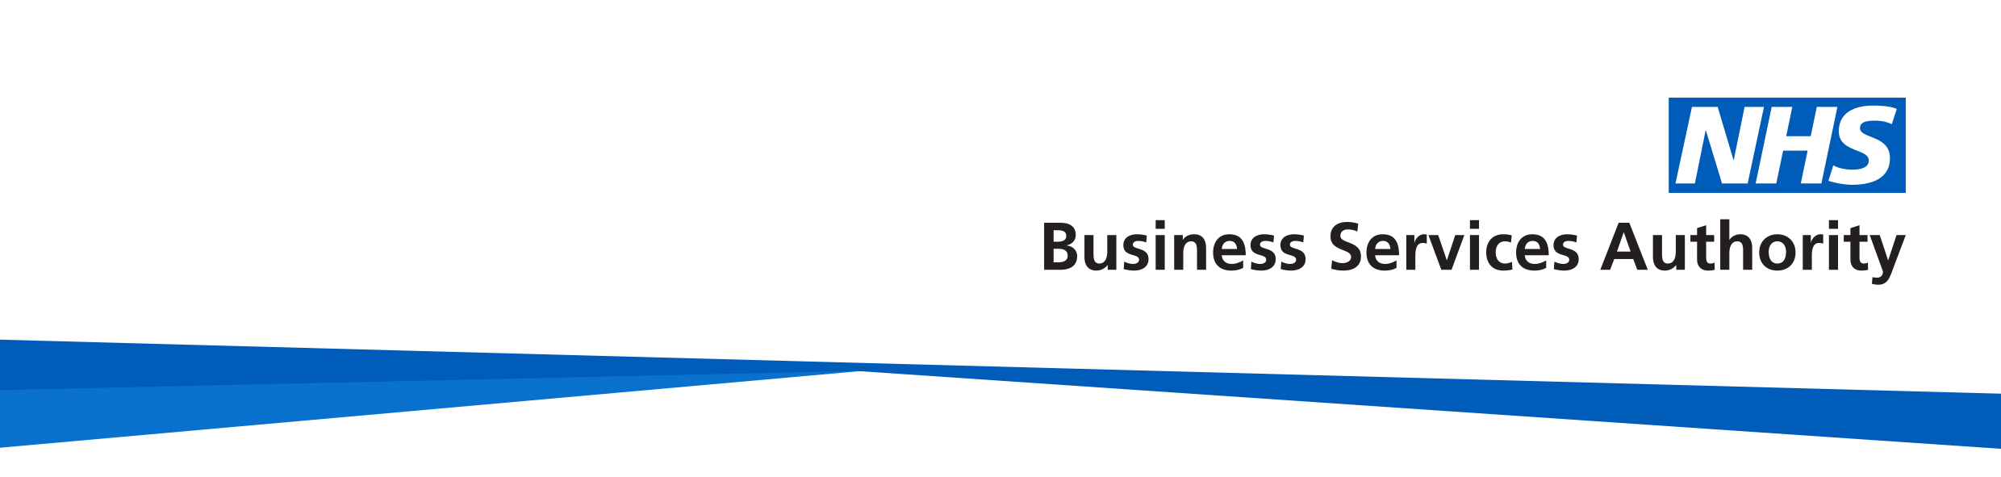
NHS Pensions
Member factsheet

Redundancy - Information for members

You may be able to claim your NHS pension benefits immediately if you retired early due to either:
- redundancy
- the interest of efficiency of the service

This includes voluntary redundancy.

To be eligible you must be an active member in the Scheme on the date of redundancy and have:
- at least 2 years qualifying membership within the Scheme
- 2 years continuous service verified by your employer
- reached your minimum pension age (age 55), and
- have not unreasonably refused:
  - to seek suitable alternative employment; or
  - to accept an offer of such employment

If you are eligible, you can choose to either:

1.Defer your pension
You take the redundancy payment (severance pay) from your employer and leave your pension deferred in the NHS Pension Scheme until retirement.

2. Retire on the grounds of redundancy
Claim your NHS pension benefits without any reduction for early payment. The cost of paying your pension without reduction is met using your redundancy payment. This is known as the capitalisation cost.

Capitalisation cost
The capitalisation cost for any pension benefits is worked out using your normal pension age (NPA) in the Scheme. In the 2015 Scheme this is either your state pension age or age 65 if this is later.
Capitalisation costs are based on the difference between an unreduced pension and a pension reduced for early payment plus the cost of paying your lump sum early.
If the capitalisation cost is more than your redundancy payment, you can elect to meet the difference in cost dependent on the terms and conditions of your contract of employment. If you do not meet the full capitalisation cost, some of your benefits will be reduced.

If you are not employed under ‘Agenda for Change’ terms and conditions or are being made redundant from a Welsh employer, your employer will meet the difference.

If the capitalisation cost is less than your redundancy payment, you’ll receive the remainder of the redundancy payment

3.Retire with a reduced pension
Claim your pension through early retirement. Your pension will be reduced depending on your age. This does not affect your redundancy payment.

General

How much will my pension be?
This depends upon your circumstances however your employer should provide you the relevant information including a statement of estimated NHS Pension benefits.

What if I have more than one NHS job?
You can either take your NHS Pension benefits from all your pensionable NHS jobs or just from the post you are leaving, providing you are age 55 or over.

If you hold another post as a general medical, dental or ophthalmic practitioner, in addition to the one you are being made redundant from, you can ask us or your employer for details of the options available to you.

What is a Mutually Agreed Resignation Scheme (MARS)?
A MARS is a form of voluntary severance. It’s designed to allow employees, in agreement with their employer, to choose to leave their employment voluntarily in return for a severance payment.

MARS is not redundancy and is not linked to the NHS Pension Scheme. A member who accepts MARS has voluntarily resigned from their post.

Any member who opts for MARS may be able to apply for:
- actuarially reduced early retirement (ARER)
- age retirement
- consideration of entitlement to early payment of preserved benefits on the grounds of ill health.
You can find out more about claiming your NHS pension benefits on redundancy on our website at: https://www.nhsbsa.nhs.uk/member-hub/applying-your-pension

How we use your information
For more information about how the NHSBSA processes your personal data, please see our Privacy Notice - www.nhsbsa.nhs.uk/our-policies/privacy/nhs-pensions-privacy-notice

NHS Pensions

Redundancy information for members name

www.nhsbsa.nhs.uk/nhs-pensions

