# Swish A4 Portrait - top

**NHS Pensions Online (POL) Guide**

**28. Form RF12 – Application for a refund of contributions**

Before completing the Pensions Online RF12 application form please ensure that the following has been completed:

* Check whether he member is entitled to a refund.
* The employment has been closed
* Contributions submitted are correct
* The member has correctly completed, signed and dated Part A of the paper RF12
* Check their name and date of birth match The National Health Service Business Services Authority (NHSBSA) records
* There is no concurrent p/t employment with you that is active and pensionable
* Member has provided bank details
* When the employment(s) span three tax years you will need contracted out National Insurance earnings for the first year

The electronic form RF12 can be found in the main E-Forms menu:

Once you have selected the link you will be asked to input the member details:

The ‘Date of Termination’ must be the same as that submitted on the employment termination details.

If it does not match you will receive the following onscreen warning message:

Once a matching Date of Termination is entered you will be taken to the employment selection screen where you should select the matching employment:

If there are any concurrent open employments displayed on this page you will need to close them before the RF12 can process successfully.

On the next screen you will be asked to check the members’ personal details and input their address. If any of the personal details are incorrect you will need to cancel out of the RF12 and submit an **SD55G** to amend the details before submitting the RF12.

If all details are correct click on ‘submit’ and you will be taken to the next screen to complete bank details.

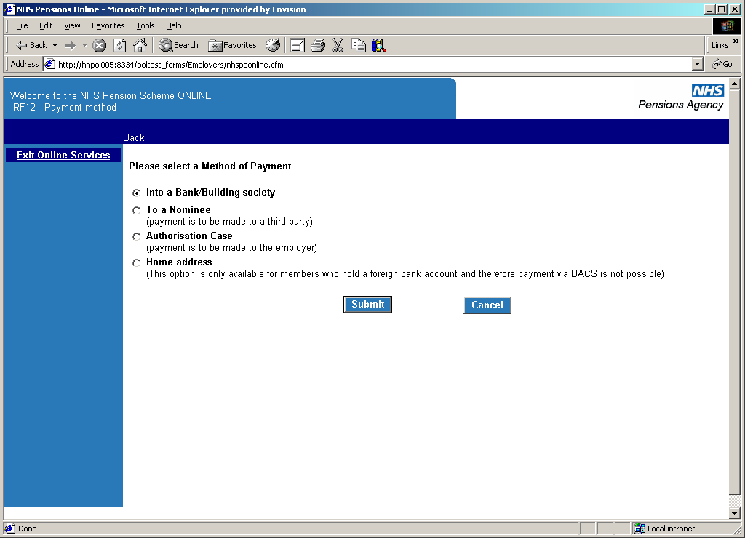

Payment can be made to:

* a bank or building society. In the case of the bank you will be asked to provide the account number, sort code and type of account. For a Building Society, the roll number will also be required.

**It is important to check the bank details are entered correctly as once submitted a successful payment will process within a few hours**.

* a nominee, in which case the name and address of the nominee will be requested.
* an authorised employer. This means the member wishes the funds to be paid to the employer to recoup monies owed.

You will need to confirm that the member left with outstanding funds owing and that they have not completed this box in error.

Written authorisation from the member should have also been received.

* the member’s home address (if they live overseas and do not have a UK bank account).

**Payment into a Bank/Building Society**

Where this option is selected you will receive the following screen:

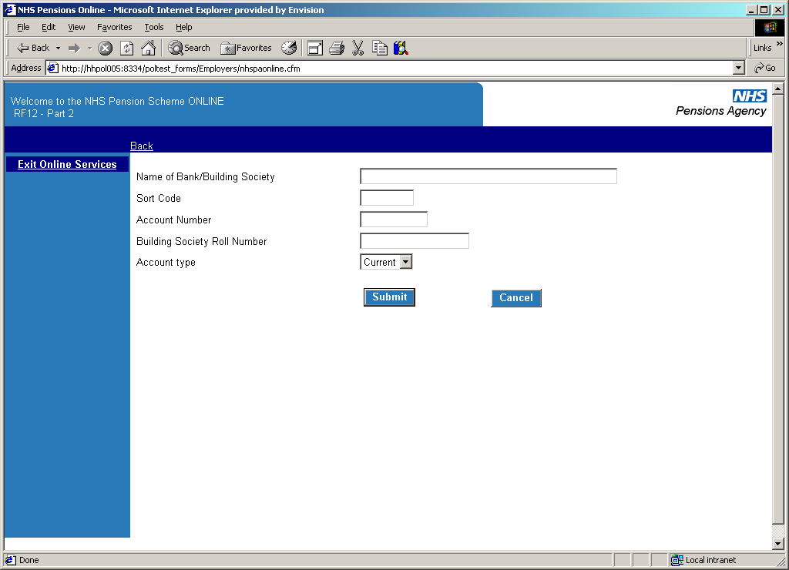

Once correct details are entered click ‘submit’. Before being taken to the next stage you will be asked to submit the bank details again:

After selecting ‘submit’ you will be asked to confirm the details before being taken to the next stage. If you have made any mistakes you also have the option to change the information.

Once you have selected ‘Confirm Bank Details’ you will see the confirmation screen.

**Payment to a nominee**

Where this option is selected you will receive the following screen:

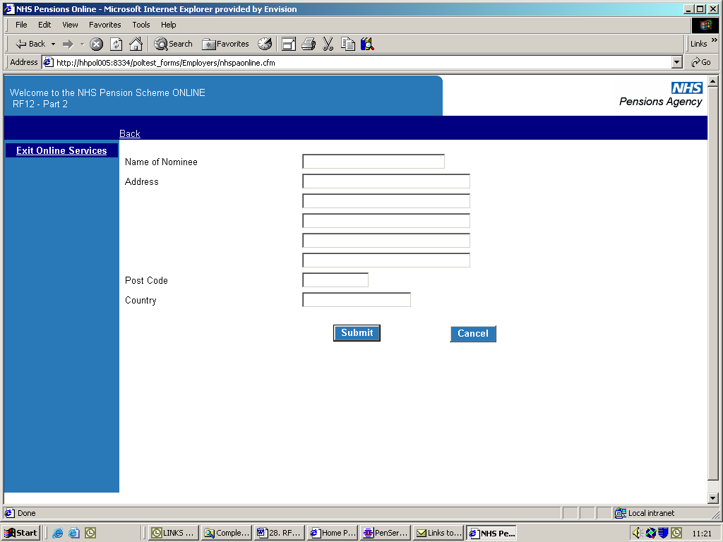

Once correct details are entered click ‘submit’ to be taken to the next screen, which asks for details of the nominee:

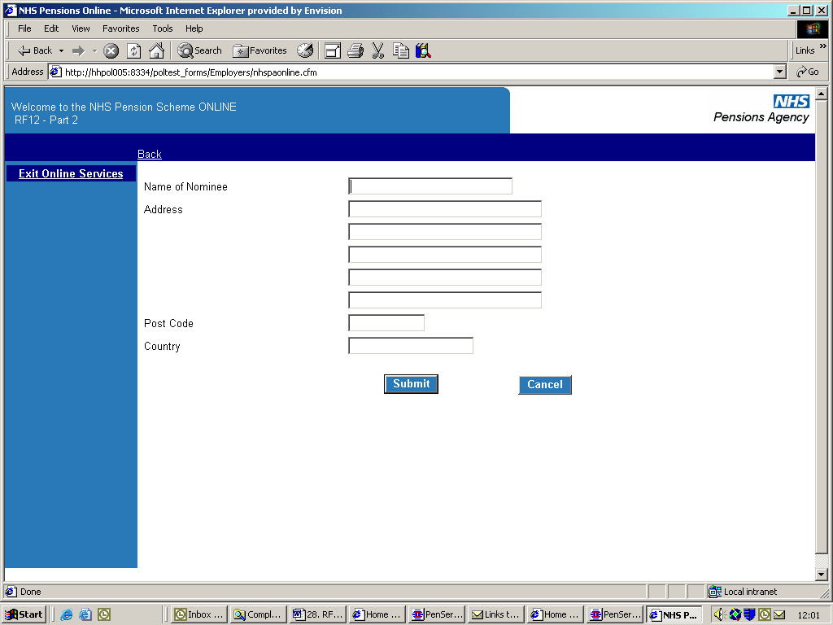

Once these details have been completed you will be given the following confirmation screen:

**Authorisation case:**

Where this option is selected you will be first asked to send the members authorisation letter to The NHSBSA.

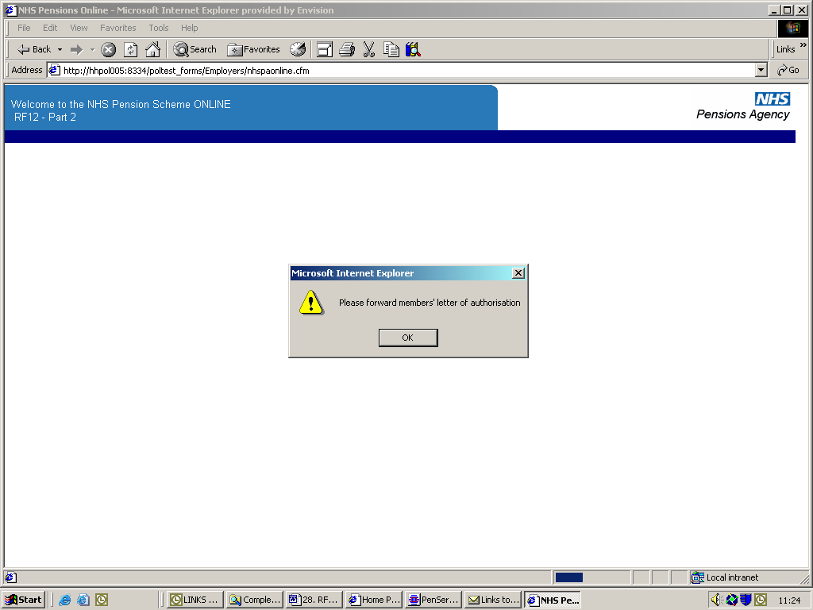

After selecting ‘ok’ you will receive a confirmation screen that the RF12 has been submitted successfully.

**Home address**

This option should only be chosen for members who live overseas and do not have a UK bank account.

Once this option has been selected you will be asked to confirm the member’s address and after selecting submit you will receive the normal confirmation page for printing and submission of the RF12.

**What happens next?**

In most cases submission of the form will result in the application processing within a few hours and the next day the payment should be issued (3-10 days should be allowed for receipt of the payment).

A letter is sent Second Class to the member’s address notifying them of the payment and providing them with a breakdown of the calculation.

A copy of this notification is also sent to Pensions Online **Noticeboard** for your records, as shown on the following example:

**Unsuccessful processing**

There are some circumstances where the refund application form will not process successfully and an example of these is as follows:

* An earlier employment has not been closed by the previous employer
* The member is not entitled to a refund as they have sufficient membership for preservation.
* The member is not entitled to a refund as they have already rejoined the Scheme in another employment or remains pensionable in a concurrent employment.
* A joiner or updating form is in error and must be resolved before the RF12 can continue with processing.

If there is any problem with either the calculation or the membership record, the refund will be held and the case will be brought to The NHSBSA attention for review.

At this stage we will liaise with the relevant employers to try to make the payment as soon as possible.

You will be notified via the **Noticeboard** once the refund has been successful.

Any enquiries concerning a delay in payment of the refund should be made to the main employer helpline number 0300 3301 353, and not the Pensions Online Helpdesk.