# Swish A4 Portrait - top

**NHS Pensions Online (POL) Guide**

9. Automated Forms Overview

Once the link is selected you will initially receive details of “Automated Forms” sent electronically from The National Health Service Business Services Authority (NHSBSA) to yourselves, requesting urgent information:

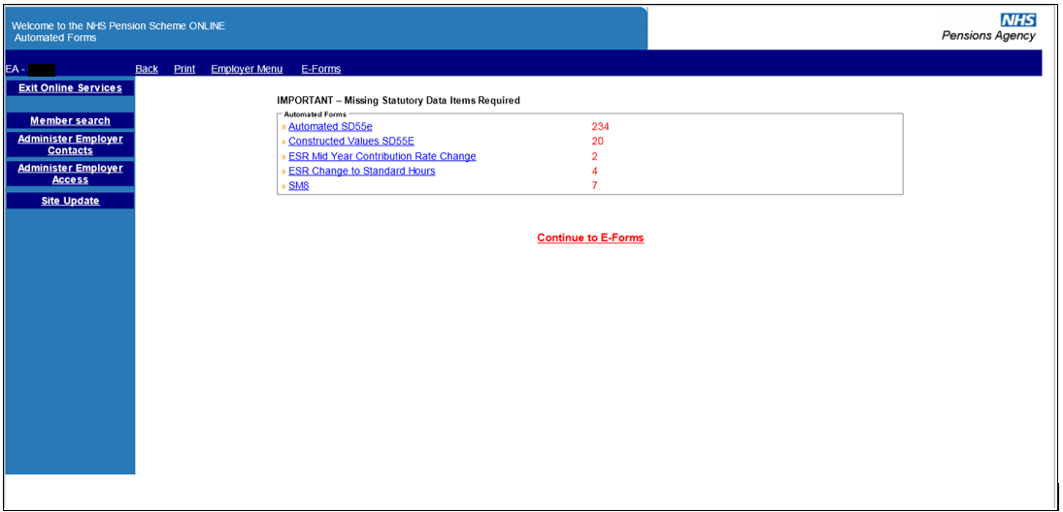

You will only be presented with the automated e-forms screen when you initially login to Pensions Online. After that the link to these automated forms is present in the main E-Forms menu. After logging out you will be taken straight to the automated requests when you next log-in.

It is important that these are looked at, and responded to, on a regular basis. As you complete and submit responses the number shown in red will reduce. Likewise, they will increase if The NHSBSA require information for additional errors.

If you do not wish to take any action on automated forms at this stage, select the link “Continue to E-Forms” to access the full E-Forms menu:

On this page there is still a link to “Member Search” if you need to check this before submitting a joiner form etc.

There is also shortcut links to the Employer Menu, Print or Back to the previous screen; these are located on the dark blue banner above the E-Forms menu.

Wherever you see “question mark symbol” within any of the E-Forms this is a link to Help Text which contains information specific to the E-Form you are completing.