NHS Pensions Online (POL) Guide

18. SD55 – Annual Update

This form is used to submit annual pay, contributions and part time hours or sessions worked, to the National Health Service Business Services Authority (NHSBSA), to update the members’ record.

It can only be submitted once you have submitted a joiner form that has processed successfully. However the joiner form does not have to have been submitted via Pensions Online (POL). If the joiner details have been submitted via Electronic Staff Records (ESR) you can still update and/or close the members’ record via the e-forms facility.

Once you select the link you will be asked to input either the members National Insurance (NI) number or NHS Pensions (SD) reference number.

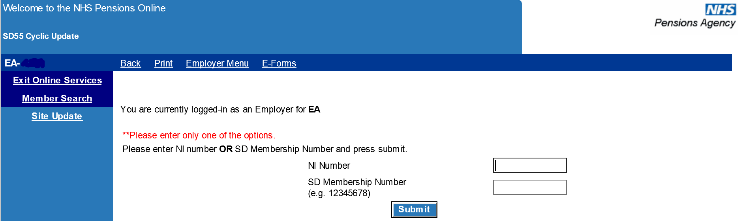

If no joiner details have been processed and there is not already a record for this member at NHSBSA you will receive the following message:

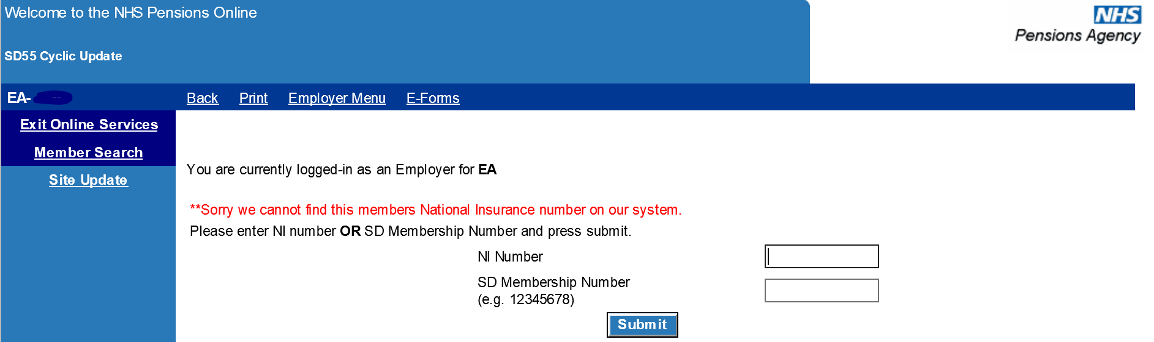
Where there is an existing record for the member at NHSBSA, but there is no trace of joiner details for their employment with you, the error message will be as follows:

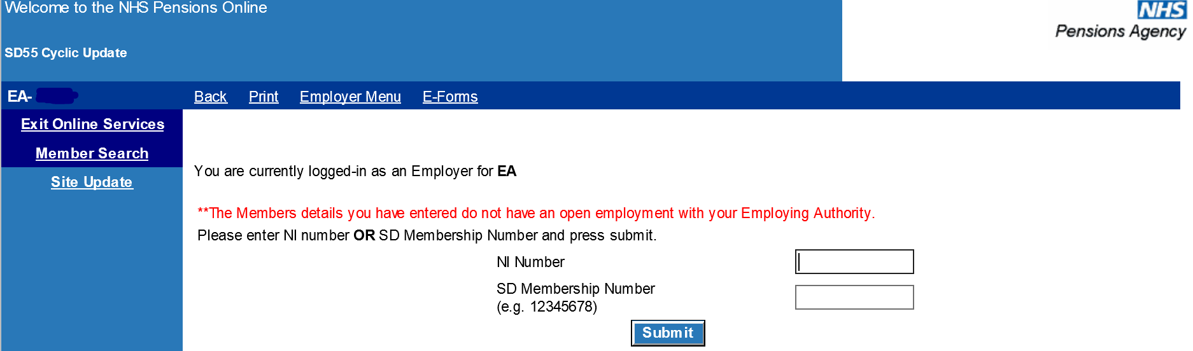As POL is a secure system, if you are ‘inactive’ for 20 minutes you will be timed out of the system therefore it is essential to have all necessary information to hand before you start to complete the form. If you are timed out you will have to login again and any information already entered into the form will be lost.

Once you have submitted a valid NI or SD number you will be taken to a list of open employments with your Authority/GP Practice and you should select the employment you wish to update by clicking the blue text:

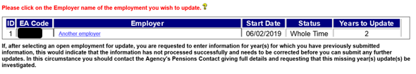

The numbers of years that require updating to bring the record up to date are displayed in the grid, but you can only update one year at a time starting with the first year that is outstanding.

By selecting the employer name you are taken to the SD55 annual update form and you should complete details for each year.

Help text:

Alongside each field is a link to help text giving information on whether the information is mandatory and how to complete it. Selecting the question marks will access this help text:

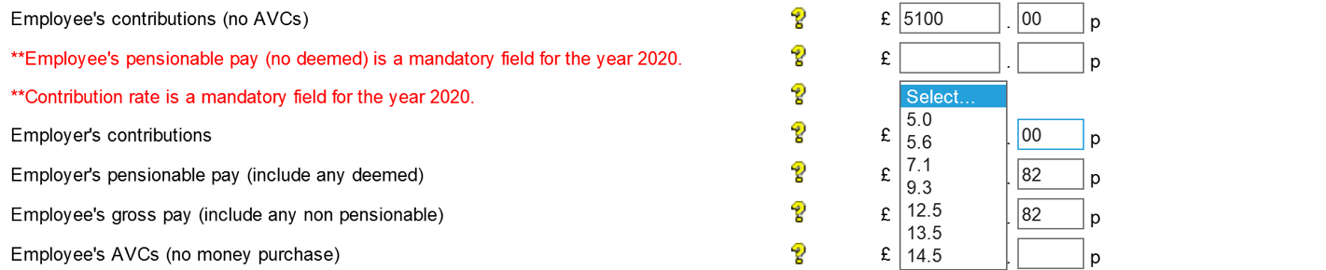

The help text available for ‘Employee’s Pensionable Pay’ is as follows:

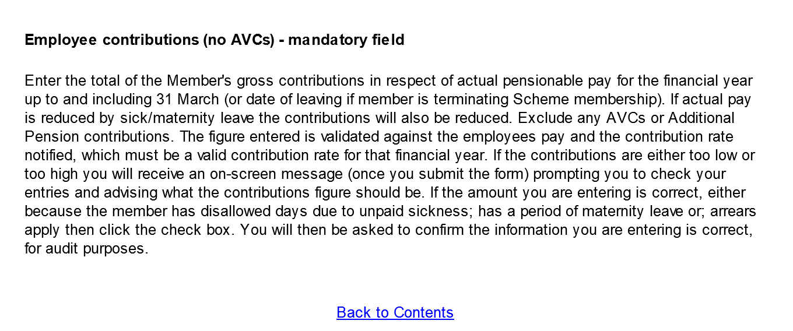
If you select ‘Back to Contents’ you will be taken to the list of contents for the complete help text document:

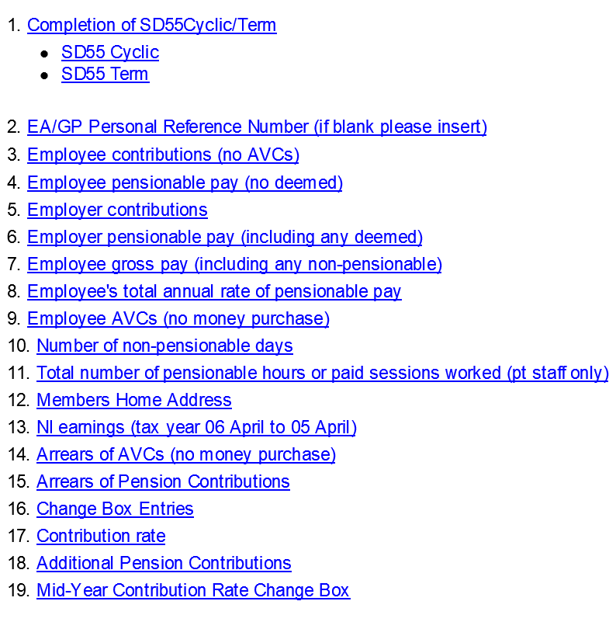
If you select ‘exit help’ you will be taken back to the form you were completing.

Completion of pay and contribution fields

The fields that need completing depend upon the member’s employment type, however on all cases the employees and employers pay and contributions must be completed together with the contribution rate for years from 01/04/2008 onwards.

Where mandatory fields are not completed, or fields are completed that are not required for that members employment type, you will receive on screen error messages advising you of the action to take.

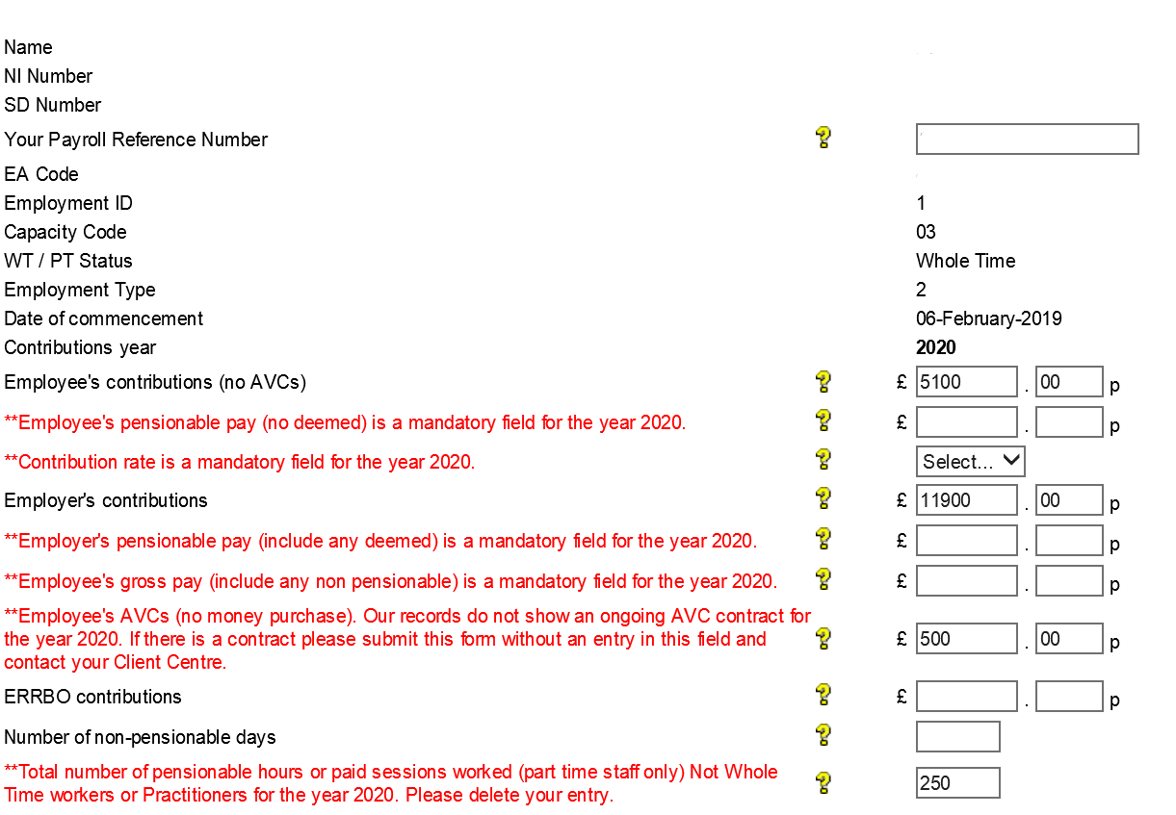

Contribution Rate:

Prior to 01/04/2008, the employee paid contributions at the rate of either 5% (manual workers) or 6% (all others). With effect from 01/04/2008 this changed and a member’s contribution rate is based on their salary rate (this is known as ‘tiered contributions’).

Completion of this field is therefore mandatory for financial years 2009 and later. The pensionable pay shown in this field should be the pensionable pay in force at the end of the financial year (or leaving date for year in which membership is terminated).

The correct rate of contributions to be applied is the responsibility of employers and not NHSBSA.
For up to date details of the relevant contribution rates with effect from 01/04/2008 please see our website at www.nhsbsa.nhs.uk or view the current tax years Contribution Rate table by going into the GP1 Payment form (for GP Practices) or RFT1 Payment Form (for all other employers).

On screen error messages:

Each field for completion has specific validation and if you complete the form incorrectly, or omit to complete mandatory information, you will receive on screen error messages advising you of the areas that need looking at, as follows:

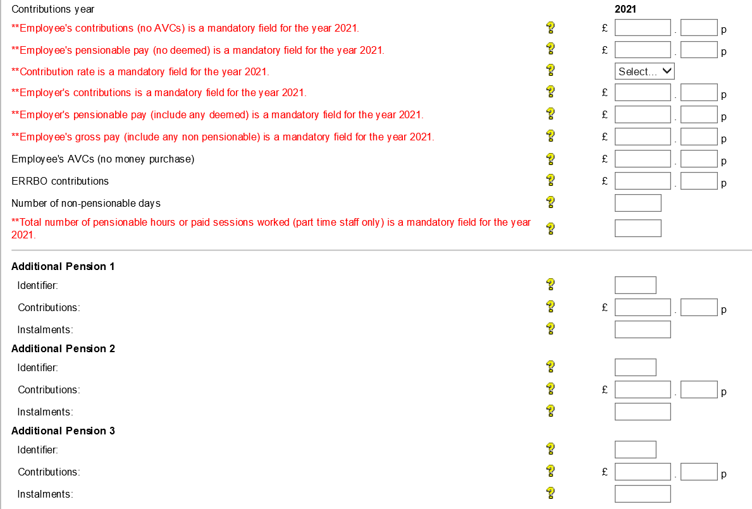

On some fields where an error message is received you have the option to override the error. For example, where an employee’s pay figure of £4000.00 has been entered with employees contributions paid of only £90.00 and employers contributions of only £140.00.

The validation on this form calculates what the expected amounts are by using the respective pay figures together with the contribution rate and will allow £10.00 either side of this expected amount. The acceptable range will then be displayed within the error message.

If the figures you have entered are not within this range but are correct you have the option to override the validation by ticking the checkboxes alongside the relevant fields. You will however receive a further confirmation screen advising that if you override these validations you are confirming the information as being correct and will be asked to provide a reason why:

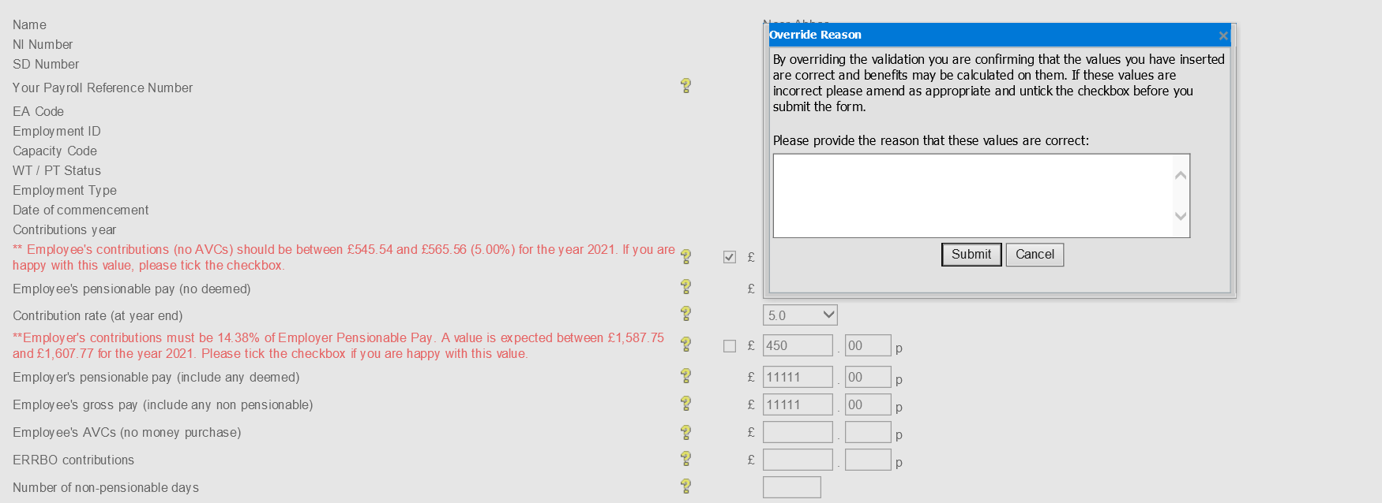

Before selecting the override check box you should always check your entries in case you have made an error.

The employee’s pay figure should generally be within the range shown but could be a lower or higher figure if for some reason contributions were underpaid (due to maternity leave when they are generally collected on return to work) or, an existing amount of outstanding contributions has been collected, either from a previous year or a previous employment.

Only if there is a valid reason for the actual amounts collected being outside the range should the override checkbox be selected and the reason entered.

Annual part time (PT) hours check

If the employment is part time a check is also done to determine if the annual hours or sessions entered exceed whole time for the period.

If they do, an error message will appear showing the maximum amount of hours or sessions that can be pensionable for the period:

The figure calculated is based on the standard hours or sessions notified to us on the joiner form (or any later change) and the number of weeks in the period of the update year.

For example, if the update is for a full year and the standard hours are 37.5 then the maximum hours that can be pensionable is 1955 (37.5 x 52.143 weeks).

If the actual hours worked are in excess of this figure then the member cannot be pensionable on any hours in excess of 1955 and any over deducted contributions should be refunded locally. The pay and contribution details should be amended before you submit the SD55.

Additional voluntary contributions (AVC) and additional pension (AP) contracts

Also recorded on this form are details of AVC contributions and AP contributions.

These fields should only be completed if the member has an ongoing contract at any time within the update year.

If there is no such contract, the fields should be left blank otherwise validation error messages will be produced.

Likewise if there is an ongoing contract and you do not complete the relevant fields an error message will be produced, as follows:

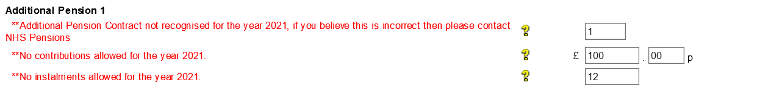
If you have details of an ongoing contract, either for AVCs or AP contributions, and you complete the relevant fields but you get an error message advising there is no contract you should leave the fields blank in order to submit the annual information and then contact the NHSBSA for further advice.

Generally in these circumstances there has been a delay before NHSBSA has been able to update the details of the contract to the member record, or the member may have contacted NHSBSA requesting the contract ceases. This will be confirmed when you contact NHSBSA.

Early retirement reduction buy out (ERRBO) only available to 2015 Scheme members

The ERRBO field is shown below which needs to be completed if the member has an going ERRBO contract, the fields shows the total amount paid in the year

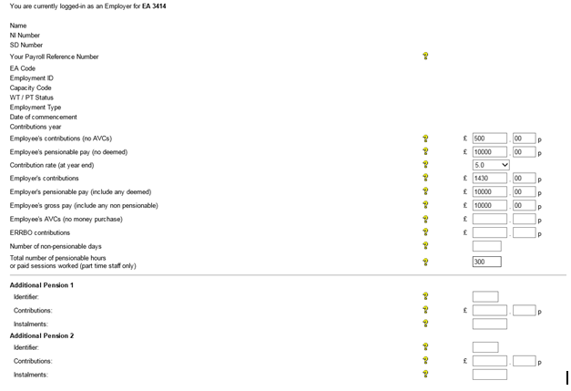

If you enter a value in the field and the member is not a member of the 2015 Scheme you will receive the following error message

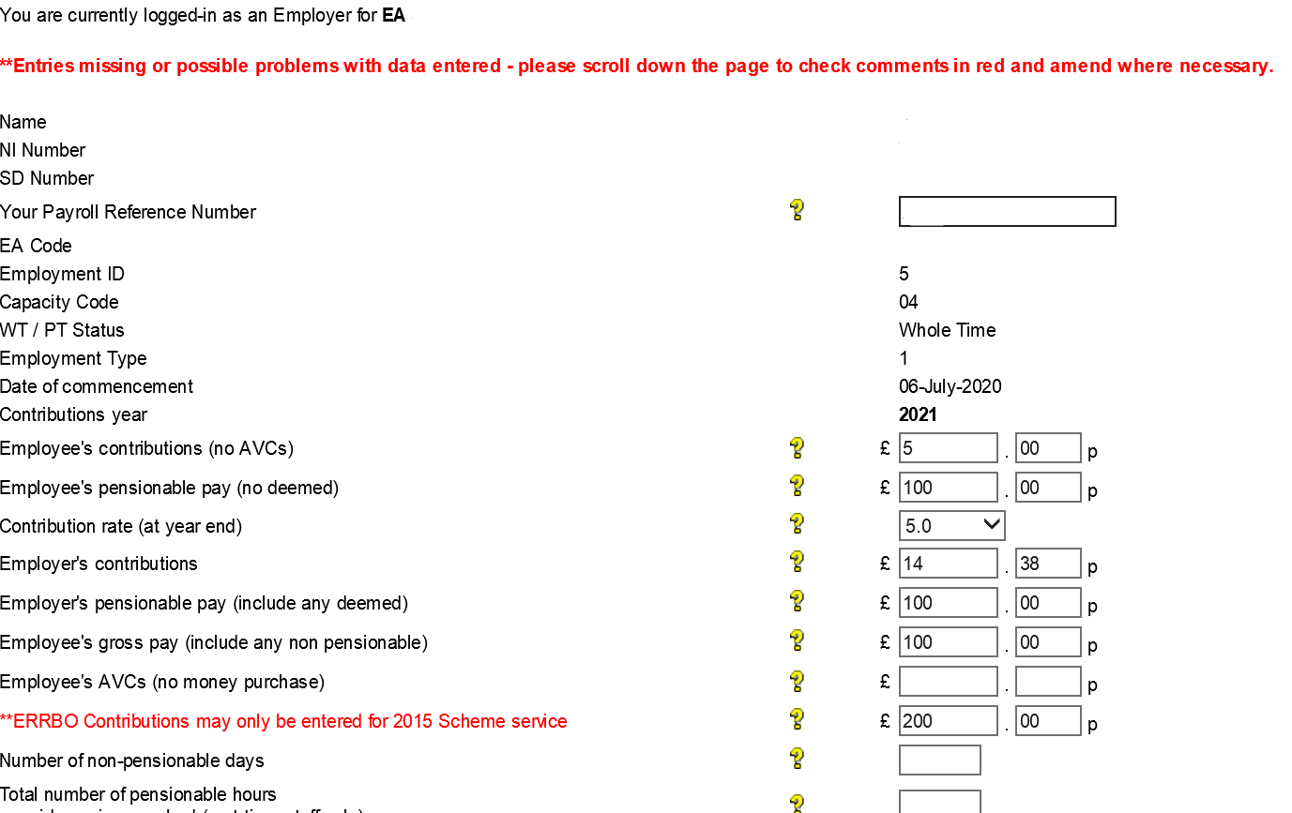

If you enter a value in the field and the member does not currently hold an ERRBO contract no error message is given on the system, but when processed the information error code 0487 – ERRBO contributions present but not expected, this error will appear in NHS Pensions allocated errors.

If there is a ERRBO contract in place and you omit to include the amount no error message is given on the system, but the record will update without the information.

Mid-year changes to contribution rates:

All users

The contribution rate you enter in the year end details on form SD55 should be the contribution rate in force at the end of the financial year on 31 March.

The earliest annual update that could show a mid-year contribution rate change would be the annual update for year ending 31/03/2010.

If you need to make more than three mid year changes to the contribution rate you can add rows as required.

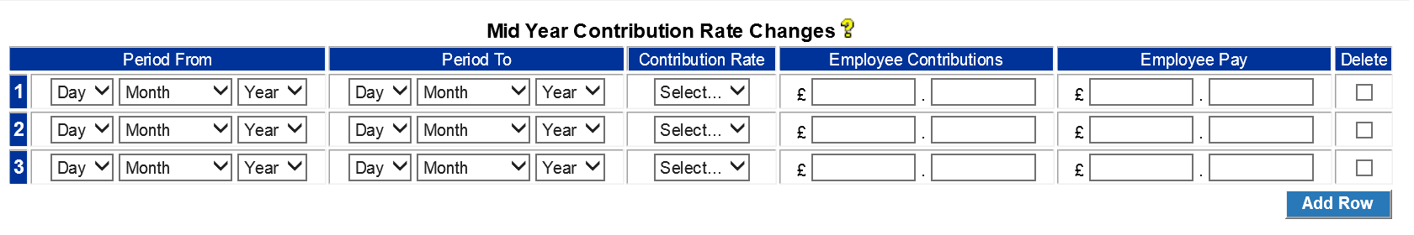There is validation within this area to ensure that the information you enter matches the contributions, pay and contribution rate that you have entered for the year end details.

For example, if you enter the year end contribution rate for 2019/2020 as 5.6%, in the main part of the form, and also enter a change to the mid year contribution rate to 7.1% with effect from 10/06/2020 to 31/03/2021 you will receive an on screen error message because the year end contribution rate for 2019/2020 should not be 5.6% but should show the latest contribution rate which is 7.1%

If the contributions and pay details entered do not match the rate of contributions shown you will again receive an on screen error message.

ESR users

If you use the Electronic Staff Records (ESR) payroll system any changes made prior to your update by the ESR interface will be visible and will be displayed on the SD55, as follows:

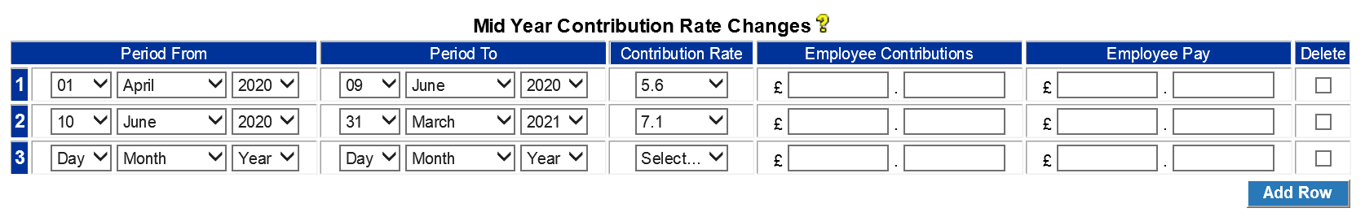

When the ESR Interface submits these details, an automated e-form is created by NHSBSA called ESR mid year contributions rate change which is sent to the list of automated requests in Pensions Online (POL).

If you have not yet responded to this automated request then the change dates and contribution rates only will be displayed. You are required to enter details of the employee’s contributions and pay for each period within the year.

The contributions and pay figures entered should match the employees’ contributions and pay details shown in the annual update part of the form.

You can access help text for this area by clicking on above the change box area.

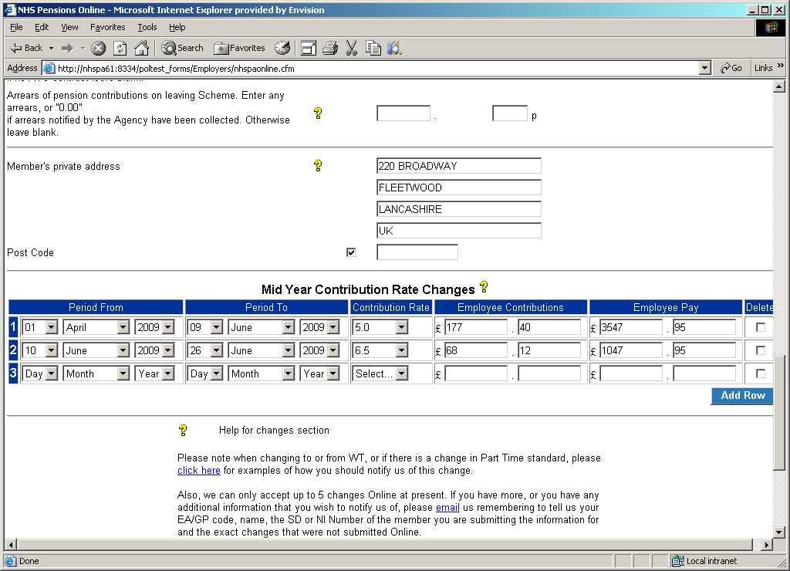

Error messages

The following screens show an example of some of the error messages you may see:

Error example 1:

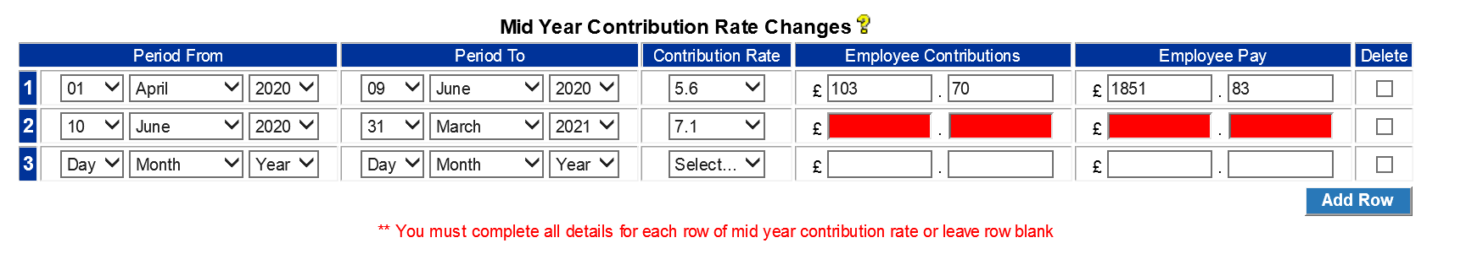
The above error messages were produced for the following reasons:

- Because the employees’ contributions for change two do not equate to 7.1% of the employees pay figure; or

- Because the contribution rate for change two does not match the contribution rate that was shown for the year ending 2021 details.

To rectify this error the contribution rate for change two needs to be corrected to 7.1%.

Error example 2:
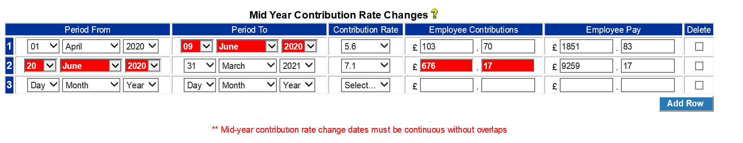
The above error message has been produced because the ‘period from’ date for change two is not immediately after the ‘period to’ date for change one.

There are three possible ways to resolve this error depending on the correct details:

- Amend the ‘period to’ date for change 09 to 19 June 2020; or
- Amend the ‘period from’ date for change 20 to 10 June 2020 or
- Insert the missing contribution rate change from 10 June 2020to 19 June 2020

Using the details from resolution two above, the mid year contribution rate changes would be entered as follows:

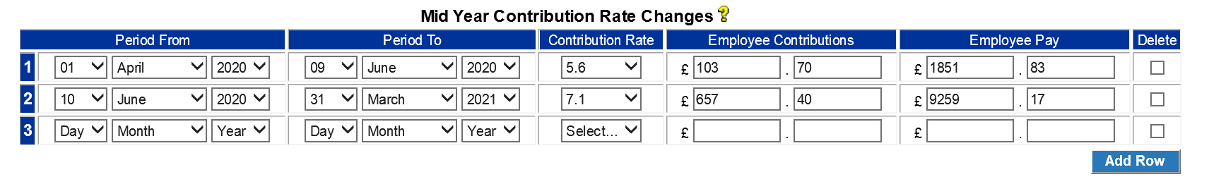
Change one is from 01/04/2020 to 09/06/2020 the day before the change to 5.6%. The employee’s contributions and pay for this period only must also be entered.

Change two is from 10/06/2020 to the end of the cyclic update year. Again the contributions and pay for this period only must be entered.

The total of the contributions and pay shown in the change area should then be the same as the total of the contributions and pay shown for the year end 2021 details.

Changes to employment/personal details:

The final part of the SD55 annual update is where you can input changes to the member’s employment details and/or personal details, as follows:

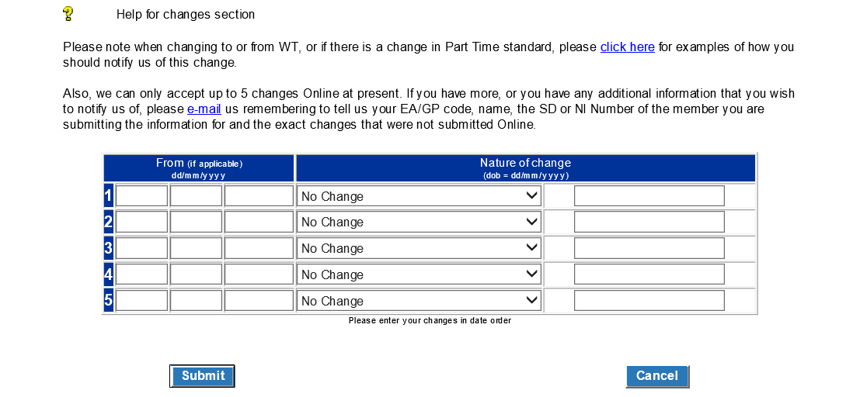

Enter date of change (if required) Select Change Type Enter change details

Again, there is full help text available and this is particularly useful if you are completing changes to part time and/or changes to standard hours.

The areas available for change are:

- Surname – no date of change is required
- Forename(s) – no date of change is required
- NI Number – no date of change is required
- Capacity code – date of change required
- EA code – no date of change required
- Date of birth – see example below
- To whole time (WT) – date of change required (only available if employment is PT) see example below
- To part time (PT) – date of change required (only available if employment is WT) see example below
- Actual part time (PT) hours – date of change required see example below
- Standard hours – date of change required (to be used when employment changes to PT for the first time)
- Change to standard hours – date of change required (relevant only where standard hours for an existing PT employment change)
- Change of mental health officer (MHO) status – date of change required
- Disallowed mental health officer (MHO days post 05/04/1988 – no date of change required (to be completed where disallowed days apply and employment is MHO)
- Date of commencement

A maximum of five changes can be completed and you should always start with the first change line. If you need to input more than five changes there is a link to email NHSBSA of the additional change data.

Some changes, that is, from whole time to part time, need to be in a specific order to enable them to process successfully.

Changes from whole time (WT) to part time (PT)

If a member (other than capacity 3, 8 or 10) is changing to PT and has previously been PT within the employment then select ‘To PT’ from the drop down selections and enter the date of change to PT.

Actual hours do not need entering. Standard hours only need entering if they are changing from those already held on our records:

Example 1

Change for members (other than capacity code 3, 8 or 10) changing from WT to PT (for the first time) with standard hours of 37.5 then later change back to WT, should be recorded as follows:

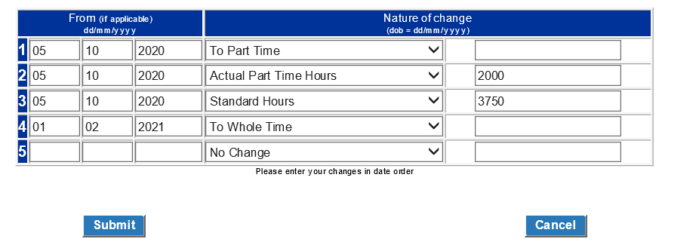
Please enter the actual PT and standard hours in the format ‘ nnnn’ within the range 0100-4900. PT hours must be less that standard hours

Example 2

Change for members (other than capacity code 3, 8 or 10) who have already been PT within the employment who change to WT and then back to PT. Only the dates of change to PT and WT are needed, unless the standard hours change from those already held:

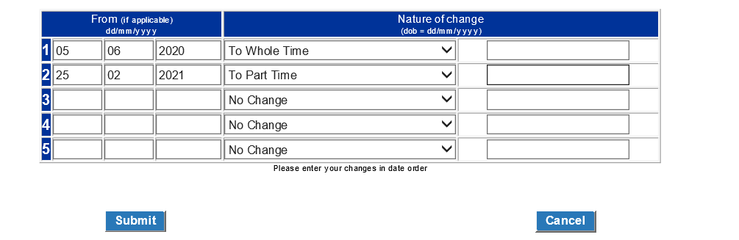
Example 3

Change for members (other than capacity code 3, 8 or 10), whose standard hours of 40.00 are changing to 37.5.

New actual hours per week are not to be shown but hours worked to date of change (Hours worked to date of change = 650 hours) must be entered as in the following example:

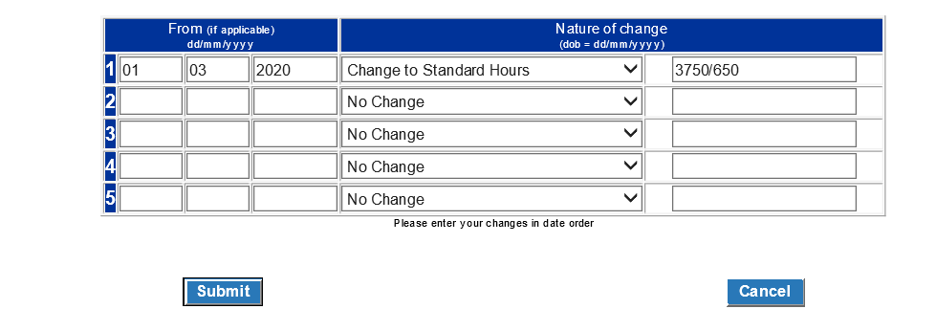

Important note for ESR users – if you have already notified us of a change to standard hours via ESR and then choose to update and/or close the employment down via POL this SD55 will not automatically pick up the change notified via ESR and you will need to repeat the change details.

Converting sessional contracts to hours for non-medical staff

For members (other than capacity code 3, 8 or 10) who are employed PT on a sessional basis, record the change to PT as hours and not sessions. Convert the sessions to hours by multiplying the paid sessions per week by the sessional length to give actual hours. The standard hours are obtained by multiplying the standard sessions by the standard length.

Capacity codes 3, 8 or 10

These members cannot change to or from WT or PT using the changes box. Their employments must be closed down and re-opened at the date of change in contract.

Disallowed MHO days post 05/04/1988

If the member changes to MHO within the period of update and has any disallowed MHO days post 05/04/1988 please select this option from the drop down menu and enter the relevant amount of disallowed days in the text box provided, in four digit format.

No date is required for this change.

The full amount of disallowed days must also be shown in the disallowed days field on the main part of the form.

General information re change area

You should always start with the first change line and changes from WT to PT need to be in chronological order.

If any mismatching information is entered you will receive on screen error messages as shown in the following examples:

No date of change entered, where date is required.

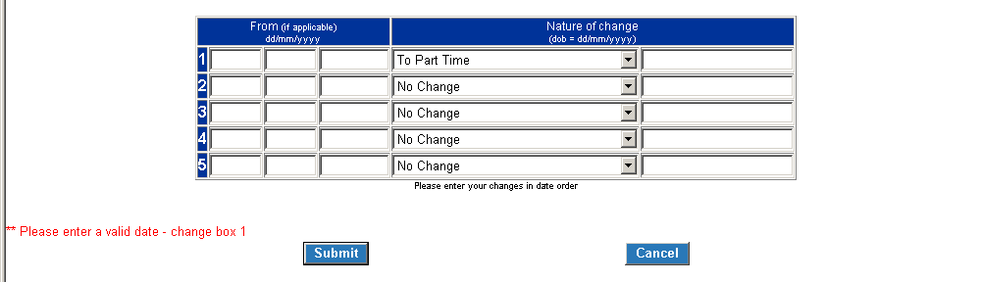

Incomplete change details where there is a change to PT for the first time:

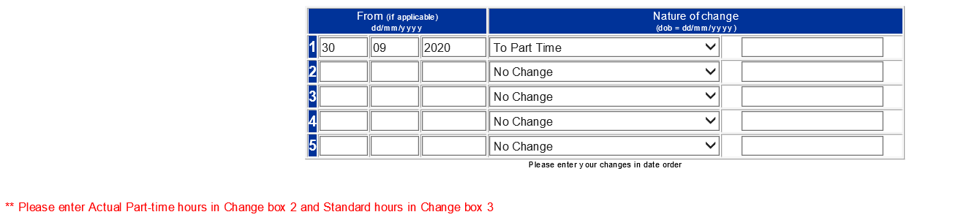

Incomplete change to date of birth:
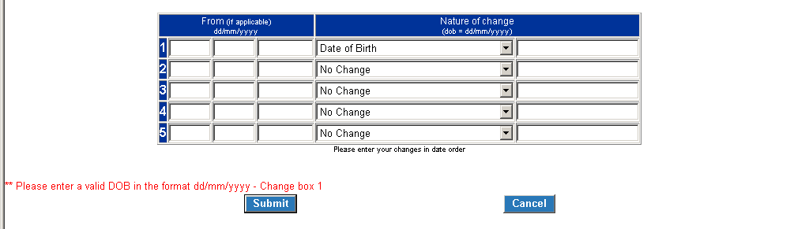

Correct date of birth change:
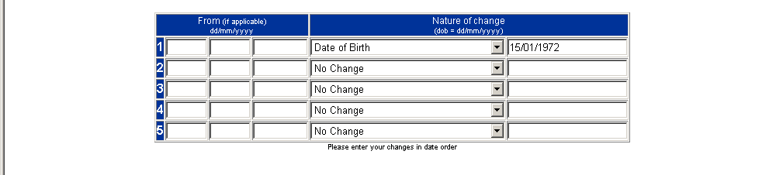

Once you have successfully completed the form you will receive a confirmation screen reflecting the details submitted to NHSBSA.

When this form processes via the NHSBSA system it will update the member record and you will receive an SD55 notification advising the date to which the employment has been updated.

If you do not receive this notification this is an indication that the form has not successfully processed to the member record either due to incorrect information on the form or interaction with other employment details on the member record.

The form will be placed in ‘Error Handling’ and be allocated to either you or NHSBSA for investigation.

‘Error handling’ is in the main employer menu of POL.

