

NHS Pensions

NHS Pensions Online (POL) Guide

12. Electronic Staff Record (ESR) Changes to Standard Hours

This is a Pensions Online form that is generated by The National Health Service Business Services Authority (NHSBSA) when a change to standard hours is received via the ESR system. The NHSBSA need to know the amount of hours/sessions worked from the beginning of the period to the day before the date of change in standard hours. This is to enable p/t membership to be corrected scaled to its wholetime equivalent for benefit purposes.

Once you have selected the link, by clicking on the relevant National Insurance (NI) Number, you will see a list of all your members for whom ESR has submitted a change in standard hours:
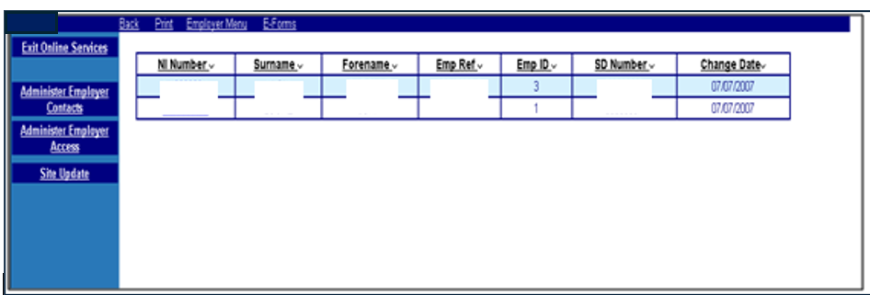

You need to insert the number of actual part time hours worked between the dates shown on the
form and submit it for processing.

Some validation is incorporated into the form and if you insert part time hours that are in excess of wholetime for the period you will receive an onscreen error message and will have to revise your entry:
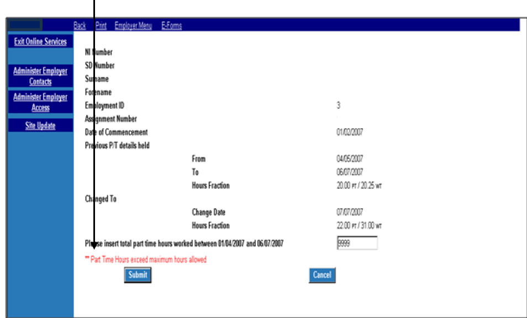

Once successfully submitted the information is held by the NHSBSA for processing when the cyclic update or leaver details are received.

How we use your information
For more information about how the NHSBSA processes your personal data, see our privacy notice - www.nhsbsa.nhs.uk/our-policies/privacy/nhs-pensions-privacy-notice

NHS Pensions

Pensions Online (POL Guide)
12. Electronic Staff Record (ESR) Changes to Standard Hours

www.nhsbsa.nhs.uk/nhs-pensions
NHS Pensions, PO Box 683, Unit 5, Newcastle Upon Tyne, NE5 9EE

