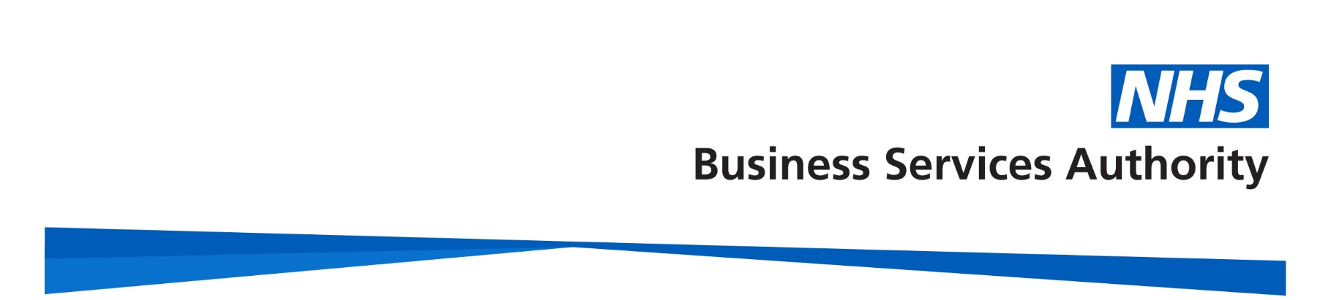
Important benefits of being in the NHS Pension Scheme
Video transcript

When you start work in the NHS you will automatically become a member of the NHS Pension Scheme.

Don’t worry, your employer will take care of all the details.

You won’t pay income tax on the contributions you pay.

And your employer also contributes the equivalent of an extra 23.7% of your pay to help meet the costs of your benefits.

Being in the scheme provides lots of important benefits for you and your family.

When you retire, you’ll get a pension payable for life. This is fully guaranteed by the government.

You can choose to swap some of your annual pension for a one-off lump sum when you retire.

There are also options to let you plan when you take your pension.

Once you reach your minimum pension age – for most members this is age 55 – you can take partial retirement. This allows you to take up to 100% of your pension benefits whilst continuing to work and build up membership in the Scheme.

If you want to you can choose to take your pension before your normal pension age. Your pension will be reduced because it is being paid to you earlier and will be paid to you for longer.

If you become too ill to work, you could apply for an early ill health retirement pension…

…and you’re covered for death benefits if you should die. This means your family may be entitled to benefits including a lump sum and a pension for partners and dependent children.

Depending on what type of member you are there are also ways you can increase the value of your NHS pension.

To help you keep track of your NHS pension, you have access to an Annual Benefits Statement or Total Rewards Statement via ESR or the My NHS Pension portal.

These statements are refreshed every year and are available online for you to look at whenever you want.

For more information about all of these benefits and the NHS Pension Scheme in general please visit our website www.nhsbsa.nhs.uk/nhs-pensions

The information contained in this video is correct at the time of publication July 2024.

