

NHS Pensions

Pensions Online (POL) Guide 34. Error Handling

Contents
NHS Pensions 1
Pensions Online (POL) Guide 34. Error Handling 1
What is Error Handling? 3
Section 1 - Error Overview 5
Breakdown of Errors 5
Error Selection Grid 6
Error Escalation 9
Example email to Pol Administrator: 9
Example email to Director of Finance or other Senior Contact: 9
Error Detail 10
Error Help 10
Error amendment and resubmission screen 11
View data only 13
Re-allocate error back to The NHSBSA 13
Delete Error 14
Extend Target 15
Checks to be made before resubmitting errors 15
How to Action Errors 17
Exception 0001- Item out of Range 17
Criteria: 17
Applies to forms: 17
Known causes: 17
Action to be taken – All form types 17
Examples of item out of range 17
Hours 17
Part Time hours 18
Update reason (termination forms) 18
Other name (joiner forms) 19
Missing Address Line 1 (ADLIN1) 19
National Insurance Number (NINO) 19
Best working practice for employers 20
Exception 0002 – Missing Mandatory field 21
Criteria: 21
Applies to forms: 21
Known causes: 21
Action to take: 21
Best working practice for employers 22
Exception 0004 – Sex in MR does not agree with sex on form 23
Criteria: 23
Applies to forms: 23
Known causes: 23
Action to take: 23
Best working practice for employers 23
Error 0007 – SD Number does not agree with member record 24
Overview 24
Action you need to take 24
Exception 0029 – Surname-maiden name on form does not agree with MR 26
Overview 26
Action you need to take 26
Criteria: 27
Applies to forms: 27
Known causes: 27
Action to take where the member already holds an open post with the same EA: 28
Action to take where the member does not hold an existing open post with the same EA 29
Best working practice for employers 30
Error 0062 – Date of commencement is before minimum age 31
Action you need to take 31
Error produced on Joiner Details 31
Error produced on Date of Birth Amendment: 31
Error 0065 – Reason for termination 11 not appropriate 33
Overview 33
Action you should take 33
Error 0067 – Mental Health Officer (MHO) details incomplete/error in form completion at box 22/23 34
Overview 34
Action you need to take 34
Error 0070 – Part time (PT) details are shown for a whole time (WT) employment 35
Overview 35
Action you need to take 35
Error 0071 – No entry shown in Whole Time (w/t), Part-Time (p/t) or Maximum Part Time (MPT) 36
Overview 36
Action you need to take 36
Error 0072 – Change to or from Whole Time (w/t) for Capacity 3 or 8 37
Overview 37
Action you should take 37
To close an employment 37
To re-open employment 37
Error 0075 – Part-time case but no p/t fraction is shown 38
Overview 38
Action you need to take 38
Error 0076 – Actual/Standard sessions shown but capacity is not 3 or 8 39
Overview 39
Action you need to take 39
Error 0077 – Incorrect mixture of part-time fractions 40
Overview 40
If member is part time (non-medical or dental) 40
If member is part time (medical or dental) 40
If member is whole time (non-medical or dental) 40
If member is whole time (medical or dental) 40
Action you need to take: 41
Error 0078 – No part-time denominator shown for As & When case 42
Overview 42
Action you need to take 42
Error 0080 – ‘As and When’ marker set but employment is not shown as p/t 43
Overview 43
Action you need to take 43
If the employment is correctly whole time: 43
If the employment should be p/t 43
Error 0081 – Part time numerator shown for ‘As and When’ 44
Overview 44
Action you need to take 44
If the employment is correctly ‘As and When’: 44
Or, if the employment is not ‘As and When’: 44
Error 0082 – Entry in actual hours but not in standard hours 45
Overview 45
Action you need to take 45
If the employment is correctly part time 45
Or, if the employment is not part time 45
Error 0083 – Actual hours not less than standard hours 46
Overview 46
Action you need to take 46
If the employment is correctly part time 46
Or, if the employment is not part time 46
Error 0084 – Incorrect mixture of p/t fractions 47
Overview 47
Action you need to take 47
If the employment is correctly part time 47
Or, if the employment is not part time 47
Error 0085 – Actual sessions not less than standard sessions 48
Overview 48
Action you need to take 48
If the employment is correctly part time 48
Or, if the employment should be whole time 48
Error 0087 – Incorrect data entered for maximum PT specialist 49
Overview 49
Action you should take 49
Error 0088 – Maximum PT specialist with incorrect capacity or employment type 50
Overview 50
Action you need to take 50
Error 0100 – Hours in year to date of change exceeds total hours for year 51
Overview 51
Action you should take 51
Error 0101 – Standard hours change but no entry in the hours to date of change 52
Overview 52
Action to take 52
Error 0109 – Incorrect capacity for a locum 53
Overview 53
Action you need to take 53
Error 0111 – Capacity clashes with employment type 54
Overview 54
Action you need to take 54
Error 0113 – Incorrect data entered for a Bed Fund appointment 55
Overview 55
Action you need to take 55
If the employment is correctly a Bed Fund: 55
If the employment is not a Bed Fund: 55
Error 0114 – There should not be an entry in WT/PT for emp types 5 or 6 56
Overview 56
Action you need to take 56
If the employment is correctly a practitioner post 56
If the employment is not a practitioner post: 56
Error 0137 – Total disallowed days exceed service covered by input 57
Overview 57
Example: 57
Action you should take 57
Error 0147 – RFT – (Reason for Termination) 13 shown but not Assistant Practitioner 59
Overview 59
Action you should take 59
Example where response required 59
Error 0154 – DOB on input not verified and different to DOB in MR 60
Overview 60
Action you should take 60
Example where response required 60
Error 0155 – NI Earnings missing for tax year of termination 61
Overview 61
Action you need to take 61
Exception 0156 – No NI conts for tax year prior to termination 62
Criteria: 62
Applies to forms: 62
Known Causes: 62
Action to be taken: 62
NI earnings (tax year 06 April to 05 April) 62
Exception 0163- Yearly conts Hrs-Sess outside period of employment 64
Criteria: 64
Applies to forms: 64
Known Causes: 64
Action to be taken: 65
Form SD55E (member not retired) 65
SD55 cyclic and termination forms 65
SD55e Amending employment details when benefits are in payment. 66
Best working practice for employers 66
Exception 0173- Yearly hours/sessions not required 68
Criteria: 68
Applies to forms: 68
Known causes: 68
Action to be taken: Cyclic and termination forms 68
Action to be taken: SD55E forms 69
Best working practice for employers 69
Exception 0186- No Emp found matching Emp ID-EA Code or DOC-DOT 70
Criteria: 70
Applies to forms: 70
Known causes: 70
Action to be taken: Cyclic, termination and SD55E amendment forms 71
Employment is showing on ADP4 71
Employment is not showing on ADP4/record not been set up 71
Employment not on ADP4 and joiner not rejected/ in Error Handling 72
Action to be taken: Deletion forms 72
Action to be taken: Open/rewind forms 73
Best working practice for employers 73
Error 0187 – More than one employment for EA Code and DOC 74
Overview 74
Action you should take 74
Exception 0188- Input for employment that has already been closed 75
Criteria: 75
Forms affected: 75
Known causes: 75
Action to be taken: 76
Best working practice for employers 77
Error 0196 – Date of change is prior to DOC (Date of Commencement) 78
Overview 78
Action you should take 78
Error 0401 – Contribution rate invalid 79
Overview 79
Action you should take 79
Error 0401 – Contribution rate invalid 80
Overview 80
Action you should take 80
Error 0402 – Contribution rate must be 5% for capacity code 5 or 7 81
Overview 81
Action you should take 81
Error 0403 – Mid Year contribution rate changes invalid 82
Overview 82
Action you should take 82
Exception 0410 – EST Update cannot be processed – initial update was not ESR 83
Criteria: 83
Applies to forms: 83
Known causes: 83
Action to be taken: 83
Error 0415 – Missing Additional Pension (AP) contributions 85
Overview 85
Action to take 85
AP conts have been paid: 85
No AP contributions have been paid 85
Exception 0420 – Earnings, contributions and/or worked hours appear low 86
Criteria: 86
Applies to forms: 86
Action to be taken (all form types) 86
Pay/contributions low or missing 86
Annual hours/sessions worked low or missing 87
Additional Voluntary Contributions (AVC) details low or missing 87
Best working practice for employers 88
Exception 0421- SD55 received: Member record not updated for previous year 89
Criteria: 89
Applies to forms: 89
Known causes: 89
Action to be taken: 89
Best working practice for employers 90
Error 0430 – Joiner start date is later than EA closed date 91
Overview 91
Action to take 91
Exception 0431- Changed end date is later than EA closed date 93
Criteria: 93
Applies to forms: 93
Known causes: 93
Action to be taken: 93
Best working practice for employers 94
Error 0432 – Changed End Date is later than the EA closed date 95
Overview 95
Action to take 95
Error 0433 – Changed EA Closed Date earlier than latest updated date 96
Overview 96
Action to take 96
Error 0434 – Change to a Direction EA code is not permitted 97
Overview 97
Action to take 97
Error 0463 – Employer’s pay less than employees pay 98
Overview 98
Further information 98
Action you should take: 98
Exception 0470 – Invalid employment status for deletion 99
Criteria: 99
Applies to forms: 99
Action to be taken: 99
Best working practice for employers 99
Error 0474 – Early retirement reduction buy out (ERRBO) contributions present – Employment deletion not permitted 100
Overview 100
Action you should take 100
Example where response required 100
Exception 8030 – No member record found to match input 101
Criteria: 101
Applies to forms: 101
Known causes: 101
Action to be taken: SD55 cyclic and termination 102
Action to be taken: SD55E amendment form 103
Action to be taken: SD55G amend personal details 103
Best working practice for employers 105
Error 8070 – Employment with matching details already present on Compendia 106
Overview 106
Action you should take 106
Example where response required 106
Exception 8086 – MR already updated for service shown 107
Criteria: 107
Forms affected: 107
Known causes: 107
Action to be taken: 107
Exception 8089 – Date of Birth in MR and input record both verified 108
Criteria: 108
Applies to forms: 108
Known causes: 108
Action to be taken: 108
Best working practice for employers 109
Comment 8094- Refund paid - input form not allowed to process 110
Criteria: 110
Applies to forms: 110
Known causes: 110
Action to take: 110
Best working practice for employers 111
Comment 8309 – Corrupt Service History 112
Criteria: 112
Applies to forms: 112
Known causes: 112
Action to be taken: 112
Best working practice for employers 112
Exception 8310 – Corrupt Member status details 113
Criteria: 113
Applies to forms: 113
Known causes: 113
Action to be taken: 113
Best working practice for employers 113
Section 2 – General Information 114
View Data Only 117
Adding Comments 117
Return to Errors List 119

What is Error Handling?

When you submit SS10 & SS14 joiner forms, SD55 cyclic updates, SD55 leaver forms, SD55E amendment forms or SD55G personal details amendment form SD55G, (or their equivalent via Electronic Staff Records (ESR), Magnetic (MAG) tape & American Standard Code (ASCII) for spreadsheets) these are processed through The NHSBSA data validation system and if there is any data on the form that fails the validation an error is created.

The error can be due to missing, incorrect or mismatching data on the form or its interaction with another employment.

If the error is due to the data on the form itself then it is allocated to you to resolve and the NHSBSA will not have access to the error.

The Error Handling facility also includes a display of the errors that are allocated to The NHSBSA for resolution.

You can access your errors via the Error Handling link in the Pensions Online Employer Menu.

Errors are not allocated to the employer where certain circumstances apply, examples of which are as follows:

- The error has been created due to interaction with another employment with a different employer.

- More than one error has been created on the same data and one of them relates to interaction with another employment with a different employer.

- Due to the employment type the employment may need closing and re-opening.

- Due to complex employment history the record may have a manual marker set which requires the record to be updated manually or we may not be able to successfully process the information due to issues with validation.

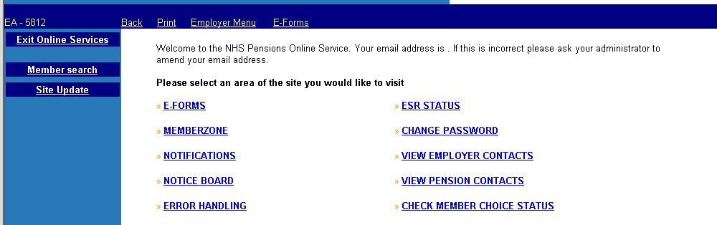
The link to Error Handling can be found on the main Employer Menu in Pensions Online:
Once you have selected this link you have the choice of selecting either:

‘Employer Allocated Errors’ or ‘Errors Allocated to The NHSBSA’

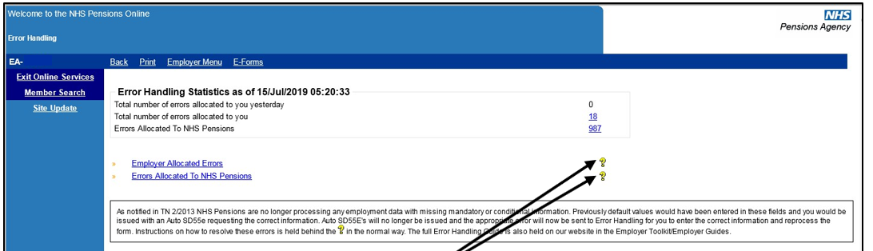

Respective help text is behind each ‘?’ as normal.
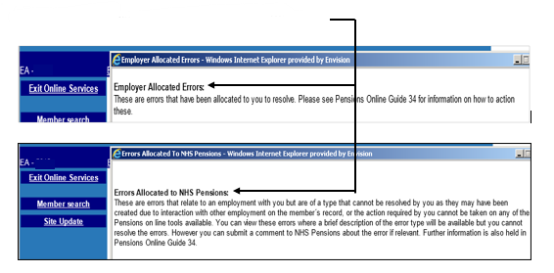

Section 1 - Error Overview

Breakdown of Errors
Selecting either of the links in the error handling statistics box will give a breakdown of the total errors allocated per form, as follows:
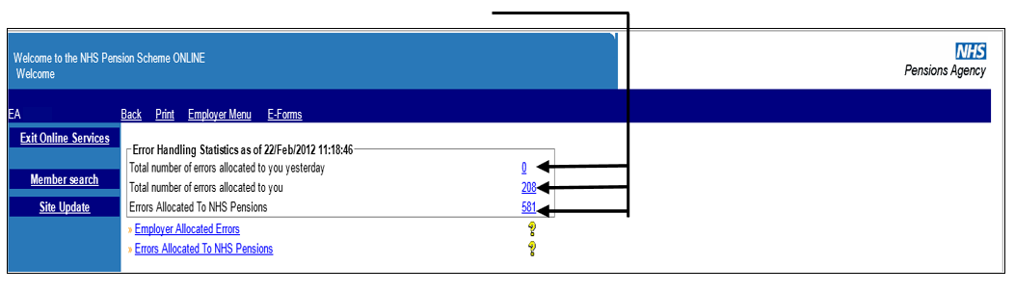
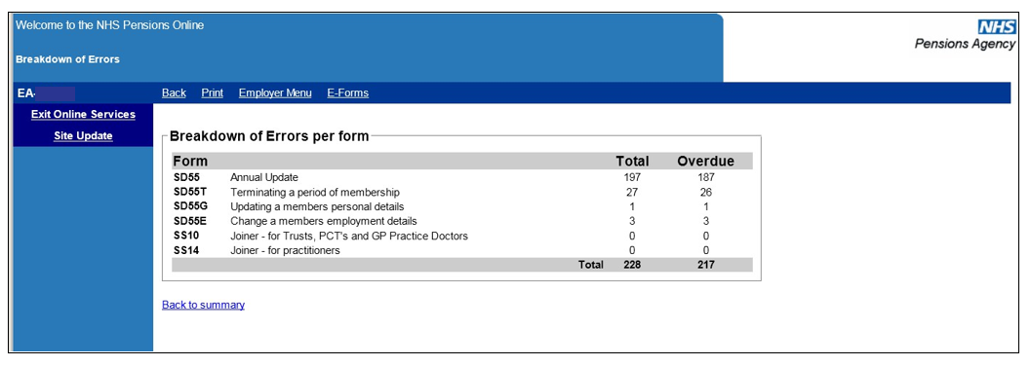
To access the actual errors select the link ‘Employer Allocated Errors’.

You will then see links to the errors for each form, as follows:
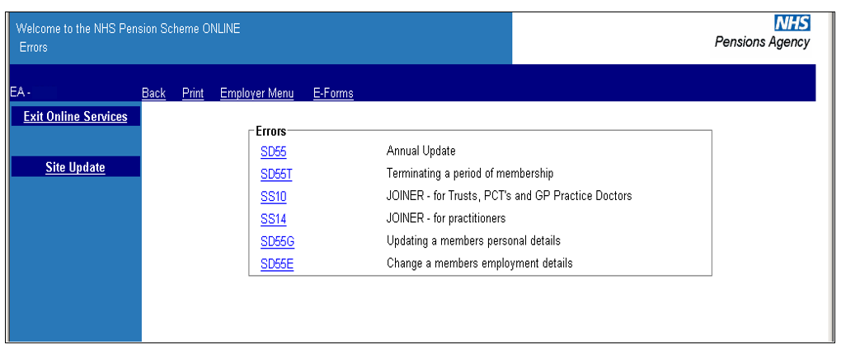

Error Selection Grid
Selecting any of the forms will return the appropriate selection grid for all errors allocated to you. You can sort on each column by clicking on the column heading. You can also move the order of the columns by left clicking and holding, then ‘dragging and dropping’ the column to where you want it to be positioned.

These examples are not holding actual member data.

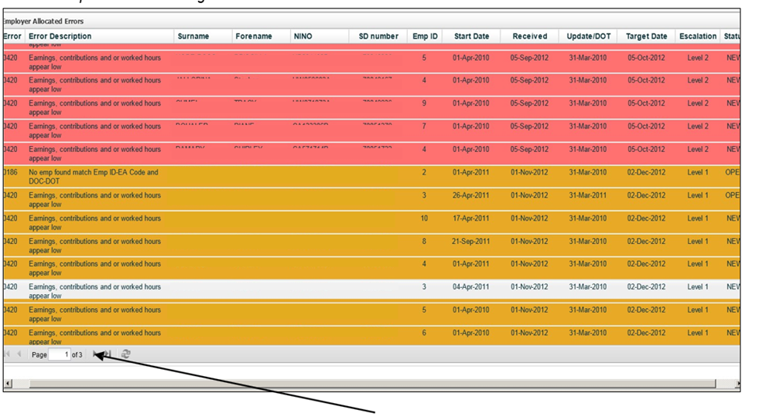
The grid will show 100 cases with an option to go to the next page, where applicable.

If you wish to sort the errors into more than one order; for instance error number and then National Insurance (NINO) within each error; it may be possible to copy the data by highlighting and copying it into Excel.
The copy function within Pensions Online is switched off so this can be done by highlighting the data then pressing the ‘Ctrl’ and ‘C’ keys at the same time to copy, open a new excel spreadsheet and then paste the data onto the spreadsheet.

You can then re-order the columns by selecting ‘Custom Sort’ in Excel.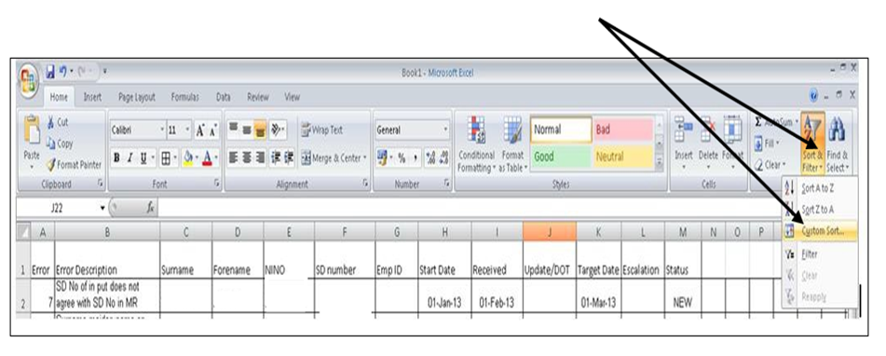
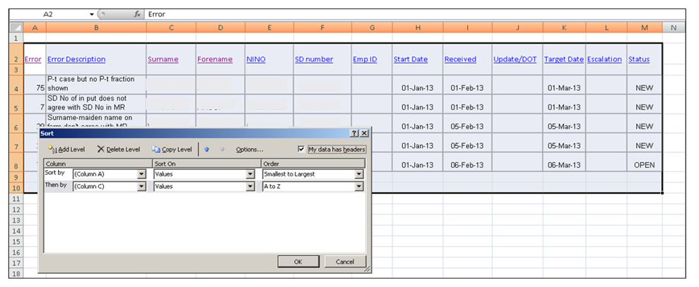

Changing the sort by column A and then by column C gives you all entries in NINO order within each error, as follows:
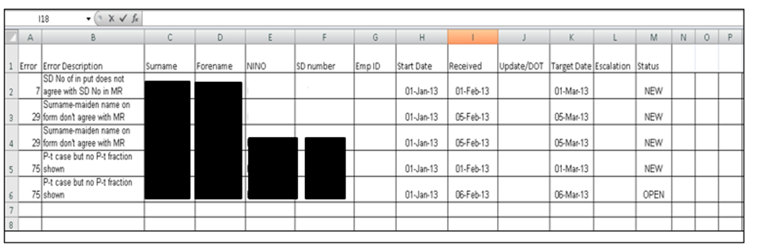

If you have more than one page of errors you will need to copy and paste each page into the spreadsheet before performing the custom sort into your preferred order.

Please note that to view and/or take any action on the error you will still need to do this via Pensions Online. Copying and pasting into Excel will only assist in viewing your errors for a particular form where the order you prefer cannot be obtained in Pensions Online.

Error Escalation
To enable you to action the errors in a priority order to meet the requirements outlined in the Employers Charter an escalation process has now been introduced.

Each level of escalation is colour coded and those at the highest level of escalation will always be displayed at the top of the screen when you first gain access to the error list.

The order can be changed by selecting any of the column headers but it will revert back to the default settings the next time you use the error handling system.

Green = not yet reached any target date

Amber (level 1) = 1 month after the creation date the error will reach the 1st escalation level and an email will be sent to Pol Administrator.

Red (level 2) = 2 months after the creation date the error will reach the2nd escalation level and an email will be sent to Director of Finance detailing the number of cases at Level 2 escalation.

Escalation emails will be issued on the 1st day of every month.

Example email to Pol Administrator:
‘You have 25 errors in POL error handling that have been outstanding for more than one month. Please address these urgently. Errors that have been outstanding for more than three months will be escalated to your Finance Director or other Senior Contact as advised’.

Example email to Director of Finance or other Senior Contact:
‘There are currently 60 errors in POL error handling that are allocated to your Trust and have been outstanding for more than three months. Please can you arrange for these to be addressed urgently’.

Error Detail
Clicking on the Error Description will give the error details and options, as follows:
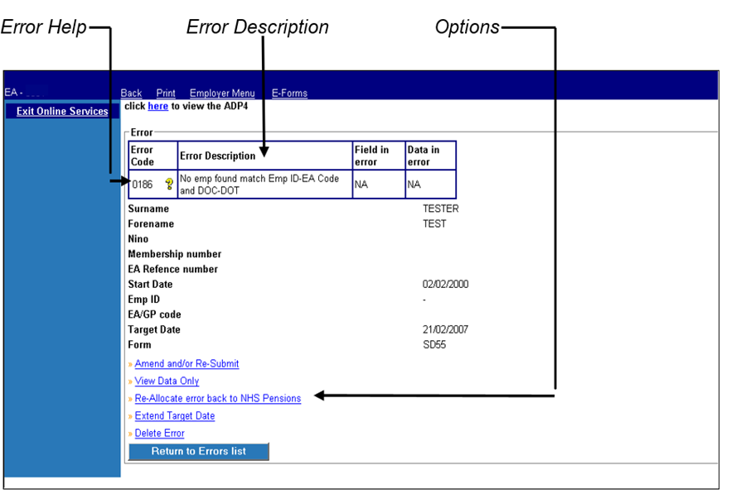

Error Help
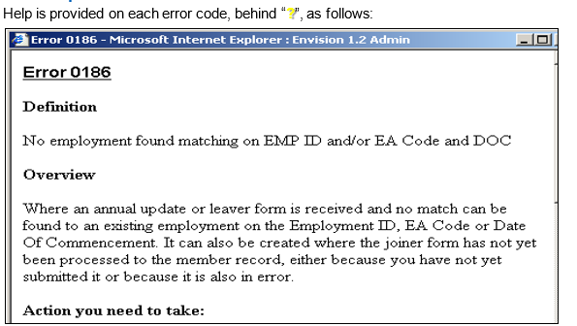

Error amendment and resubmission screen
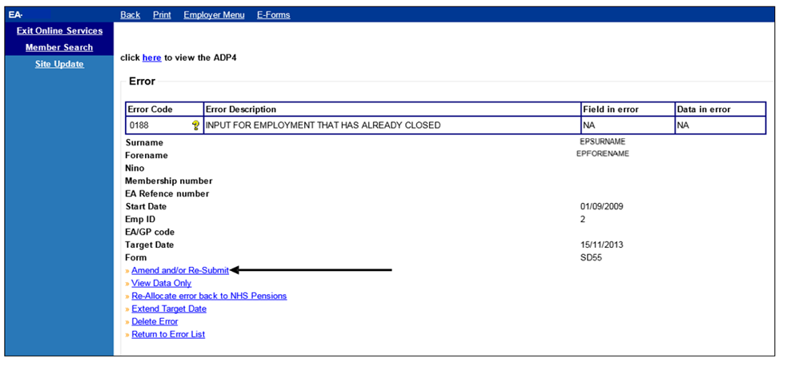

Selecting ‘Amend and/or resubmit’ will allow you to view; edit and resubmit the form that is in error. First the screen will allow you to check and amend if necessary, as shown on the example screen below:
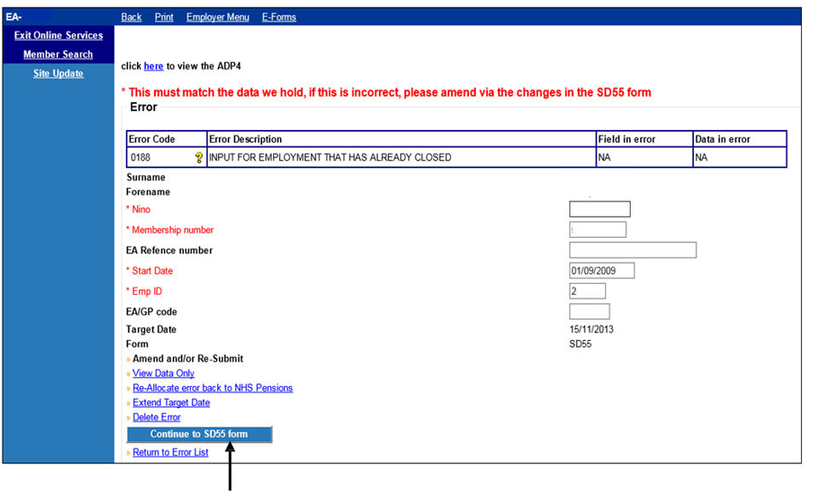
Selecting ‘continue to SD55 form’ button will provide the remainder of the form, which can then be amended – see next page

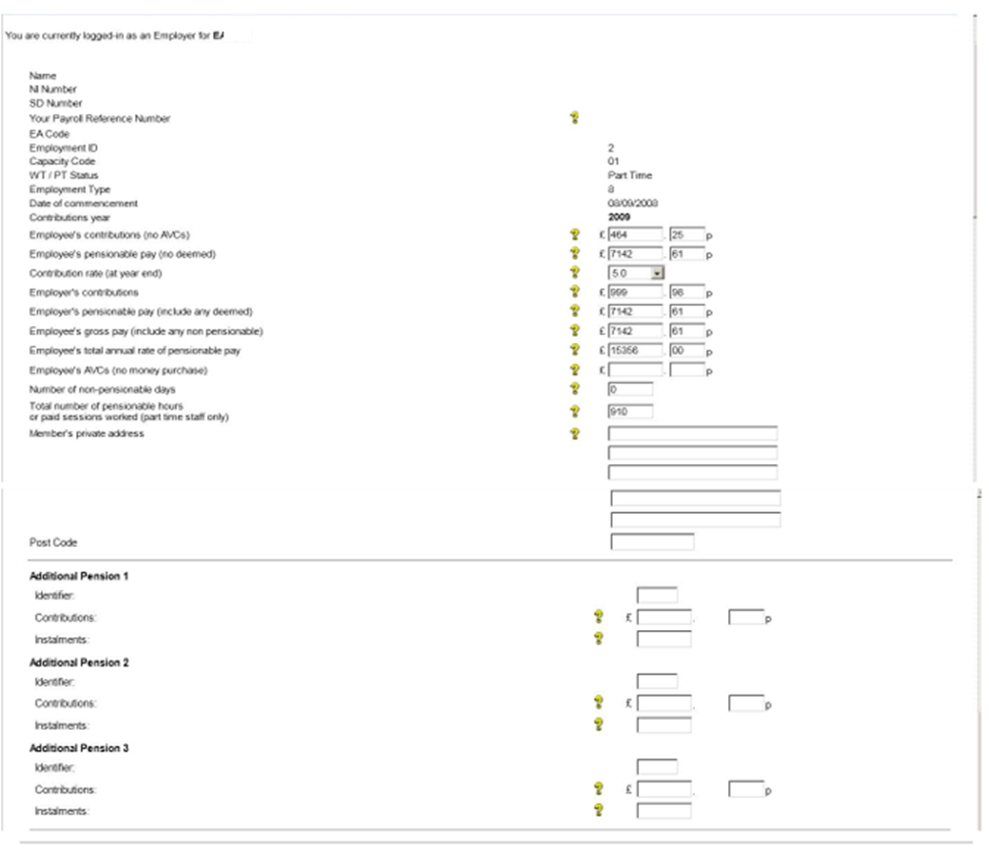

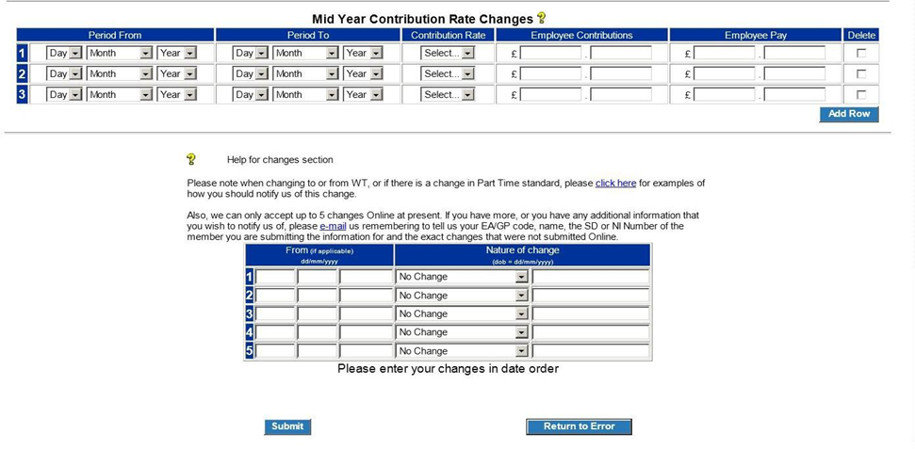
On this example the contributions paid do not match the contribution rate notified – and you should check whether the correct details have been entered in the employees’ contributions, employees pay and the contribution rate. The instructions for error 0400 give more information.

View data only
This option allows you to view the form contents only. The fields are not amendable in this option
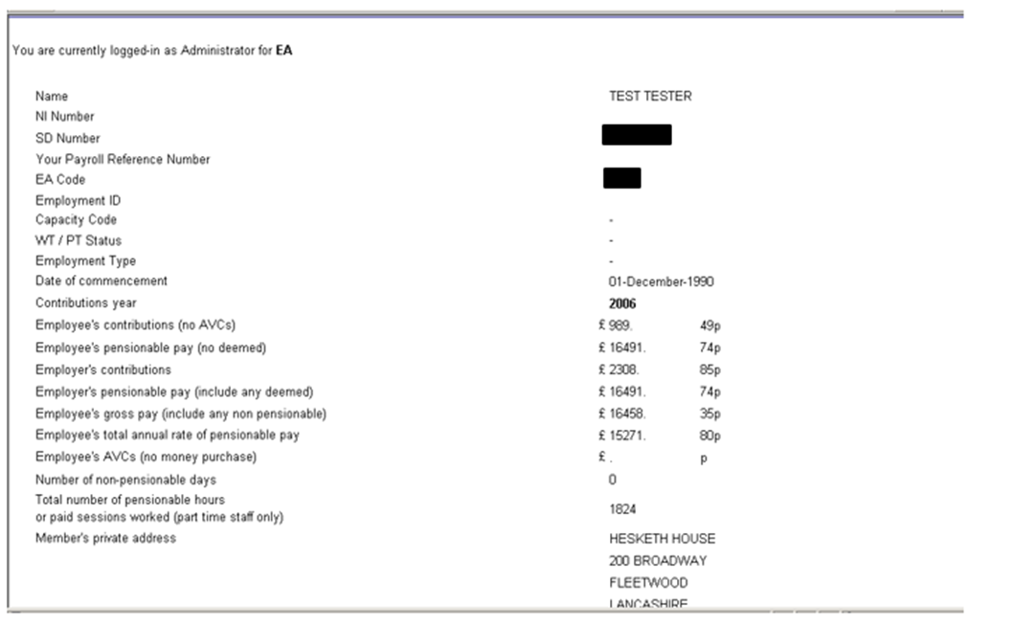

Re-allocate error back to The NHSBSA
Errors must only be re-allocated back to The NHSBSA if it is not possible for you to take any action to correct the error. Once you select this option you must enter the reason why you are reallocating the error back to The NHSBSA and then select ‘submit’ or ‘return to errors list’ if you have selected this option in error.
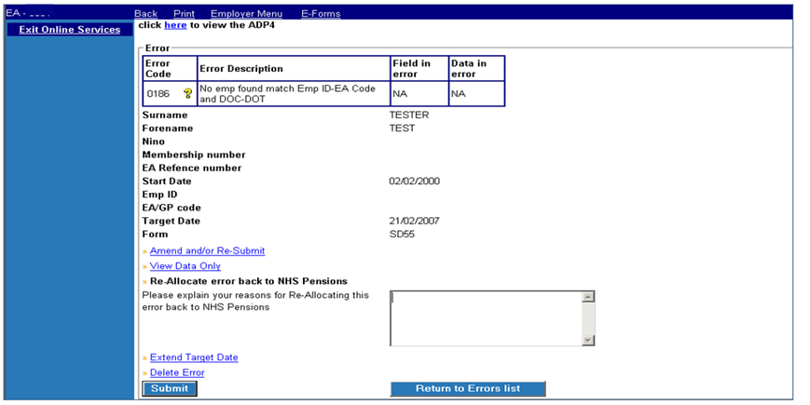

If amendments are needed to the members employment record for a previous year which will then allow the information in error to process successfully, you should not re-allocate the error to The NHSBSA but leave it in error handling. Email the Data Management Team asking for the amendments to be made and when this has been done you can then resubmit the error without making any changes.

If you receive an error in your list for which an instruction is not included in this Guide you may re- allocate the error back to The NHSBSA for resolution as it may have been allocated to you in error. Please state the reason for re-allocation as: ‘No instructions found to resolve this error’.

Delete Error
Errors should only be deleted for the following reasons:

- The form was submitted in error
- The data is already held on the member record
- You will submit revised data at a later date

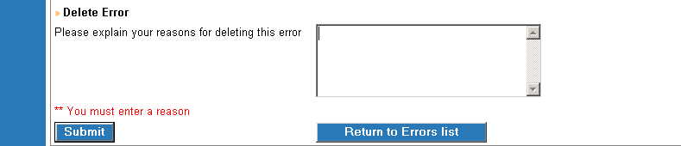
You must enter the reason why you are deleting the error in the text box provided and then select ‘submit’ or ‘return to errors’ list if you have selected delete in error.

Extend Target
If you need to make investigations with either the member or another department before being able to resolve the error you can choose to extend the target date.
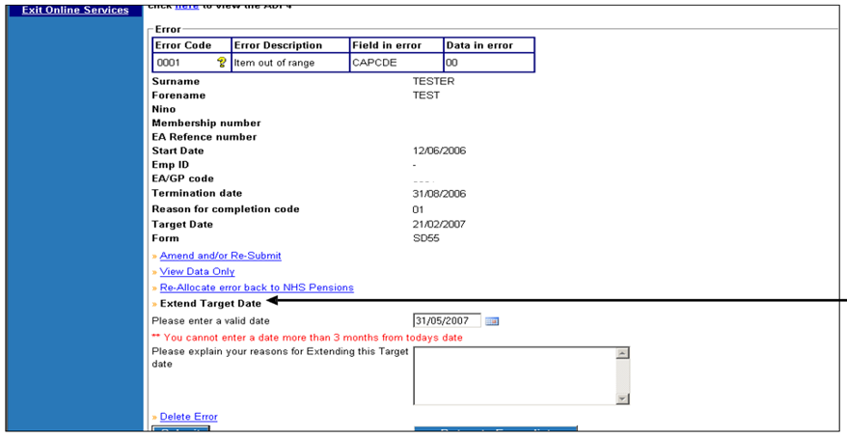
Once you select this option a text box opens for you to enter the reason why the target is being extended. You also enter a date that you wish to review the action needed on this error.
The reason you enter can help to remind you or a colleague of the action needed when the revised target date matures.

An example of an entry on a joiner form is as follows:
‘Wrote to member 9th December asking for copy of birth certificate’

Checks to be made before resubmitting errors
The list of errors includes the Year of Update/Date of Termination for the forms that are in error. This will help you to check if there is more than one error for the same member record and to deal with the errors in year order.

Joiners, annual updates and leavers are in different groups to enable you to resolve and submit the errors on joiners and annual updates before attempting resolving an error on the leaver form for the same member. If multiple errors for the same member are not dealt with in order a further error may be created.

Before reprocessing an error you should check whether the employment has already been updated for the period of the form in error, as sometimes The NHSBSA receives duplicate information.

If you attempt to amend and resubmit errors created on leaver forms and it has already closed by other means then you may get an on screen message advising that the employment cannot be found. If the same is done for an employment that has already been cyclic updated then a further error may be created advising that duplicate information has been received.

For example: The NHSBSA has received an annual update to year ending 31.03.2017 and this has produced an error for you to resolve. However the member record has already been updated to 31.03.2017. If you were to resolve the error and resubmit the annual update via the Error Handling System it would produce another error as the record is already updated to that date.

To avoid creating a further error you should make a check via the ADP4 link to see what date the employment has been updated to. If it is then determined that the annual update in error handling is a duplicate you should delete the error.

Additionally, a duplicate annual update/leaver form may have been received at The NHSBSA and the employment is not displayed on the ‘ADP4 link’. As closed employments cannot be displayed on the ADP4 link, you may wish to check the membership details via Memberzone and this should show the start and end date of the employment.

Once it has been confirmed that the employment is closed, you can then delete the duplicate form that is in error.

If it is confirmed that the update/leaver form in error handling is not a duplicate then continue to resolve the error and re-submit the form for processing.

How to Action Errors

Exception 0001- Item out of Range
Before taking action on an error, check that NHSP records have not already been updated with the information on the form.

Criteria:
A form has been submitted with an invalid entry in one of the fields
For example: alpha characters have been entered in a numeric field or the pensionable hours value exceeds the limit for that field.
The field which is out of range will be shown on the first page of the error under ‘field in error’.

Applies to forms:
Joiner forms, SD55 cyclic and termination, SD55E Amend employment details, SD55G Amend Personal Details, Deletion and open/rewind.

Known causes:
See examples below.

Action to be taken – All form types

Step | Action
1 | Check the first page of the error for the item that is out of range (shown under ‘field  in error’).
2 | Confirm correct details. To process the form, select ‘Amend and/or resubmit’ and then continue to form, e.g. ‘continue to SD55’. Amend the relevant field, and then  select submit at the bottom of the page.

Examples of item out of range

Hours
Step | Action
1 | Confirm correct yearly hours. If the original figure was input incorrectly, amend the  error to show the correct figure and resubmit (see process above).
2 | If the original input figure was correct but is exceeding the maximum value for the hours field, the hours will need revising to the maximum whole time equivalent.  Calculate the maximum number of yearly hours for the relevant period (number of  days in period ÷ 7 x by the standard hours).
3 | Amend the error to the revised figure and resubmit.
4 | Any pension contributions collected on hours or sessions worked in excess of whole time should be returned locally, as when notified of exceeding whole time hours by  NHSP.

Part Time hours
Occurs when the part time hour’s entry is invalid on either a joiner form or in the changes section at the bottom of an update form.
Part time posts require both the actual and standard hours/sessions fields to be populated. They should not be held as 0.00.

Step | Action
1 | Joiner forms:  For part time employments, confirm the actual and standard hours/sessions and input on the error (see action to be taken, above). Bank posts should be populated with actual hours/sessions of ‘1’.  If the employment is As and When, just the standard hours/sessions should be entered and the ‘As and when’ field (Q19) marked ‘Yes’.  For whole time employments, both the actual and standard hours/sessions fields  should be left blank.
2 | Cyclic and termination forms:  The PT hour’s field is in the change box at the bottom of the form. This can only be viewed by selecting ‘Amend and/or re-submit’ and then ‘continue to form’ (you are unable to see it by using the view data only option).  Confirm that there has been a change from whole time to part time or a change to the standard hours/sessions and determine the correct part time fraction.  Note: if there is only a change to the actual hours/sessions, NHS Pensions do not  need to be notified and any changes can be deleted from the form.
2.1 | Enter the correct details in the change box and resubmit the error.

Update reason (termination forms)
Occurs when a termination form has been submitted and the reason for completion code is not valid, e.g. shows as 00.

Step | Action
1 | If end date on form is 31/03/ --, confirm that the employment is closed. If still open  an SD55 cyclic should be completed instead and the error deleted.
2 | If employment is closed, confirm the correct end reason code.
3 | Populate the reason for completion field with the correct code and resubmit the  form.

Other name (joiner forms)
The members’ surname, former surname and forename fields accept only alpha characters, apostrophes and hyphens.

Step | Action
1 | On the error, check the former surname and remove any characters that are not  alpha, or not an apostrophe or hyphen.
1.1 | Double barrel names should be displayed with a hyphen between the two names,  with no spaces.
1.2 | Only the most recent previous surname should be input on the joiner. If a list of names is provided such as Roberts/ Jones or Roberts, Jones it will create error  0001 as ‘/’ and ‘,’ are not acceptable characters.

Missing Address Line 1 (ADLIN1)

Step | Action
1 | Confirm the full address for the member.
1.1 | Ensure that both address lines 1 and 2 are populated on the form that is in error and  resubmit the form. Ensure that the address line 1 and 2 are correctly populated in ESR.

National Insurance Number (NINO)
When a new NINO prefix is introduced, the NHS Pension systems are updated to accept this prefix. Occasionally a joiner form can be submitted prior to the system update being made, in which case, the form will create error 0001 as the NINO suffix is not recognised.

Step | Action
1 | Confirm that the national insurance number on the form is correct.
1.1 | If correct, then re-allocate the 0001 error to NHS Pensions and inform them that  the National Insurance suffix has not been accepted by Pensions Online.
1.2 | NHS Pensions will inform you when they have added the suffix to the NINO  range and have successfully resubmitted the form.

Best working practice for employers
Action
To avoid reoccurring errors, ensure that your payroll/ESR records reconcile when amending address or name details on a form for resubmission to NHSP. Details should match on both
content and format.

Known Issues
Where a joiner is submitted without the member’s correct NINO and the NINO is amended before NHSP have processed the monthly joiners, error 0001 or 8030 may be generated.

To avoid future errors, regularly check your ADP4 to identify members with a temporary NINO (ZZ……Z) and amend by submitting a SD55G.

Where a member opts out in the first period and the joiner/leaver notification is processed prior to successful processing of the joiner, error 0001 will be generated.

NHS Pensions are investigating and hope to soon find a solution to these scenarios.

Date Created/updated (Exc 0001) | 16/07/2019

Exception 0002 – Missing Mandatory field
Before taking action on the error, check that NHSP do not already hold the employment details on their records.

Criteria:
A joiner form has been submitted and one or more of the mandatory fields has not been populated or causes a mismatch with other information on the joiner.

Applies to forms:
SS10 and SS14 Joiners

Known causes:
- Personal details are not complete, such as title, forename, surname or date of birth.
- Employment details are incomplete, such as date of commencement.
​

Action to take:
Step | Action
1 | Using the ADP4 form in E-forms, compare the details held on the joiner in error handling against any other open employments held by NHSP for this member (a trace can be made using the name, SD or NINO).
1.1 | Where matching joiner details are found on the ADP4, the Exception 0002 can be deleted from error handling.
1.2 | Where no other open employments are held by NHSP, check the first page of the error to determine which mandatory field is missing, (shown under field in error).  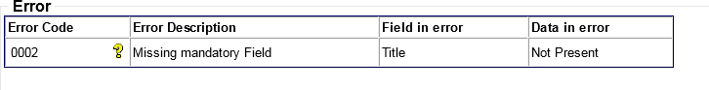  Note: where the field in error is ‘title’, the title is pre-populated as ‘Mr’ when ‘Amend and/or Resubmit’ is selected. This needs to be amended to the correct title.
1.3 | Confirm the correct details for the missing field. Enter this on the joiner form by selecting ‘Amend and/or Resubmit’ and then ‘continue to joiner’. Amend the relevant field, and select submit at the bottom of the page.

Best working practice for employers
Ensure that payroll/HR records are updated if they hold incorrect details. Ensure that all mandatory fields are populated in ESR. These are:
- Capacity code
- Employment type
- Date of birth
- Forename
- Surname
- Title

Date Created/updated (Exc 0002) | 16/07/2019

Exception 0004 – Sex in MR does not agree with sex on form
Before taking any action on the error, check that NHS Pensions do not already hold the employment details on their records.

Criteria:
A joiner form has been submitted for a previous or existing scheme member. The gender on the joiner causes a mismatch with the gender on the NHS Pensions member record.

Applies to forms:
SS10, SS10GP and SS14 Joiners

Known causes:
- Gender has been mis-keyed or incorrect gender originally input.
- National Insurance or SD reference number on the joiner form is held on NHSP records, but for a different member.

Action to take:

Step | Action
1 | Confirm the gender of the scheme member.
1.1 | If the gender on the joiner form is incorrect, access the joiner form in NHSP error handling and provide confirmation via Employer comments. NHSP will then amend the joiner and resubmit it.
1.2 | If the gender on the joiner is correct, access the joiner form in NHSP error handling and confirm that the original details entered are correct with collaborative information via employer comments.  NHSP will then amend their records and resubmit the joiner form.

Best working practice for employers

Ensure that payroll/HR records are updated if they hold incorrect details

Date Created/updated (Exc 0004) | 16/07/2019

Error 0007 – SD Number does not agree with member record

Overview
This error is produced when the SD number submitted on a joiner form or SD55G amendment form does not match the SD number on the member record held by The NHSBSA. Both the SD number submitted on the form and the SD number held by The NHSBSA will be displayed on the error:
SD number submitted SD held by NHSBSA
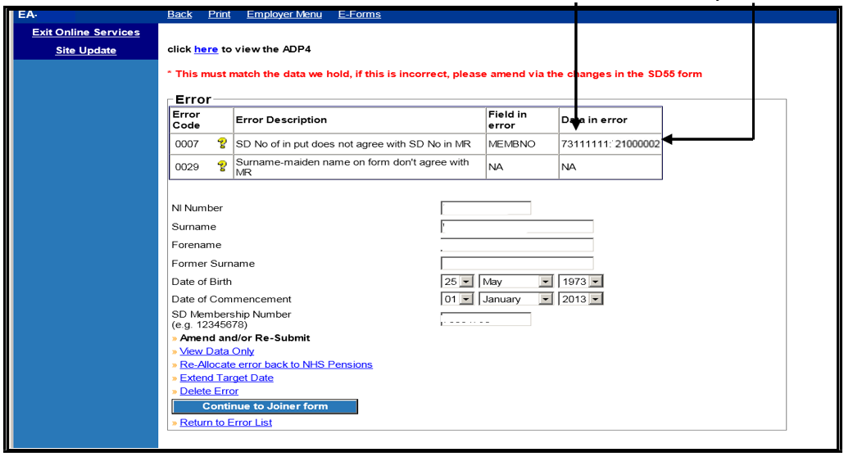

This can happen for various reasons some of which are as follows:

- You are using an old SD number that the member may have had some years ago but received a refund for that membership or transferred it to another pension scheme. Members who have had refunds or transfers since October 2005 will keep the same SD number if they re-enter the Scheme.

- The NHSBSA had more than one record for the same member and since you received notification of the SD number the records have been amalgamated under the other SD number

- An error has been made when entering the SD number into your Payroll system and this matches to another person when your form data goes through The NHSBSA validation.

Action you need to take
Check the NINO you have entered on the form to make sure this is for the correct person.

If either of the following apply it is best to contact the NHSBSA to discuss before attempting to resolve the error:
- If this error is produced with Error 0029 then it is possible that the details held either by ESR or by The NHSBSA has become confused for 2 different members.
- If you think The NHSBSA have duplicate records for the same person

Otherwise to prevent this error being produced on any further data submitted to The NHSBSA you need to change the SD and/or NI number within your payroll system and then action the error as follows:

- Select ‘amend and/or resubmit’ and amend the SD number on this page to the correct number. Check the other details are also correct and amend where relevant.
- Select ‘continue to joiner form’. The full joiner form will then be displayed in the same format as Pensions Online. This should now hold the data you amended on the previous page.
- Click ‘submit’ at the bottom of the form.

Exception 0029 – Surname-maiden name on form does not agree with MR

Overview
This error is produced on processing cyclic and termination information where the date of birth in the personal details section of the update form does not match the date of birth held by the NHSBSA. The date of birth on the update form needs to match that held on the members’ record.

Action you need to take
Check the Date of Birth you hold on your Human Resources (HR)/Payroll record and then check the Date of Birth that was submitted on the cyclic update/leaver information. If an error was made on the update/leaver then the Date of Birth can be changed and the form submitted for re- processing, as follows:

- Select ‘amend and/or resubmit’
- Select ‘continue to form’. The full form will then be displayed in the same format as Pensions Online.
- Amend the Date of Birth and then click ‘submit’ at the bottom of the form.

The DOB held by The NHSBSA is displayed within the error page, as follows:

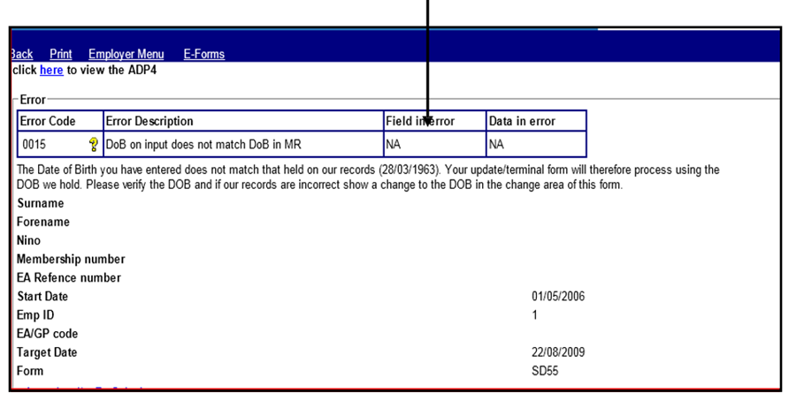

If the Date of Birth (DOB) held by the NHSBSA is correct then resubmit the form for processing without making any amendments, as follows:

Select ‘Amend and/or Re-Submit’ Select ‘Continue to SD55’
Select ‘Submit’ at the bottom of the form.

If the DOB held by the NHSBSA is incorrect then you should submit form SD55G, to change the DOB and show it as verified, via Pensions Online and then re-submit the error, as above, without making any changes.

Note: You should only change the date of birth if the new date has been verified by sight of Birth Certificate or Passport etc.

Before taking any action on the error, check that NHS Pensions do not already hold the employment details on their records.

Criteria:
Where a joiner form for an existing member of the pension scheme contains an entry for the surname and neither this, nor the maiden name if present, matches with the surname on the NHSP member record.

Applies to forms:
SS10 joiner, SS14 Joiner

Known causes:
- There is a change of surname. NHSP records show the previous surname and the joiner form does not include the maiden name/previous name to create a match.

- Name is misspelt on either the joiner form or on NHSP records, resulting in a mismatch.

- Punctuation marks and spaces within names are considered as characters therefore they should also match where present. Note – spaces may have been input incorrectly at the end of the surname.

- Incorrect NINO/SD entered on joiner and therefore matching to incorrect member record.

Action to take where the member already holds an open post with the same EA:
Step | Action
1 | Ensure all information on the joiner form is correct for the relevant member,  including NINO, date of birth and gender.
1.1 | Using the ADP4 form in E-forms, compare the details held on your records to those held by NHSP for other open employments (a trace can be made using the name,  SD or NINO).
2 | Where the joiner details on the form are incorrect, amend the form to match NHSP records. To do this, select ‘Amend and/or resubmit’. Amend the relevant field and then select ‘continue to joiner’ at the bottom of the page. On the next page, submit  the form.
3 | Where the data held on the joiner form is correct but the ADP4 form shows an incorrect surname (e.g. the member has married or divorced) the previous name (shown on the ADP4) can be entered in the ‘former surname’ field on the joiner.  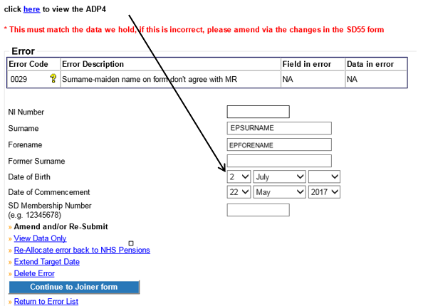  Select ‘continue to joiner form’. On the next page, submit the form.  NHSP will match on this information and the surname on NHSP records will be amended.
4 | If there is any uncertainty regarding the member’s surname, take steps to obtain  verification of the member’s details.

Action to take where the member does not hold an existing open post with the same EA
Step | Action
1 | Ensure all information on the joiner form is correct for the relevant member,  including NINO, date of birth and gender. If there is any uncertainty regarding the member’s surname, take steps to verify the member’s details.
2 | If any details on the form are incorrect, amend them by selecting ‘Amend and/or  resubmit’. Correct the relevant field and then select ‘continue to joiner’ at the bottom of the page. On the next page, submit the form.
3 | Where the details on the form are correct but there is a surname mismatch as the member has married, divorced, or remarried, action needs to be taken to find out what name is held by NHSP. Contact NHSP by either email or by re-allocating the  error via Employer comments.
3.1 | Once confirmed, enter the previous name (as held by NHSP) in the ‘former surname’ field on the joiner. Then select ‘continue to joiner form’ and on the next page submit the form.  NHSP will match on this information and the surname on NHSP records will be amended.
3.2 | NHSP may request confirmation of NINO if they hold an existing member record with the same NINO but other personal details do not match those on the joiner. In these circumstances, no amendments should be made to the joiner details until the NI is verified.

Example:
NHS Pensions member record shows surname as O’Neil and the input form shows surname as ONeil.

Step | Action
1 | Access the error in Employer Error Handling and choose ‘Amend and/or re-  submit’ option.
2 | Amend the surname to O’Neil
3 | Select ‘Continue to joiner form’
4 | If any other details need amending, do so before clicking ‘submit’ at the bottom  of the form.

Best working practice for employers
Action
Ensure that payroll/HR records are updated if incorrect personal details are held.

Ensure that the correct details are shown in ESR, in particular the NINO.

Date Created/updated (Exc 0029) | 16/07/2019

Error 0062 – Date of commencement is before minimum age
This error is produced where the Date of Commencement on a joiner form is before the minimum age a person can join the NHS Pension Scheme or an amendment to the members Date of Birth has been received and this has resulted in their first pensionable NHS employment having a start date before the minimum joining age.

This error is only allocated to employers for action where the joiner or amendment details are received via the Electronic Staff Record (ESR) system. It is often found that the change to DOB is incorrect and the original DOB held by The NHSBSA is the correct date.

Action you need to take
- Check the members’ date of birth; if this is incorrect it could be responsible for the production of this error.
- Check the start date of the employment to determine if this is incorrect.
- Check whether more than one member with the same name is employed with you and determine the correct details for each member*

Note: It is also worth checking the correct NINO’s as these can often get confused where ESR holds records for 2 members with the same name with the same employer.

Error produced on Joiner Details
- Access the error and select ‘Amend and/or resubmit’
- Change the DOB or date of commencement on the personal details page
- Select ‘continue to joiner form’ – the details you have amended should now be visible on the actual joiner form.
- Scroll down to the bottom of the form and select ‘Submit’

Error produced on Date of Birth Amendment:
If the date of birth amendment is found to be incorrect access the error and select ‘Delete’ – enter the reason as ‘Incorrect DOB amendment’

If the date of birth amendment is correct you will need to contact The NHSBSA via Email and request the employment start date is amended to the minimum joining age, which age 18 before 06.04.1988 and age 16 thereafter.

If the 1st employment is with you Pension contributions deducted before the minimum joining age should be refunded to the member via the payroll system. If with another employer, The NHSBSA will advise them to make the adjustments.

Once the employment start date has been amended Error 0062 can be reprocessed via ‘Error Handling’ without any amendments being made.

- Access the error.
- Select ‘Amend and/or resubmit’
- Select ‘Continue to form’
- Scroll down the page and select ‘Submit’

Important Note: Where the DOB held by The NHSBSA is correct you need to ensure that the DOB held in the ESR system is amended otherwise an error may be produced every time data is submitted

Error 0065 – Reason for termination 11 not appropriate

Overview
Produced on cyclic update, leavers and form SD55Es where the reason for termination is showing as 11 AND the member is either:
- Under age 60 less one day at the date of termination
- Under age 65 less one day for Mental Health Officer’s (MHO) and Special Classes, and has less than 45 years’ service (including doubled years)
- Is not MHO or Special Class and is under age 70 (75 for service on or after 01/04/2008) less one day and has less than 45 years’ service.

Action you should take
If you have been advised previously by The NHSBSA that the member has attained maximum age/service, please check the date you have submitted.

If you have not previously received any information from The NHSBSA, please re-check your end date and the ‘11’ exit code (Employment continues but contributions cease to be payable as member has reached maximum Pensionable age/service).

To amend the date of termination or the exit code, access the error via ‘Amend and/or re-submit’ to alter the necessary field/s and re-submit the form to The NHSBSA.

Note: If you are submitting a date and exit code as notified by The NHSBSA please re-allocate the error advising such and requesting further investigation into the reason the error is being produced.

Error 0067 – Mental Health Officer (MHO) details incomplete/error in form completion at box 22/23

Overview
This error is produced when there is a claim for MHO status on a joiner form and the question concerning previous MHO employment has not been answered, or vice versa.

Action you need to take
Check that the questions at boxes 22 & 23 have been completed correctly. Box 22 must be answered as ‘yes’ or ‘no’
If Box 22 is answered as ‘yes’ then box 23 must be completed as either ‘yes’ or ‘no’ If Box 22 is answered as ‘no’ then box 23 should be left unanswered.

- Access the error.
- Select ‘Amend and/or resubmit’
- Select ‘Continue to form’
- Amend the details at questions 22 & 23 accordingly
- Scroll down the page and select ‘Submit’

Error 0070 – Part time (PT) details are shown for a whole time (WT) employment

Overview
This error will be produced on joiner forms where the employment is shown as w/t but a p/t fraction is also shown.

Action you need to take
Check the contract of employment to determine whether the employment is wt or pt and either delete the actual and standard hours or sessions or amend the wt/pt indicator to part time.

If you complete mismatching information within the error you will receive onscreen error messages.

- Access the error.
- Select ‘Amend and/or resubmit’
- Select ‘Continue to form’
- Amend the details at questions 17 - 21 accordingly
- Scroll down the page and select ‘Submit’

Error 0071 – No entry shown in Whole Time (w/t), Part-Time (p/t) or Maximum Part Time (MPT)

Overview
A joiner form has been received with no entry in the pt/wt indicator. This error is sometimes produced with error 0070.

Action you need to take
Check the contract of employment to determine whether the employment is wt or pt and amend the joiner details at box 17.

You should also make sure that boxes 18-21 hold correct data to match - please see information for error 0076 & 0077

- Access the error.
- Select ‘Amend and/or resubmit’
- Select ‘Continue to form’
- Amend the details at questions 17 - 21 accordingly
- Scroll down the page and select ‘Submit’

Error 0072 – Change to or from Whole Time (w/t) for Capacity 3 or 8

Overview
A cyclic update/leaver form has been submitted with a change to WT/part time (PT) in the changes box for an employment held with a Capacity code of 3 or 8 (Doctor or Dentist).
Although ESR can accept such a change, The NHSBSA and POL require a split to ensure calculations for capacities 3, 8 and 10 are accurately assessed by their systems.

The NHSBSA are assessing options to better align The NHSBSA and ESR systems.

Action you should take
Where a change to W/T or P/T is shown in the changes box of form SD55 the change will not process as the batch processing system is currently designed not to accept these changes. It expects the member record to be closed down and re-opened at the date of change.

If the change is genuine, the employment will need to be terminated the day before the change occurs and a new joiner submitted with a data of commencement on the day of the change. (E.g. If the member went WT 26/05, then the original post would be closed 25/05 and a new post would start 26/05)

To close an employment
- Access E-forms and select form SD55T
- Fill in the form with the contributions paid up to the date before the change inc. hours worked if necessary.

To re-open employment

- Submit an SS10 (SS14 if Practitioner/Principle Practitioner) for the new service beginning on the date of change.
- Once the joiner has processed the employment will need to be updated/terminated via POL form SD55/55T as above.

Error 0075 – Part-time case but no p/t fraction is shown

Overview
A joiner form has been received with no entry for the pt fraction. This error is sometimes produced with error 0070.

Action you need to take
Check the contract of employment to determine the actual and standard hours/sessions.

You should make sure that boxes 18-21 also hold correct data to match - please see information for error 0076 & 0077.

- Access the error.
- Select ‘Amend and/or resubmit’
- Select ‘Continue to form’
- Amend the details at questions 17 - 21 accordingly
- Scroll down the page and select ‘Submit’

Error 0076 – Actual/Standard sessions shown but capacity is not 3 or 8

Overview
A joiner form, cyclic update or leaver has been received showing a sessional contract / change to a sessional contract but this is only acceptable by The NHSBSA for medical or dental grades.

Action you need to take
Check if the capacity code is correct as ESR defaults to capacity code 01. If the capacity code is correct then the sessional contract must be converted to hours.

You should make sure boxes 18-21 also hold correct data to match.

Capacity Code | Employment Type | WT/PT  Indicator | Locum | As & When | If PT  Sessions or hours?
01 | Officer | PT or WT | No | No | Hours
02 | Officer | PT or WT | No | No | Hours
03 | Non-spec, or | PT or WT | Yes or No | Yes or No | Either
03 | Specialist | PT or WT | Yes or No | Yes or No | Either
08
08 | Specialist, or | MPT | Yes or No | No | Sessions
10
10 | Bed Fund | Leave as | Leave as | Leave as | Leave as
 | Bed Fund | ‘select’ | ‘select’ | ‘select’ | ‘select’
04 | Officer | PT or WT | No | No | Hours
05 | Officer | PT or WT | No | No | Hours

- Access the error.
- Select ‘Amend and/or resubmit’
- Select ‘Continue to form’
- Amend the details at questions 17 - 21 accordingly
- Scroll down the page and select ‘Submit’

Error 0077 – Incorrect mixture of part-time fractions

Overview
A joiner form has been received showing details of a part time employment with an incorrect mixture of data.

Box 17 = is employment w/t, p/t or max p/t?
Box 18 = is this a locum employment?
Box 19 = is this employment As & When?
Box 20 = Sessional p/t fraction
Box 21 =Hourly p/t fraction

If member is part time (non-medical or dental)
Box 17 should be part time only
Box 18 should be ‘no’
Box 19 should be ‘no’
Box 21 should be completed in full showing both actual and standard hours

If member is part time (medical or dental)
Box 17 can be part time or maximum part time specialist*
Box 18 can be ‘yes’ or ‘no’
Box 19 can be ‘yes’ or ‘no’ #
Box 20 or Box 21 can be completed but not both

*If max p/t specialist is completed box 19 should be no and box 21 should be 10/11th

#If box 19 = yes then actual hours or sessions should be left blank and only standard hours or sessions should be completed.

If member is whole time (non-medical or dental)
Box 17 should be whole time
Box 18 should be ‘no’
Box 19 should be ‘no’
Box 20 should not be completed
Box 21 should not be completed

If member is whole time (medical or dental)
Box 17 should be whole time
Box 18 can be ‘yes’ or ‘no’
Box 19 should be ‘no’
Box 20 should not be completed
Box 21 should not be completed

Action you need to take:
- Access the error.
- Select ‘Amend and/or resubmit’
- Select ‘Continue to form’
- Amend the details at questions 17 - 21 accordingly
- Scroll down the page and select ‘Submit’

Error 0078 – No part-time denominator shown for As & When case

Overview
Joiner details have been received showing the member is employed on an As & When basis but the standard hours/sessions field has not been completed.

Action you need to take
Where a member employment as a doctor or dentist (capacity code 03 or 08) is also employed on as ‘as and when required’ contract then we need to know what the standard hours or sessions would be, per week, if they worked whole time. The actual hours or sessions per week should be left blank.

If the member is not a doctor or dentist then the As & When field should state ‘no’ and both the actual and standard hours/sessions fields should be completed (see error 0079).

- Access the error.
- Select ‘Amend and/or resubmit’
- Select ‘Continue to form’
- Amend the details at questions 17 - 21 accordingly (See details under error 0077)
- Scroll down the page and select ‘Submit’

Error 0080 – ‘As and When’ marker set but employment is not shown as p/t

Overview
Joiner details have been received for a whole time employment and the ‘As and When’ indicator = yes.

Only part time medical or dental employments can be recorded as ‘As and When’.

Action you need to take
Check the contract of employment to determine if it is whole time or part time.

- Access the error.
- Select ‘Amend and/or resubmit’
- Select ‘Continue to form’

If the employment is correctly whole time:
- Amend the ‘as & when’ indicator to no.
- Scroll down the page and select ‘Submit’

If the employment should be p/t
- Amend from whole time to part time
- Insert either standard hours or sessions (leave actual hours/sessions blank)
- Scroll down the page and select ‘Submit’

Error 0081 – Part time numerator shown for ‘As and When’

Overview
If an employment contract is on an as and when required basis, then the actual weekly hours or sessions worked fluctuate, therefore the joiner details should not notify any actual weekly hours or sessions and this field should be left blank.

Action you need to take
Check the contract of employment to determine if it is as and when or not
- Access the error.
- Select ‘Amend and/or resubmit’
- Select ‘Continue to form’

If the employment is correctly ‘As and When’:
- Delete the entry in actual hours or sessions.
- Scroll down the page and select ‘Submit’

Or, if the employment is not ‘As and When’:
- Amend the ‘As and When’ indicator to ‘no’
- Scroll down the page and select ‘Submit’

Error 0082 – Entry in actual hours but not in standard hours

Overview
If an employment is part time (but not As & When) then an entry is needed in both the actual hours or sessions and the standard hours or sessions. This error can be produced on joiner details or annual update/leaver details that show a change to p/t.

Action you need to take
Check the contract of employment to determine if it is correctly part time
- Access the error.
- Select ‘Amend and/or resubmit’
- Select ‘Continue to form’

If the employment is correctly part time
- Enter the standard hours or sessions
- Scroll down the page and select ‘Submit’

Or, if the employment is not part time
- Delete the actual hours or sessions if present
- Amend the WT/PT field to whole time
- Scroll down the page and select ‘Submit’

Error 0083 – Actual hours not less than standard hours

Overview
If an employment is part time (but not As & When) then the actual hours/sessions must be less than the standard hours/sessions.

This error can be produced on joiner details or annual update/leaver details that show a change to p/t.

Action you need to take
Check the contract of employment to determine if it is correctly part time, and the actual hours/sessions are in the correct fields.

- Access the error.
- Select ‘Amend and/or resubmit’
- Select ‘Continue to form’

If the employment is correctly part time
- Enter the correct actual hours
- Scroll down the page and select ‘Submit’

Or, if the employment is not part time
- Delete the actual hours and standard hours
- Amend the WT/PT field to whole time
- Scroll down the page and select ‘Submit’

Error 0084 – Incorrect mixture of p/t fractions

Overview
This error is produced where joiner details are received for a p/t employment and the p/t fraction is a mixture of hours and sessions.

Action you need to take
Check the contract of employment to determine if it is correctly part time
- Access the error.
- Select ‘Amend and/or resubmit’
- Select ‘Continue to form’

If the employment is correctly part time
- Enter the correct p/t fraction, either all hourly or all sessional
- Scroll down the page and select ‘Submit’

Or, if the employment is not part time
- Delete the actual hours/sessions and standard hours/sessions
- Amend the WT/PT field to whole time
- Scroll down the page and select ‘Submit’

Error 0085 – Actual sessions not less than standard sessions

Overview

This error is produced where joiner details are received for a p/t sessional employment and the actual sessions are equal to or greater than the standard sessions. If the figures are the same and they are correct, i.e. ¹⁰/_{10ths} then the employment should be classed as whole time and no entry should be made in the actual or standard hours or sessions fields.

Action you need to take
Check the contract of employment to determine if it is correctly part time

- Access the error.
- Select ‘Amend and/or resubmit’
- Select ‘Continue to form’

If the employment is correctly part time
- Enter the correct actual/standard sessions
- Scroll down the page and select ‘Submit’

Or, if the employment should be whole time
- Delete the actual hours/sessions and standard hours/sessions
- Amend the WT/PT field to whole time
- Scroll down the page and select ‘Submit’

Error 0087 – Incorrect data entered for maximum PT specialist

Overview
Where the employment is a Maximum Part Time (MPT) specialist (Emp. Type 3) and there are positive entries on either the member record or the input form in the following fields:

Locum indicator
Actual Hours
Standard Hours

Action you should take
Check to ensure the member should be MPT or if further information is needed. If it is apparent that some details have been entered incorrectly e.g. all other details are correct but Locum = Yes, then take the following action.

- Access the error
- Select ‘Amend and/or resubmit’
- Change any personal details if necessary.
- Select ‘Continue to joiner form’ to amend/remove data before resubmitting the form back to the NHSBSA.

If the error has occurred where the member is PT and not MPT then please ensure that you provide the correct PT fraction they are working e.g. 30.00/37.50 (Hrs.) or 8/11 (Sess.)

Note: maximum part time specialists are recorded as follows: Cap code 03, employment type 03, WT/PT = 3.

A 10/11th MPT Specialist is a doctor who works in a hospital under contract, but with special terms. He is obligated to work 11/11th at the hospital, but only paid for 10/11th. If they clear their work within 10/11th, the hospital gives them the use of their facilities for use in private practice during the extra 1/11th.

Error 0088 – Maximum PT specialist with incorrect capacity or employment type

Overview
This error is produced where joiner details are received showing maximum part time, but the capacity code is not 03 or 08 and/or the employment type is not specialist.

The matching employment details are as follows:

Capacity Code | Employment Type | WT/PT  Indicator | Locum | As & When | If PT  Sessions or hours?
01 | Officer | PT or WT | No | No | Hours
02 | Officer | PT or WT | No | No | Hours
03 | Non-spec, or | PT or WT | Yes or No | Yes or No | Either
03 | Specialist | PT or WT | Yes or No | Yes or No | Either
08
08 | Specialist, or | MPT | Yes or No | No | Sessions
10
10 | Bed Fund | Leave as | Leave as | Leave as | Leave as
 | Bed Fund | ‘select’ | ‘select’ | ‘select’ | ‘select’
04 | Officer | PT or WT | No | No | Hours
05 | Officer | PT or WT | No | No | Hours

Action you need to take
Check whether the employment is medical or dental – if not the capacity code should not be 03 or 08.

Check if the member has an actual maximum p/t specialist contract – if not and the member is a doctor or dentist then the employment type should be non-specialist, otherwise it should be officer.

- Access the error.
- Select ‘Amend and/or resubmit’
- Select ‘Continue to form’
- Enter the correct capacity code and/or employment type or amend the p/t contract from maximum p/t specialist to either specialist or officer, whichever is relevant
- Scroll down the page and select ‘Submit’

Error 0100 – Hours in year to date of change exceeds total hours for year

Overview
When a change to the standard hours has been received and the entry in the ‘Hours in year to change’ field exceeds the total number of hours worked for the year.
This field should only contain the hours worked in the financial year up to the day before the change.

Action you should take
- Check the change is genuine and not already recorded at The NHSBSA by using POL form SD55.
- If the change is correct, check the number of hours being submitted. This should only be the PT hours worked from the 01/04 of the financial year (or DOC if first update)
- This figure will always be less than the yearly hours worked as it should be included in the overall hourly value.
- Any amendments to make can be done by accessing the error and changing/removing the necessary values using:

- ‘Amend and/or Re-submit’
- ‘Continue to SD55 form’

Error 0101 – Standard hours change but no entry in the hours to date of change

Overview
Annual Update or Leaver information has been submitted with a change to the standard hours for a p/t employment but no entry for the actual hours worked up to the date of change have been entered.

This figure is needed so that the part time membership can be correctly calculated at benefit stage.

Action to take
- Access the error.
- Select ‘Amend and/or resubmit’
- Select ‘Continue to form’
- Enter the hours worked to the date of change, in the format on the example below
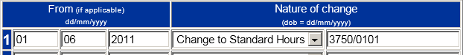

- Scroll down the page and select ‘Submit’

Error 0109 – Incorrect capacity for a locum

Overview
Joiner details have been received showing the employment as a ‘locum’ but the capacity code is not 03, 08 or 10.

Only medical or dental employments can be recorded as locum posts.

Capacity Code | Employment Type | WT/PT  Indicator | Locum | As & When | If PT  Sessions or hours?
01 | Officer | PT or WT | No | No | Hours
02 | Officer | PT or WT | No | No | Hours
03 | Non-spec, or | PT or WT | Yes or No | Yes or No | Either
03 | Specialist | PT or WT | Yes or No | Yes or No | Either
08
08 | Specialist, or | MPT | Yes or No | No | Sessions
10
10 | Bed Fund | Leave as | Leave as | Leave as | Leave as
 | Bed Fund | ‘select’ | ‘select’ | ‘select’ | ‘select’
04 | Officer | PT or WT | No | No | Hours
05 | Officer | PT or WT | No | No | Hours

Action you need to take
Check whether the employment is medical or dental – if not then the locum indicator should be ‘no’.

If it is medical or dental then the capacity code on the joiner should be amended accordingly.

- Access the error.
- Select ‘Amend and/or resubmit’
- Select ‘Continue to form’
- Enter the correct capacity code or change the locum indicator to ‘no’, whichever is relevant
- Scroll down the page and select ‘Submit’

Error 0111 – Capacity clashes with employment type

Overview
Joiner details have been submitted where there is a mismatch between the capacity code and the employment type.

These fields are also validated against the wt/pt, locum and As & When fields.

For example, if this indicator states maximum part time for a capacity code 03 then the employment type must be ‘specialist’.

If you enter mismatching data you will receive onscreen error messages and must amend the data before being able to re-submit the error for processing. Matching capacity codes and employment types are:

Capacity Code | Employment Type | WT/PT  Indicator | Locum | As & When | If PT  Sessions or hours?
01 | Officer | PT or WT | No | No | Hours
02 | Officer | PT or WT | No | No | Hours
03 | Non-spec, or | PT or WT | Yes or No | Yes or No | Either
03 | Specialist | PT or WT | Yes or No | Yes or No | Either
08
08 | Specialist, or | MPT | Yes or No | No | Sessions
10
10 | Bed Fund | Leave as | Leave as | Leave as | Leave as ‘select’
 | Bed Fund | ‘select’ | ‘select’ | ‘select’ | Leave as ‘select’
04 | Officer | PT or WT | No | No | Hours
05 | Officer | PT or WT | No | No | Hours

Action you need to take

- Access the error.
- Select ‘Amend and/or resubmit’
- Select ‘Continue to form’
- Amend the capacity code and/or the employment type
- Scroll down the page and select ‘Submit’

Error 0113 – Incorrect data entered for a Bed Fund appointment

Overview
If the employment is correctly a Bed Fund appointment there must not be any entries in the following joiner fields:

- As & when indicator
- Locum Indicator
- WT/PT Indicator
- Actual or Standard Hours or Sessions

Action you need to take
- Access the error.
- Select ‘Amend and/or resubmit’
- Select ‘Continue to form’

If the employment is correctly a Bed Fund:
- Remove any entries for boxes 17 - 21
- Scroll down the page and select ‘Submit’

If the employment is not a Bed Fund:
- Amend the employment type
- Review any entries in boxes 15 - 21 to match
- Scroll down the page and select ‘Submit’

Capacity Code | Employment Type | WT/PT  Indicator | Locum | As & When | If PT  Sessions or hours?
01 | Officer | PT or WT | No | No | Hours
02 | Officer | PT or WT | No | No | Hours
03 | Non-spec, or | PT or WT | Yes or No | Yes or No | Either
03 | Specialist | PT or WT | Yes or No | Yes or No | Either
08
08 | Specialist, or | MPT | Yes or No | No | Sessions
10
10 | Bed Fund | Leave as | Leave as | Leave as | Leave as
 | Bed Fund | ‘select’ | ‘select’ | ‘select’ | ‘select’
04 | Officer | PT or WT | No | No | Hours
05 | Officer | PT or WT | No | No | Hours

Error 0114 – There should not be an entry in WT/PT for emp types 5 or 6

Overview
If the employment is correctly an assistant or principal practitioner appointment there must not be any entries in the following joiner fields:

- As & when indicator
- Locum Indicator
- WT/PT Indicator
- Actual or Standard Hours or Sessions

Action you need to take
- Access the error.
- Select ‘Amend and/or resubmit’
- Select ‘Continue to form’

If the employment is correctly a practitioner post
- Remove any entries for boxes 17 - 21
- Scroll down the page and select ‘Submit’

If the employment is not a practitioner post:
- Amend the employment type
- Review any entries in boxes 15 - 21 to match
- Scroll down the page and select ‘Submit’

Capacity Code | Employment Type | WT/PT  Indicator | Locum | As & When | If PT  Sessions or hours?
01 | Officer | PT or WT | No | No | Hours
02 | Officer | PT or WT | No | No | Hours
03 | Non-spec, or | PT or WT | Yes or No | Yes or No | Either
03 | Specialist | PT or WT | Yes or No | Yes or No | Either
08
08 | Specialist, or | MPT | Yes or No | No | Sessions
10
10 | Bed Fund | Leave as | Leave as | Leave as | Leave as ‘select’
 | Bed Fund | ‘select’ | ‘select’ | ‘select’ | Leave as ‘select’
04 | Officer | PT or WT | No | No | Hours
05 | Officer | PT or WT | No | No | Hours

Error 0137 – Total disallowed days exceed service covered by input

Overview
Annual update or leaver information has been submitted and the number of disallowed days exceeds the number of calendar length days for the period.

Or

An SD55E has been submitted either amending the amount of disallowed days or amending the date of termination of the employment to an earlier date resulting in the original disallowed days submitted being greater than the number of calendar length days in the revised period.

The calendar length days are calculated from 1st April to 31st March or from the employment start date if later than 1st April or to the employment end if earlier than 31st March.

The number of disallowed days reported can be less than or equal to the calculated calendar length days but cannot be more than.

Where the member has accumulated less than a full day of unauthorised absences, for whatever reason, this should not be recorded as a disallowed day.

ESR users – it is understood that ESR counts any unauthorised absence as a full day, even if it is only 1 hour. Where this applies you should reduce the number of disallowed days accordingly and where this accumulates to less than 1 full day it should not be recorded as a disallowed day for pension purposes.

Example:
Leaver form received for year end 2012 with a date of termination = 21.04.2012

The calendar length days = 21 but disallowed days of 23 have been reported on the same form – Error 0137 would be produced.
Note: Disallowed days should be notified for both part time and whole time employments but are only deducted from reckonable membership for whole time employments. However they are deducted from the qualifying membership for both whole time and part time employees.

Action you should take
- Access the error.
- Select ‘Amend and/or resubmit’
- Select ‘Continue to form’
- Correct the number of disallowed days or the date of leaving if this is incorrect
- Scroll down the page and select ‘Submit’

Error 0147 – RFT – (Reason for Termination) 13 shown but not Assistant Practitioner

Overview
This is produced when a leaver form has been received with a reason for termination of 13 (Asst. Pract. (contracted out of GPS) becomes Principal) and the corresponding employment type is not an Assistant Practitioner

Action you should take
- Confirm the Employment and termination details are correct
- If the details are correct i.e. the member is not an Assistant Practitioner, amend the exit code accordingly.
- Resubmit the error.

If the employment details are incorrect and the member record needs amending to show them as an Assistant Practitioner:
- Re-allocate the error back to The NHSBSA and notify them of the changes that need to be made in the comments box.

Example where response required
This member was working as an Assistant Practitioner for the duration of this post. Please amend all employment details to reflect Assistant Practitioner status, (Cap code 03 and Employment type 06)

Error 0154 – DOB on input not verified and different to DOB in MR

Overview
A form has been submitted to change the Date of Birth and/or the verification indicator but the DOB on the input is unverified and different to the DOB held at The NHSBSA.

Action you should take
- Confirm that both the change and the date are both genuine and correct.
- If incorrect, the change can be either deleted or amended before resubmitting.
- If the change is correct and proof has been seen of the DOB then amend the verification marker to ‘Yes’ and resubmit the error to The NHSBSA with a comment advising them verification has been seen for the new DOB.

To change any data held on the form-

- Amend and/or Re-submit
- Ensure Ni and SD numbers are present
- Continue to SD55G/SD55/SD55T form
- Change entries as appropriate before re-submitting back to the NHSBSA

Example where response required
Please amend the Date Of Birth held on your records as we have obtained the correct, verified date from the member’s birth certificate/passport/driving license etc.

Error 0155 – NI Earnings missing for tax year of termination

Overview
This error is produced where a leaver form is being processed for a member who is contract-out of the State Pension Scheme, and no NI earnings have been provided for the final or preceding tax year. If the employment spans 2 tax years then both errors may be produced.

Action you need to take
Access the error and choose the amend/resubmit option, which will take you to the leaver form. Insert NI earnings in the final tax year (and the penultimate tax year if Error 0156 has been produced). The form should then be submitted for processing to the member record.

- Access the error.
- Select ‘Amend and/or resubmit’
- Select ‘Continue to SD55 form’
- Input the correct NI earnings figures
- Scroll down the page and select ‘Submit’

Exception 0156 – No NI conts for tax year prior to termination
Before taking any action on an error, check that NHSP records have not previously been updated with the information on the form.

Criteria:
This error is produced where a leaver form is being processed for a member who is contract-out of the State Pension Scheme, and no NI earnings have been provided for the preceding tax year.

Applies to forms:
SD55 Termination

Known Causes:
A leaver form is submitted for a member who is contracted-out of the State Pension Scheme, and no NI earnings have been provided for the preceding tax year.

Action to be taken:

Step | Action
1 | Confirm Ni conts are required by ensuring NHSP hold the correct employment details  (Principal Practitioners do not require NI entries)
2 | If Ni conts are not required because NHSP hold incorrect employment details, contact datamanagement@nhsbsa.nhs.uk to make the necessary changes before  resubmitting the error via POL.
3 | If employment details are correct, calculate the correct entry by adding columns 1(b)  and 1 (c) from the member’s P11 form
4 | Add this figure onto the form in error and re-submit, ensuring the final year’s Ni  contributions are entered.

NI earnings (tax year 06 April to 05 April)
Where the employment spans only 1 tax year only the final years NI earnings are required. Where the employment spans 2 tax years both years NI earnings are required.

Principal Practitioner - You should not complete these boxes. This will be validated and you will receive an on-screen message asking you to remove an incorrect entry.

Date Created/updated (Exc 0156) | 16/07/2019

Exception 0163- Yearly conts Hrs-Sess outside period of employment
Before taking action on an error, check that NHS Pensions records have not already been updated with relevant information, you can check this by utilising the SD55E function and the ADP4.

Criteria:
- An SD55E amendment form with revised yearly hours, pay/contributions or date of termination has been submitted and falls outside the period of employment.
- A cyclic or termination form has been received for a financial year that does not fall within the period of employment.

Applies to forms:
SD55 cyclic and termination, SD55E amend employment details.

Known Causes:

- SD55E has been submitted with a revised termination date that falls in the previous financial year.
- ESR generated SD55E, cyclic or termination form incorrectly matches to different employment ID with the same employer, such as an earlier bank period.
- SD55E amendment has been submitted for an employment that has been included in an Award. The amendment incorrectly refers to a period outside the employment dates, usually the following financial year. However, normally the adjustment is for the closing period and should be allocated to the final financial year.
- SD55 or termination has been submitted for an employment but the post has been rewound and or terminated prior to the date on the form prior to but on the same day as the initial form was processed.

Note: There is a separate procedure for the 0163 error when benefits have been paid, which is detailed after the standard procedure below.

Action to be taken:

Form SD55E (member not retired)
Step | Action
1 | Check if the SD55E shows a revised end date.
1.1 | If the employment has been terminated with an incorrect end date that falls within a different financial year, open the employment using the POL open/rewind form.  Once the employment has been re-opened, submit the revised details on form SD55/SD55 termination and delete the SD55E 0163 error from error handling.
2 | If there is no revised end date on the form, check the figures currently held for the ID in question.
2.1 | If identical figures to those on the form can be found on the member’s record, the error can be deleted giving a valid reason in the box provided.
2.2 | If no matching contributions can be found, check which employment the revised figures are for and which employment ID this is held under on NHS Pensions  records.
2.2.1 | If the employment should not have been terminated, open the employment via POL open/rewind form and submit a new SD55.
2.2.2 | If the revised figures are for a different employment ID or year end, submit a new SD55E on POL under the correct ID and year end.
2.2.3 | If the contributions are for an employment which is not currently on the record, submit an SS10 and then submit new updates for the new employment.
3 | In all cases please delete the 0163 error from error handling once the record has been amended as required.

SD55 cyclic and termination forms
Step | Action
1 | Check the member’s record to establish if the supplied figures are already held on record.
2 | If identical figures to those on the update can be found on the member record or if the form does not hold any values, the error can be deleted.
3 | If no matching values are present, confirm which employment the SD55 refers to.
3.1 | If the form relates to an employment not currently on the record, submit a SS10 on POL then re-submit the update with the new employment details, ensuring that there  are no missing years.
3.2 | If the form relates to an employment which was incorrectly terminated, open the  post via POL Open/rewind form and re-submit the form in error handling, ensuring that there are no missing years.
3.3 | If the contributions are for a different year end or ID, submit a new SD55 for the correct year end and ID.
4 | In all cases please delete 0163 error from error handling once the record has been amended as required

SD55e Amending employment details when benefits are in payment.
Step | Action
1 | Determine if the final figures or termination date we hold needs amending.
2 | If the figures on the 0163 error need adding to the final year, or if the date of termination needs revising within the same financial/Tax year, you will need to submit another SD55E form on POL ensuring it matches to the correct employment. Include the current figures that we hold on record and the figures on the amendment for this.  **Please check your amendments have been accepted and complete and send an AW171
3 | If the last day of employment changed to the next financial year, please forward the correct figures for both years along with the revised termination date to datamanagement@nhsbsa.nhs.uk. Once you have received an e-mail back from data management confirming your changes have been made please complete and  send an AW171.
4 | In all cases please delete 0163 error as it is not needed.

Best working practice for employers
Action
As many employer email responses to 0163 queries state that the employment has been terminated early, check to see if an SM14 has ever been received prior to amending an employment end date/re-opening an employment.
If an SM14 form has been received, please do not re-open the employment and submit an SD55c as this will create another 0056 error.
Please ensure that you delete the 0163 error once action has been taken as it will not be needed.

Known Issues
NHS Pension and ESR teams are currently investigating the high number of amendment forms being generated where the SD55E shows 0.00 figures for a year outside the employment period.
Please could you e-mail NHS Pensions at datamanagement@nhsbsa.nhs.uk with any examples you receive of these errors and think that a cause has been identified.

Exception 0173- Yearly hours/sessions not required
Before taking action on an error, check that NHSP records have not already been updated with the information on the form.

Criteria:
A form has been submitted with an entry for actual yearly hours/sessions worked, however, the employment is showing as whole time.

Applies to forms:
SD55 cyclic and termination, SD55E Amend employment details

Known causes:
- There has been a retrospective change to part time. NHSP have either not been notified of the change, or the change has been received but has not yet been input on the member record.
- Joiner form incorrectly showed employment as whole time.

Action to be taken: Cyclic and termination forms
Step | Action
1 | Determine whether the employment is whole time or part time during the year of  update.
2 | Where NHSP records are correct and the employment is whole time throughout the year in question, select ‘Amend and/or resubmit’ in error handling. Next select ‘continue to SD55 form’ and remove the hours/sessions that are entered on the  update. Then resubmit the form.
2.1 | If the employment has been set up incorrectly as whole time from the start date and it is the first year of update, delete the employment and then set up a new joiner with the part time details. Once the joiner has processed (this can be checked on the  ADP4) the form in error handling can be resubmitted.
2.2 | Where the employment changed to part time during the year of update, input the change details on the form that is in error.  To do this, select ‘Amend and/or re-submit’ and then ‘continue to form’. Scroll to the bottom of the SD55 or SD55T form, where there is a change box. Input the correct details in the change box (guidance for this can be found on the form) and then  resubmit.
2.3 | Where the employment changed to part time during a previous year, first rewind the employment to the year that falls prior to the year with the change. For example, if the change was in YE2017, the employment will need to be rewound to 31/03/2016. The YE2017 details can then be re-input, including the change to part time. Then  resubmit any later updates held in error handling.

Action to be taken: SD55E forms
Step | Action
1 | Determine whether the employment is correctly whole time or part time during the  year of amendment.
1.2 | If the employment is correctly held as whole time throughout the year in question, remove the hours/sessions that were entered on the update and then resubmit the  form.
1.3 | If the employment changed to part time during the year of amendment or in a previous year, the employment needs to be rewound prior to the year with the change. For example, if the change was in YE2017, the employment will need to be rewound to 31/03/2016. The YE details, including the change to part time, should then be re-input. Any missing updates should then be input via form SD55 or 55T.  The SD55E in error handling can then be deleted.

Best working practice for employers
Action
Ensure that your records show the correct whole time/part time status for the employment in question.
Rewinding and deleting employments must be done on POL, if you have access. Please be aware that when rewinding or deleting, data held by NHSP is deleted and you will need to re
input figures for all relevant periods.

Known Issues
Exc. 0173 is at times incorrectly generated as a change to PT has not been recognised.
If you believe that this is the case on a 0173 reported in error handling, please advise NHSP by reallocating the error to us advising that the change is held as the member is shown as PT on the ADP4.

Date Created/updated (Exc 0173) | 16/07/2019

Exception 0186- No Emp found matching Emp ID-EA Code or DOC-DOT
Before taking action on an error, check that NHSP records have not already been updated with the information on the form.

Criteria:
A form has been submitted and there is no match with NHS Pensions’ records on one or more of the following:-

ESR forms:
- ESR assignment number ( if not a unique match, exception 0187 will be generated)
- EA Code
- Date of Commencement
- Valid update year on form
- Form end date (SD55E amendment only)

POL forms:
- Employer selects relevant employment ID therefore 0186 should not be generated through POL submissions.

Applies to forms:
SD55 cyclic and termination, SD55E Amend employment details, deletion and open/rewind.

Known causes:
a mismatch of employment details or the joiner form details are not held on record with NHS Pensions. This could be for one of the following reasons:

- The joiner form is in either Employer or NHS Pensions Error Handling.
- The joiner form has not yet been submitted.
- The joiner form has been deleted as the member opted out/received a local refund.
- The joiner form was for a re-employed pensioner who was not eligible to re-join the Scheme, and so has been rejected (this can be viewed in POL notifications).
- The joiner form has been deleted by NHS Pensions due to overlapping employments.

Action to be taken: Cyclic, termination and SD55E amendment forms

Employment is showing on ADP4
Step | Action
1 | Check the ADP4 form to check whether or not the joiner details are held by NHS Pensions.  Note: if there has been an EA merge or if you administer more than one EA code  then check the ADP4 under any possible codes.
1.2 | If the employment details are showing on the ADP4, firstly identify the cause of the mismatch (listed under criteria section above). The correct details then need to be confirmed.  Note: the NHSP record start/end date may have been amended due to overlapping employments. If this is the case, your records need to be amended  (see 1.3) in order to prevent future 0186 errors.
1.3 | Where the details on the form in error are incorrect, amend them by selecting ‘Amend and/or resubmit’ on the first page of the error. Change the relevant fields, then select ‘continue to form’ and submit.  A check should be made to ensure that there are no missing updates prior to  resubmitting the form.
1.4 | Where the details that NHSP hold are incorrect, re-allocate the error to NHSP via employer error handling/employer comments. Provide NHSP with full details of what amendments are required.  See ‘Best practice for employers’ below for suggested employer comment template.  NHSP will amend the record and process the 0186, providing that there are no missing year end updates.

Employment is not showing on ADP4/record not been set up
1 | If the employment details are not showing on the ADP4 and the member is a re- employed pensioner, check the ‘re-employed pensioner rejections’ on POL to confirm whether or not the member is eligible to re-join the scheme. If the joiner has been rejected, check the reason why and take appropriate action to update relevant payroll records and refund any contributions. Delete any updates from  error handling that relate to the rejected joiner.
2 | If the member is not a re-employed pensioner, check Employer Error Handling (SS10 or SS14). Where the joiner is in error, resolve any data issues (refer to joiner error procedure note if necessary) and resubmit the joiner.  Once the joiner has processed (appears on ADP4 the following day or in POL forms on the same day) resubmit the 0186 and any other outstanding updates, ensuring that they are in order of year.
3 | If the joiner is not held in Employer errors, view NHS Pensions Error Handling (SS10 or SS14). Where the joiner is in error, re-allocate the 0186 to NHSP via employer error handling/employer comments advising of the joiner error code and any additional information NHSP will need to clear the joiner error (see ‘Best practice for employers’ below for suggested employer comment template).  Check the relevant guide for the joiner error if you are unsure.

Employment not on ADP4 and joiner not rejected/ in Error Handling
1 | Where no employment match is found on the ADP4 and the joiner is not held in  error handling, submit a new joiner form if the employment was pensionable.
1.1 | Check POL forms to ensure that the joiner has successfully processed. If so, 0186 cyclic and termination forms can be resubmitted in order, ensuring first that there is no missing YE updates (it may be necessary to check error handling for any other outstanding errors).  If the 0186 is an SD55E form, correct figures and end dates may need to be  checked and input via POL.
2 | If the employment was not pensionable as the member opted out in the first period, delete any other forms from error handling that relate to the employment. Check that payroll records have been amended to show that the period of  employment is not pensionable.
3 | If the employment was not pensionable at all due to an overlap (member employed in concurrent whole time post), delete any updates from error handling that relate to the employment. Check that payroll records have been amended to  show that the period of employment is not pensionable.

Action to be taken: Deletion forms
4 | Check whether the joiner form is in employer error handling. If the joiner is in error but no contributions were paid in the employment, delete the joiner details.  NHSP will review and clear the 0186 error.

Action to be taken: Open/rewind forms
5 | NHSP will review and clear the 0186 error.

Best working practice for employers
Action
- When resubmitting cyclic or termination forms, please ensure that there are no earlier, missing year end updates, as error 0421 will occur.
- Where employment details are amended, ensure that ESR or relevant payroll records have been updated to reflect the change.
- Where an overlap notification is received, ensure that ESR or relevant payroll records have been amended to show not pensionable or revised start/end dates. This will prevent future 0186s.
- Make regular checks for re-employed pensioner notifications, and delete any 0186s where member is not eligible to re-join the scheme.
- When submitting more than one form for an employment e.g. a cyclic and a termination, allow time for the first form to process before moving onto the next.
- When allocating an error to NHSP via employer comments, ensure all information required to clear the error is provided. If the information is not provided, NHSP will reprocess the 0186 error without amendments and this will be allocated back to you.
Suggested employer comment template:

‘Joiner form is in error and allocated to NHSP. Please take relevant action to update the member record.
The joiner error is (insert joiner error code) and the information required to clear this error is
(please insert information)’.

Known Issues
Deletions - if joiner has been rejected, e.g. re-employed pensioner, ESR will still send a deletion notification. As employment has already been deleted from NHSP records, the second deletion causes error 0186.

Date Created/updated (Exc 0186) | 16/07/2019

Error 0187 – More than one employment for EA Code and DOC

Overview
Where an annual update or termination form is received and a match can be found to more than one existing employment on the EA Code or Date of Commencement and the employment ID is missing on the update. The system cannot determine which employment the update belongs to without the Employment ID.

Action you should take
- Check the ADP4 link to see which employment matches the form in error. This can be done by checking the EA reference/Assignment number.
- Access the error
- Select ‘Amend and/or resubmit’
- Insert the Emp ID
- Select ‘continue to form’
- Select ‘submit’

Exception 0188- Input for employment that has already been closed
Before taking action on an error, check that NHSP records have not already been updated with the information on the form.

Criteria:
An SD55 update or termination form has been submitted for an employment that has already been updated and closed.

Forms affected:
SD55 cyclic and termination.

Known causes:
Can occur when a leaver has successfully processed via Pensions Online and then a cyclic for the final year is received via ESR.

Action to be taken:
Step | Action
1 | 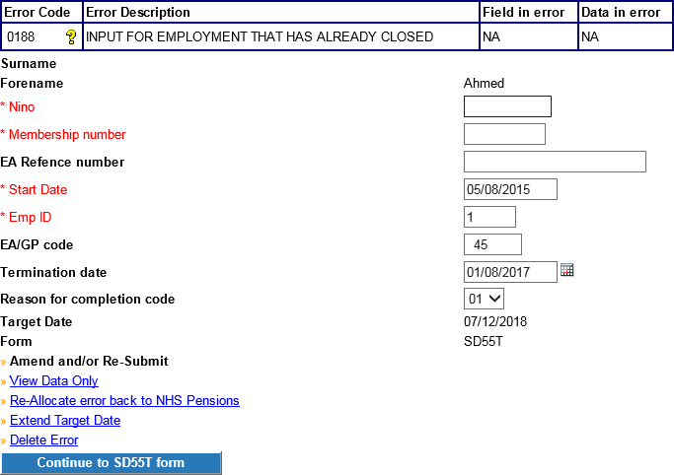  In error handling, check the start date and employment ID on the front page of the 0188 error. If there is a mismatch between these and the actual employment details, amend by selecting ‘Amend and/or resubmit’ and then changing the relevant fields (below). Then continue to form (at bottom of page) and resubmit the update.
1.1 | Where a start date has been amended, ensure that a matching start date is also  held in ESR so that future errors are prevented.
2 | Where the employment ID and start date are correct then check the details already held by NHS Pensions. To do this, access the SD55E forms in POL and input the members’ NI number or SD. Then select the employment ID that relates to the  0188 error.
2.1 | You will see the termination date that is currently held for that employment.  If the date of termination held is incorrect, but is in the same financial year, enter the correct date in the ‘Revised date of termination’ field:  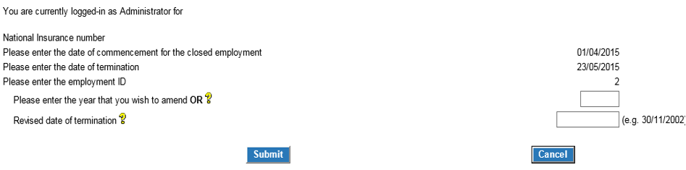  Then select submit, scroll to bottom of next page and submit form. The 0188 error can be deleted.
2.2 | If the date of termination held is incorrect, but is in a different financial year, rewind the employment to the year before the year of termination. Then submit a  termination form. The 0188 error can be deleted.
2.3 | Where the termination date is correct you can also check the contributions and earnings, by entering the relevant year in the ‘year that you wish to amend’ field and selecting submit. If the correct details are held by NHSP, select cancel to exit  the SD55E. Then delete the 0188 from error handling.
2.4 | If the conts/pay are incorrect, enter the revised amounts in the right hand side column on the SD55E and select submit. Once the form has processed, the member record will be updated with the correct information and the 0188 error can  be deleted from error handling.
3 | If the employment has been closed in error an open/rewind needs to be submitted on POL. Once the employment has been reopened, the cyclic update that is in error handling can be resubmitted (ensuring that any missing year end updates have  also been completed).
4 | If none of the above applies, re-allocate the error to NHSP for further information. You must confirm that none of the scenarios above apply and provide information  for NHSP to clear the error.

Best working practice for employers
Action
Ensure that when allocating the error to NHSP you provide the information needed to clear the error. If you do not provide the information NHSP will reprocess the error and it will be allocated back to you.

Date Created/updated (Exc 0188) | 16/07/2019

Error 0196 – Date of change is prior to DOC (Date of Commencement)

Overview
A change has been received on an SD55 update/SD55 termination form, but the date the change is for is prior to the DOC of the employment, and there is not a change to the DOC present as well.

Action you should take
- Check the date of change and the employment details to ensure that the correct date has been supplied and that it is being applied to the correct post.
- If any changes to the form are necessary, click ‘Amend and/or resubmit’ to take you to the form, and then continue to SD55 form.
- Here you can amend/remove the change or request a change to the DOC if required as well as the employment details.
- Once altered the form can be resubmitted to The NHSBSA.

Note: If you are inserting a change to P/T you must also insert the annual p/t hours or sessions worked at the same time for the all of the p/t period (split at financial year ends).
If you are inserting a change in standard hours you must amend the yearly hours to show a split in the annual hours on the date of change in the ‘Hours in year to date of change’ so the total yearly hours are spilt pre and post the change date.

Error 0401 – Contribution rate invalid

Overview
This error is created when the amount of employees contributions paid are not equal to the contribution rate shown on the form (with a £10 tolerance either side).

Action you should take
Check that the employees pay, employees’ contribution figures are correct and that the contribution rate shown is correct for the level of salary. Details of the tiered contributions rates are published on the NHSBSA Website. If any of the contributions or pay figures are incorrect they should be amended within the form and resubmitted for processing as follows:

- Select ‘Amend and/or Resubmit’
- Select ‘Continue to form’
- Amend the contributions, pay and/or contribution rate
- Select ‘Submit’

Alternatively, if the information is correct and the contributions are either: low because arrears are going to be collected at a later date or; high because arrears have been collected from an earlier year or previous employment elsewhere; then select ‘submit ‘without making any changes and this will produce a checkbox alongside the employees’ contributions field. Tick the checkbox on the form and then select ‘submit again’ you will be asked to confirm your entry again:
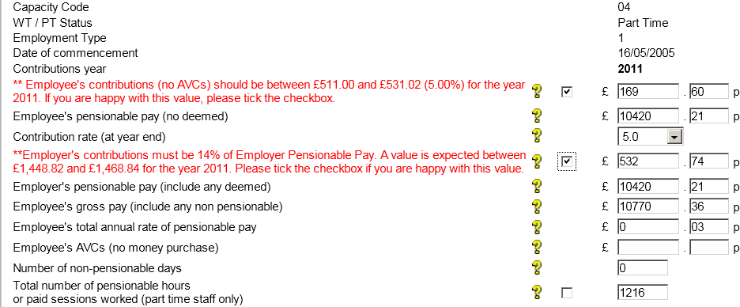
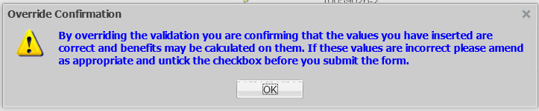

Note: By clicking ‘ok’ and overriding this validation you are confirming the details you have entered are correct and can be used for the calculation of benefits.

Error 0401 – Contribution rate invalid

Overview
This error is created when a contribution rate other than a valid contribution is entered after 1st April 2008.

Where a rate is mandatory but has not been entered Error 0420 will be produced.

Action you should take
- Access the error in the normal way and select ‘Amend and/or Resubmit’
- Select ‘continue to SD55 form’
- Amend/Enter the contribution rate
- Select ‘submit’ at the bottom of the form.

Note: If the contributions paid do not match the contribution rate entered you will receive an onscreen error message advising you to check the data entered. Make the same check as you would for error 0400 and either amend the incorrect data or tick the checkbox if the information is correct due to arrears of contributions being collected.

Error 0402 – Contribution rate must be 5% for capacity code 5 or 7

Overview
This error is generated when the contribution rate is other than 5% when the employment is Capacity Code is 5 or 7. Irrelevant of the rate of pay the member is receiving. It is only generated for contributions paid between 1 April 2008 and 31 March 2009 and is not produced when the scheme code is ‘2008’ as this rule only applies to existing manual members of the 1995 Section (Scheme Code = NHS)

Action you should take
Check if the employee is a manual worker that would be shown as capacity code 5 or 7 when the employment started.

If they are not then it is possible that an incorrect capacity code was entered on the joiner details and this would need changing on the NHSBSA database before this error can be resolved.

Contact The NHSBSA asking for the capacity code to be amended from the employment start date – advising which capacity code should be used. Ask them to confirm when this has been done.
Then access the error in the normal way and select ‘Amend and/or Resubmit’, continue to the form and then select ‘submit’ without making any changes.

If the member is correctly a manual grade then check the contribution rate entered on the cyclic update/leaver form as contributions may have been deducted at an incorrect rate. Amend the rate and the employees’ contributions and pay details, if necessary, and resubmit the form for processing.

If contributions have been either under or over deducted this should also be rectified so the correct amount is paid.

Error 0403 – Mid Year contribution rate changes invalid

Overview
Where mid-year changes to the contribution rate have been received and the information is not valid. One of the following reasons will be displayed on the error:

- 'Date of change start date must be entered.'
- ‘Change start and end dates must be in order without breaks.'
- 'Details from start of update period also need entering.'
- 'End dates must be completed except for the latest change.'
- 'Scheme contributions and Total Pensionable Pay (TPP) details must also be entered.'
- 'A change start or end date cannot be later than the form end date/dot.'
- 'The latest change to contribution rate must match that shown in the year end information above'
- 'This is a 2 year update therefore conts rate details to 31/03/yy and from 01/04/yy are required.'
- 'No mid year conts for existing contrate year'
- 'Mid year conts cannot be before 01/04/2009

Action you should take
Obtain the correct information and then access the error in the normal way. Choose ‘Amend/Resubmit’ and then ‘continue to form’. Amend the incorrect information and resubmit the form.

Note: The contribution rate shown for the financial year end on the main part of the cyclic update/leaver form should be the rate in force at the end of the financial year/Leaving date. The mid-year contribution rate changes should therefore show the same rate at the end of the changes. In addition the totals of pay and contributions shown in the mid-year changes box should equal the amounts shown for the update year in the main part of the form.

For further information please see the guides for SD55 Update/Leaver (Guides 18 & 19)

Exception 0410 – EST Update cannot be processed – initial update was not ESR
Before taking action on an error, check that NHSP records have not already been updated with the information on the form.

Criteria:
NHSP member record has been updated but not via ESR. An SD55E with revised figures has then been sent via ESR.

For POL employers and where there are no other error/comments present on the same form, exception 0410 will be allocated to Employer Error Handling.

For non-POL registered employers or where there is a further exception/ comment on the same form, exception 0410 will be allocated to NHSP.

Applies to forms:
SD55E Amend employment details

Known causes:
Employment has been manually terminated with projected benefits via POL in advance of retirement.
When the correct figures are known, ESR sends through an SD55E to revise the values already held at NHSP. The form is stopped on receipt to enable the employer to verify the correct details.

Action to be taken:

Step | Action
1 | Confirm the correct contributions for the relevant year.
2 | Check what NHSP hold by accessing POL form SD55E for the corresponding year end and comparing the left hand column with what you hold.
3 | Where the contributions held on the error form are correct, enter the revised figures  on the SD55E and submit. The error 0410 can then be deleted.
4 | Should neither hold the correct values, enter the revised figures on the SD55E form  and submit. The error 0410 can then be deleted.
5 | Where the contributions held by NHSP are correct the error can be deleted.

Date Created/updated (Exc 0410) | 16/07/2019

Error 0415 – Missing Additional Pension (AP) contributions

Overview
This error is produced when cyclic update or leaver information is submitted without any additional pension contributions and the member has an open AP contract. Even payment of AP contributions is optional, if a contract is in place the annual update or leaver information should still be completed with the AP contract number with the instalment and contribution fields left blank.

If none of the AP fields are completed and there is an open contract this error will be produced. Likewise if the AP contract number and the instalment field is completed but the AP contribution field isn’t; this error will be produced.

On some ESR updates the AP contract ID has incorrectly been populated with the employment ID. To avoid errors being created in the future you will need to correct the ESR system with the correct AP contract ID.

Action to take
Check whether AP contributions were paid and re-process the error as follows:

AP conts have been paid:
- Select ‘Amend and/or Resubmit’
- Select ‘Continue to form’
- Insert the AP contributions, number of instalments and AP contract ID (not the Employment ID)
- Select ‘Submit’

No AP contributions have been paid
- Select ‘Amend and/or Resubmit’
- Select ‘Continue to form’
- Insert the AP contract number but leave the instalment and AP contribution fields blank.
- Select ‘Submit’

Exception 0420 – Earnings, contributions and/or worked hours appear low
Before taking any action on an error, check that NHSP records have not previously been updated with the information on the form.

Criteria:
This is produced when entries for earnings, contributions and/or annual hours/sessions are missing or appear low. It is also produced where a contribution rate is mandatory but is missing from the update form.

Applies to forms:
SD55 cyclic and termination, SD55E Amend employment details.

Action to be taken (all form types)
Step | Action
1 | View the first page of the error to determine which entry appears low or is missing. This is shown in the ‘field in error’ column. The value that has been entered is shown in the ‘data in error’ column.  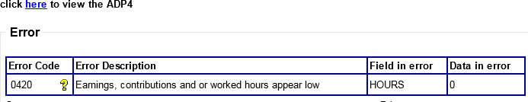

Pay/contributions low or missing
Step | Action
1 | If the contribution rate on the form is missing or incorrect, calculate the correct value. To amend the rate on the form, select ‘Amend and/or Re-submit’ and then Continue to form (at bottom of page). Amend the contribution rate field and re-  submit the form.
2 | If the contribution rate is correct and the contributions or pay are genuinely low, select ‘Amend and/ or Re-submit’ in error handling. Then continue to the form (at bottom of page). Submit the form without amending any details and a check box will  appear so that the 0420 validation can be overridden.
2.1 | Input a comment in the check box to explain why the contributions or pay are low  and re-submit the form.

Annual hours/sessions worked low or missing
Step | Action
1 | If the employment is part time but the hours are genuinely low, select ‘Amend and/ or Re-submit’ in error handling. Then continue to the form (at bottom of page).  Submit the form without amending the hours and a check box will appear so that the  validation can be overridden.
1.1 | Input a comment in the check box that verifies the low hours.
2 | If hours/sessions are being requested but the employment is whole time, a change  to whole time needs to be entered.
2.1 | If the change is within the same financial year as the form in error then it can be entered in the change area at the bottom of the SD55. The form will then process  once re-submitted.
2.2 | If the change occurred within the previous 2 financial years, you will need to rewind the record and re-input each cyclic year end including the change and any associated values e.g. hours. If the change occurred more than 2 years ago, you can contact NHSP to input the change on the record. Add an employer comment to the error, with the change date, part time fraction and the hours/sessions worked for each year between the change and the period in error before reallocating to NHSP  who can then update the record.

Additional Voluntary Contributions (AVC) details low or missing
Step | Action
1 | Where details of the AVC contract are held the figure has been provided for the  relevant year, then enter this on the form and re-submit.
2 | Where details of the AVC contract are held but a figure has not been provided for  the relevant year, determine whether or not AVCs / APs were paid. If paid, enter the figures on the form and re-submit.
2.1 | If there are arrears of AVCs on an SD55 cyclic, enter 00.03 in the AVC field. Upon submission of the form, an override checkbox appears. Please provide details of the arrears and make arrangements for them to be collected.  Additionally, on the SD55 termination form, the amount of arrears can be entered in  the Arrears of AVC’s field (under NI earnings).
3 | Where the 0420 error has been produced and no details are held of an open AVC contract then contact NHSP and ask them to investigate why AVC contributions are being requested. This can be done by adding an employer comment to the error and  reallocating to NHSP.

Best working practice for employers
Action
Note to employer - ‘Please ensure that all comments supplied when overriding validations due the figures appearing low are specific enough to explain the low figure/s. Please also be aware these comments are retained by NHSP and may be provided to the member upon request’

Date Created/updated (Exc 0420) | 16/07/2019

Exception 0421- SD55 received: Member record not updated for previous year
Before taking any action on an error, check that NHSP records have not previously been updated with the information on the form.

Criteria:
A cyclic update or leaver form has been submitted and the member record is not updated for the previous year(s).
The latest year to which the employment has been updated is displayed on the first page in error handling, in the ‘data in error’ column.

Applies to forms:
SD55 cyclic and termination.

Known causes:
- Previous year update has not been submitted or received.
- Previous year update is held in either employer or NHSP error handling.

Action to be taken:
Step | Action
1 | 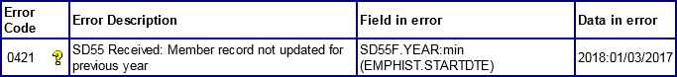  Determine which year the employment has been updated to by viewing the first page of the 0421 error and the ‘data in error’ column.  NB: Start date will be shown where the employment has not been updated as in the above example.
2 | Check whether the missing updates are held in error handling (either in Employer  allocated errors or errors allocated to NHS Pensions).
2.1 | Employer allocated Errors: put the SD55 errors in either SD or NI order and check to see whether or not there is a missing update for the relevant member. All errors for the relevant employment should be resolved and resubmitted. Once all missing years  have processed, the 0421 error can be resubmitted.
2.2 | Errors allocated to NHS Pensions: put the SD55 errors in either SD or NI order and check to see whether or not there is a missing update for the relevant member.  Contact NHSP with any relevant information needed to clear the error. This can be  done by adding an employer comment to the 0421 and reallocating to NHSP.
3 | Where there are no missing updates in error handling, complete an SD55 update for  each missing year and then resubmit the 0421 error.

Best working practice for employers
Action
Action can be taken to prevent year end updates from falling out as an error 0421. In February/March, check the ADP4 form to ensure that all active employments are updated to the current year end. Check error handling for any ‘missing’ updates. Contact data management for assistance if you are unable to update the record yourself.
Ensure that when allocating the error to NHSP you provide the information needed to clear the error. If you do not provide the information NHSP will reprocess the error and it will be
allocated back to you.

Known Issues
Where the ADP4 shows that the previous year is updated, but error 0421 is still being generated after the error has been resubmitted, please refer to NHS Pensions as there may be
a corruption on the member record.

Date Created/updated (Exc 0421) | 16/07/2019

Error 0430 – Joiner start date is later than EA closed date

Overview
A joiner/update/leaver has been submitted where the start date/date of leaving is after the EA closed date. The EA closed date held by The NHSBSA will be the actual date the EA closed plus 30 days to allow for leaver forms to be submitted with outstanding annual leave that has extended the date of leaving.

Action to take
Check that the correct start date has been entered and if it is incorrect, amend on the 1st page of the error and then select ‘continue to SD55Tform’ scroll down to the bottom of the form and select ‘submit.’
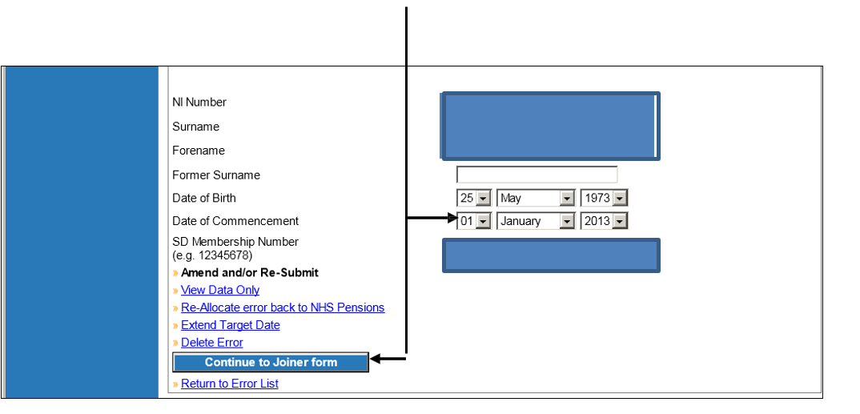

If you administer Pensions for more than one employer then check that you have submitted the joiner with the correct EA Code. If it is incorrect then delete the error, log into Pensions Online under the correct EA Code and submit the joiner again.

Otherwise, if you disagree that the EA has been closed, or the start date you have entered is before the date the EA closed, then it is possible an error has been made at The NHSBSA and you should email the Data Management Team at
datamanagement@nhsbsa.nhs.uk to query this.

To avoid the error being escalated to the next level whilst you are waiting for a response from The NHSBSA you should extend the target date on the error and place a suitable comment in the box to explain why the target date has been extended.

When The NHSBSA have confirmed the EA Closed Date has been amended or removed you should then be able to reprocess the error without making any changes.

Exception 0431- Changed end date is later than EA closed date
Before taking action on an error, check that NHSP records have not already been updated with the information on the form.

Criteria:
A cyclic update or leaver form has been submitted but the cyclic update date or date of leaving is after the EA closed date held at NHSP.
The EA closed date held by NHS Pensions will be the actual date the EA closed plus 30 days to allow for leaver forms to be submitted with outstanding annual leave that has extended the date of leaving of the member.

Applies to forms:
SD55 cyclic and SD55 Termination

Known causes:
When an employer closes down and ceases to operate, NHSP will close the employer’s EA record as described above in order to restrict any further administration on that code.

Action to be taken:
Step | Action
1 | Check if the employment is still continuing under the EA Code provided.
1.1 | If the employment moved to a new Employer Code you need to submit a change to the member’s EA Code via the ADP4 in E-Forms.
1.2 | Once the EA code has been changed, amend the EA Code on the first page of the  error to match the new employer code and select ‘continue to form’. Resubmit the error for re-processing.
2 | For leavers you should also check that the Date of Leaving (DOT) is correct on the error. If the DOT is incorrect your only action is to amend this on the first page of the error and select ‘continue to SD55T form’ scroll down to the bottom of the form and  select ‘submit’.
3 | If the EA record should not have been closed at the date held be NHSP, you should re-allocate the error to NHSP via employer comments. The comment needs to confirm  the correct closing date.
5 | To avoid the error being escalated to the next level whilst you are waiting for a  response from NHS Pensions you should extend the target date on the error and place a suitable comment in the box to explain why the target date has been extended.
6 | When NHSP have amended or removed the EA Closed Date they will resubmit the  error.

Best working practice for employers
Action
Ensure all member forms are submitted prior to the Ea closing date where possible.

Date Created/updated | 16/07/2019

Error 0432 – Changed End Date is later than the EA closed date

Overview
An SD55E has been submitted with a revised date of leaving that is after the EA closed date. The EA closed date held by The NHSBSA will be the actual date the EA closed plus 30 days to allow for leaver forms to be submitted with outstanding annual leave that has extended the date of leaving.

Action to take
Check that the Date of Leaving (DOT) is correct and no errors have been made. If the DOT is incorrect then your only action is to amend on the 1st page of the error and then select ‘continue to SD55Eform’ scroll down to the bottom of the form and select ‘submit’.
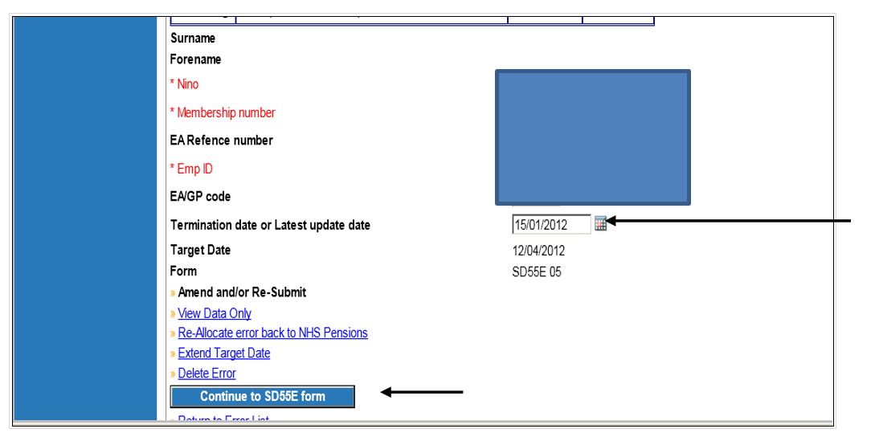

Otherwise, if you disagree that the EA has been closed, then it is possible an error has been made at The NHSBSA and you should email the Data Management Team at datamanagement@nhsbsa.nhs.uk to query this.

To avoid the error being escalated to the next level whilst you are waiting for a response from The NHSBSA you should extend the target date on the error and place a suitable comment in the box to explain why the target date has been extended.

When The NHSBSA has confirmed the EA Closed Date has been amended or removed you should then be able to reprocess the error without making any changes.

Error 0433 – Changed EA Closed Date earlier than latest updated date

Overview
An EA Code change has been made via the ADP4 function in Pensions Online E-Forms and this EA is shown as closed on the NHSBSA EA Database and the employment for which the change is recorded is updated to a date that is later than the date the EA closed.

Action to take
Check you have entered the correct EA Code. If incorrect delete the error and resubmit the EA Code change, via the ADP4 again, if still relevant.

Otherwise, if you disagree that the EA has been closed, then it is possible an error has been made at The NHSBSA and you should email the Data Management Team at datamanagement@nhsbsa.nhs.uk to query this.

To avoid the error being escalated to the next level whilst you are waiting for a response from The NHSBSA you should extend the target date on the error and place a suitable comment in the box to explain why the target date has been extended.

When The NHSBSA has confirmed the EA Closed Date has been amended or removed you should then be able to reprocess the error without making any changes.

Error 0434 – Change to a Direction EA code is not permitted

Overview
An EA Code change has been actioned via Pensions Online ADP4 function to amend the EA Code of an employment to an EA Code that starts with 8 or 9.

A change to a Direction EA Code is not permitted because an application to be pensionable in the Direction employment must be made, as not all employees of a Direction employer are eligible to join the Scheme.

If an employee transfers to a Direction employer the previous employment must be closed down the day before and a new joiner and SD65 application form should be completed for the Direction employment.

Action to take
Check that the EA code entered is correct and no error was made. If an error was made then amend the EA code change details entered in the change area of the SD55 and resubmit the error for processing.

If it is correctly a change to a Direction employer then the employment must be closed the day before the change.

The form in error should be deleted and a leaver form submitted via Pensions Online.

The Direction employer should then submit a new joiner and application form for the new employment.

Error 0463 – Employer’s pay less than employees pay

Overview
Produced on cyclic update, leavers and form SD55E’s where the employers pay is less than the employees pay. A £1 tolerance is present to allow for rounding.

Further information
Employers pay should never be less than the employees pay figure as the employers pay should include any deemed pay. This error can occur if a mistake has been made inputting the data or if arrears of contributions and pay are recorded in the year paid and not the year due. This mainly appears to relate to collection of contributions during maternity leave.

Action you should take:
Check that there is not an error in the amounts entered. If they are correct and they include arrears for a previous financial year then the amounts for both years should be adjusted.

- Access the error in the normal way
- Select ‘Amend and/or re-submit’
- Select ‘continue to SD55 form’
- Amend the employees’ contributions and pay (and hours if p/t) to exclude any arrears for the previous year.
- Select ‘submit’ to reprocess the form
- Then access SD55E in the main e-forms menu
- Amend the employee contributions and pay (and hours if p/t) for the previous financial year to include the arrears

Exception 0470 – Invalid employment status for deletion

Before taking action on an error, check that NHSP records have not already been updated with the information on the form.

Criteria:
A deletion request has been submitted for an employment with a status of pensioner, no liability or deceased.

Applies to forms:
Deletion

Known causes:

- Duplicate employment on record which should not have been included in refund/ Award.

Action to be taken:
Step | Action
1 | Confirm the reason for the deletion.
1.1 | If the employment is correctly held on the record and should have been included in any payments, delete the form from error handling.
1.2 | Where the employment needs deleting from the record, add an employer comment to the error to explain the reason for the deletion and re-allocate the error to NHSP.

Best working practice for employers
Action
When asking NHSP to delete an employment in these circumstances please ensure this is
correct as it will result in a recovery of payments made to the member.

Date Created/updated | 16/07/2019

Error 0474 – Early retirement reduction buy out (ERRBO) contributions present – Employment deletion not permitted

Overview
A request to delete an employment has been received but The NHSBSA hold an ERRBO figure greater than 0.00

Action you should take
- Check whether the employment that has been submitted for deletion is the correct post and does need removing.
- If this has been submitted by mistake use the ‘Delete error’ facility, ensuring that you supply a reason you wish the error to be deleted.
- If the form relates to a different post and you need to amend the information held to match the correct employment, select ‘Amend and/or Re-Submit’ and alter the data accordingly.
- Once amended, click ‘Continue to EmpDel form’ to re-submit the deletion request.
- If the deletion is correct and the post does still need removing from the records at The NHSBSA, use the ‘Re-allocate error back to The NHSBSA’ option and include a reason to support your request to aid Pensions staff with the request.

Example where response required
Example: ‘Please remove this post from your records as member made no contributions in this employment and therefore should not have been applicable for any ERRBO payments’

Exception 8030 – No member record found to match input
Before taking action on an error, check that NHSP records have not already been updated with the information on the form.

Criteria:
This error is created when a form is submitted with an NI number and there is no matching NHS pension record held by NHS Pensions.

Applies to forms:
SD55 cyclic and termination, SD55E Amend employment details, SD55G Amend Personal Details, Deletion and open/rewind.

Known causes:
- ESR is sending information through to NHS Pensions for non-scheme members, for example changes to address or NINO.

- It is the members’ first pensionable NHS employment and NHSP do not yet hold the joiner details. This could be because the joiner has not yet been submitted, or it is held in error handling. For ESR employers the NINO verification which generates the SD55G is sometimes received prior to the joiner form being processed

- Since submitting the joiner details, the NINO within your payroll system has been changed but NHS Pensions have not yet been notified of the change. Therefore, no record with a matching NINO can be found. This usually happens where NHSP still hold a temporary NINO.

Action to be taken: SD55 cyclic and termination
Step | Action
1 | Access the ADP4 via the link in error handling.  Search the ADP4 to find whether there is a valid SD number under the member name  and employment details (e.g. EA ref, start date). If the NINO also matches, then resubmit the error with no amendments.
1.1 | If an existing record is found but under a different NI number to that held on the update form, enter the first page of the error by selecting ‘‘Amend and/or re-submit’’. Amend the NINO to match that shown on the ADP4.  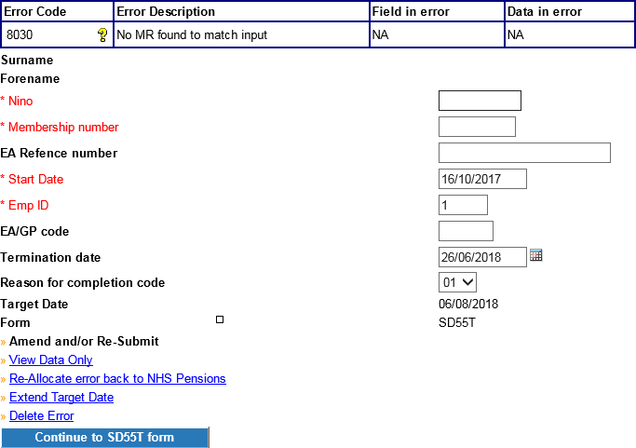  Then continue to SD55 form.
1.2 | Once in the error, scroll to the bottom of the SD55 or SD55T form, where there is a change box. Input the revised NINO details in the change box (guidance for this can be  found on the form) and then resubmit.
2 | If you have checked the ADP4 and no matching employment details to those on the form in error can be found, a joiner form should be submitted if the post is pensionable. The joiner may have been submitted previously but has not processed.  - Check Employer Error Handling (SS10 or SS14). If the joiner is held, take the action needed to resolve any data issues and resubmit the joiner.  - Once the joiner has successfully processed, the 8030 can be resubmitted, ensuring first that there are no missing updates (it may be necessary to check error handling for any other outstanding errors).  Please be aware that the ADP4 form is updated overnight and while the joiner can  process within the hour, this will not be reflected on the ADP4.
2.1 | If the joiner is not held in Employer errors, view NHS Pensions Error Handling (SS10 or SS14). If the joiner is held, re-allocate the 8030 error to NHS Pensions, providing full details to resolve the joiner error and any other useful information. They will then be able to process the 8030; provided that there are no missing year end updates (again it  may be necessary to check error handling for any other outstanding errors).
2.2 | Once the employment has been updated it will show on the ADP4 form.

Action to be taken: SD55E amendment form
1 | Check your records to confirm that the employee is a member of the NHS Pension  Scheme and, if so, that the details on the SD55E are correct.
1.1 | If they are not a member and do not have a record with NHS Pensions, or if the details  on the SD55E are incorrect, delete the error.
2 | Open employments  -Where the SD55E amendment needs processing and the employment is open, access the ADP4 via the link in error handling.  -In the ADP4, search for the member name and employment details (e.g. EA ref, start  date) in order to trace the member record. If the SD number and the NINO matches those held on the form in error, resubmit the SD55E with no amendments.
2.1 | If the record found on the ADP4 shows a different NI number to that held on the form in error, enter the first page of the error by selecting ‘‘Amend and/or re-submit’’. Amend the NINO to match that held by NHSP and resubmit the SD55E without making any  further changes.
2.2 | If the NINO held by NHSP was incorrect, submit an SD55G form to amend it.
2.3 | If the NINO you hold is incorrect, amend your payroll details to avoid any future 8030  errors.
3 | Closed employments - Where the SD55E amendment needs processing and the employment is closed, go into E forms and form SD55E. Enter the SD number on the error and select the relevant employment ID. You can then view the NINO that is  currently held by NHSP. - Follow steps 2.1 -2.3

Action to be taken: SD55G amend personal details
1 | Check your records to confirm whether the employee is a member of the NHS Pension  Scheme.
1.1 | If they are not a member and do not have a record with NHS Pensions, delete the error.  Note: SD55Gs in error handling will sometimes refer to the SD number of a deleted record, which cannot be amended. Contact data management if further information is required on the status of a record.
2 | If the employee is an NHSP Scheme member, search the ADP4 to find whether there is a valid SD number under the member name and employment details (e.g. EA ref, start date). If it is not a NINO change on the SD55G and the NINO on the ADP4 also matches, then re-submit the SD55G with no amendments.  Note: For ESR employers with new employees, the NINO verification which generates  the SD55G is sometimes received prior to the joiner form being processed, resulting in error 8030.
2.1 | If an existing record is found but under a different NI number to that held on the update form then enter the first page of the error by selecting ‘‘Amend and/or re-submit’’.  Amend the NINO to match that shown on the ADP4.  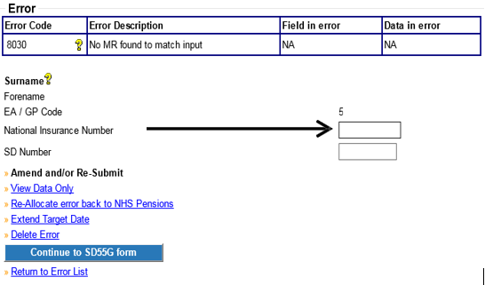  Continue to SD55G form.
2.2 | If the NINO held by NHSP is incorrect, enter the correct NINO on the SD55G and resubmit the form  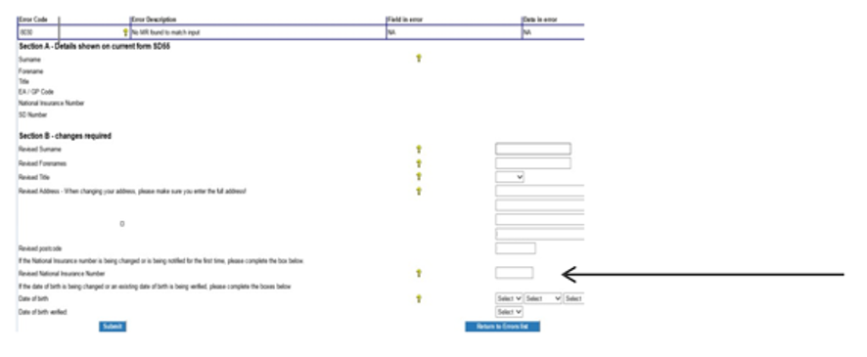
2.3 | Where the NINO you hold is incorrect, amend it in your payroll system to avoid any  future 8030 errors.
3 | If the SD55G needs submitting but a record cannot be found for the member, contact  data management for details of the NINO held.

Best working practice for employers
Known Issues
For ESR employers with new employees, the NINO verification which generates the SD55G is at times received prior to the joiner form being processed, resulting in error 8030.

Date Created/updated | 16/07/2019

Error 8070 – Employment with matching details already present on Compendia

Overview
A joiner form has been received but The NHSBSA already holds matching information on their systems.
Details checked for a match are:

EA Code, Date of commencement, Capacity code, employment type, Locum indicator, As and When indicator, WT/PT indicator and P/T fraction.

Action you should take
- Check the form to ensure the above details are held correctly on the form.
- If the details held are correct, check whether this is a duplicate of the post (inc. Payroll/assignment number) already held. If this is the case, the error can be deleted with a comment telling The NHSBSA the joiner was sent in error as it is a copy of an existing post.
- If the post is not a duplicate, re-submit the form back to The NHSBSA with a comment explaining the member holds two identical posts. Ensuring the payroll/ESR assignment Ref. is amended accordingly to differentiate between the two.
- If the details held on the form are incorrect, use the ‘Amend or/resubmit’ option to access the form and alter the necessary values before returning it to The NHSBSA for processing.

Example where response required
Member has two identical concurrent posts that are both pensionable. Please add this employment onto the member’s record.

Exception 8086 – MR already updated for service shown
Before taking action on an error, check that NHSP records have not already been updated with the information on the form.

Criteria:
An SD55 update or termination form has been submitted for an employment that has already been updated and closed.

Forms affected:
SD55 cyclic and termination.

Known causes:
Can occur when a leaver or cyclic has successfully processed via Pensions Online and then a duplicate update is sent to NHSP through ESR.

Action to be taken:
Step | Action
1 | This is an NHSP allocated error.  However, where the figures on the form in error handling differ to those held on existing NHSP records, they will sometimes require confirmation of the correct figures.  The SD55E form and NHSP error can be viewed and a comment added to the error advising which figures are correct, and what action NHSP need to take.

Date Created/updated | 16/07/2019

Exception 8089 – Date of Birth in MR and input record both verified
Before taking action on an error, check that NHSP records have not already been updated with the information on the form.

Criteria:
An SD55G form has been submitted for a change to the date of birth. An Award has already been paid on the member record.

Applies to forms:
SD55G amend personal details.

Known causes:
Where a member’s benefits have been paid, NHSP restricts amendments to some member details as the changes will affect the Award calculations and subsequently the member’s pension benefits.

Action to be taken:
Step | Action
1 | Confirm the member’s correct date of birth.
2 | Check the first page of the error to determine what DOB is held by NHSP. It is shown in the ‘Data in error’ field.
3 | If the DOB on the SD55G form and the DOB held by NHSP are the same, or the DOB is incorrect on the form, the error can be deleted.
4 | If there is a mismatch between the revised DOB on the SD55G and NHSP records, re- allocate the error to NHSP using the comments box. Confirm that you have proof of the DOB through sight of official documentation, such as birth certificate or passport.
5 | Once amended by NHSP, you will receive confirmation and will need to submit/send an AW171. NHSP can then re-calculate the member’s pension and adjust payments accordingly.

Best working practice for employers
Action
Ensure member date of birth is correct on your payroll records and on NHSP records prior to
submission of AW8/AW8P.

Date Created/updated | 16/07/2019

Comment 8094- Refund paid - input form not allowed to process
Before taking action on an error, check that NHSP records have not already been updated with the information on the form.

Criteria:
A joiner form has been submitted and the start date falls either before or within a refunded period. The additional service will mean that the refund will need to be adjusted.

Applies to forms:
SS10 joiner

Known causes:
- Late notification of service for which contributions were deducted.
- The joiner form is a duplicate of an employment held on NHSP records, and has already been included in the refund.
- The start date on the joiner form is incorrect.
- The joiner form was submitted in error and the employment was non-pensionable/refunded locally.

Action to take:
Step | Action
1 | If contributions that were paid in the employment have already been refunded, access the joiner in NHSP error handling and confirm the refund via Employer comments. NHSP will then delete the joiner form.
2 | If the start date on the joiner form is incorrect, and falls after the refunded period, access the joiner form in NHSP error handling and provide the correct information via Employer comments. NHSP will then amend the start date on the joiner and resubmit the form.
3 | If the joiner form shows service that was pensionable and contributions have not been refunded, contact NHSP to confirm the dates of employment and to provide any cyclic/termination details. These can be sent via email, or via employer comments if the missing updates are in Employer Error handling and can be reallocated to NHSP.

Best working practice for employers
Action
Before contacting NHSP, check whether or not a local refund has been paid for the employment in error.

Ensure all service with you is held on the NHSP member record prior to submission of RF12.

Date Created/updated | 16/07/2019

Comment 8309 – Corrupt Service History

Criteria:
The NHS Pensions member record shows a mismatch in data, such as different employment end dates recorded for the same period of service. This will cause any submitted forms to error as an 8309 until the record has been corrected.

Applies to forms:
All form types.

Known causes:
NHSP system fault.

Action to be taken:
Step | Action
1 | This is an NHS Pensions error; no action can be taken by employers to correct the record.
2 | In urgent cases, such as an Award or refund pending, an email should be sent to the data management team requesting clearance of the form in error. The email needs to clearly state in the email subject that the case is urgent (including the reason why), so that it will be prioritised.

Best working practice for employers
Action
Please do not email or send an employer comment for error 8309. The only exceptions to this are:
- Payment of benefits is due and an error is stopping the submission of an application or will delay the payment.
- Unable to successfully process a rewind or deletion form to then provide revised details.

Where an email or employer comment is received asking us to clear a NHSP allocated error but the above does not apply, no action will be taken with regard to the email or employer comment as these are already allocated to the team for clearance.

Date Created/updated | 16/07/2019

Exception 8310 – Corrupt Member status details

Criteria:
The NHS Pensions member record holds either an incorrect scheme or status. Forms will error as an 8310 until the scheme/ status has been corrected.

Applies to forms:
All form types

Known causes:
NHSP system fault.

Action to be taken:
Step | Action
1 | This is an NHS Pensions error; no action can be taken by employers to fix the record. Sweeps are run periodically by NHSP to correct the records.
2 | In urgent cases, such as where there is an Award or refund pending, an email should be sent to the data management team requesting a status/scheme fix and for the forms to be resubmitted. The email should clearly state in the email subject that the case is urgent (including the reason why), so that it can be prioritised.

Best working practice for employers
Action
Please do not email or send an employer comment for error 8310. The only exceptions to this are:
- Payment of benefits is due and an error is stopping the submission of an application or will delay the payment.
- Unable to successfully process a rewind or deletion form to then provide revised details.

Where an email or employer comment is received asking us to clear a NHSP allocated error but the above does not apply, no action will be taken with regard to the email or employer comment as these are already allocated to the team for clearance or cleared in a sweep.

Date Created/updated | 16/07/2019

Section 2 – General Information
Access to NHSP allocated errors is via the same link in the main Employer Menu on Pensions Online:

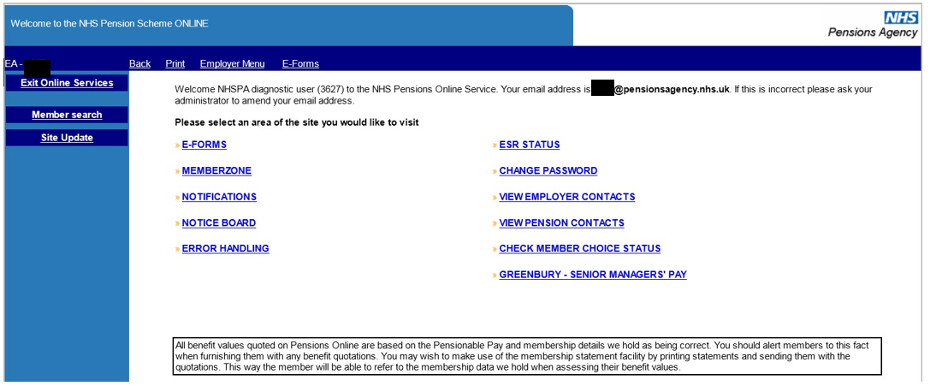

Then select the link ‘Errors allocated to The NHSBSA’

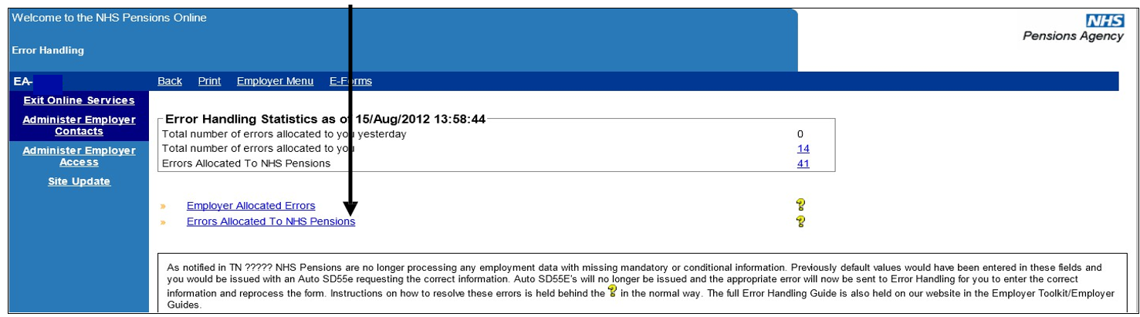

You can then choose which form you wish to view the errors for by selecting the relevant link:

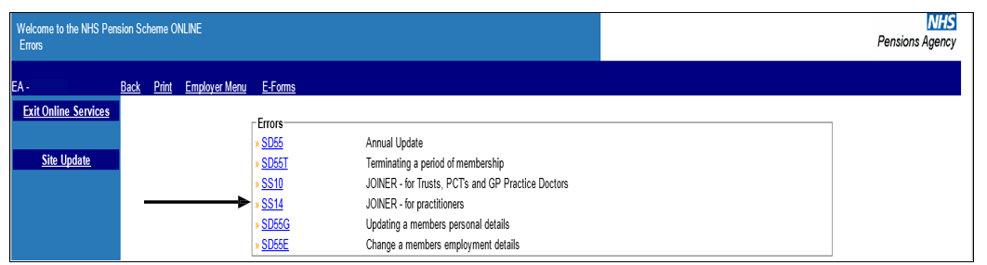
There could be occasions where an annual update or leaver form creates an Error 0186 for you to resolve and the joiner is in error for resolution by The NHSBSA.
It is therefore suggested that before trying to resolve any Error 0186’s that you check if the matching joiner information is in the list of errors for The NHSBSA to resolve.

Once you have selected the form you wish to view a list of all the errors for that type of form that have been allocated to The NHSBSA will be displayed:
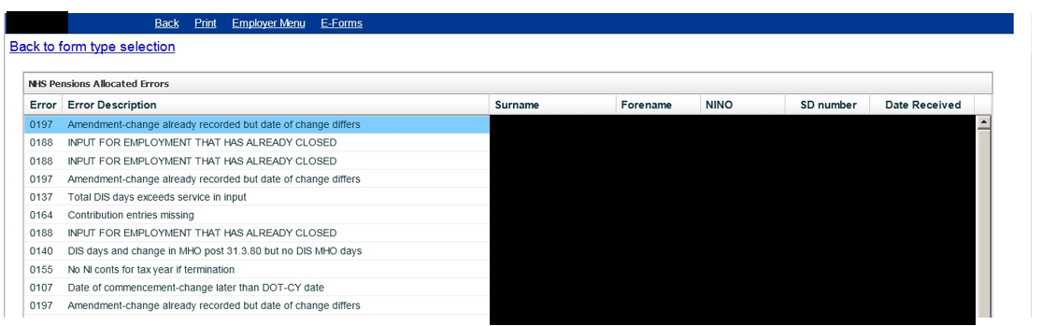
The order of the list can be changed by clicking on the header of the column that you wish the order to be in.

The order of the columns can also be changed by clicking; holding and then dragging and dropping the column to the position you want.

To open an error for a specific member you should then select the specific entry in the Error Description column.
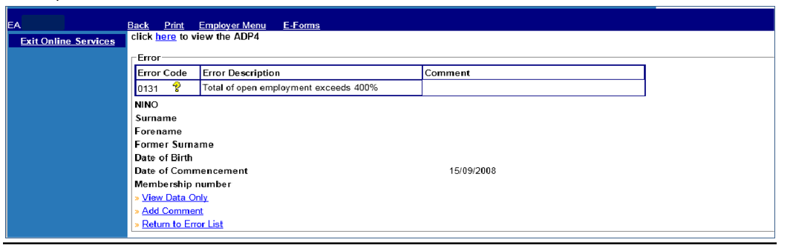
You then have the options to:
- View data only
- Add comment
- Return to error list

There is also a link to the ‘ADP4’ list at the top of this page to allow you to view details of the member, for example:
- The number of open employments with you
- The employment start dates
- Employment identifiers
- The date to which the employment is updated
- SD or NI numbers held by The NHSBSA

View Data Only
Once you have selected this link you will see the details submitted to The NHSBSA:
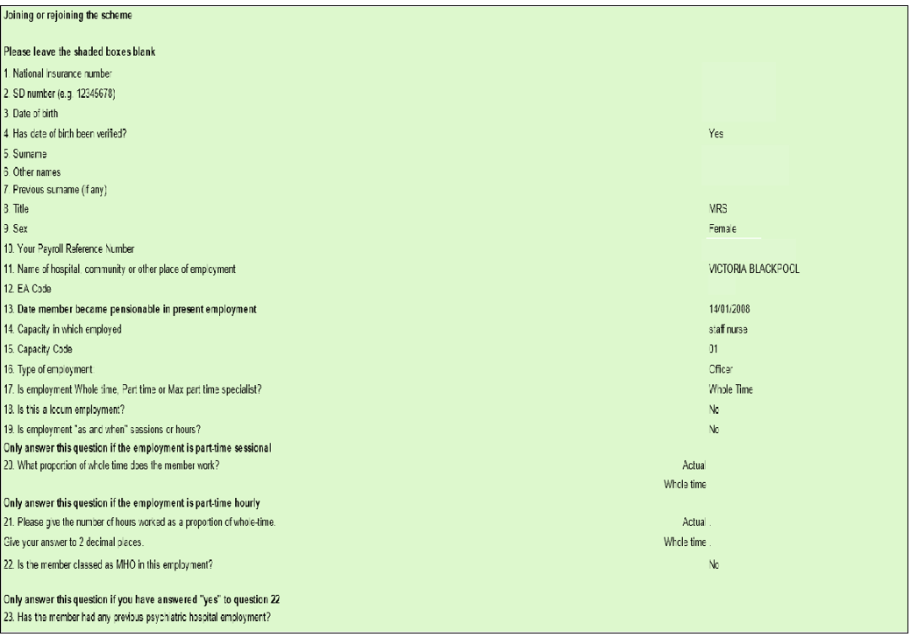
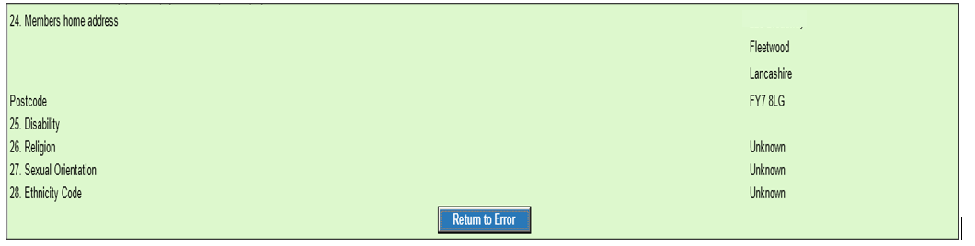

Adding Comments
Once you have selected this link a text box will be available for you to enter a comment to submit to The NHSBSA.
For example if the joiner form has produced Error 0056 (overlapping whole time employments) this may have been caused because you were not aware of the exact date of termination with a previous employer at the time you submitted the joiner.

If you now have information confirming the date pensionable employment ended with the previous employer was after the date the member commenced employment with you then it would be helpful to The NHSBSA if you advised them of the revised date of commencement, as shown on the following screen:
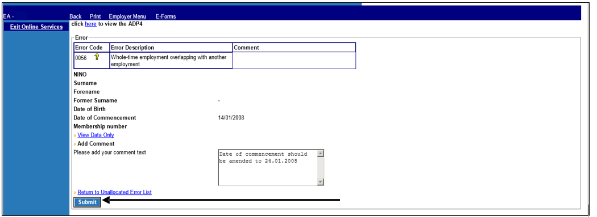
After inserting the comment in the text box select ‘submit’ and this will submit the comment to The NHSBSA and also insert it in the comment box.
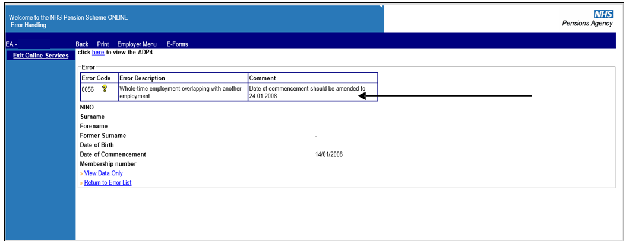

There is only the opportunity to submit 1 comment and the link is removed when your comment has been submitted.
The comment will then be displayed on the error information held by The NHSBSA:
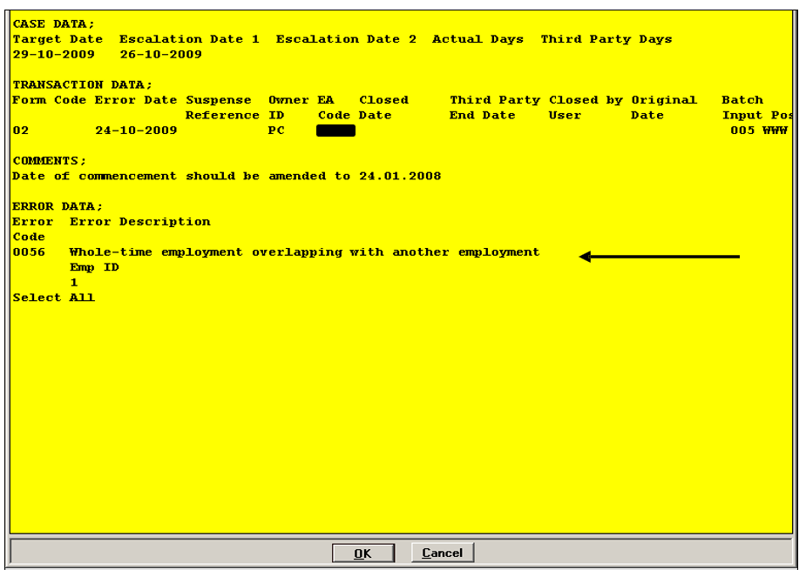

Return to Errors List
To view another error or to exit the errors allocated to The NHSBSA, select ‘Return to Errors List’.
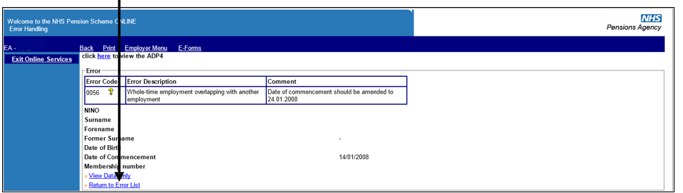

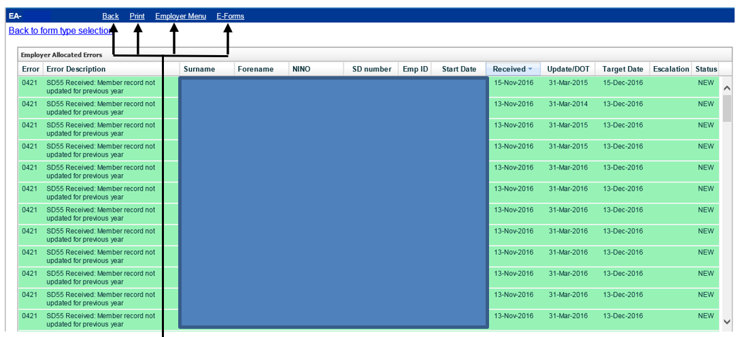

To exit, completely select any of the options on the menu bar in the normal way.

If you amend the employment start date, EA Code, NINO, Surname, Forename or Date of Birth within the error you must ensure ESR holds the same information otherwise further errors will be produced in the future.

How we use your information
For more information about how the NHSBSA processes your personal data, see our privacy notice - www.nhsbsa.nhs.uk/our-policies/privacy/nhs-pensions-privacy-notice

NHS Pensions

Pensions Online (POL )Guide 34. Error Handling

www.nhsbsa.nhs.uk/nhs-pensions
NHS Pensions, PO Box 683, Unit 5, Newcastle Upon Tyne, NE5 9EE

