

NHS Pensions

Pensions Online (POL) Guide

4. Signing in

Once you have registered to use Pensions Online (or been registered by your Pensions Manager) and have been issued with your personal PIN and password you can sign in to use the system. When you select the link, you will be asked for these details, as follows:

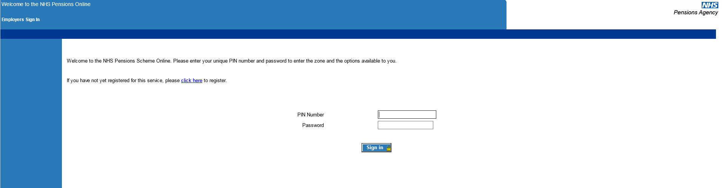

Important Note: You must never log in to Pensions Online using someone else’s PIN and password, as this is a serious breach of NHSBSA security policy.

If you have forgotten your PIN and/or password and you are the main administrator of Pensions Online then you should contact NHSBSA for the PIN/password to be re-set. Details of how to do this are explained in the Frequently Asked Questions link.

If you are not the main user, then your access rights have not been authorised by NHSBSA and you should ask the main administrator to re-set your PIN and password for you. Details of how this is done are also in Frequently Asked Questions.

Once you have successfully accessed the system you are then presented with details of all the contact names, addresses, telephone numbers and email addresses. There is an option to amend these details if needed, otherwise select the link at the bottom of the page to continue into the Pensions Online Employer Menu:

If all these contacts are correct, please click here to continue

Now go to the section headed Employer Menu.

How we use your information
For more information about how the NHSBSA processes your personal data, please see our Privacy Notice -
www.nhsbsa.nhs.uk/our-policies/privacy/nhs-pensions-privacy-notice

NHS Pensions

Pensions Online (POL Guide) 4. Signing in

www.nhsbsa.nhs.uk/nhs-pensions

