

NHS Pensions

NHS Pensions Online (POL) Guide

2.Frequently asked questions

Once you have accessed ‘N3 Pensions Online’ the link to ‘Frequently Asked Questions’ is displayed at the bottom of the page:

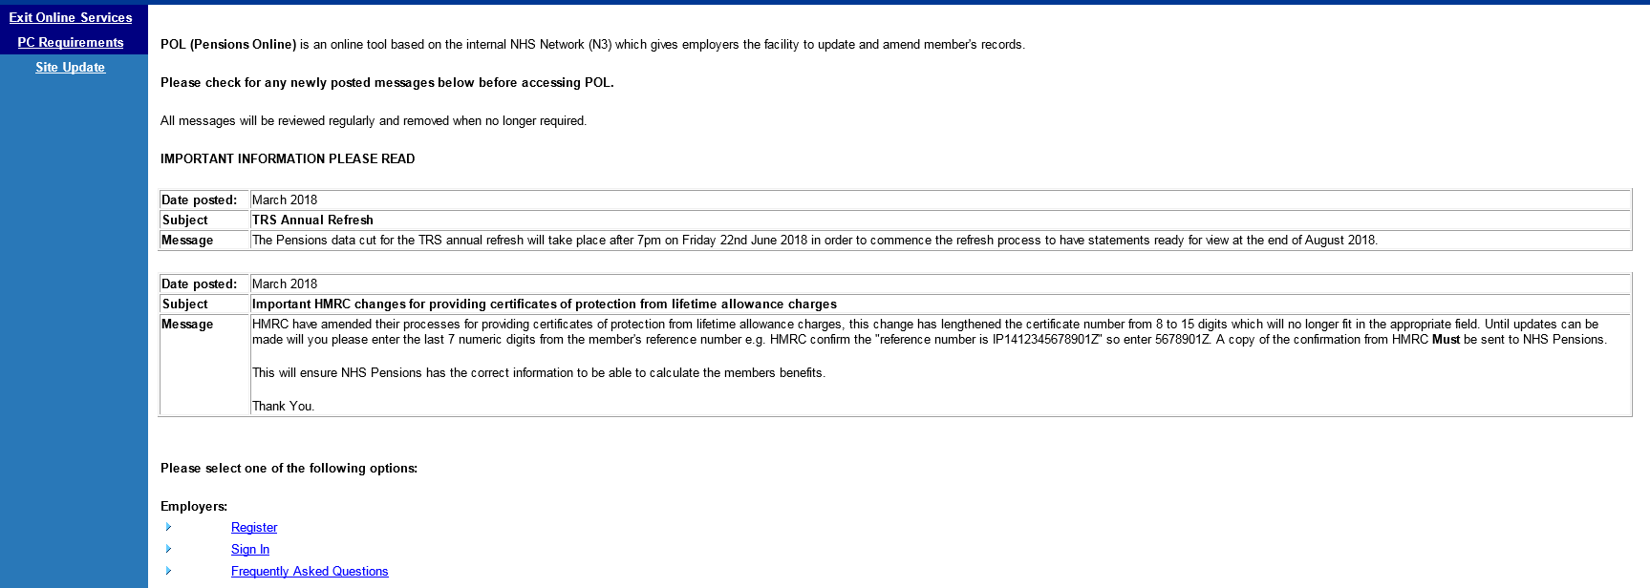

Once this link is selected the page covers the following issues:

- Connection Issues
- Registration Issues
- E Forms Issues
- Pol Estimates
- General Issues

Each section then includes links to a list of frequently asked questions for that area of Pensions Online.

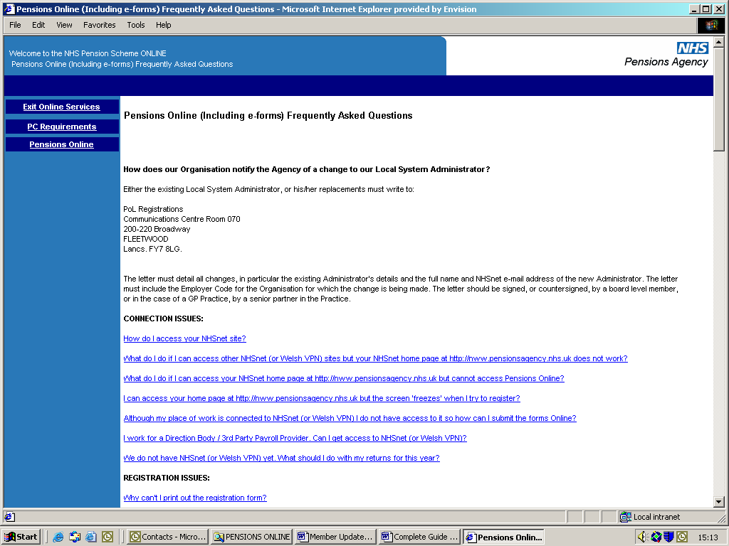

At the top left hand side of the page there are links present to take you to the following areas:

- Pensions Online - this takes you back to the previous page
- PC Requirements – which gives details of the PC specification required to access Pensions Online
- Exit Online Services – this takes you out of the service completely

How we use your information
For more information about how the NHSBSA processes your personal data, please see our Privacy Notice -
www.nhsbsa.nhs.uk/our-policies/privacy/nhs-pensions-privacy-notice

NHS Pensions

POL Guide 2. Frequently asked questions

www.nhsbsa.nhs.uk/nhs-pensions

