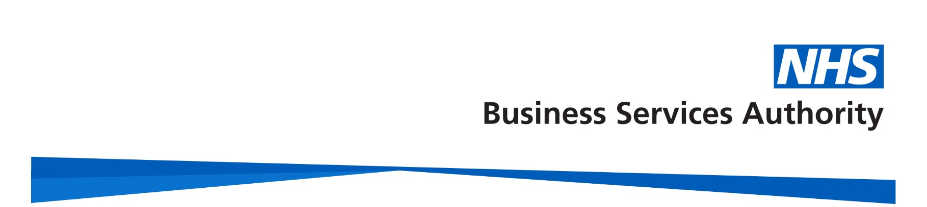

NHS Pensions

Pensions Online (POL) Guide

28. RF12 Form – Application for a refund of contributions

Before completing the Pensions Online RF12 application form, please ensure that you have checked:

- whether the member is entitled to a refund

- that the employment has been closed

- that the submitted contributions are correct

- that the member has correctly completed, signed and dated RF12 form Part A

- their name and date of birth match NHS Business Services Authority (NHSBSA) records

- there is no concurrent part-time employment with you that is active and pensionable

- that the member has provided bank details

- that when the employment(s) span three tax years you will need contracted out National Insurance earnings for the first year

The electronic RF12 can be found in the main E-Forms menu:

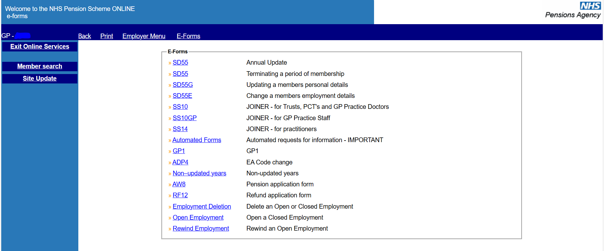

You will be asked to input the member’s details once you have selected the link:

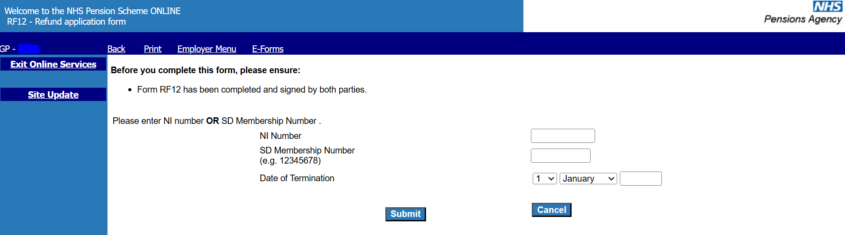

The ‘Date of Termination’ must be the same as that submitted on the employment termination details.

If this does not match, you will see the following warning message:

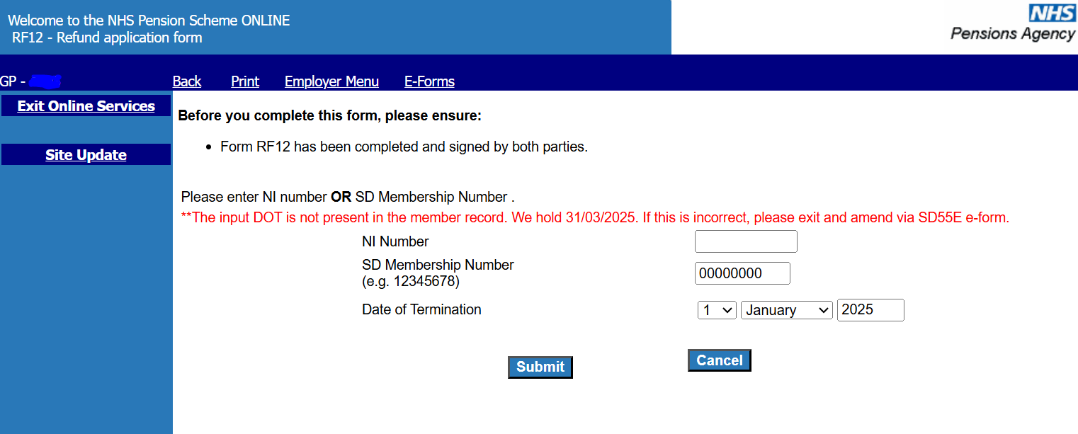

Once a matching Date of Termination is entered you will be taken to the employment selection screen where you should select the matching employment:

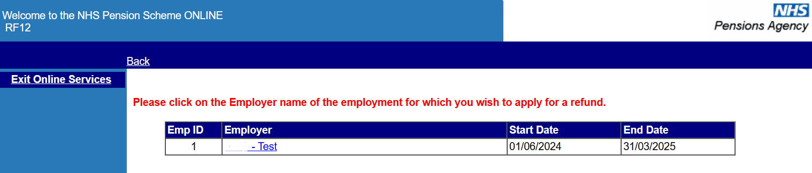

If there are any concurrent open employments displayed on this webpage you will need to close them before the RF12 can process successfully.

You will then be asked to check the members’ personal details and input their address. If any of the personal details are incorrect, you will need to cancel out of the RF12 and submit an SD55G to amend the details before submitting the RF12.
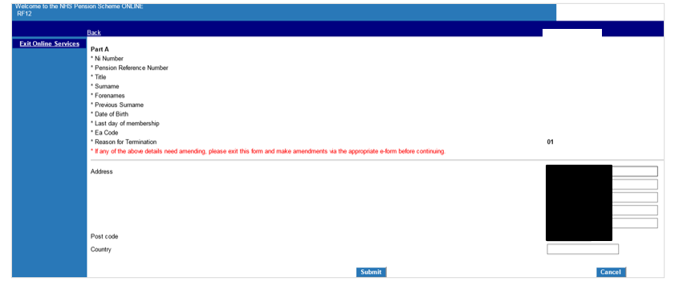
If all details are correct, select ‘submit’ and you will be taken to the next screen to complete bank details.

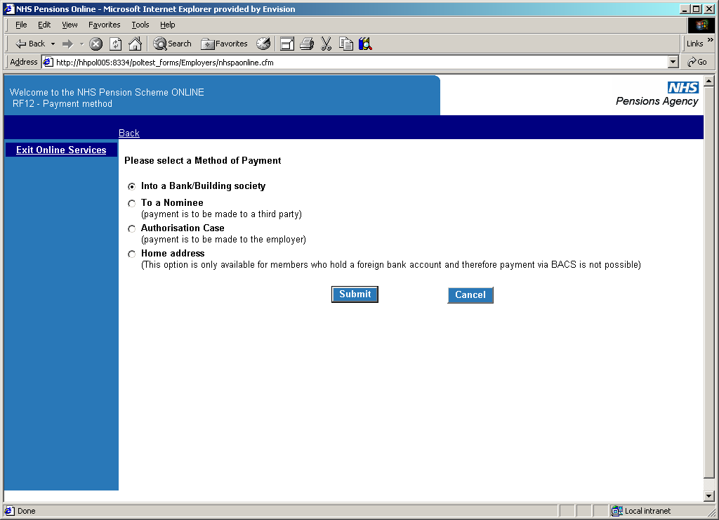

Payment can be made to:

- a bank or building society. For banks, you will be asked to provide the account number, sort code and type of account. For building societies, the roll number will also be required.

It is important to check the bank details are entered correctly as once the RF12 is submitted, the refund will process within a few hours.

- a nominee, in which case the name and address of the nominee will be requested.

- an authorised employer. This means the member wishes the funds to be paid to the employer to recoup monies owed.

- You will need to confirm that the member left with outstanding funds owing and that they have not completed this box in error.

- Written authorisation from the member should have also been received.

- the member’s home address (if they live overseas and do not have a UK bank account).

Payment into a bank/building society
Where this option is selected you will see the following screen:

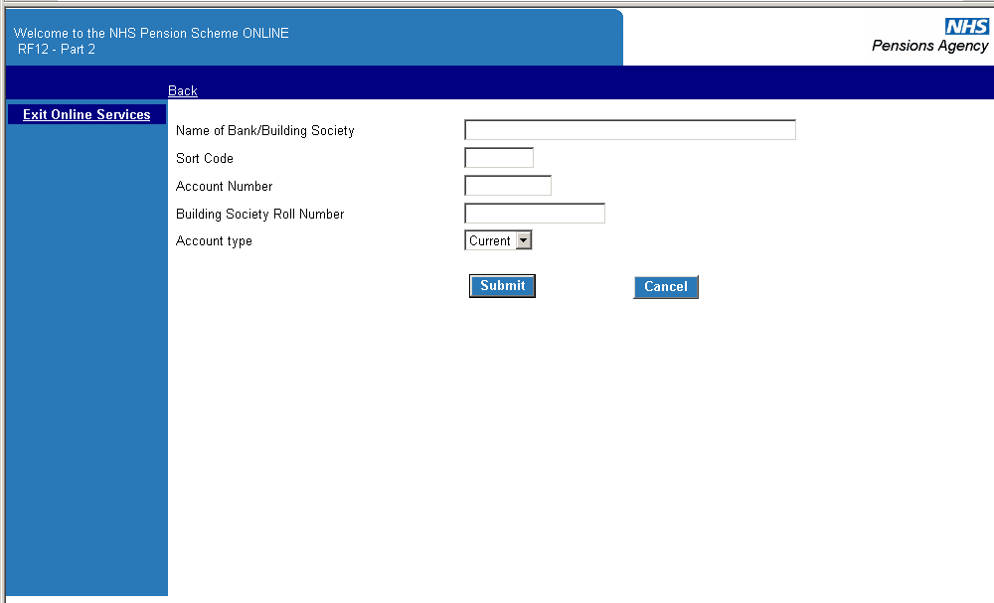

Once the correct details are entered, select ‘submit’. You will be asked to submit the bank details again before being taking to the next stage:

Screenshot of how to submit bank details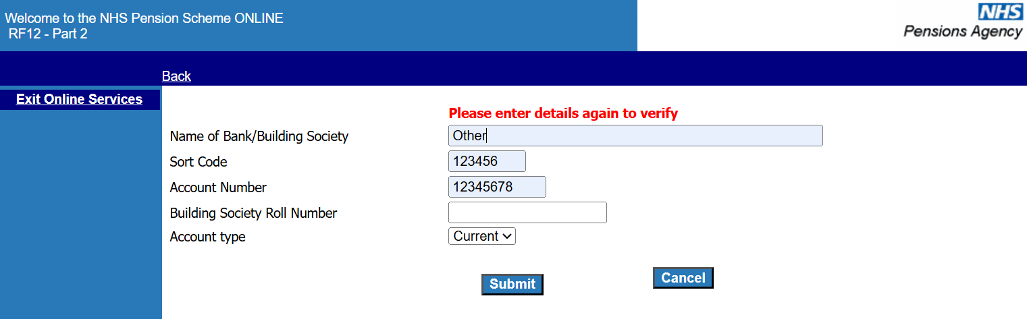
After selecting ‘submit’ you will be asked to confirm the details before being taken to the next stage. If you have made any mistakes, you also have the option to change the information.

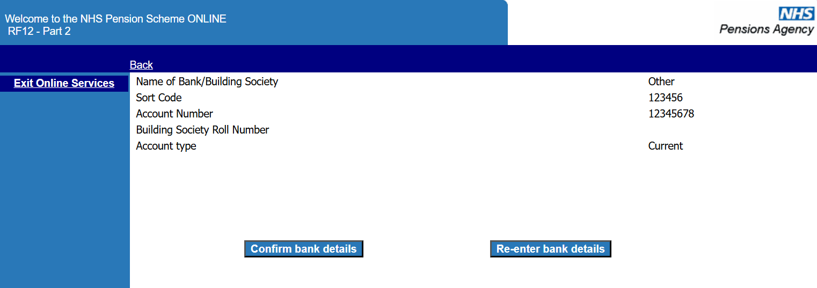
Once you have selected ‘Confirm bank details’ you will see the confirmation screen.

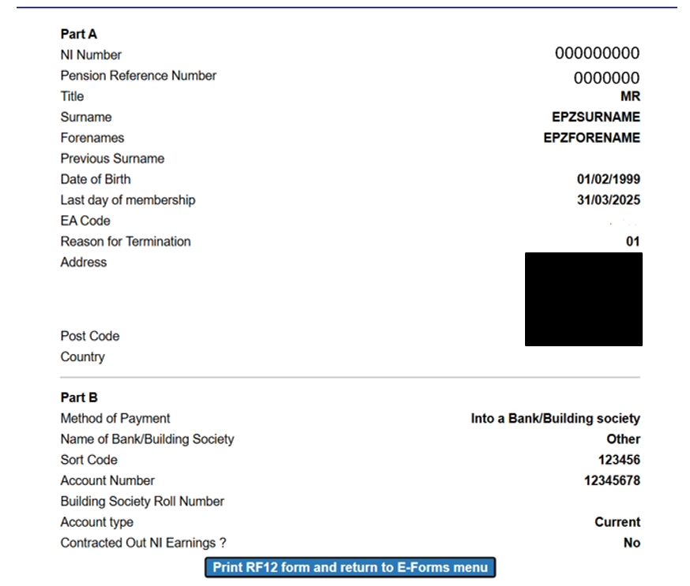

Payment to a nominee
Where this option is selected you will see the following screen:

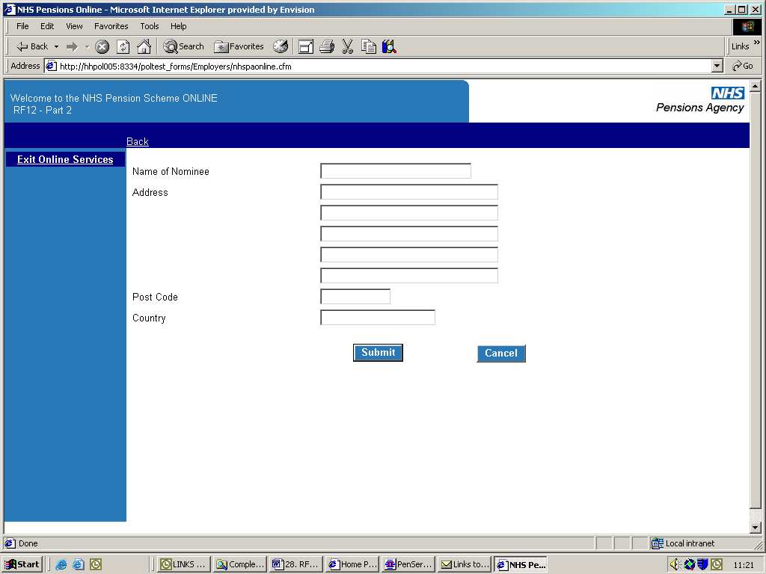

Once the correct details are entered, select ‘submit’. You will then be asked for the nominee’s details:

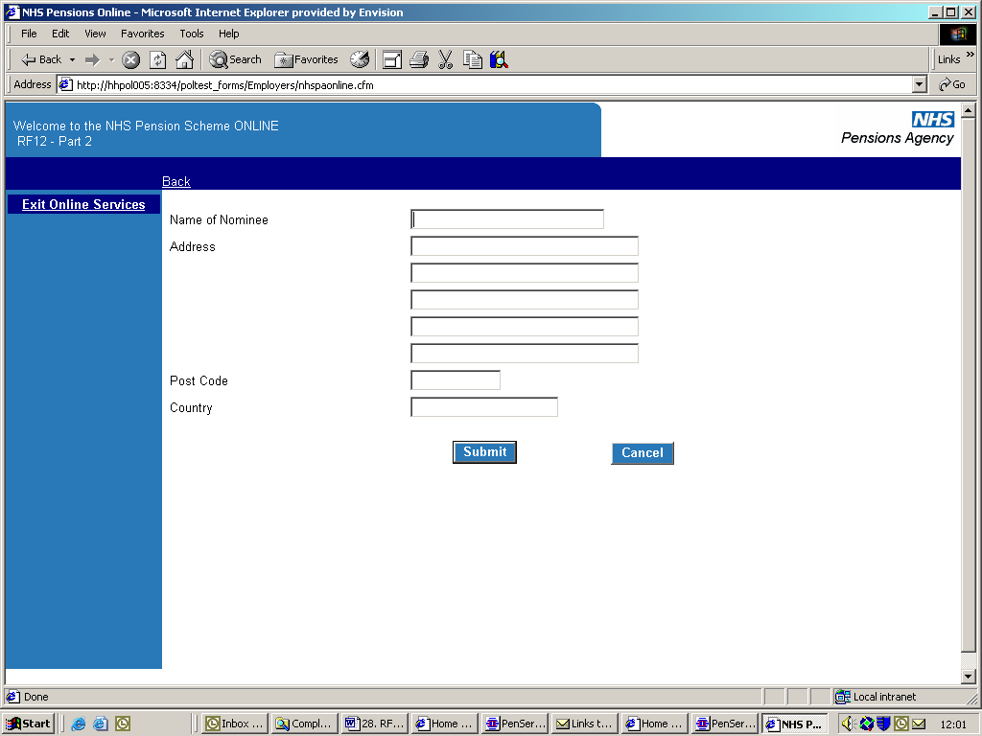

Once these details have been completed, you will be shown the following confirmation screen:
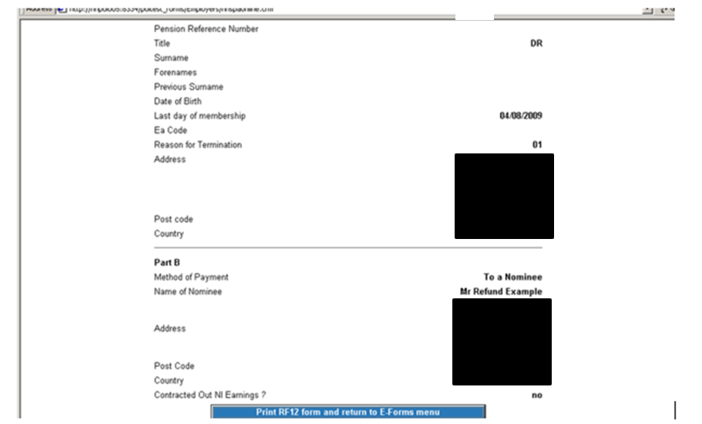

Authorisation case:
Where this option is selected, you will be first asked to send the member’s authorisation letter to the NHSBSA.

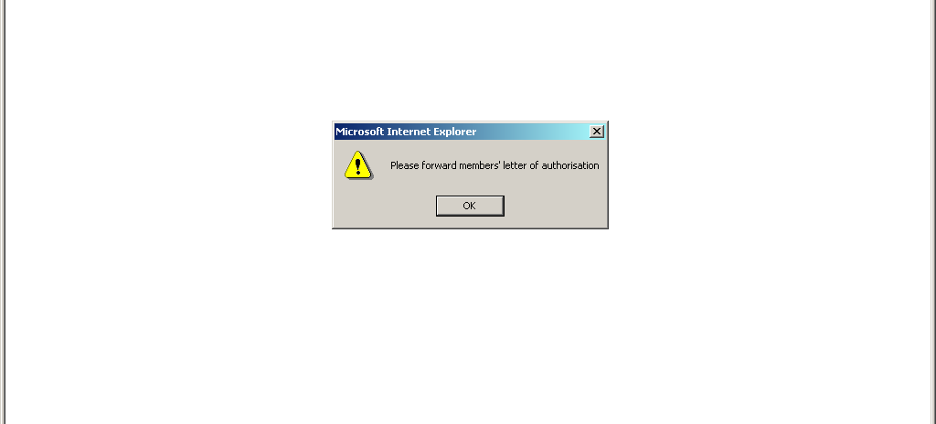

After selecting ‘ok’ you will be shown a confirmation that the RF12 has been successfully submitted.
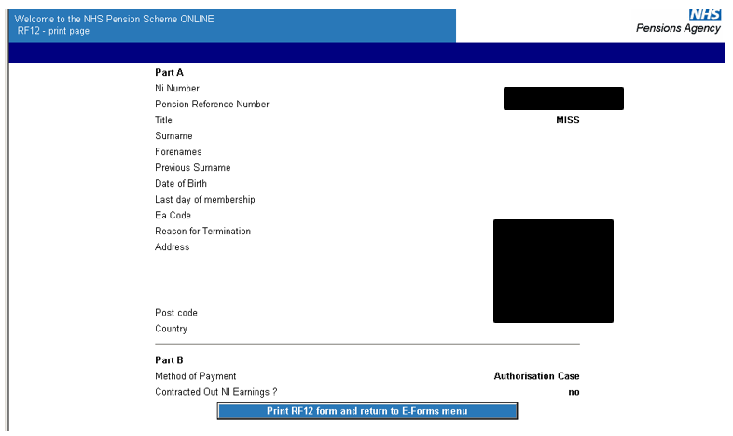

Home address
This option should only be chosen for members who live overseas and do not have a UK bank account.

Once this option has been selected you will be asked to confirm the member’s address and after selecting submit, you will be shown the normal confirmation page for RF12 printing and submissions.

What happens next?
In most cases, the form’s submission will result in the application processing within a few hours and the next day the payment should be issued (3 to 10 days should be allowed for the payment’s receipt).

A letter is sent by Second Class postage to the member’s address notifying them of the payment and providing them with a breakdown of the calculation.

A copy of this notification is also sent to Pensions Online Noticeboard for your records, as shown on the following example:
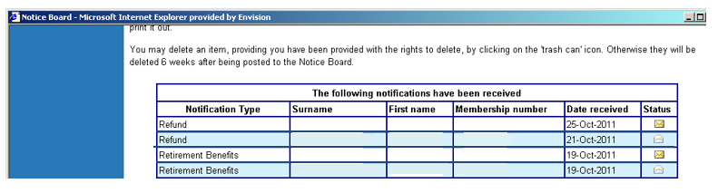

Unsuccessful processing
Circumstances where the refund application form will not process successfully include:

- an earlier employment has not been closed by the previous employer

- the member not being entitled to a refund as they have sufficient membership for preservation

- the member not being entitled to a refund as they already rejoined the Scheme in another employment or remains pensionable in a concurrent employment.

- a joiner or updating form is in error and must be resolved before the RF12 can continue with processing.

If there is any problem with either the calculation or the membership record, the refund will be held, and the case brought to the NHSBSA for review.

At this stage, we will liaise with the relevant employers to try to make the payment as soon as possible.

You will be notified via the Noticeboard once the refund has been successful.

Any enquiries concerning refund delays should be made to the main employer helpline number 0300 330 1353, and not the Pensions Online helpdesk.

How we use your information
For more information about how the NHSBSA processes your personal data, please see our Privacy Notice -
www.nhsbsa.nhs.uk/our-policies/privacy/nhs-pensions-privacy-notice

NHS Pensions

Pensions Online (POL) Guide

28. RF12 Form – Application for a refund of contributions
www.nhsbsa.nhs.uk/nhs-pensions

