

NHS Pensions

NHS Pensions Online (POL) Guide

1.What is Pensions Online?

Pensions Online is a facility available to National Health Service Business Services Authority (NHSBSA) employers, General Practitioner (GP) Practices and some Direction employers who have access to the NHS Net (or Welsh VPN). It allows access to the following NHSBSA Pensions functionality for members of the NHSBSA Pension Scheme:

- Create new pensionable employments via Electronic (E)-Forms
- Electronic submission of contributions and pay details via E-Forms
- Electronic amendment of contribution and pay details via E-Forms
- Calculation of estimates of benefits via Memberzone
- Calculation of cost to purchase Additional Membership via Memberzone
- View membership history for your current members via Memberzone
- Submission of application forms to claim retirement benefits via E-Forms
- Submission of application forms to claim refunds of contributions via E-Forms
- View a list of your current Scheme members – via E-Forms
- View details of where your members records are updated to – via E-Forms
- Resolve errors that have been created on member updating forms – via Error Handling
- Amend personal details for your Scheme members, i.e. surname, address – via E-Forms SD55G.

If you do not have access to the NHS Net or Welsh VPN then you will not be able to access any of the above.

Did you know that you can:
- use the SD55E E-Form to check the contribution and pay details that you have submitted for an employment that has been closed
- use the ADP4 in E-Forms to view a list of your current members to check if this is correct or any leaver forms are outstanding
- use the ADP4 to check if a joiner form for a new member has processed and obtain their membership (SD) number
- check the date to which your current members records have been updated, also via the ADP4 or Non-Updated Records

Did you know that you cannot:
- make changes to pensionable employment start dates
- change the reason for termination code
- use a temporary National Insurance number when submitting a new joiner form. Leave this field empty and a ‘ZZ’ National Insurance number will be allocated by NHSBSA Pensions

Additional information
- if you have submitted a form that has not processed successfully within 24 hours this means that an error has been produced and you should check ‘Error Handling’. If there is no error allocated to the Employer but it is allocated to NHS Pensions then this means that the error is a type needed to be resolved by NHSBSA Pensions and you can email them at: datamanagement@nhsbsa.nhs.uk to investigate
- from 1 October 2011 any amendments that can be carried out via Pensions Online will be returned to the originator for completion with a brief explanation of the correct action to take. It is important to us that employers registered to use Pensions Online make full use of the Pensions Online tools we have made available
- if you have any suggestions for improvements to Pensions Online tools, we are happy to give them our full consideration
- the Employers Helpline number is 0300 330 1353 option 2

When contacting NHS Pensions by email please state the following details:
- Membership (SD) number
- Member’s surname
- Your EA code
- The date of commencement of the employment
- Payroll /Electronic Staff Record (ESR) reference number

Important note: For security reasons do not include the member’s National Insurance number or address in an email.

If you already have access to the NHS Net or Welsh VPN then you can use Pensions Online by logging on to our website.

You have access to the NHSBSA Pension’s website which includes a link to Pensions Online via the Pensions Online | NHSBSA page.
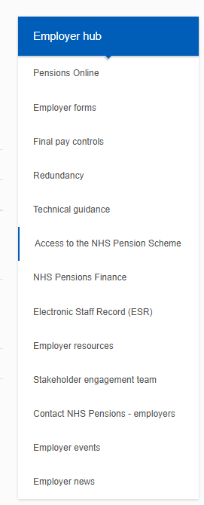
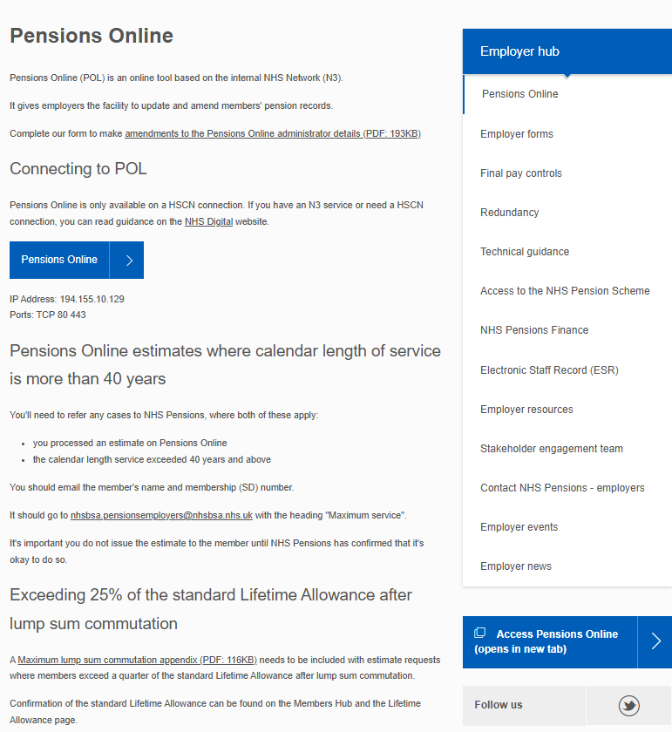

Selecting the page Contact NHS Pensions - for employers | NHSBSA takes you to NHS Pensions contact details page that holds further links to contact NHS Pensions, Pensions Online (POL) helpdesk, NHS Pension Scheme Finance and order forms.

By selecting the ‘Connecting to POL’ link you are then taken to the Pensions Online log in screen:
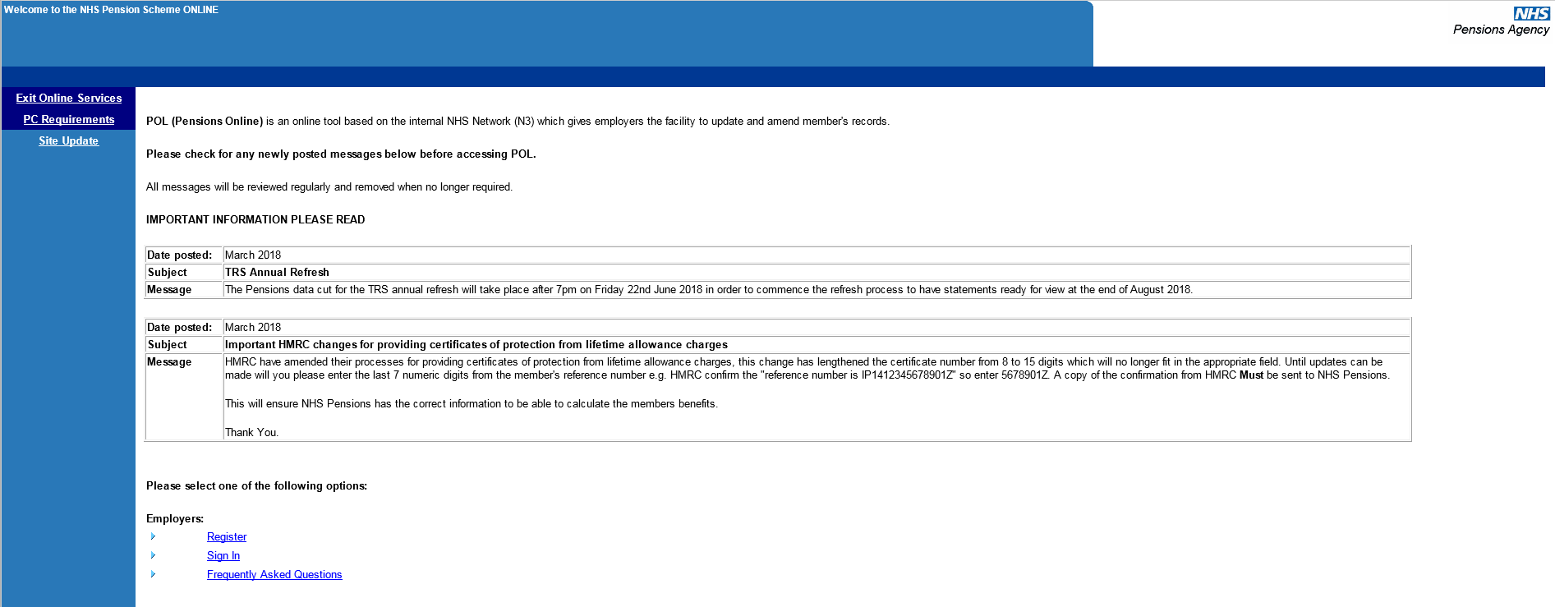
This page also includes links to the following:
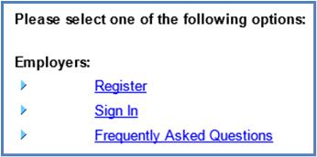

How we use your information
For more information about how the NHSBSA processes your personal data, please see our Privacy Notice -
www.nhsbsa.nhs.uk/our-policies/privacy/nhs-pensions-privacy-notice

NHS Pensions

POL Guide 1. What is Pensions Online?
www.nhsbsa.nhs.uk/nhs-pensions

