

NHS Pensions

NHS Pensions Online (POL) Guide

26. Non-Updated records

The Non-updated records function lists all your current scheme members whose employment(s) is not updated to the latest financial year-end.

If the member has concurrent part-time posts of which neither are updated to the current year-end then they will have more than one entry on the list, but these will display different employment identifiers.

The list displays the first 100 records, but there is a facility to search the database for any of your members using their NI number. This search will find any of your current members - not just those in the first 100.

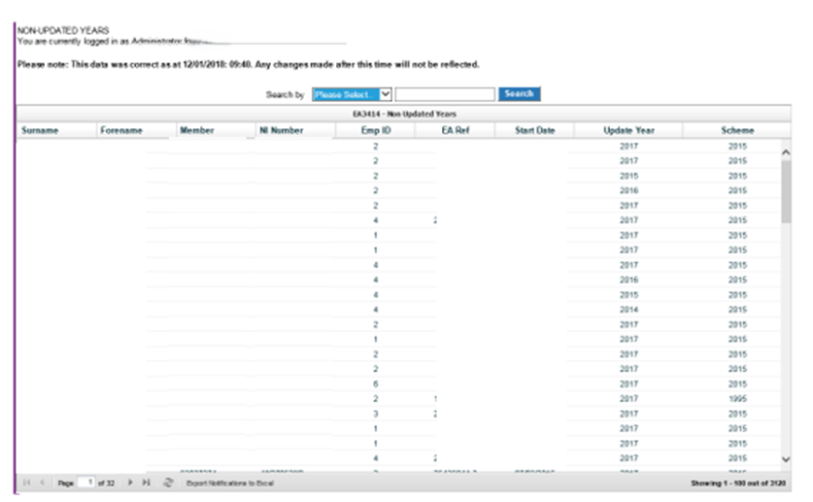

The list can be sorted into any order by selecting ‘∧’ or ‘∨’ at the sides of the title at the head of the column that you want the list to be displayed in. Once sorted into your preferred order the first 100 records will be relisted.

For example, if you select and sort by Pensions Membership (SD) Number using ‘∨’ then the first 100 records starting with the earliest Member (SD) number will be displayed, as illustrated below:

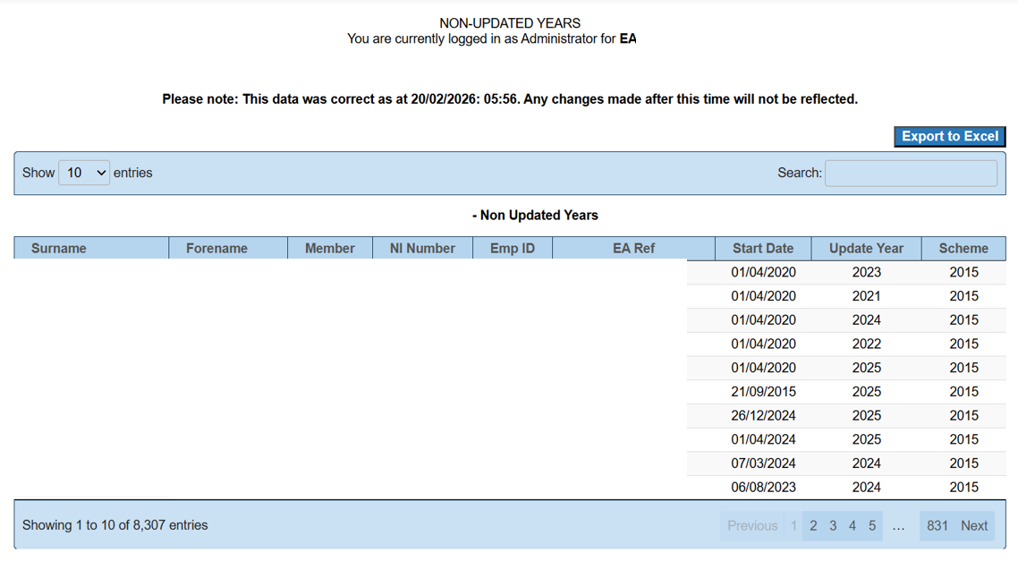

Suggested ways to sort and action these records:
To deal with members who may be near retiring age, sort via ‘Member (SD)number – v’

To action updates that have been outstanding the longest, sort via ‘Update Year – v’

Once you have identified a member whose update you wish to action it is also advisable to then do a search using their Member (SD) number. This will identify if there is more than one year that requires updating for the same member.

Any updates for the same member must then be submitted in year order via the SD55 Annual update form in POL.

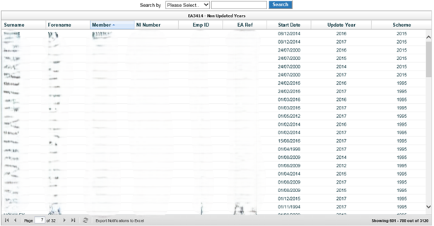

The list can also be exported, by using the ‘Export Notifications to Excel’ option at the bottom of the page.

As updates are submitted and processed the list is updated. This is not immediate - it is an overnight process.

How we use your information
For more information about how the NHSBSA processes your personal data, please see our Privacy Notice -
www.nhsbsa.nhs.uk/our-policies/privacy/nhs-pensions-privacy-notice

NHS Pensions

Pensions Online (POL Guide) 26. Non-Updated records

www.nhsbsa.nhs.uk/nhs-pensions

