

NHS Pensions

NHS Pensions Online (POL) Guide

3. Registration process

For those employers who do not yet have access to Pensions Online, select the ‘Register’ link and this will take you through the online registration process.

You access Pensions Online via the home page of the NHSBSA website, the NHS Pensions homepage on our website, you will find the link to the portal within the employer hub section of the website

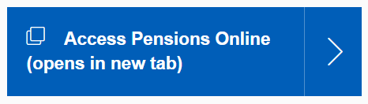
Only one registration per National Health Service Business Services Authority (NHSBSA) employer is allowed and this initial registration must be completed by the Pensions Manager or other nominated person with suitable authority. Once registration is completed then other users can be added. More information on this can be found in the POL guide 7 – administer employer access

The electronic registration form is available via the ‘Register’ link
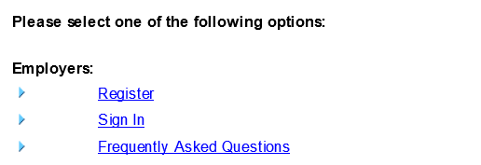

Once selected you will be asked to insert your Employing Authority code or GP Practice code (EA code), as follows:
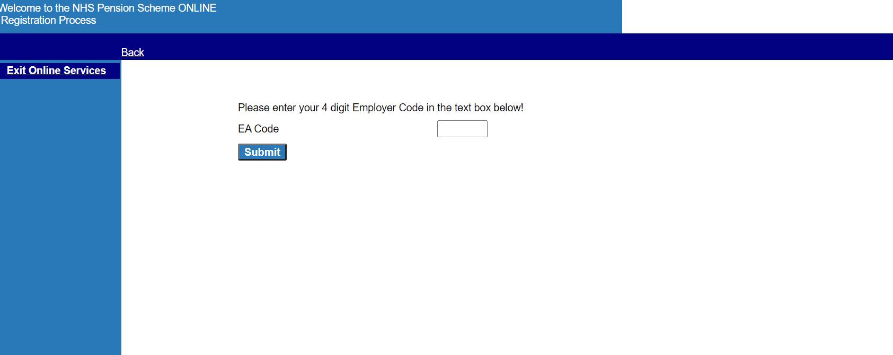
If you select this link and your Authority or GP Practice already has access to Pensions Online you will receive the onscreen message “Sorry, it appears that we already hold a registration for this EA code, please check your entry and try again. Should you continue to get this error message please contact the Agency”.

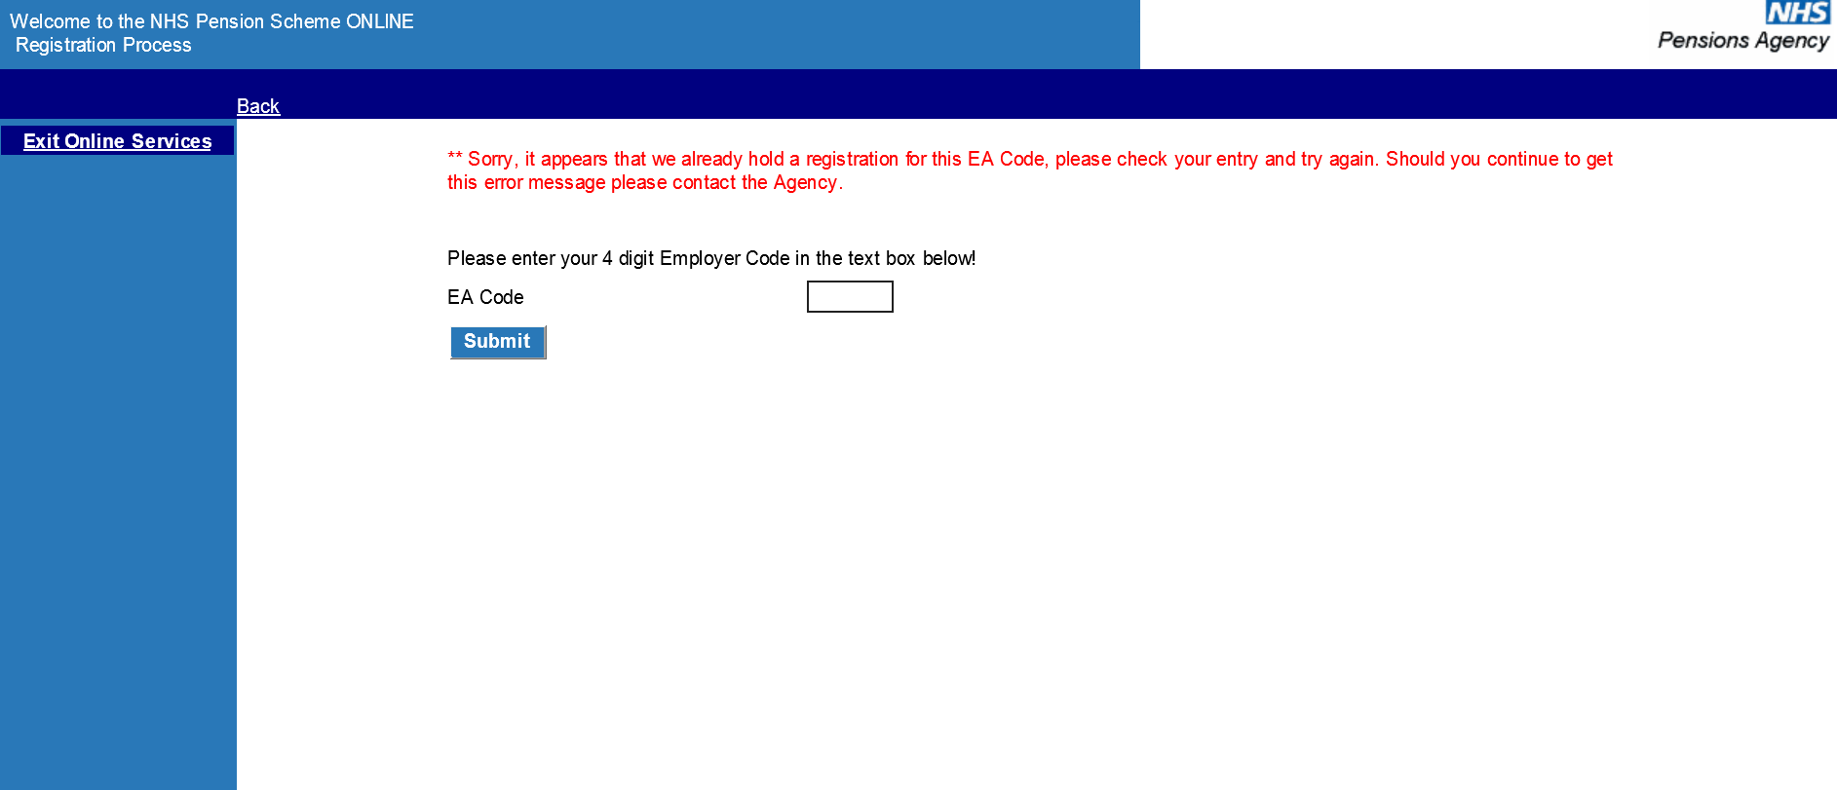

If this is your first registration you will continue to the next stage, as follows:
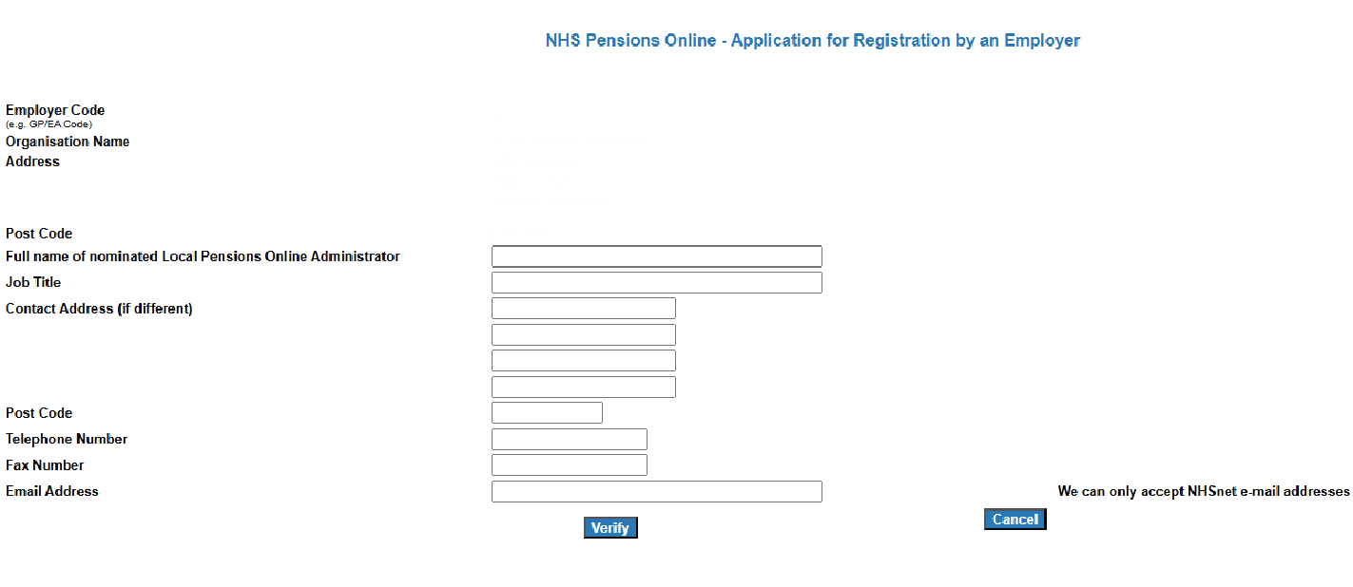

Once you have completed the form and selected ‘verify’ you will receive a confirmation page. You need to:
- print the page
- arrange for it to be countersigned by the Local Pensions Online Administrator's Board level manager or Principal Practitioner, for GP Practices.
- scan the countersigned form
- and then email it to polhd@nhsbsa.nhs.uk

Example of confirmation page:

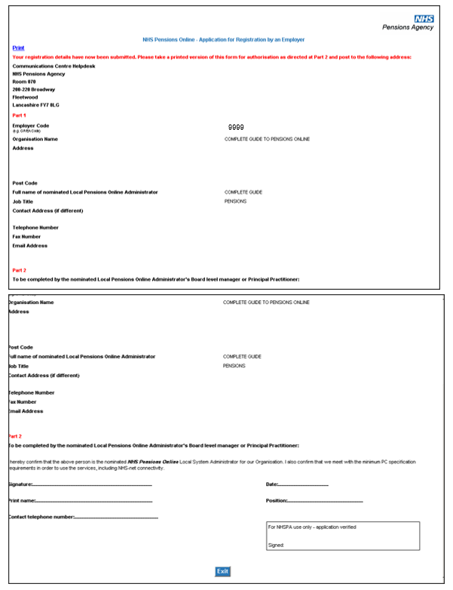

We will then verify the application and you will be issued with a pin and password. Details of how you can then register other users are contained in the ‘Pensions Online (POL) Guide 7. Administer Employer Access’, in the section for ‘Add New Access Rights’.

You will then receive an email with details of your pin number containing an icon called ‘Read Me’ which you can select for further details. Once you have received your PIN number, you must email polhd@nhsbsa.nhs.uk confirming your pin number and they will provide your password.
Once we have received a copy of the registration form. it generally takes 3 to 4 working days before you have system access.

Important note: If you have any problems with the registration process, or if you are an employer or third party administrator with access to the Health and Social Care Network (HSCN) and do not have access to a NHS.net email account, you must email polhd@nhsbsa.nhs.uk .

How we use your information
For more information about how the NHSBSA processes your personal data, please see our Privacy Notice -
www.nhsbsa.nhs.uk/our-policies/privacy/nhs-pensions-privacy-notice

NHS Pensions
POL Guide 3. Registration process

www.nhsbsa.nhs.uk/nhs-pensions

