

NHS Pensions

NHS Pensions Online (POL) Guide

7. Administer Employer Access

Main Pensions Online Administrator
This is the person who was given the authority to register a user to POL with the NHS Pension Scheme. They have different access rights to other users within your Authority/General Practice (GP), as mentioned in the following paragraphs.

As a main administrator you now have access to the full POL menu, as pictured here:

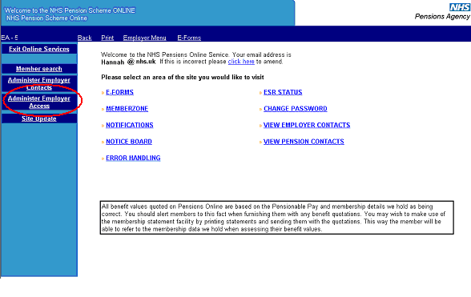

Administer Employer Access
This option is only available to the main POL Administrator and is not present on your screen if you are not the main administrator.

As the main administrator it is essential that you never allow any other administrator to use your Personal Identification Number (PIN) and password.

If a different POL user needs to be supplied with access rights then the main administrator can set these via the ‘Administer Employer Access’ link, as shown on the above screenshot and as detailed in the next section.

Add New Access Rights
After selecting this link you will be taken to the Employer Access screen that shows your POL user accounts. Select the link to ‘Add New Access Rights’.

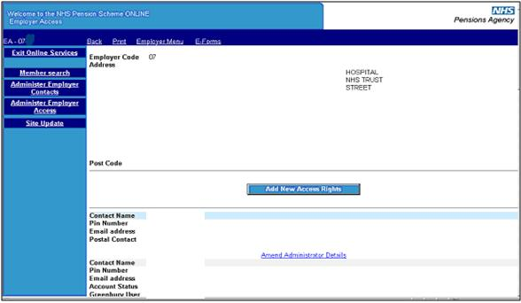

This will allow you to add the new users and assign them their access by ticking the relevant access boxes.

An email address must be supplied to allow any automated emails or notifications to be directed to the intended POL user.

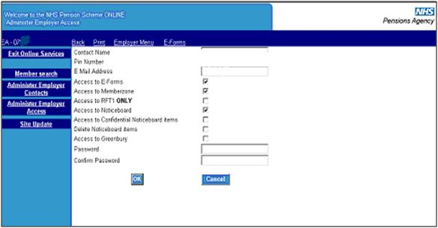

Amend Access Rights
If you have given an administrator access rights to an area on a temporary basis, (for example: access to ‘Greenbury’), then you can remove these access rights at the appropriate time by selecting ‘Amend Administrator Details’ alongside the administrator’s name, and unticking the relevant box(es):

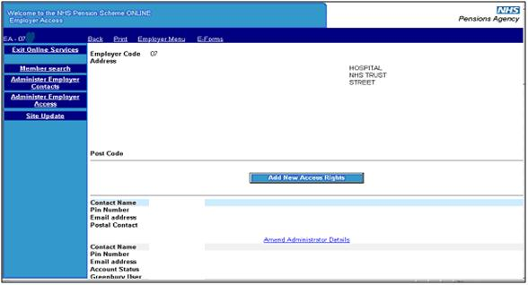

It is important that access rights for an administrator who is no longer employed by your Authority/GP Practice, or changes jobs within the Authority/Practice, and no longer requires access to POL, are deleted immediately to avoid any potential breaches of NHS Business Services Authority (NHSBSA) security policies.

If you wish to delete an administrator’s access selecting the ‘delete’ link does this:

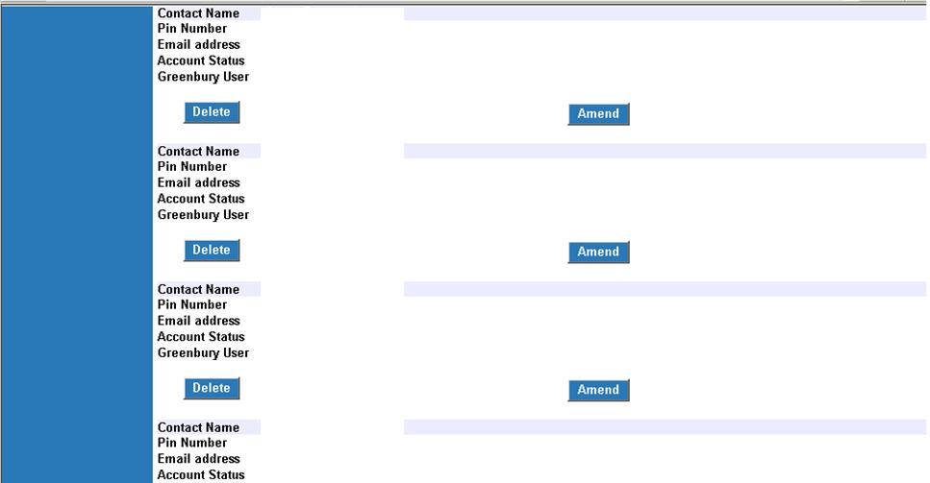

Administer Employer Contacts
This link allows you to add, edit or delete contact information for all pensions managers and administrators within your Authority/GP Practice, including those who do not require access to POL.

It is important that this information is reviewed regularly and kept up to date to enable the correct person to be contacted.

If an ‘employer contact’ leaves your Authority/GP Practice then their details should be deleted from the list.

All Registered Users
A pensions administrator, who is not the main user, would see the following screen once they login to POL. The links to ‘Administer Employer Contacts’ and ‘Administer Employer Access’ are not present, but all other functionality is available.

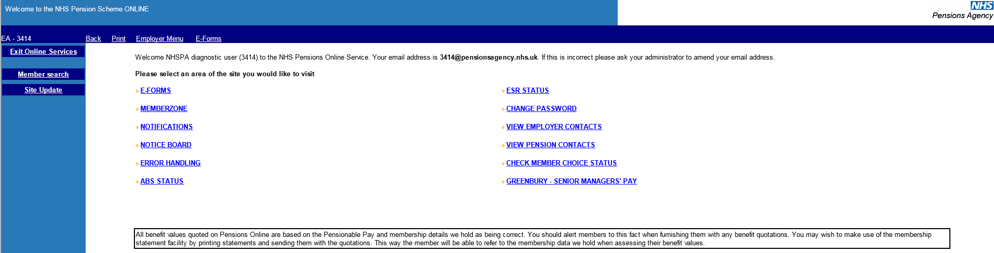

How we use your information
For more information about how the NHSBSA processes your personal data, please see our Privacy Notice -
www.nhsbsa.nhs.uk/our-policies/privacy/nhs-pensions-privacy-notice

NHS Pensions

Pensions Online (POL Guide) 7. Administer Employer Access
www.nhsbsa.nhs.uk/nhs-pensions

