

NHS Pensions

NHS Pensions Online (POL) Guide

16. SS10GP Joiner Form

The link to this form is only available for GP practices and should only be used for non-medical staff only.

Once you have accessed the E-Forms menu select the link for the SS10 and you will be presented with a page asking for the members’ personal details, as seen in the image below:

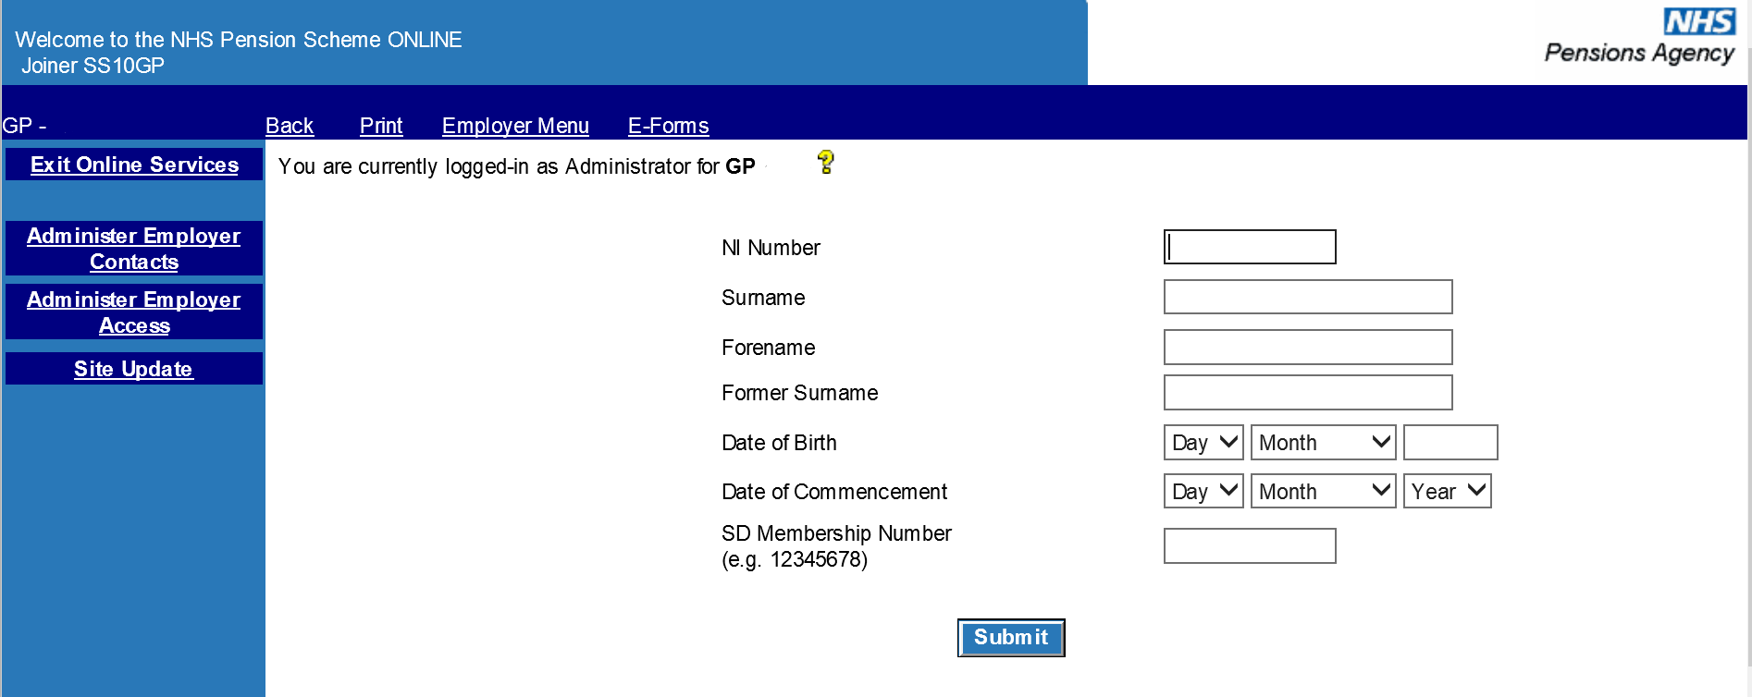

It is essential that correct information be entered on this screen to enable the joiner form to be processed to the correct member record.

Important Note:

If you do not know, or are unsure of, the member’s National Insurance (NI) number then this field should be left blank. If the member has been issued with a temporary NI number by HMRC (NI number prefixed with TN) or a temporary NI number used by NHS Pensions (NI number prefixed with ZZ), you should not use these numbers and the field should be left blank.

The following fields must be completed for you to be able to proceed and submit full joiner details:

- surname

- forename(s)

- former surname (any other name they have been known as e.g. maiden name), if applicable

- date of Birth

- date of Commencement (start date of this employment, not the date the member originally joined the Scheme)

Existing scheme members will already have a Pensions membership (SD) reference number. If you do not know this information, the field should be left blank.

If you know the member’s NI number, you can do a search for the membership (SD) number via the ‘Member Search’ link on the main Employer menu.

If the search identifies an existing member record for the NI number entered, it is important to check that the traced record matches your employee by checking their full name and date of birth against that of the traced record.

Where the details do not match, then the NI number you hold must be checked with HMRC. In these cases, you can submit the joiner form without an NI number.

When this page has been completed and you select ‘submit’ you will be taken to the SS10GP joiner form.

Where an existing member record is found the ‘SD number’ will be pre-populated on the joiner form, as seen in the below:

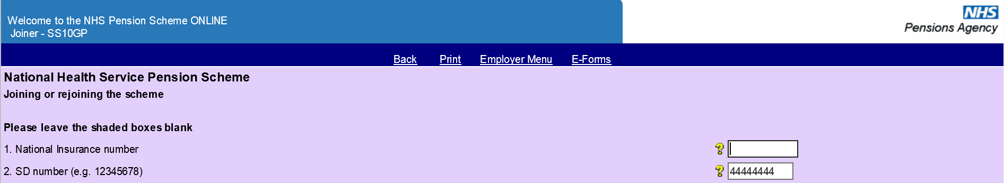

Once you access the actual SS10GP itself, the form does not include options to select details that relate to medical grades, as seen in the below:

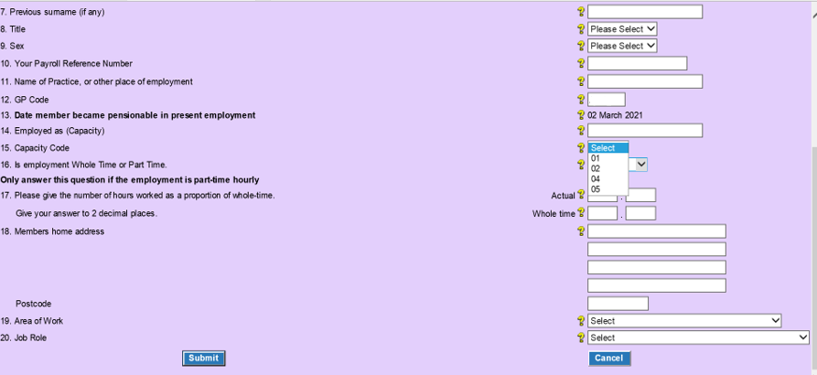

The only capacity codes available for selection are 01 (nurse, midwife, physiotherapist etc), 02 (nurse tutor), 04 (admin, clerical or supervisory) or 05 (manual staff).

Further information for completion of a specific field can be found in the ‘Help Text’ by selecting the ‘’ icon at the side of the field.

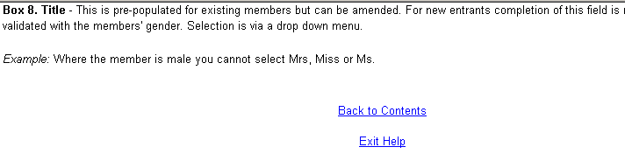

If mandatory fields are omitted or mismatching data is input, you will receive an onscreen error message.

For example, if you select ‘part time’ at box 16 you must also input the weekly actual contracted hours and the whole time hours for the job. A nurse contracted to work 16 hours a week out of a whole time 37.5 hour week would be entered in Box 17 as ‘Actual = 16.00’ and ‘Whole time = 37.50’.

An example of some of the error messages can be seen in the image below:

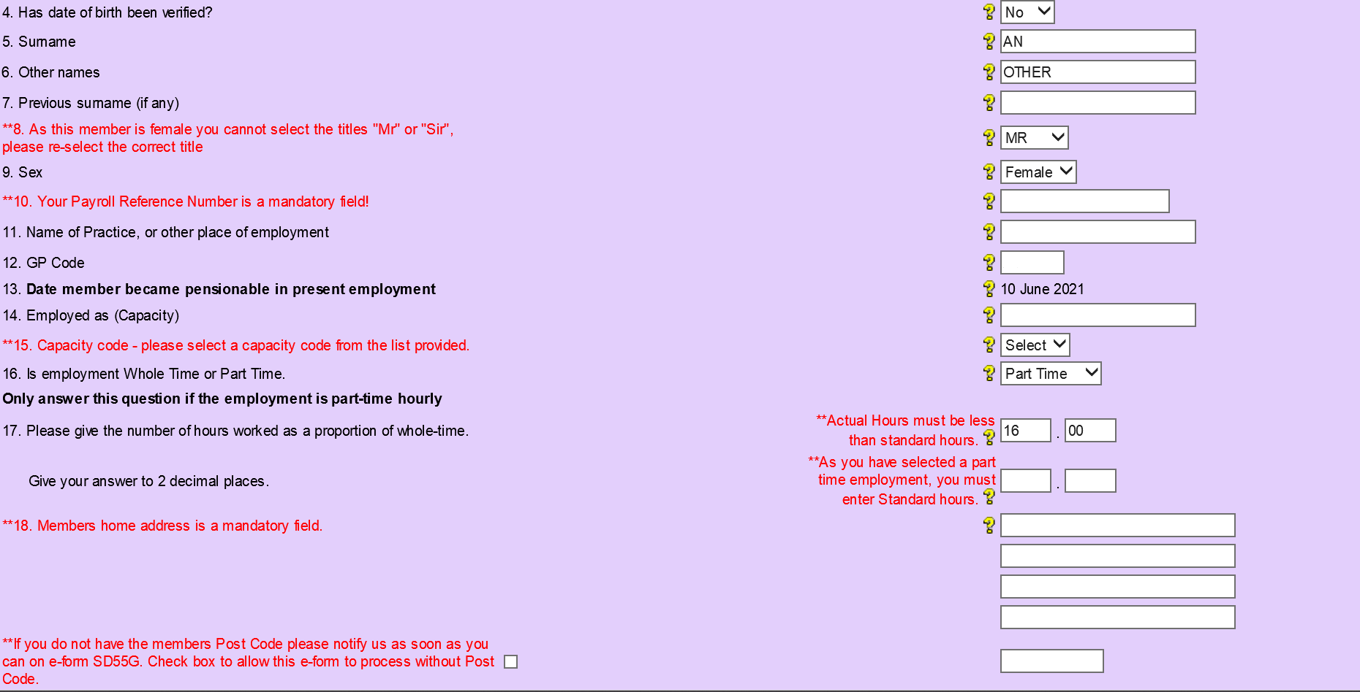

Fields 19 - 20 on the form relate to the area of work and job role.

On the fields, the options for completion are held in the drop down menu by selecting the arrow at the side of the completion area, pictured below:

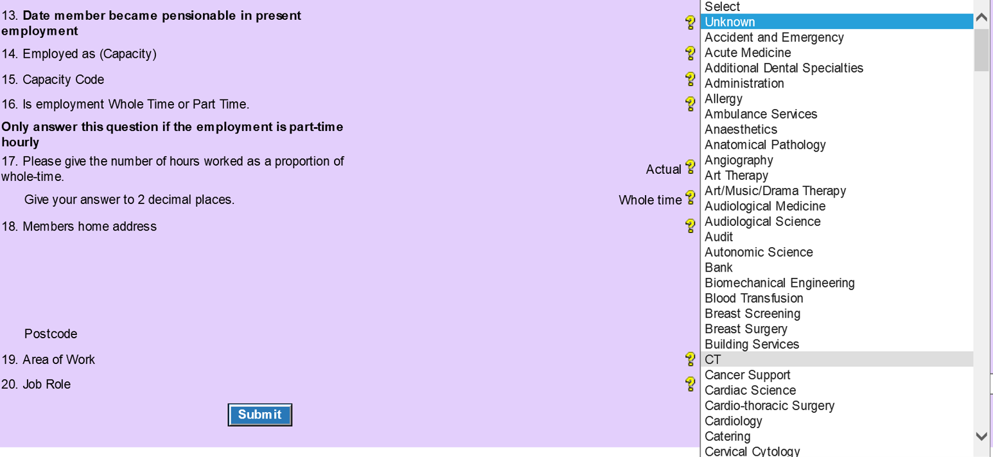

When successfully submitted you will receive a confirmation screen of the details input, which you can print if necessary.

Remember though that an accepted submission does not mean that the details successfully process to the member record.

If this form processes successfully you will receive an SD55 Notification confirming the joiner has processed and advising the member’s Pension Scheme membership (SD) Number. It will also show which Section of the 1995/2008 Scheme, or the 2015 Scheme, they are in and any other relevant details. These details include if they have an ongoing additional voluntary contributions (AVC) contract for which you need to deduct contributions or whether there is any arrears of contributions from a previous employment that require collecting.

If you do not receive the SD55 Notification then this is an indication that the joiner form has not processed successfully and an error has been created. Errors are either allocated to you or NHS Pensions for resolution, depending on the reason for the error.

In this circumstance check your ‘Error Handling’ cases and resolve the error if it is present. If no error is present then it has been allocated to NHS Pensions for resolution and will be dealt with in due course.

How we use your information
For more information about how the NHSBSA processes your personal data, please see our Privacy Notice -
www.nhsbsa.nhs.uk/our-policies/privacy/nhs-pensions-privacy-notice

NHS Pensions

16. SS10GP Joiner Form

www.nhsbsa.nhs.uk/nhs-pensions

