

NHS Pensions

NHS Pensions Online (POL) Guide

43. Open and rewind employment

Open a closed employment
A new menu option ‘open employment’ will be added to the existing e-form menu, as follows:
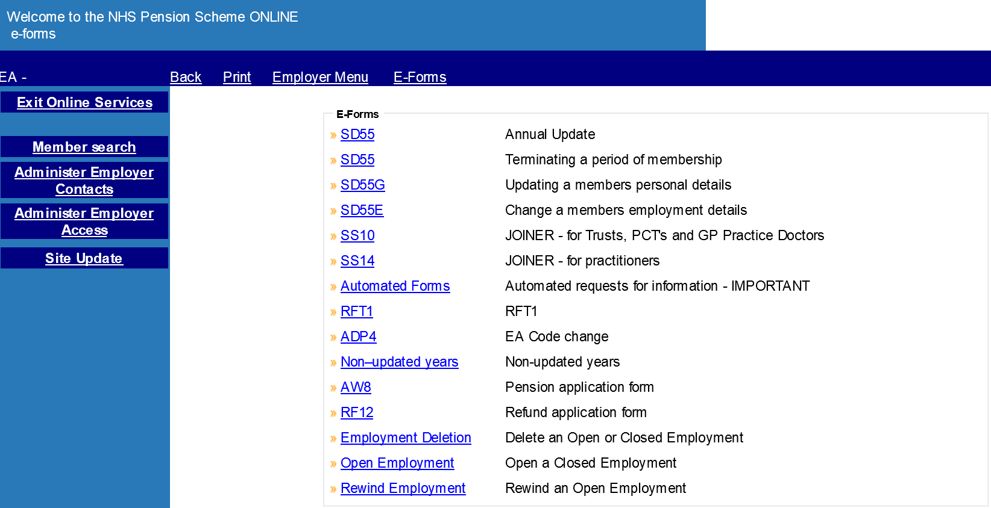

Member selection
You may select a member by entering either the National Insurance number or ‘SD membership number’

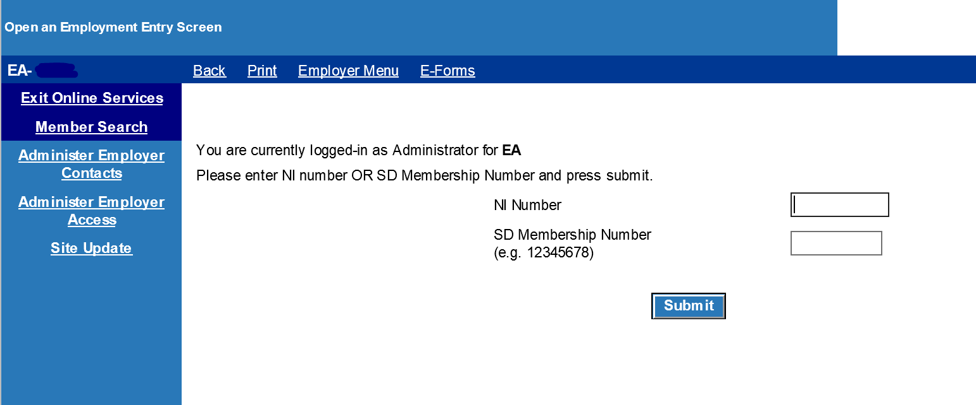

Employment selection grid
On passing the member validations, a grid will be produced showing all closed employments for that member.

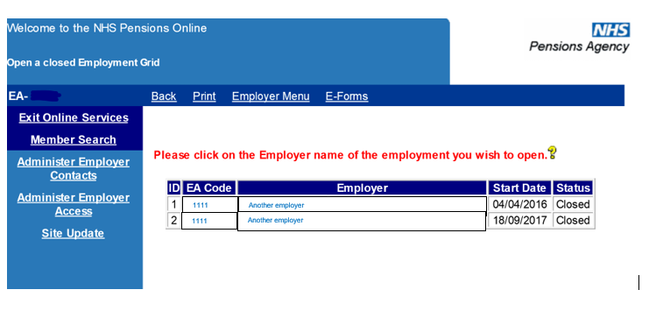
Note: For linked employments the grid will provide a single row combining both the 1995 / 2008 Section and 2015 Scheme employment elements.

Summary screen
On selecting the relevant closed employment to open, the summary screen will be produced.
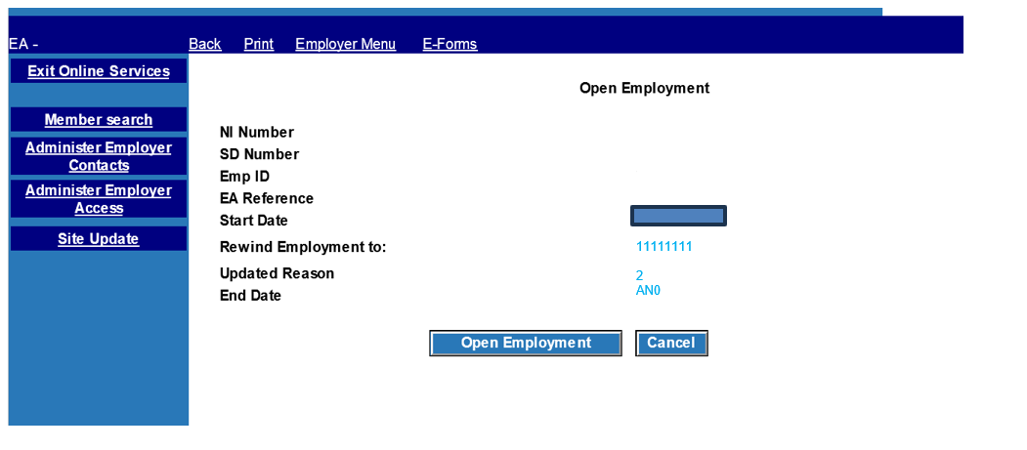

The ‘rewind employment to’ field is prepopulated:
- to 31 March immediately before the employment end date, as long as this date is no earlier that the service start date; or
- otherwise set to the service start date.

You may amend this date to:
- an earlier 31 March, as long as it is not before the service start date; or
- the service start date (to indicate removing all cyclic data for the employment).
When you select ‘submit’, you will be prompted with a confirmation message.
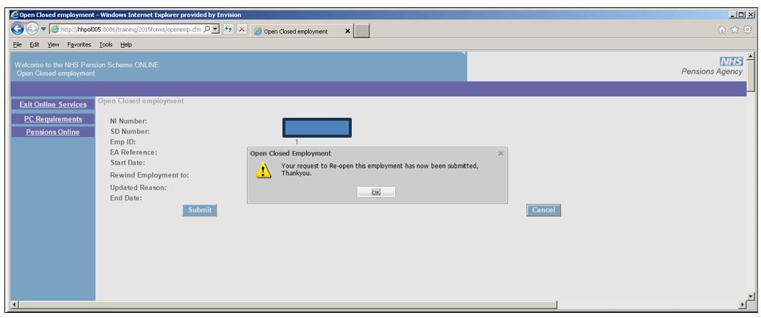
The following confirmation message is produced: “Your request to re-open this employment has now been submitted, Thank you.”

Rewind Open Employment
Rewind open employment is a new Pensions Online (POL) form present in the e-forms menu.
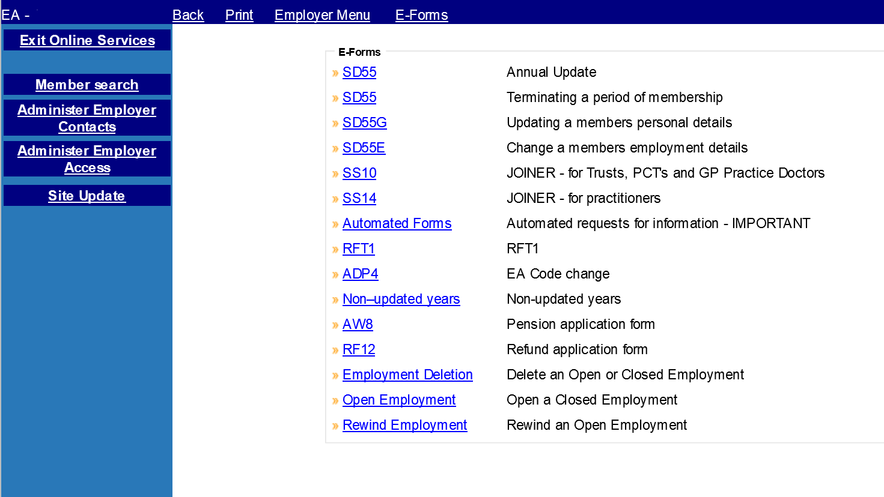

Member selection
When you select the ‘rewind open employment’ form, the member input screen is produced, existing validation rules will apply to the member input screen.
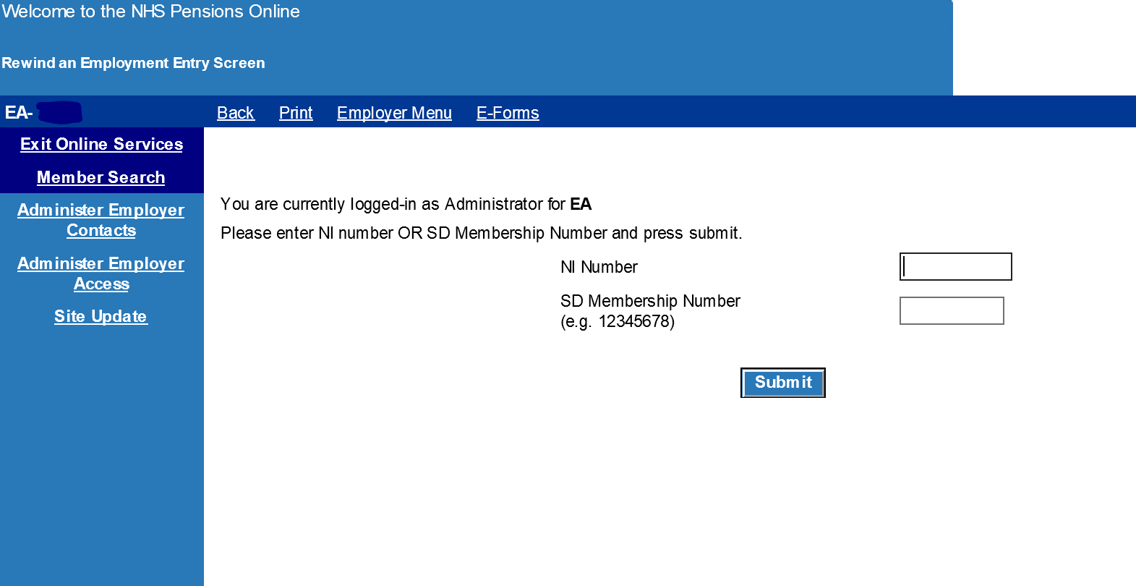

Employment selection grid
On passing the member validations, a grid will be produced showing all open employments for that member.
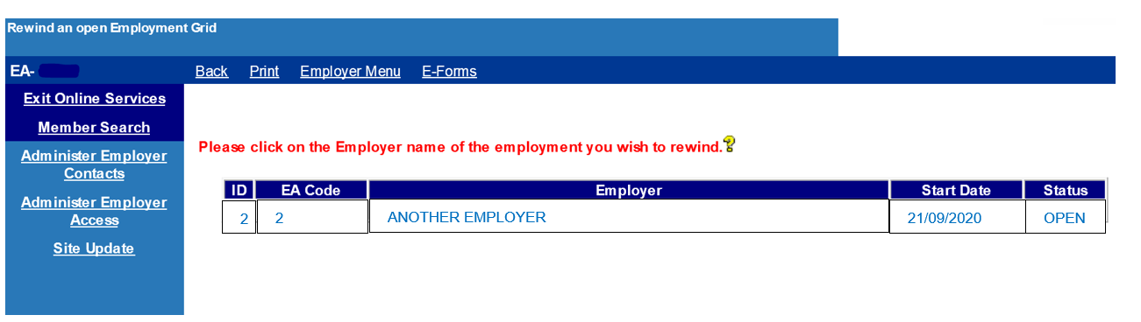

Note: For linked employments, the grid will provide a single row combining both the 1995/2008 Scheme and 2015 Scheme employment elements.

Summary screen
On selecting the relevant open employment to rewind, the summary screen will be produced.
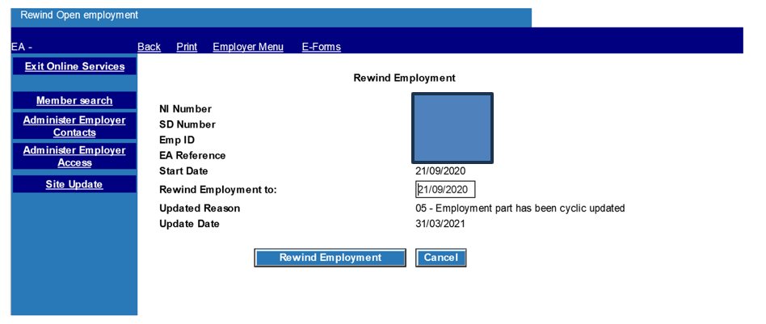

The ‘rewind employment to’ field is prepopulated as follows
- to 31 March immediately before the employment end date, as long as this date is no earlier than the service start date; or
- otherwise set to the service start date.

You may amend this date to:
- a previous year’s 31 March as long as it is not before the service start date; or
- the service start date (to indicate removing all cyclic data for the employment).

When you select, ‘submit’ you will be prompted with a confirmation message.

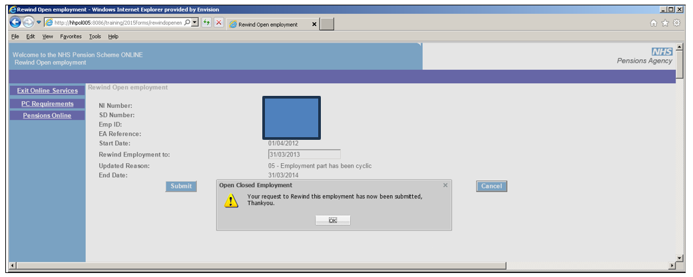

The following confirmation message is produced: ‘Your request to rewind this employment has now been submitted, Thank you.’

Employer error handling
The existing Employer Error Handling (EEH) menus will be extended to support the rewind open employment forms.
Error handling breakdown will now include the new forms, as shown below:
Select ‘Error Handling’ from the main POL menu and you are presented with the sub menu:

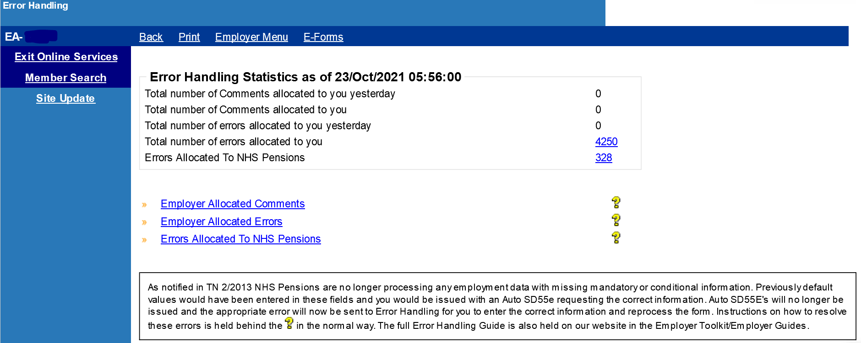
If you then select any of the 3 numbers in the ‘Error Handling Statistics’ section, then a breakdown of the number of errors by form type is displayed.
These statistics are to be extended to include the new forms, as follows:
- Open employment: Open a closed employment
- Rewind employment: Rewind an open employment
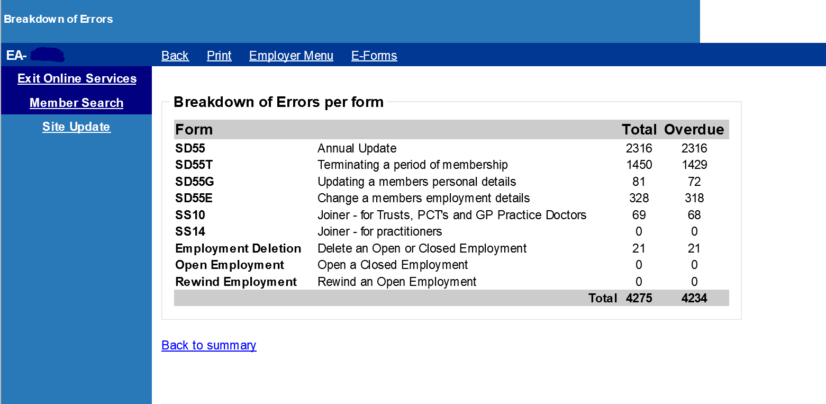

Employer allocated errors
If you select the option ‘Employer Allocated errors’ from the sub menu, the following menu is displayed allowing you to select a form type.
This menu has been extended to include:
- Open Closed Employment
- Rewind Open Employment

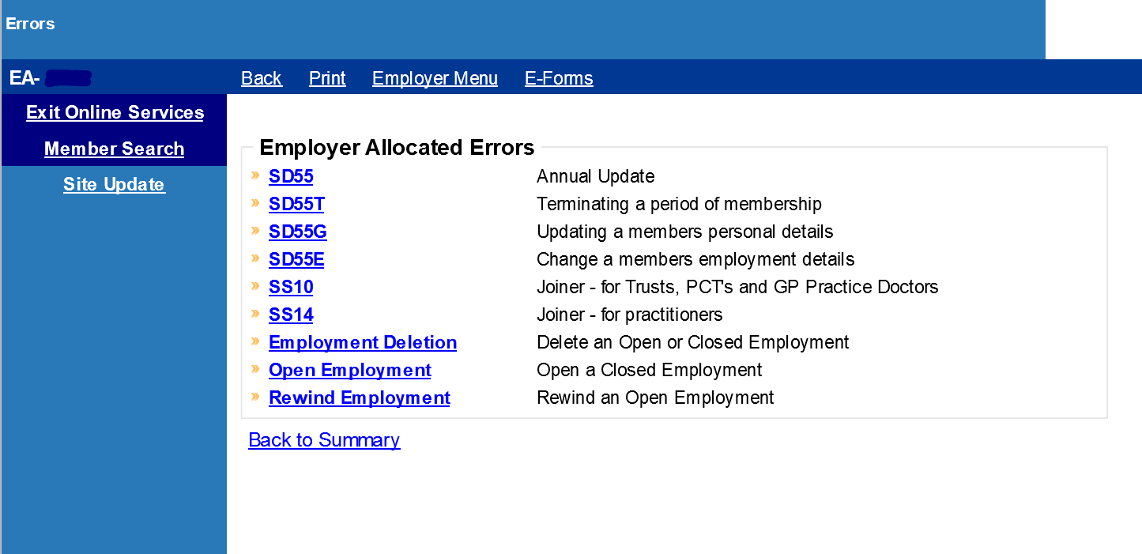

Employer errors selection grid
Errors for each form will be produced in the standard employer error handling grid.
Errors for the new forms option will be included; the grid is unchanged apart from the inclusion of the new form options.
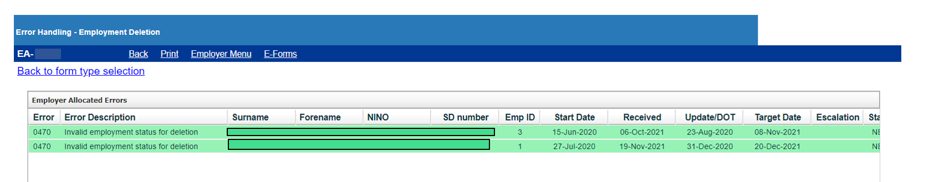

Error handling sub menu
On accessing an employer error, you will have the standard options for dealing with the error. All options will work the same as all other current employer error handling forms.
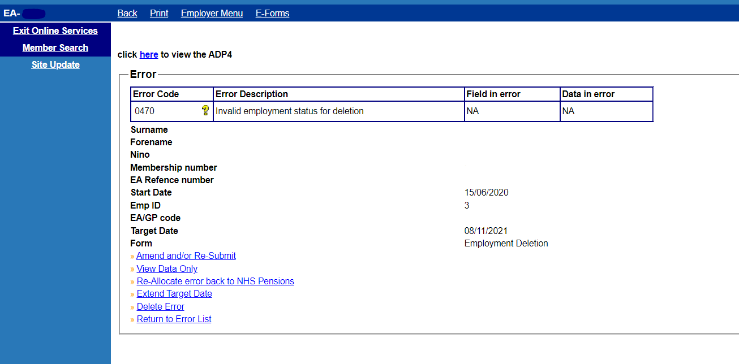

Amend and/or submit

Open a closed employment

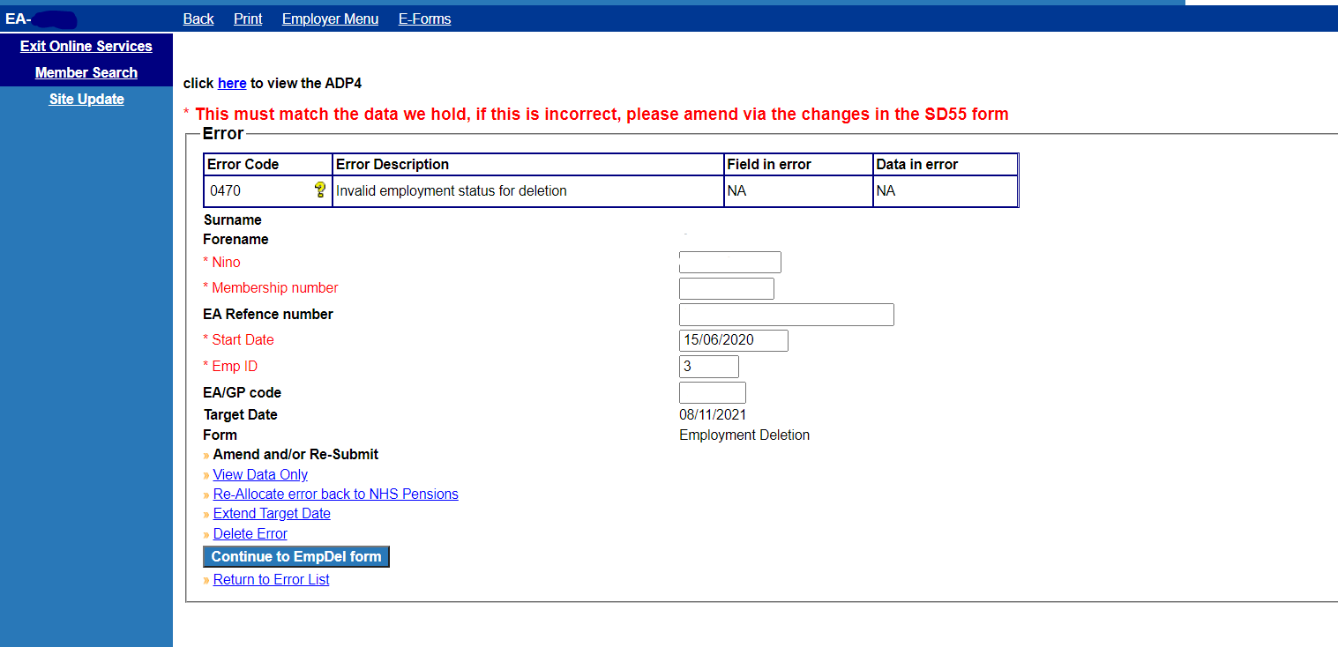

On selecting the ‘continue to OpenEmp form’, the following confirmation page is presented subject to all mandatory fields populated and matching the member record. Please note, on the Error Handling form you can only amend EA reference number, start date, emp ID, and EA/GP code.

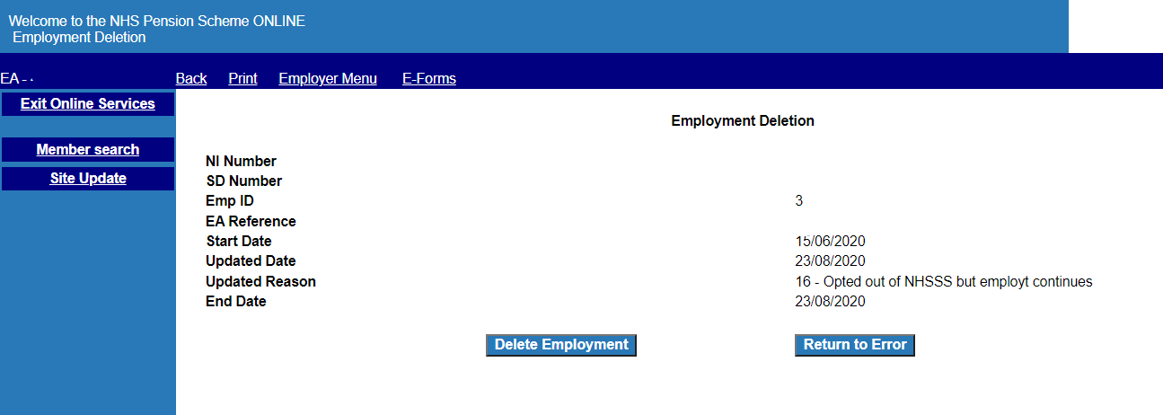

Rewind an open employment
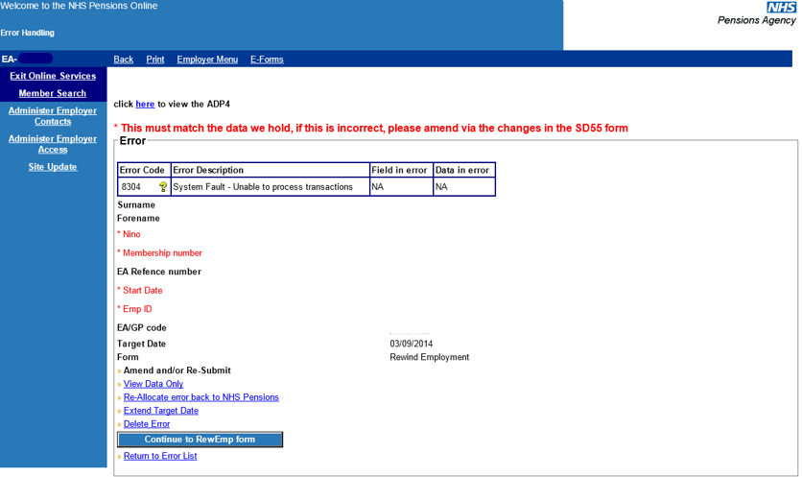
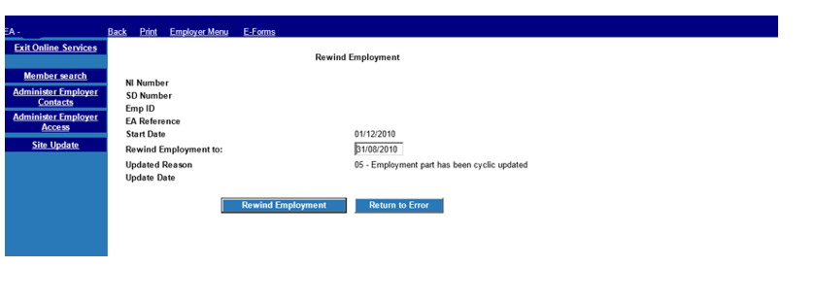

View data only
Both ‘open a closed employment’ and ‘rewind an open employment’ forms are identical except for the form title.
The example screen shot given is for ‘Open a Closed Employment’.

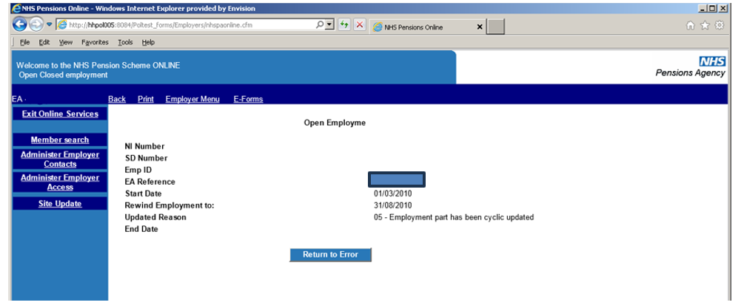
The page title for rewind employment is ‘Rewind Employment’

This is provided in an identical manner to existing forms,:

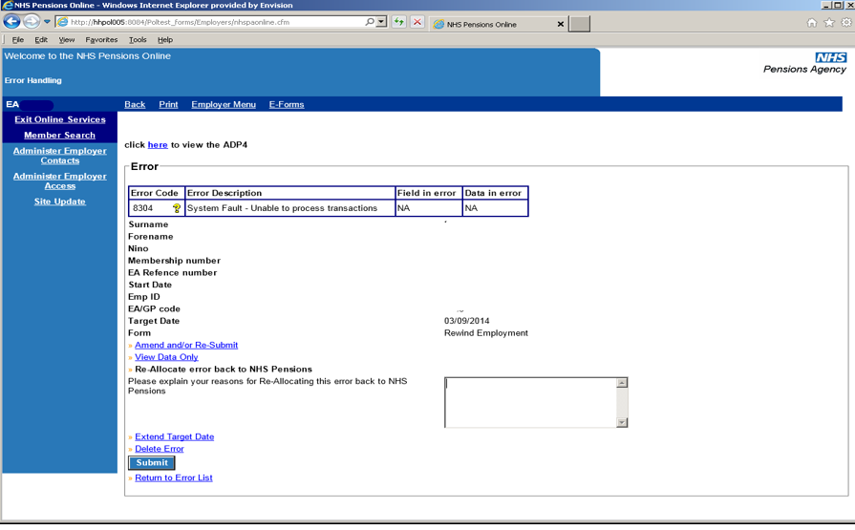
The only difference between the 2 form types is the title. The above screenshot is for ‘Rewind an Open employment’.

Extend target
This is provided in an identical manner to existing forms, ( the example given is ‘Rewind Employment’)

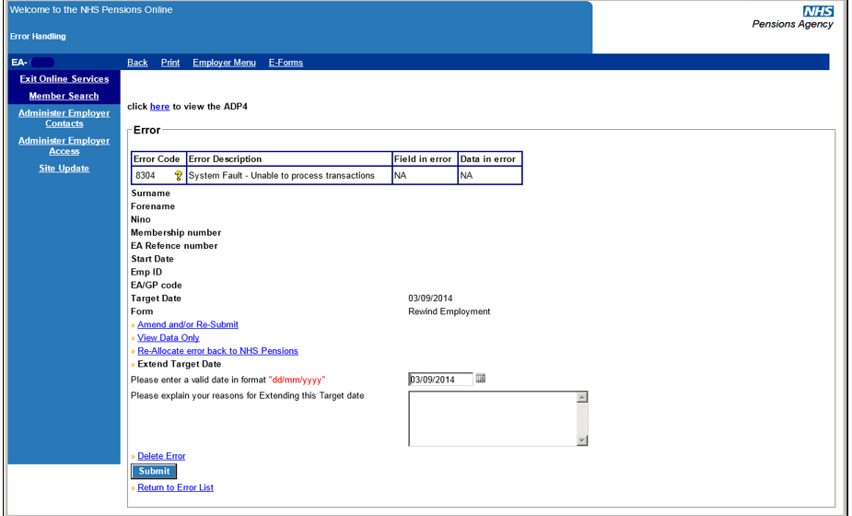

Delete error
This example is for ‘open a closed employment. Again, the screen is identical except for the form name description.

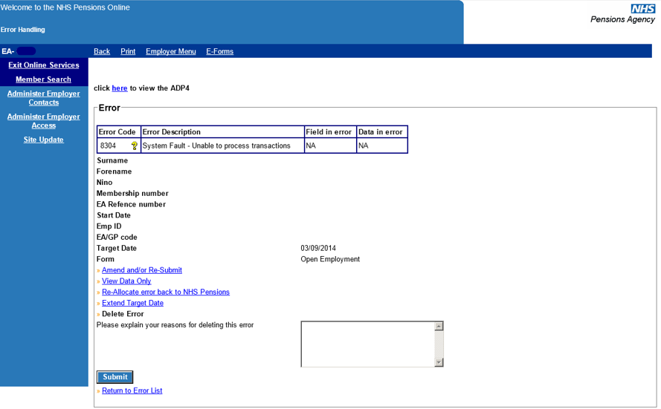

How we use your information
For more information about how the NHSBSA processes your personal data, please see our Privacy Notice -
www.nhsbsa.nhs.uk/our-policies/privacy/nhs-pensions-privacy-notice

NHS Pensions
43. Open and rewind employment

www.nhsbsa.nhs.uk/nhs-pensions

