

NHS Pensions

NHS Pensions Online (POL) Guide

9. Automated Forms Overview

Once the link is selected you will electronically receive details of ‘Automated Forms’ from the NHS Business Services Authority (NHSBSA) requesting urgent information:

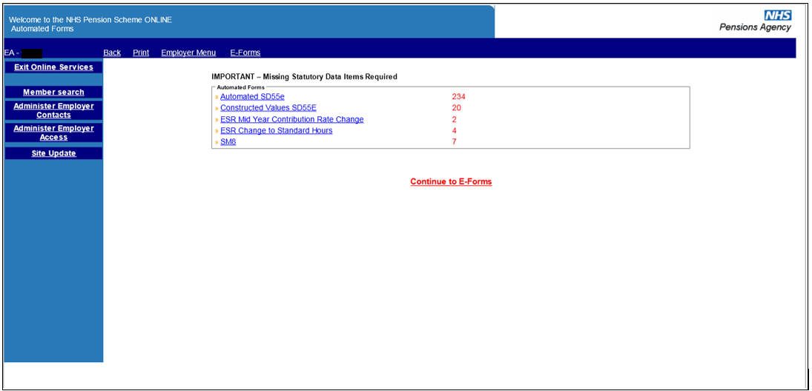

You will only be presented with the automated e-forms screen when you login to Pensions Online. After that, the link to the automated forms is present in the main E-Forms menu. When you next log-in, you will be taken straight to the automated requests page.

It is important that these are looked at, and responded to, on a regular basis. As you complete and submit responses, the number shown in red will reduce. Likewise, they will increase if the NHSBSA require information for additional errors.

If you do not wish to take any action on automated forms at this stage, select the link “Continue to E-Forms” to access the full E-Forms menu:

On this page, there is still a link to ‘Member Search’ if you need to check this before submitting a joiner form.

There are also shortcut links to the ‘Employer Menu’, ‘Print’ or ‘Back to the previous screen’. These are located on the dark blue banner above the E-Forms menu.

Any instances of “” within any of the E-Forms, indicates that there is a link to Help Text containing information specific to the E-Form you are completing.

How we use your information
For more information about how the NHSBSA processes your personal data, please see our Privacy Notice -
www.nhsbsa.nhs.uk/our-policies/privacy/nhs-pensions-privacy-notice

NHS Pensions

9. Automated Forms Overview

www.nhsbsa.nhs.uk/nhs-pensions

