

NHS Pensions

NHS Pensions Online (POL) Guide

21. SD55G – Change of personal details

The SD55G e-form and employer error handling form has been enhanced to include the members’ title as an amendable field, as well as the following personal details:
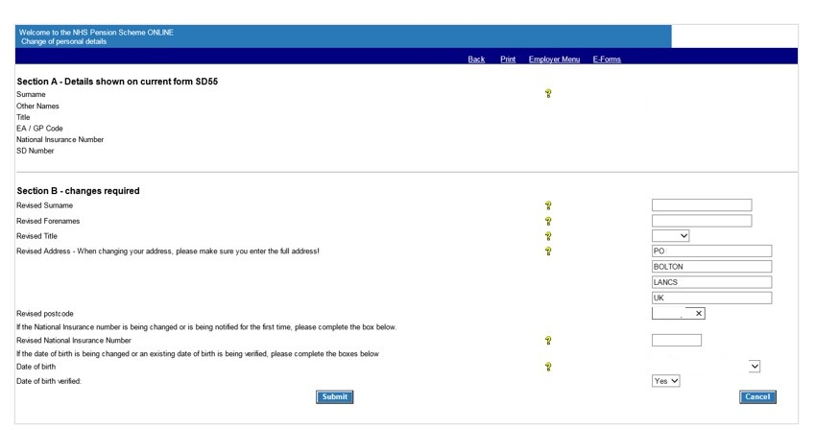

Revised title drop down options:
Code | Translation
DR | DOCTOR
M/S | M/S
MISS | MISS
MR | MR
MRS | MRS
MS | MS
PROF | PROFESSOR
REV | REVEREND
SIR | SIR

You can only submit changes on the SD55G e-form if the member is currently in pensionable employment with your authority/GP practice.

The SD55G e-form does have some validation checks as follows:

the surname, forename and address fields must be recognised characters
the date of birth (DOB) must have valid dates in the relevant fields
if you change a non-verified DOB to a revised date then you must have also verified this date by sight of the member’s passport or birth certificate and you must show the verification marker as ‘yes.’

If invalid information is entered on the SD55G e-form, you will receive on screen messages as follows:
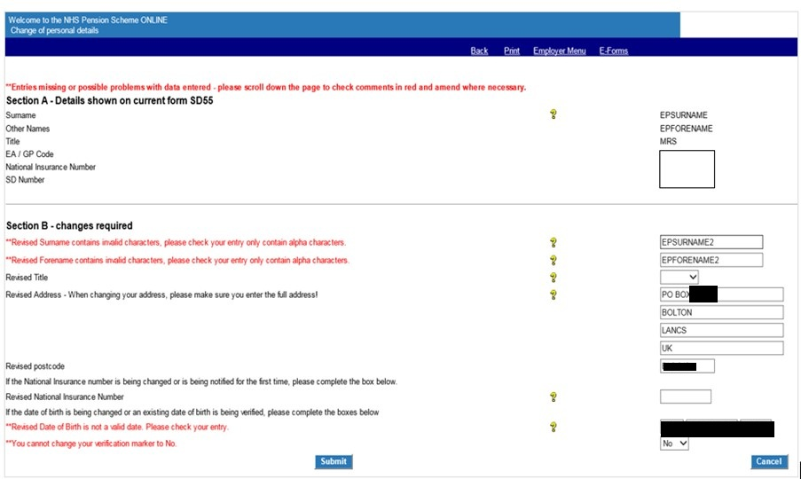
Once a successfully completed form is submitted, you will receive confirmation of the changed details as follows:
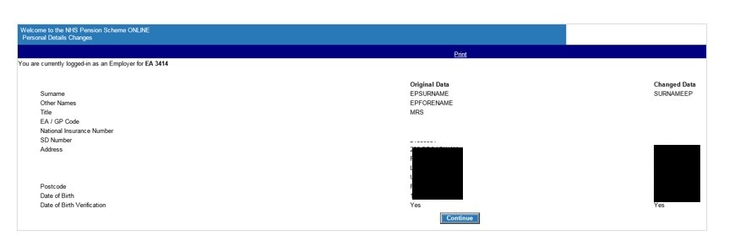
Select ‘continue’ to be taken back to a new SD55G e-form. From there, you will see links to other areas of Pensions Online.

How we use your information
For more information about how the NHSBSA processes your personal data, please see our Privacy Notice -
www.nhsbsa.nhs.uk/our-policies/privacy/nhs-pensions-privacy-notice

NHS Pensions

Pensions Online (POL Guide) 21. SD55G – Change of personal details

www.nhsbsa.nhs.uk/nhs-pensions

