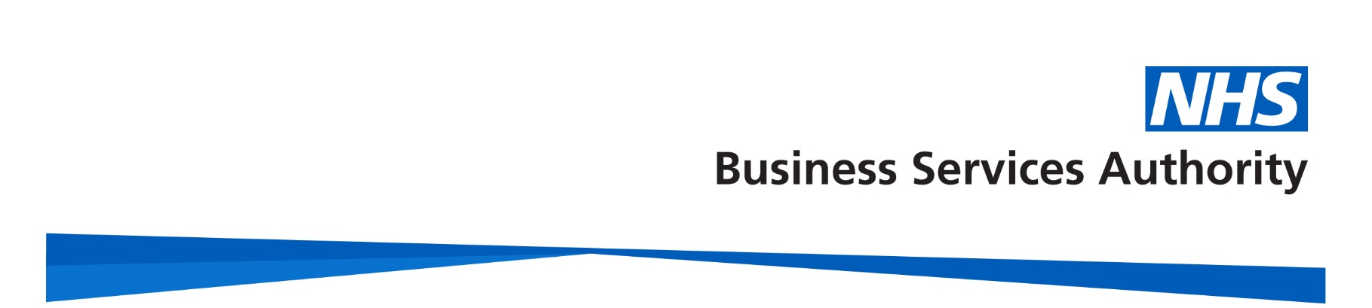

NHS Pensions

NHS Pensions Online (POL) Guide

33. Notice Board
The link to the Notice Board is held on the main employer’s menu.

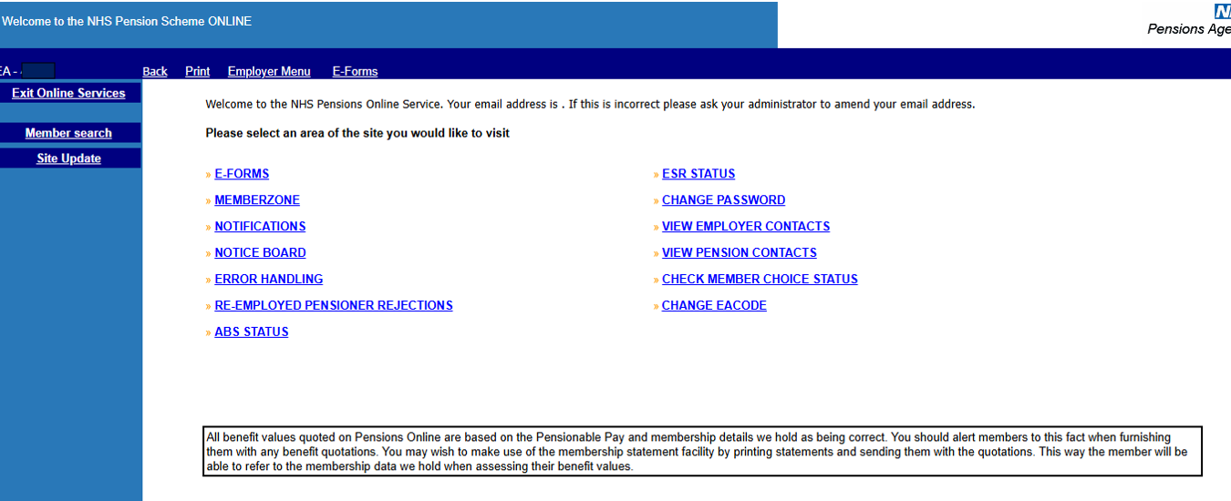
After selecting the link the 1st page shows the total number of items on the Notice Board that have not been opened and the number that were posted to Notice Board the previous day that have not yet been opened.

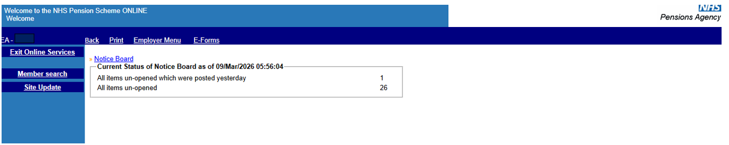
To view all items on Notice Board select the blue link.

This then displays all items sent to the Notice Board for your attention, with the newest items at the top of the list.

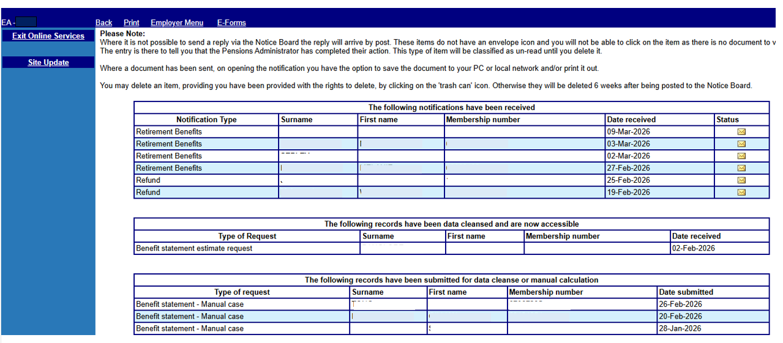
The Notice Board screen is split into 3 sections:

- Received notifications
- Completed Data Cleanse Items
- Submitted Data Cleanse Items or Manual Cases

Received notifications

The types of notifications you will receive are as follows:

- Refund - this is confirmation of a refund of contributions being paid to someone who has left your employment
- Retirement Benefits
- Age Estimates – Manual Case
- Ill Health Estimate – Manual Case
- Redundancy Estimates – Manual Case
- ARER Estimates – Manual Case
- Employer Funded ER Estimate – Manual Case
- Benefit Statement – Manual Case
- Service Statement – Manual Case
- AVC Request – Manual Case

You will be able to view the notification; save the document to your PC or local network and/or print it out.
Where it is not possible to send a reply via the Notice Board the reply will arrive by post. These items do not have an envelope icon and you will not be able to click on the item, as there is no document to view. The entry is there to tell you that the NHS Pensions administrator has completed their action. This type of item will be classified as un-read until you delete it.
You may delete an item, providing you have been provided with the rights to delete, by clicking on the 'trash can' icon. Otherwise they will be deleted 6 weeks after being posted to the Notice Board.

Records Submitted for Data Cleanse or Manual Calculation

If, when you try to calculate benefits in Memberzone, you receive a message advising that the member record is excluded from Pensions Online it may be because a Data Cleanse needs performing or a manual calculation is needed.

An electronic request will be sent to NHS Pensions and the Notice Board will record this and display the type of request that has been made.

When completed by NHS Pensions this entry will be removed and you will either receive a notification in section 1 or 2 of the page advising that either the manual calculation or Data Cleanse action has been completed.

How we use your information
For more information about how the NHSBSA processes your personal data, please see our Privacy Notice -
www.nhsbsa.nhs.uk/our-policies/privacy/nhs-pensions-privacy-notice

NHS Pensions

Pensions Online (POL) 33. Notice Board

www.nhsbsa.nhs.uk/nhs-pensions

