

NHS Pensions

NHS Pensions Online (POL) Guide

8. E-Forms Overview

E-Forms can be selected by using either of the links shown on the example screen below.

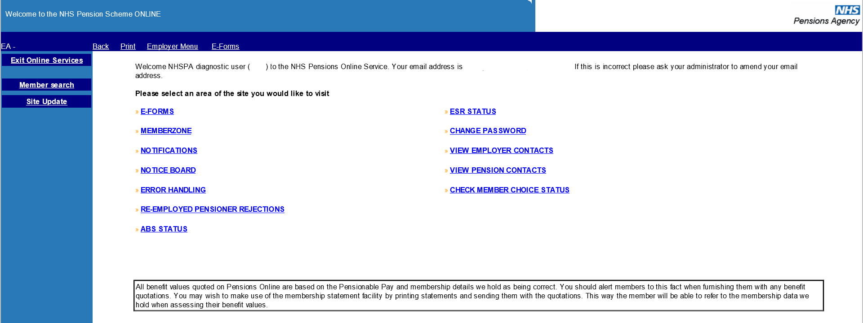

E-Forms allow you to electronically complete and submit pensions related forms to NHS Pensions. If you require a record of the information you have submitted via E-Forms you can print out the confirmation page when the form is successfully submitted.

The submitted form then processes through NHS Pensions validation and a processing system before being updated to the members’ record. Not all forms process successfully and those that ‘fail’ go into a ‘suspense file’ and are either allocated to NHS Pensions to investigate the reason why it will not process or is allocated to yourselves for action. Forms allocated to employers for action are available in the ‘Error Handling’ link in the main ‘Employer Menu’ of Pensions Online.

Further information about dealing with errors is explained in the Guide ‘34. Error Handling Guide.’

Before you are taken to the full menu of electronic forms you will see a list of Automated Requests (Guide no.9) for information from NHS Pensions, as follows:

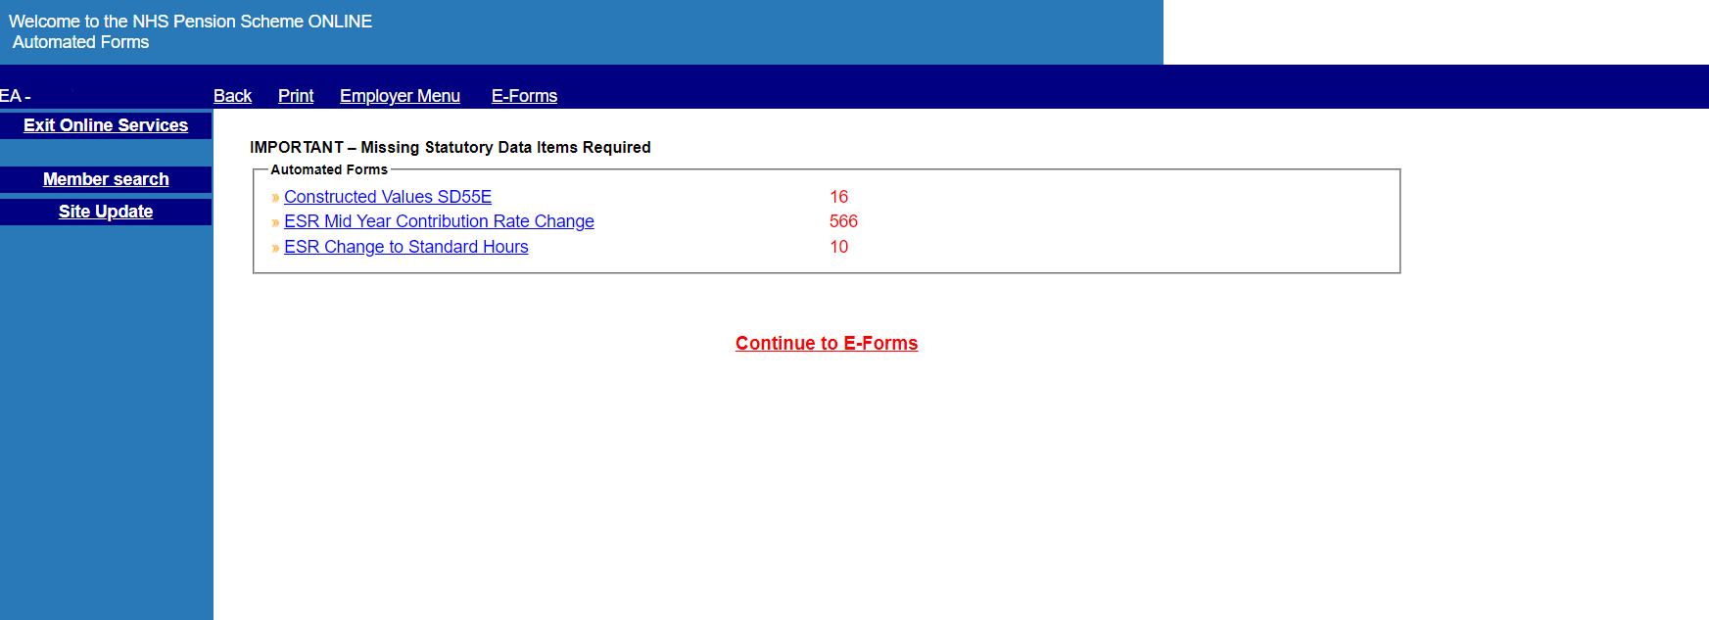

Further detail for each of these forms is explained in the following guidance documents:

‘09. Automated Requests Overview’
‘10 Constructed Value SD55E’
‘11. ESR Mid Year Contribution Rate Changes’
‘12. ESR Changes to Standard Hours’
These automated requests should be actioned as soon as possible as NHS Pensions are waiting for information to enable them to update or amend the member record.
As you complete and submit responses the number shown in red will reduce. Likewise they will increase if NHS Pensions require information for additional errors.

To see the full list of E-Forms select the link ‘Continue to E-Forms’ and the following menu will then be displayed:

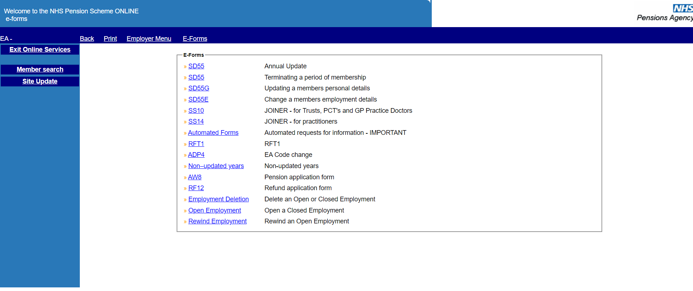

Further guidance for each form is available in guides:

- 14 – Joiner form overview
- 15 – SS10 joiner form
- 16 – SS10 GP joiner form
- 17 – SS14 joiner form
- 18 – SD55 – Annual update
- 19 – SD55 – Terminating a period of employment
- 21 – SD55G – Changes to personal details
- 22 – SD55E – Amending contributions, pay and hours
- 23 - RFT1
- 25 – ADP4
- 26 – Non-updated records
- 27 – AW8 – Retirement benefit claim form
- 28- Application for refund of contributions
- 31 – GP1 (GP Practices only)

How we use your information
For more information about how the NHSBSA processes your personal data, please see our Privacy Notice -
www.nhsbsa.nhs.uk/our-policies/privacy/nhs-pensions-privacy-notice

NHS Pensions

Pensions Online (POL) 8.E-Forms Overview

www.nhsbsa.nhs.uk/nhs-pensions

