

NHS Pensions

NHS Pensions Online (POL) Guide

14. Joiner Forms overview

If this is the first time the employee has been in the Scheme, processing of the joiner form will allocate the member with an NHS Pensions membership number (SD number) and an electronic pensions scheme record will be created.

If the individual has previous scheme membership the same SD number and existing electronic record will be used.

There are three joiner forms used to submit details of new scheme members to NHD Pensions. For their employment to be recorded correctly it is important that you select the correct joiner form.

Before you can notify NHS Pensions of annual contribution and pay details via form SD55 annual update or an SD55 Termination form, a joiner form must be submitted and process successfully via NHS Pensions processing system.

The three forms are:

SS10 – available to all NHS employers, general practitioner (GP) practices (for practice doctors that are employed at a trust) and/or direction employers

SS10GP – only available to GP practices for non-medical employees

SS14 – available to all NHS employers, GP practices and direction employers

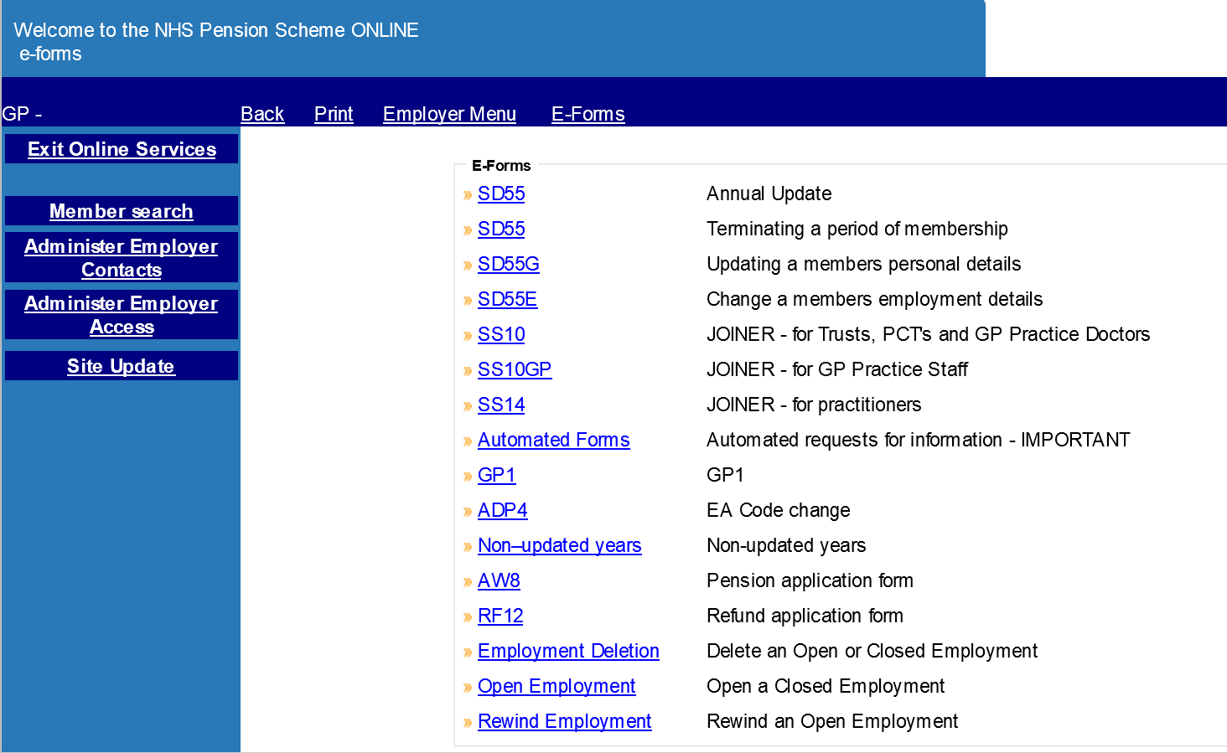

Note: Temporary National Insurance (NI) Numbers cannot be input on joiner forms. If the member has not yet been issued with a NI number by HM Revenue and Customs (HMRC) then this field should be left blank and NHS Pensions will issue a ‘ZZ’ number. When a number is issued by HMRC you should then notify NHS Pensions by completing form SD55G with the revised NI number

If the member has previously been a member of the Scheme but you do not know their SD number, you can look for this using the Search facility in Pensions Online.

How we use your information
For more information about how the NHSBSA processes your personal data, please see our Privacy Notice -
www.nhsbsa.nhs.uk/our-policies/privacy/nhs-pensions-privacy-notice

NHS Pensions

POL Guide 14. Joiner Forms overview

www.nhsbsa.nhs.uk/nhs-pensions

