

NHS Pensions

NHS Pensions Online (POL) Guide

25. ADP4 (EA Code Change)

ADP4 E-Form uses
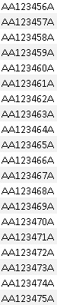
The ADP4 E-Form allows you to:

- change the Employing Authority (EA) code for single, multiple or all members who are currently employed with you and are changing to another EA Code but remaining in the same employment.

- see a full list of members who have a current open employment with you.

- check start dates, employment ID, NHS Pensions membership number (SD Number)
- check the date to which their pension record has been updated

- extract the information from the list into an Excel spreadsheet

- print the full list of your active scheme members

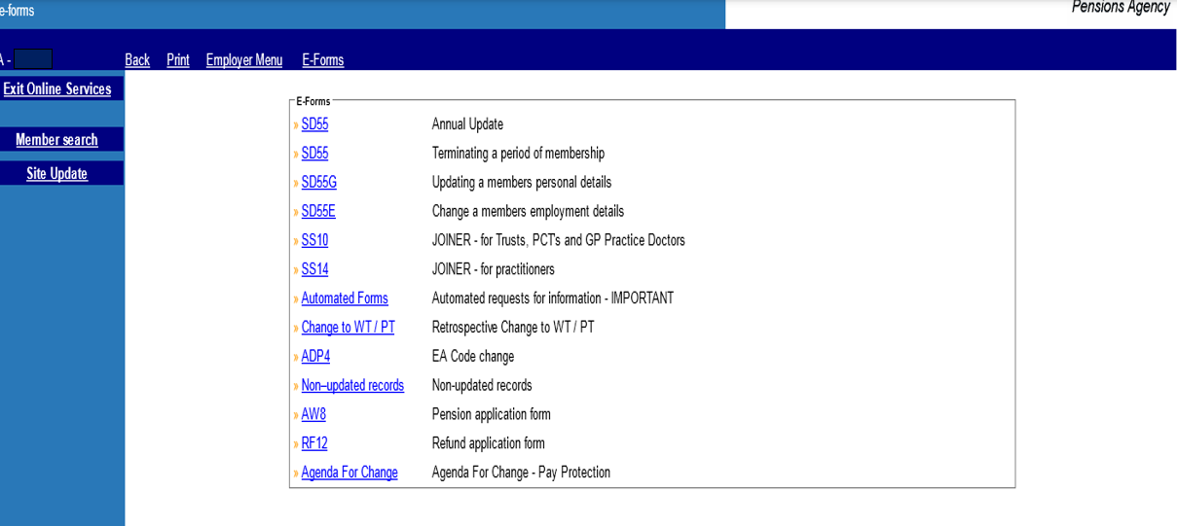
Although the member record will be updated with an EA Code change within a couple of hours, the list of members in the ADP4 for the new EA Code is updated overnight and you will not see the changes you have made until the next day.

If you have submitted a joiner form or a cyclic update and you want to check if this has processed successfully, the ADP4 list is a good way of checking this.

It is also useful when dealing with some errors and the Error Handling Guide explains how the ADP4 can help.

Sorting the list
Once you have selected the link in the E-Forms menu you will be presented with the list shown below:
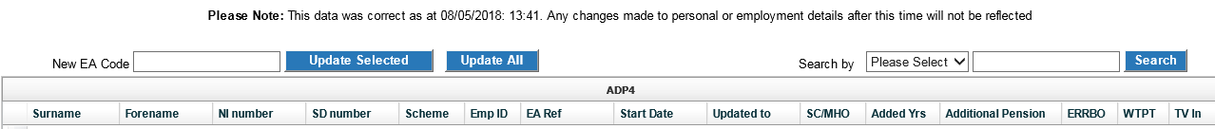

Please note: The details shown on all screen examples are taken from a test database.

The list can be sorted into any order by clicking on the column title that you wish the order to be in.

For example, if you want the list in National Insurance number (NINO) order, click on the title and the list will be sorted into NINO order.

You can also change the order of the columns by dragging and dropping the column into the position you wish. This is done by left clicking and holding and moving the mouse into the position you want.

The following example shows the ‘Scheme’ column is being moved next to ‘Forename’:

The column has now been successfully moved:

If you wish to find a specific member it is best to amend the order to ‘NINO’ or ‘Surname’ to allow you to scroll down until you find the relevant member.

Alternatively, you can enter either the SD number, NI number, Surname or EA Ref/Assignment number in the search field and select the relevant field on the drop down menu on the ‘Search by’ field, as shown below.

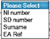

Please note however, that where you are changing the EA Code for a member found using the search field, the change is restricted to that member only.

Exporting the data
There is the option to extract the data from the list into Excel or Acrobat, and this is done by selecting one of the links ‘Export Notifications to Excel/PDF.’

Once you select this link you will be asked whether you wish to open the information in Excel or save it in Excel.

The following box will appear at the bottom of your screen:

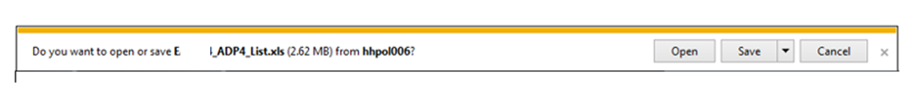

If you select ‘open,’ an Excel spreadsheet will be displayed showing all members details held in the ADP4 list. You will not be taken out of Pensions Online.

If you select ‘save’ you then have the options to ‘save,’ ‘save as’ or ‘save and open’:

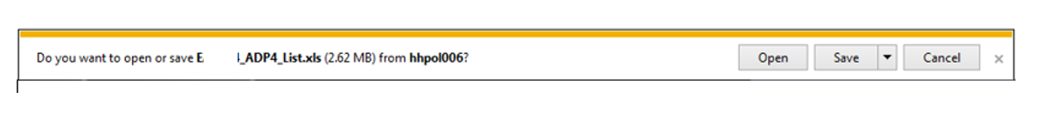

It is suggested that you choose ‘save as.’ You will then be asked to name the document and can choose in which local directory and folder you wish it to be saved in. Choose a title for your document and enter this in the ‘File Name’ field. If you wish it to be saved in a directory other than that automatically opened by your computer, then choose the correct directory or search for your preferred local directory in the normal way:

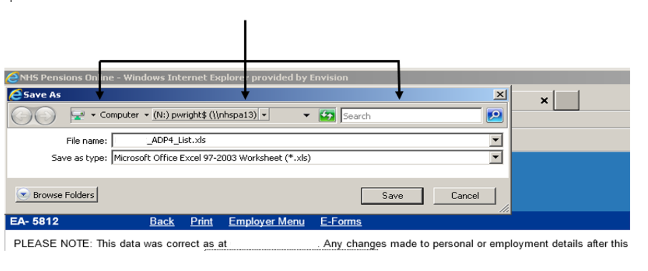

To change member EA code
To change a members EA Code, type the new EA Code in the ‘EA Code’ box and then select ‘Tick to change’ alongside the member(s) that you wish to allocate the new EA Code, as follows:

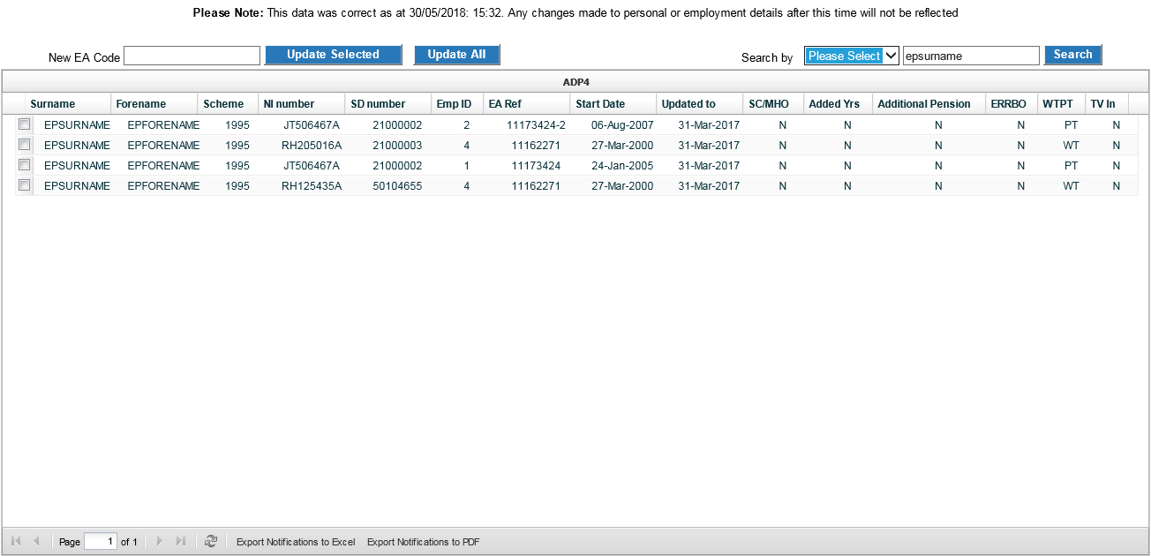

Then click ‘Update Selected.’ No more than 40 members can be selected at any submission.

If all your members are changing over to a new EA Code click ‘Update All,’ there is no need to select each member.

The bottom of the list will show further pages: click on the arrows to move between pages.

Once your selection is made you will be requested to confirm your action, as follows:

Confirmation message if ‘Update All’ is selected:

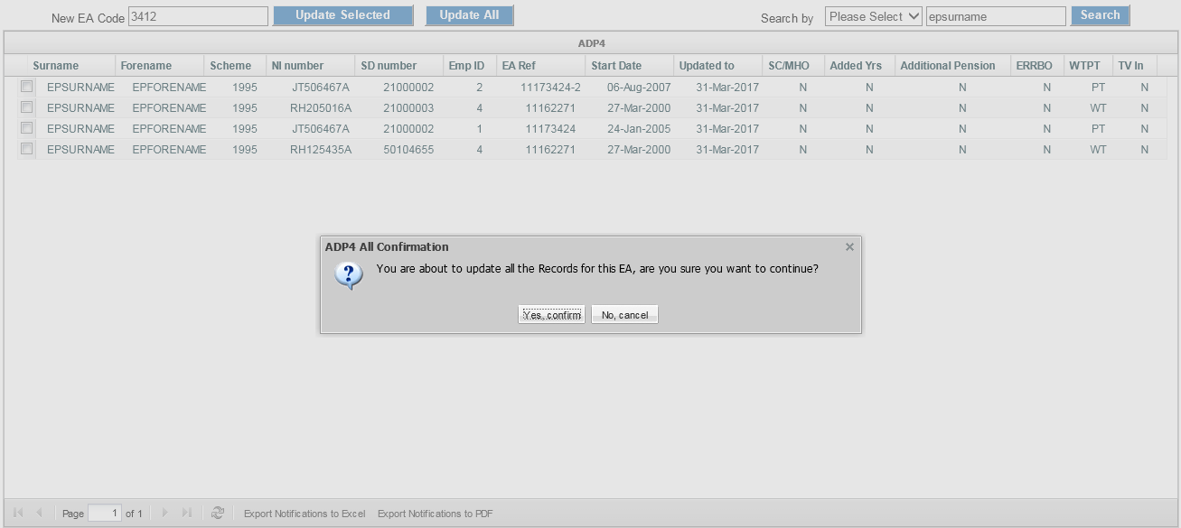

Confirmation message if ‘Update Selected’ is selected:

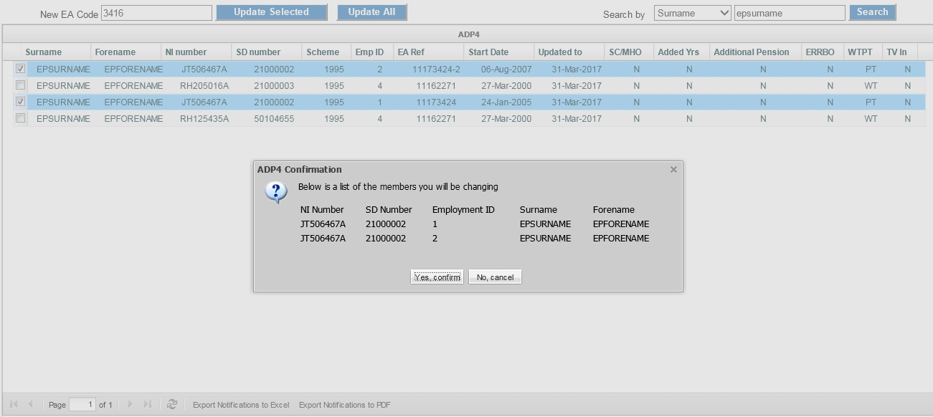

Check the proposed changes carefully before selecting continue and if you have made any errors either on the new EA Code entered or the members that have been selected; select ‘cancel’ and this will take you out of the ADP4 and back to the E-Forms menu.

If you are happy with the changes, select ‘continue’ and they will be processed at NHS Pensions the same day but will not be reflected in the ADP 4 list for the new EA Code until the next day.

How we use your information
For more information about how the NHSBSA processes your personal data, please see our Privacy Notice -
www.nhsbsa.nhs.uk/our-policies/privacy/nhs-pensions-privacy-notice

NHS Pensions

POL Guide 25. ADP4 (EA Code Change)
www.nhsbsa.nhs.uk/nhs-pensions

