

NHS Pensions

NHS Pensions Online (POL) Guide

31. GP1 (General Practitioner (GP) Practices only)

Form GP1 is only available for use by GP Practices only, to advise NHS Business Services Authority (NHSBSA) of the total amount of employee and employer contributions being paid each month.

The form can be found in the main E-Forms list but is only visible to GP Practices:

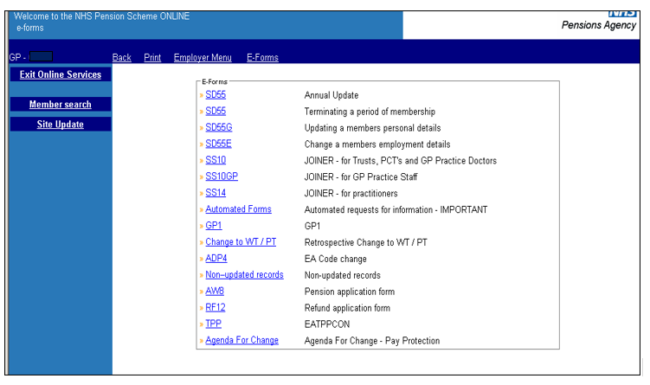
Once the link has been selected you will first see information on the deduction of tiered contributions, as follows:

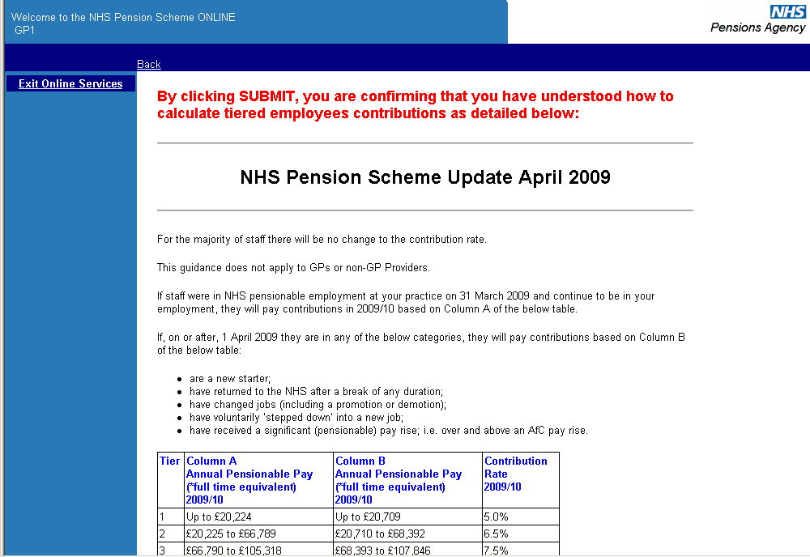

By clicking ‘submit GP1’ at the bottom of the page you are confirming that you have read and understood this information.

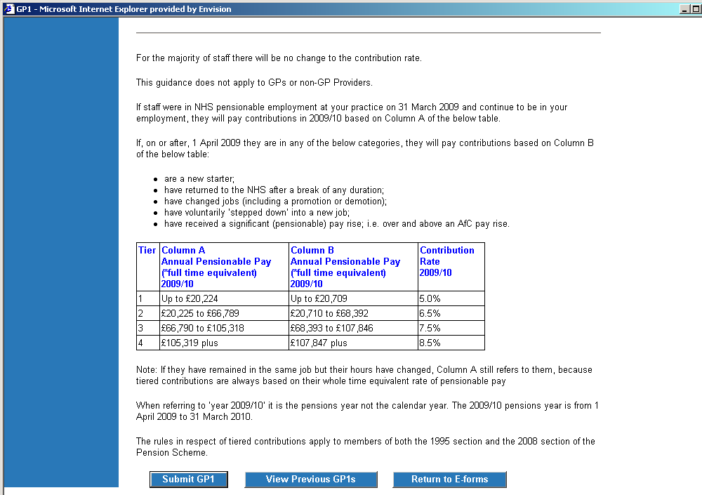

Help text is available for each field if you select ‘?’.

Example Help text for ,Total Pensionable Pay’ in Part 2 of the form:

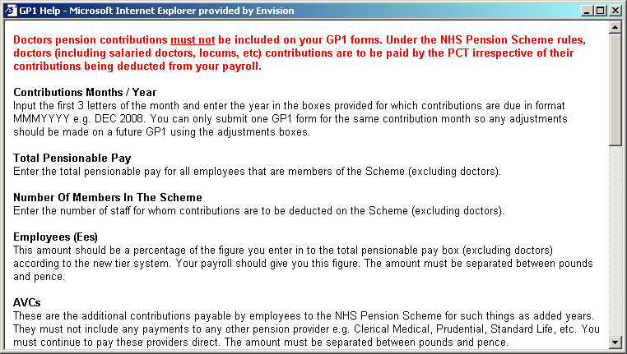

If you do not complete any fields, you may receive one of the following on screen warning messages:

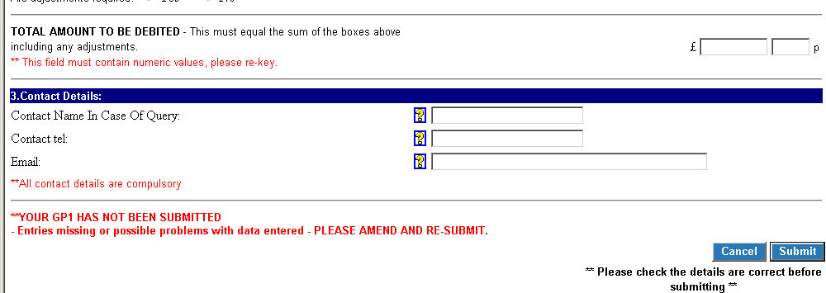

Once you have input the correct information select ‘Submit’ at the bottom of the page:

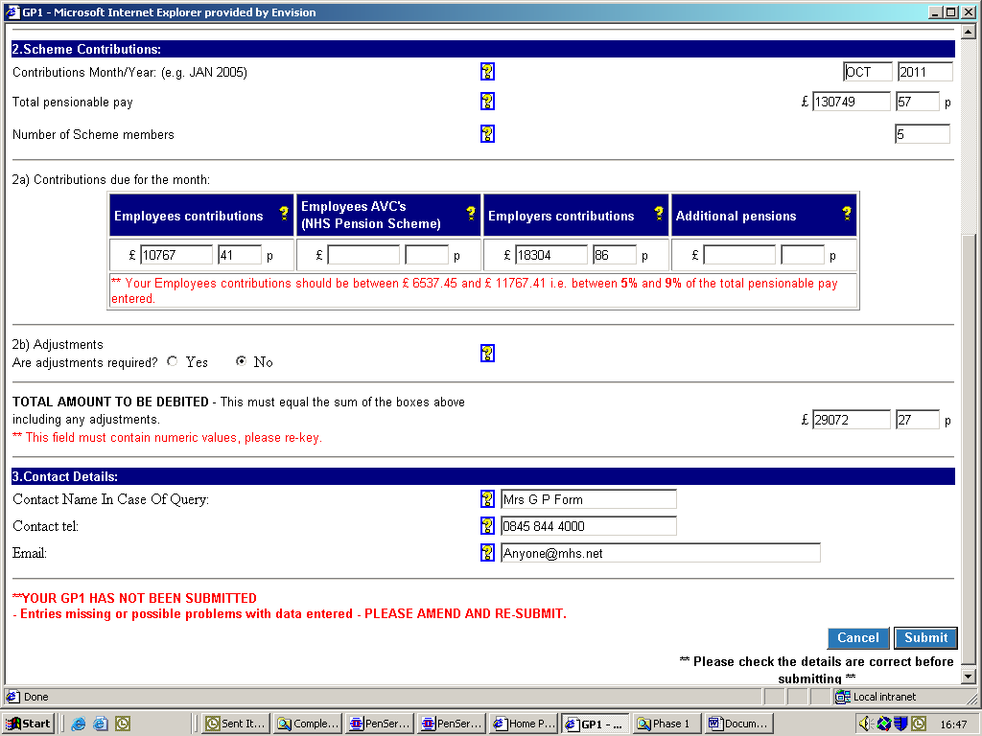

You will then receive a confirmation of the details you have submitted which can be printed for your records by selecting the option at the bottom of the page:

Previously submitted GP1 information can be viewed by selecting the link, as follows:

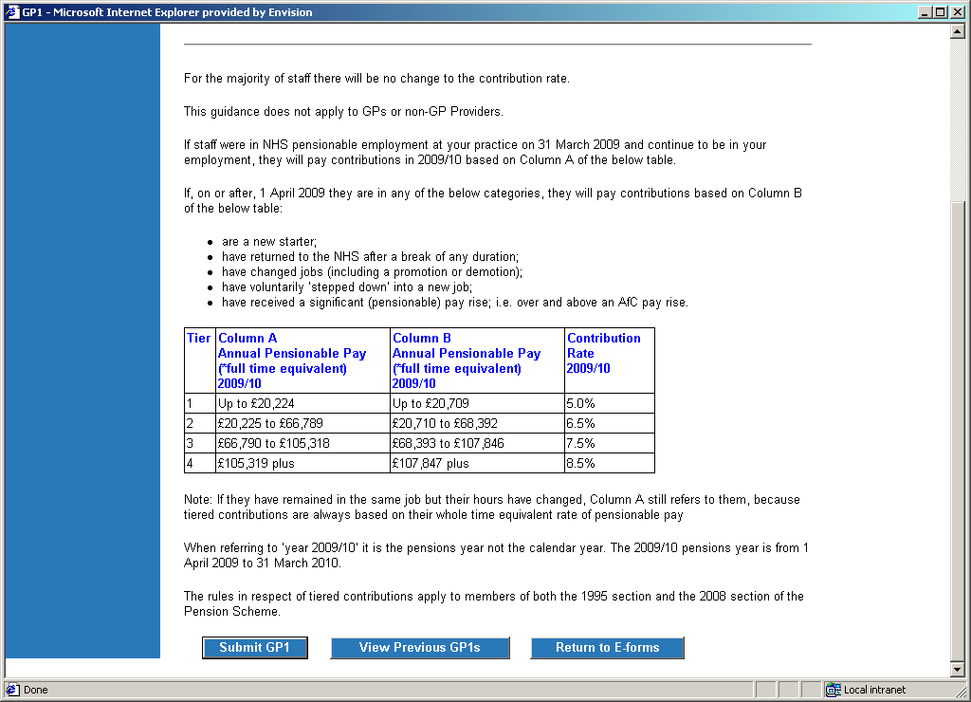

Once selected, a list of previously submitted forms will be shown and to view the details submitted, select the relevant month.

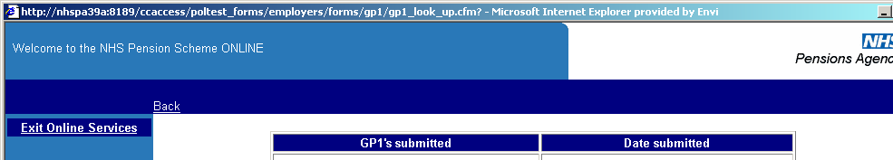
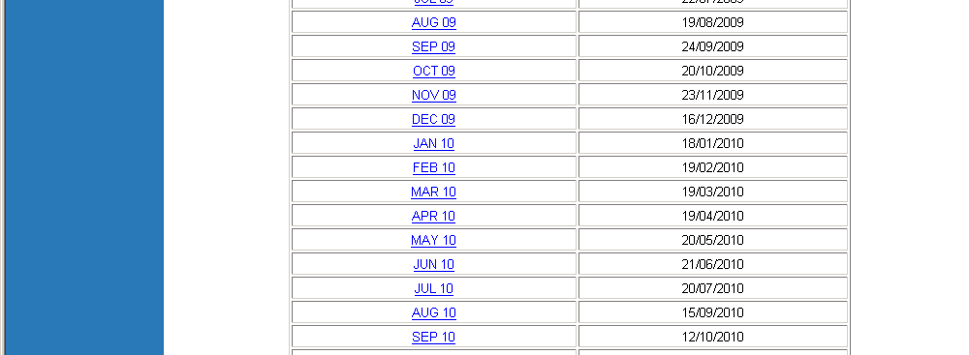

You can then view the details you submitted for the selected month, which is useful to identify if any adjustments are needed to that payment.

You can navigate back to E-Forms, Employer Menu or select ‘Back’ to take you back to the previous page; by selecting the options on the blue bar in the normal way.

How we use your information
For more information about how the NHSBSA processes your personal data, please see our Privacy Notice -
www.nhsbsa.nhs.uk/our-policies/privacy/nhs-pensions-privacy-notice

NHS Pensions

POL Guide 31. GP1 (General Practitioner (GP) Practices only)

www.nhsbsa.nhs.uk/nhs-pensions

