

NHS Pensions

NHS Pensions Online (POL) Guide

35. Electronic Staff Record (ESR) Status

ESR status

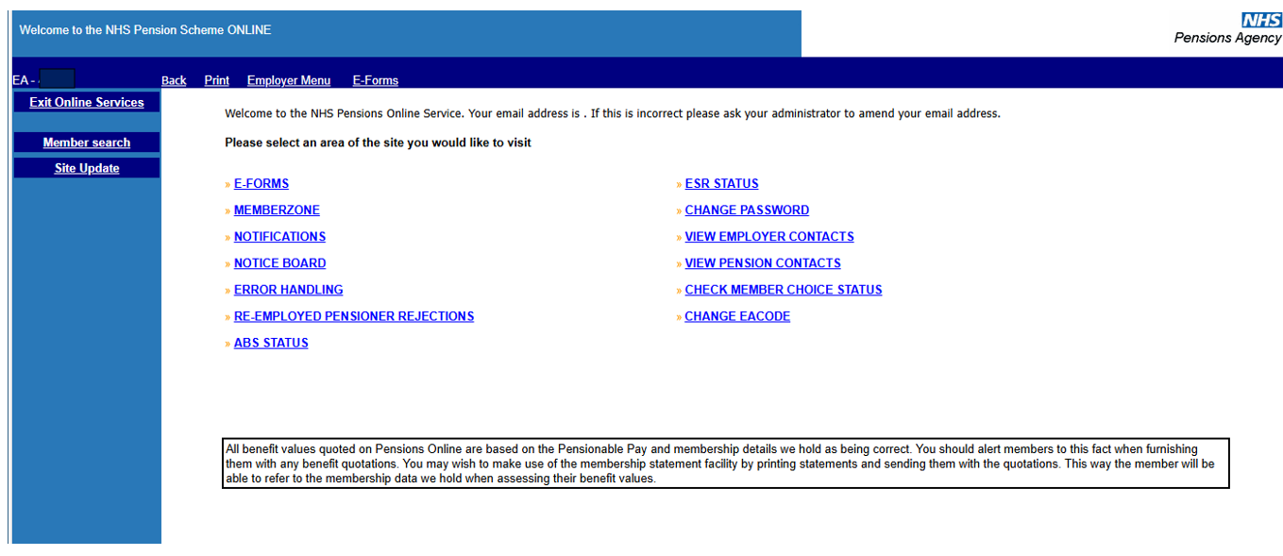

The ESR status page displays information as illustrated below:

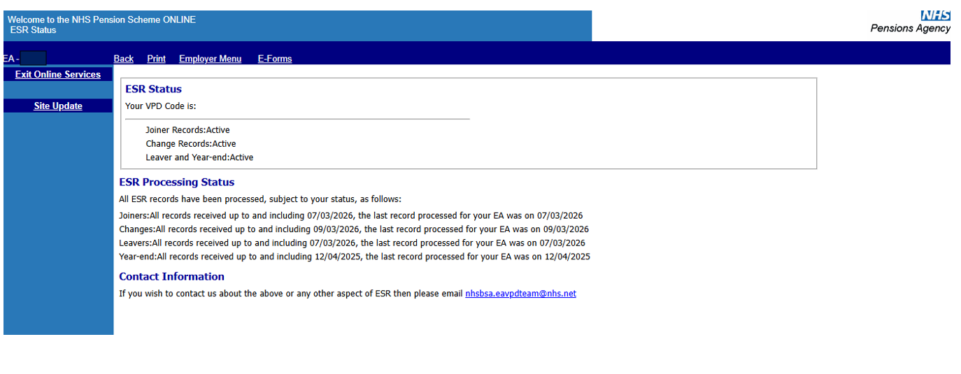
The Virtual Private Database (VPD) code is your unique ESR identification code.

Also displayed are the active ESR interfaces. On this example ESR submits joiner, change, leaver, and year end interfaces, for this employer.

ESR Processing Status shows to what date each of these interfaces have been processed and the date the last record was processed.

If you are not able to submit information via ESR the page will display the following information:

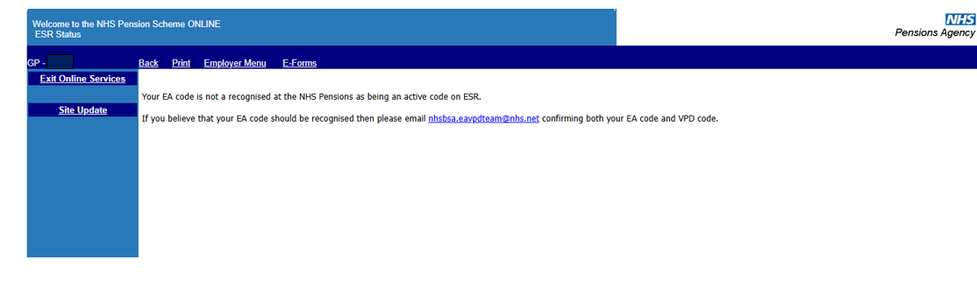

How we use your information
For more information about how the NHSBSA processes your personal data, please see our Privacy Notice -
www.nhsbsa.nhs.uk/our-policies/privacy/nhs-pensions-privacy-notice

NHS Pensions

POL Guide 35. Electronic Staff Record (ESR) Status

www.nhsbsa.nhs.uk/nhs-pensions

