

NHS Pensions

NHS Pensions Online (POL) Guide

36. Change Password

Once you select the link you are asked to insert your old password and select a new password together with a password hint question in case you forget your password at any time.

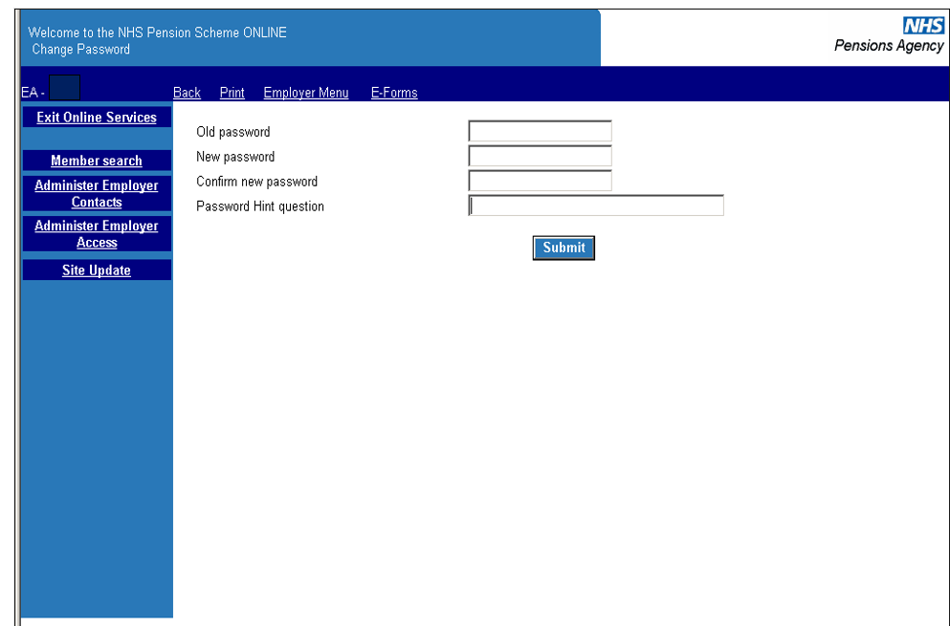
If you forget your password at logging in stage, and enter an incorrect password, the password hint question will be displayed as a reminder.

If you are still unable to remember your password the main Pensions Online administrator and not NHS Pensions can reset it for you.

However, NHS Pensions must re-issue new passwords for the main Pensions Online administrator.

Important: Passwords should not be given to anyone else to use and should not be written down.

How we use your information
For more information about how the NHSBSA processes your personal data, please see our Privacy Notice -
www.nhsbsa.nhs.uk/our-policies/privacy/nhs-pensions-privacy-notice

NHS Pensions

POL Guide 36. Change Password
www.nhsbsa.nhs.uk/nhs-pensions

