

NHS Pensions

NHS Pensions Online (POL) Guide

37. View Employer/Pension Contacts

These links display the contact details for your organisation and should be checked periodically to ensure they still contain up to date information:
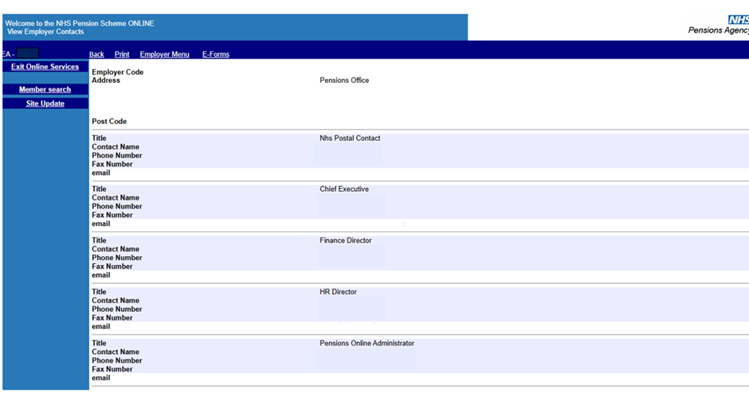
If any information is out of date, it can be amended when you first log-in to Pensions Online:
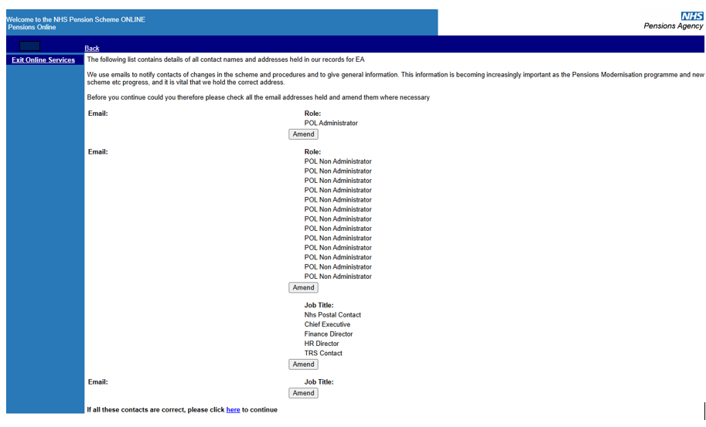
See the guide ‘07. Administer Employer Access’ that gives further details of how to make these amendments.

How we use your information
For more information about how the NHSBSA processes your personal data, please see our Privacy Notice -
www.nhsbsa.nhs.uk/our-policies/privacy/nhs-pensions-privacy-notice

NHS Pensions

POL Guide 37. View Employer/Pension Contacts

www.nhsbsa.nhs.uk/nhs-pensions

