

NHS Pensions

NHS Pensions Online (POL) Guide

38. Check Member Choice Status

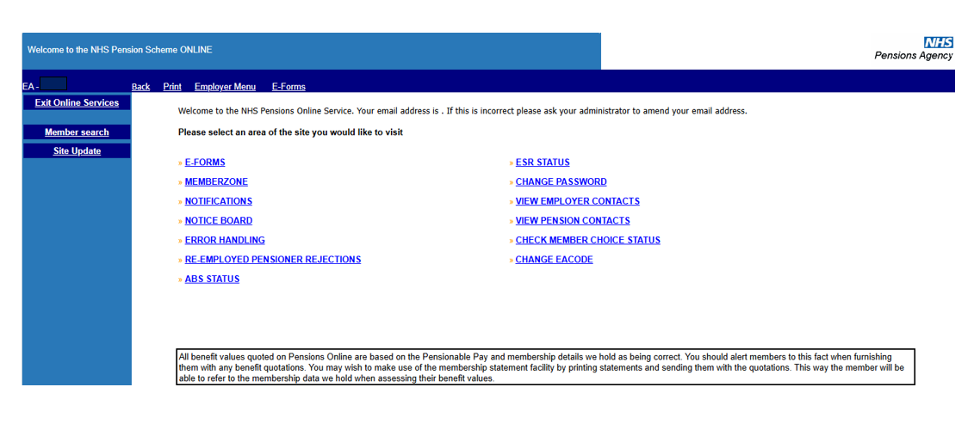
The link to check members Choice Status is located on the main employer menu.

The Choice Status will show the stage the member is at within the Choice process. The message will be one of the following:

• Member has chosen not to participate in Choice
• Member selected for statement production
• Member statement calculations complete
• Member is currently not eligible for a Choice
• Member statement ready for printing
• Member statement ready for dispatch
• Member statement returned or not delivered
• Member Choice disregarded – AW8 not received in time
• Member left during disclosure period
• Member left during statement production
• Member no longer excluded
• Member needs new statement
• Member has chosen to remain in 1995 scheme
• Member has chosen to move to 2008 scheme
• Member remains in 1995 scheme
• Member choice of 2008 scheme enacted
• No Choice record found

Important – You should use this functionality to check the members Choice status before processing an estimate of benefits through Memberzone.

Memberzone must not be used to calculate any estimates of pension benefits for any member with a Choice Status of ‘Member has chosen to move to 2008 Section’.

In these circumstances you should send the request to NHS Pensions for calculation ‘marked 2008 Choice transferee’.

You should also use the new functionality to check the members’ Choice status before processing an AW8 form through Pension Online.

Pension Online should not be used to submit an AW8 for any member with a Choice Status of ‘Member has chosen to move to 2008 Section’. In these cases, send the AW8 form to NHS Pensions marked ‘2008 Section member’.

Once the link is selected you will be asked to input either their member reference (SD) number or National Insurance number.

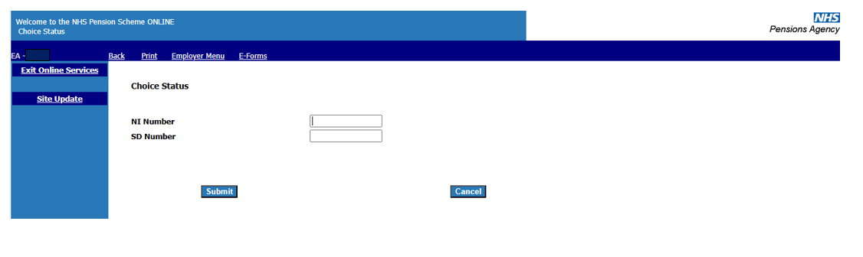
You will only be able to view the status for members who are currently in an open employment with you.

Once a valid reference number has been entered the members’ Choice status will be displayed:

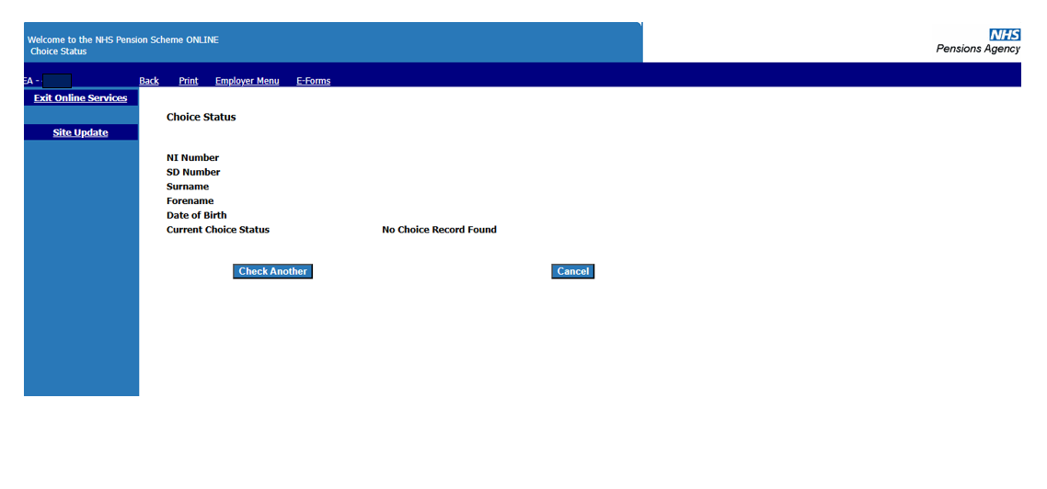
On the above example the members choice statement has been delivered.

If you wish to check the status for another member select ‘Check Another’ and you will be asked to input the ‘SD number’ or ‘NI number’.

If status is ‘no Choice record found’ the member has either not been selected for the Choice Exercise or has been selected but there is a data error outstanding.

On the example below the member did not commence pensionable employment in the NHS until after 1 April 2008 and ‘Choice’ is not therefore relevant.

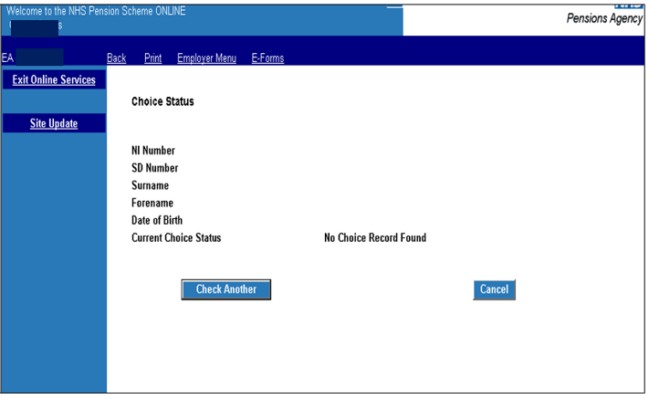

How we use your information
For more information about how the NHSBSA processes your personal data, please see our Privacy Notice -
www.nhsbsa.nhs.uk/our-policies/privacy/nhs-pensions-privacy-notice

NHS Pensions

POL Guide 38. Check Member Choice Status
www.nhsbsa.nhs.uk/nhs-pensions

