Guide to monthly pay statements

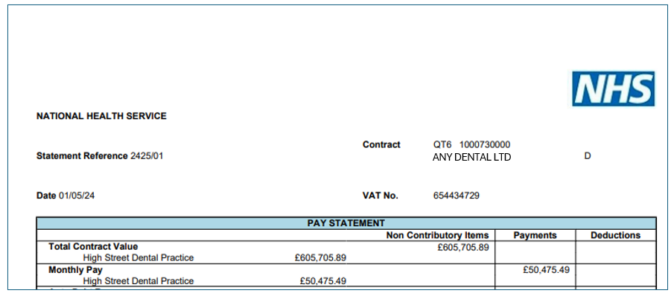

Statement Reference: = YYYY/MM this example shows 2425/01 is April 2025.
Contract: Commissioner code and contract number (ten digits) and
name of Provider
Date: Payment date into account.
VAT No.

Guide to monthly pay statements
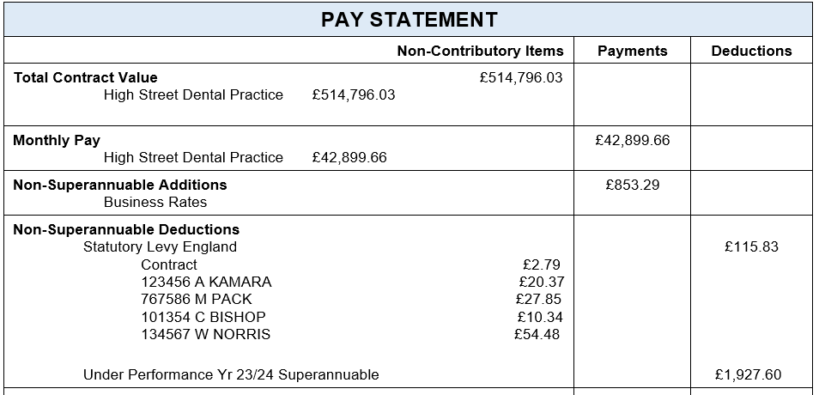
Total Contract Value – This is the annual contract value for the contract. There may be multiple lines if the contract has more than one service line.
Monthly Pay – This is the contract value for the month. Normally this amounts to one twelfth of the total contract value. The figure will be different if the contract is uplifted (DDRB) or adjusted retrospectively. There may be multiple lines if the contract has more than one service line. If additional service lines are non-recurrent and do not cover the whole year, they will only show in the months that a payment is received.
Non-Superannuable Additions – These include business rates, health body advance payments, and payment to clear debit on a contract either by transfer from another contract or by direct payment to NHS Dental Services. There are a range of additional payments made under this category. These would be payments to the contract that are not superannuable.
Non-Superannuable Deductions – This includes the performer and provider (Contract) LDC levy and recovery of underperformance on a contract. If underperformance is included on the pay statement, the provider would be expected to reconcile the superannuation contributions made by a performer via the year end Annual Reconciliation Report (ARR) declaration return. Recovery of an advance payment outside the normal payment run would also appear under this category (also see page six).

If the contract has received additional payments under the Statement of Financial Entitlement they will appear on the statement as a Superannuation @100% Additions.
Superannuation @100% Additions – Payment in this category would include parental, long term sickness and adoptive leave pay. Where applicable, maternity pay will be supported by a statutory maternity allowance deduction (under the category Superannuable @ 100% deductions).

Dealing with performer net pensionable earnings
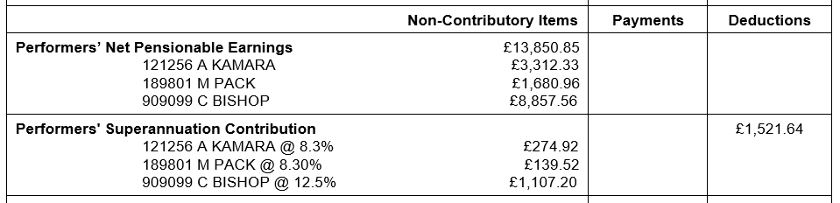
Performer’s Net Pensionable Earnings – In the example above the figure of £13,850.85 is the total net pensionable earnings for all performers on the contract. The subsequent figures relate to each individual performer. This will only appear if the provider has allocated estimated net pensionable earnings for a performer on the contract. The performer will also receive a separate superannuation notification that includes details of any additional pension payments (see page six) and a summary of forms processed.
Performers’ Superannuation Contribution – This is the performer’s contribution on their net pensionable earnings.
From 1 April 2024 the pension regulations changed, and new tiered contribution rates were established. These range from 5.2% to 12.5% and are determined each financial year based on the provider’s annual declaration. The declared net pensionable earnings for financial year 2024/2025 determined your contribution tier for 2026/2027. The tier applies to all contract earnings.

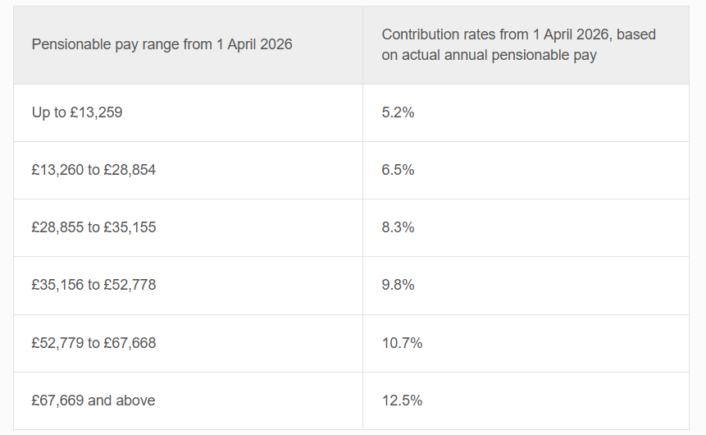

Dealing with patient charges
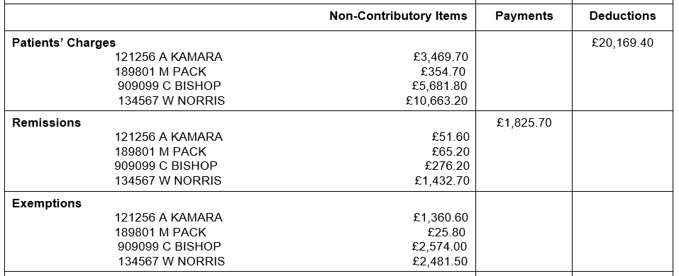
Patients’ Charges - The gross patient charges figure (£20,169.40) does not include those entitled to automatic exemption. These are patients under eighteen, expectant and nursing mothers, adults aged eighteen in full time education and prisoners (including young offenders). Free examination available in Wales for under 25/60 or over. It does include patient charges for remitted patients (see Remissions).
Remissions – Patients who have a low income may be able to claim help with NHS charges. This is known as a remission. The figure of £1,825.70 is the total payment on the contract for all performers activity reports (FP17s) that include remissions. The remitted payments are being deducted from the Patient’s Charges.
There is a subtle difference between an exemption and a remission. An exemption means there is no charge to the patient. A remission means there is a charge, but the patient is entitled to help paying it.
The patient is entitled to full or partial help with the charge if, on the date of acceptance or the date the charge was made, they (as a claimant, partner, or dependent person under 20) are receiving:
- Income Support (Incapacity benefit and Disability Living Allowance does NOT count)
- Income-based Jobseeker’s Allowance (Contribution-based does NOT count).
- Income-related Employment and Support Allowance (Contribution-based does NOT count).
- Pension Credit Guarantee Credit (Savings Credit on its own does NOT count)
- Universal Credit and meets the criteria. Find out more at www.nhsbsa.nhs.uk/UC
- HC2 certificate (full) or HC3 certificate (partial remission)
Exemptions – There is no charge to patient (see above).

Contracts that have a foundation dentist
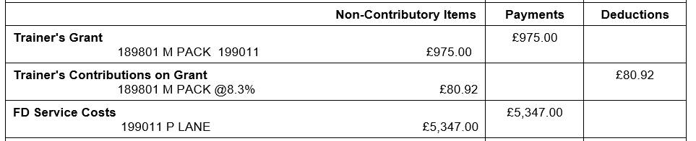

If the provider has a foundation dentist (FD) on their contract the payments will appear as above.

The salary for a foundation dentist is managed through a single lead employer.

Trainer’s Grant – The grant is shown against the trainer responsible for the FD. If the trainer has two FDs on the contract the figures are shown against each FD as a payment.

Trainers’s Contribution on Grant – The trainer pays superannuation on the grant dependent on their contribution tier. The grant is superannuable at 100%.

FD Service Costs – This payment is a contractor payment and if there is more than one FD on the contract individual payments are shown.
These payments are non-superannuable.

If there is more than one FD on a contract the values will be displayed separately for each FD.

Reporting of employer‘s contributions and performers not in NHS Pension Scheme
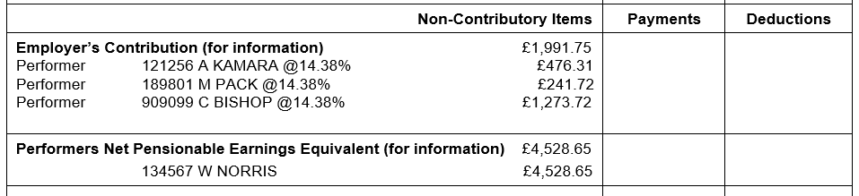
Employer’s Contribution @ 14.38% (for information). If you are part of the NHS Pension Scheme in addition to your own contributions (see page three) the health body contributes an amount equal to 14.38% of net pensionable earnings.
The employer contribution rate from 1 April 2024 is 23.7% of pensionable pay. This is an increase from the previous rate of 20.6%, in place for the period 1 April 2019 to 31 March 2024.
Employers are responsible for paying 14.38% of contributions, with the remaining 9.4% being funded centrally.
NHSBSA and NHS Dental Services are legally required to collect the employee, additional contributions and employer contributions and pay these directly to NHS Pensions (Dental Services). NHSBSA acts as the employer for NHS pension purposes.
Performers’ Net Pensionable Earnings Equivalent (for information) The figure shown would be earnings for performers who are not in the NHS Pension Scheme. (for example retired, opted out, incorporated, or working on the contract through an agency)
Performers have the ability to pay additional pension contributions outside of the payments for the contract, this is an individual arrangement. For your information these appear as follows on the performers superannuation notification and not the main contract monthly statement

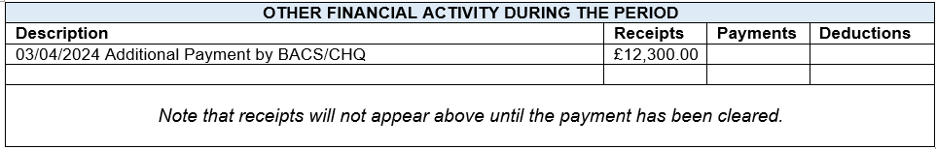

The payment into the nominated bank account
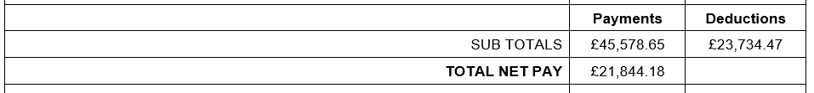
SUB TOTALS – The total of all payments and deductions on the statement.
TOTAL NET PAY – The payment less the deduction is the total net pay to the contract.
If the contract is in negative, there will be no payment to the contract until the debt is cleared. In most cases negatives are generated by the closure of a contract where further patient charges are processed by NHS Dental Services without a monthly payment being due.
The outstanding debt is documented separately (see page seven).

You will continue to receive the Activity Statement, which is formatted in line with the pay statement.
Please note that the Activity Statement will now include "Current Financial Year (2024/25)", "Last Financial Year (2023/24)" and "Other Years". Note that “Other Years" will only be shown if there is a value appropriate to it. The Units of Dental Activity per Performer will also show a similar breakdown. The Cumulative Units of Dental Activity will be broken down into “Current Financial Year (2024/25)" and "Last Financial Year (2023/24)" but will not show cumulative values for "Other Years".
The same change as described above will apply to the sections concerned with Units of Orthodontic Activity.

Advance payment
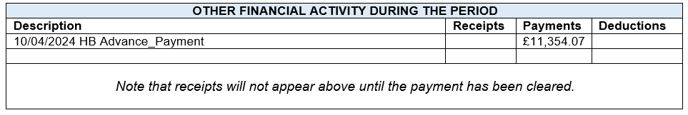
Other Financial Activity During the Period. If an advance payment is made to a contract outside the normal payment run, it appears just after the TOTAL NET PAY.
It appears on the monthly statement as a Non-Superannuable Deduction.

Outstanding debt
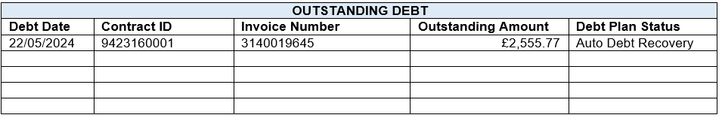
If the contract has any outstanding debt it will appear underneath the update for other financial activity during the period.

