

NHS Pensions

NHS Pensions Online (POL) Guide

5. Member Search

The ‘Member search’ facility allows you to search the NHS Business Services Authority (NHSBSA) database to confirm the personal details held for scheme members who have an open employment with you. It is accessed using the following link in all pages of Pensions Online:
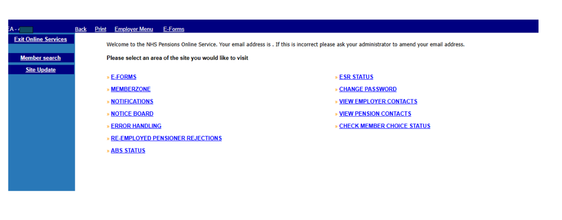

This may be useful if the original joiner details were submitted with some incorrect details and you are now unable to trace the member on the ADP4 list in E-Forms, or you have more than one employee with the same name. It now also allows you to copy and paste the data from any of the fields.

Example of a search using surname only:

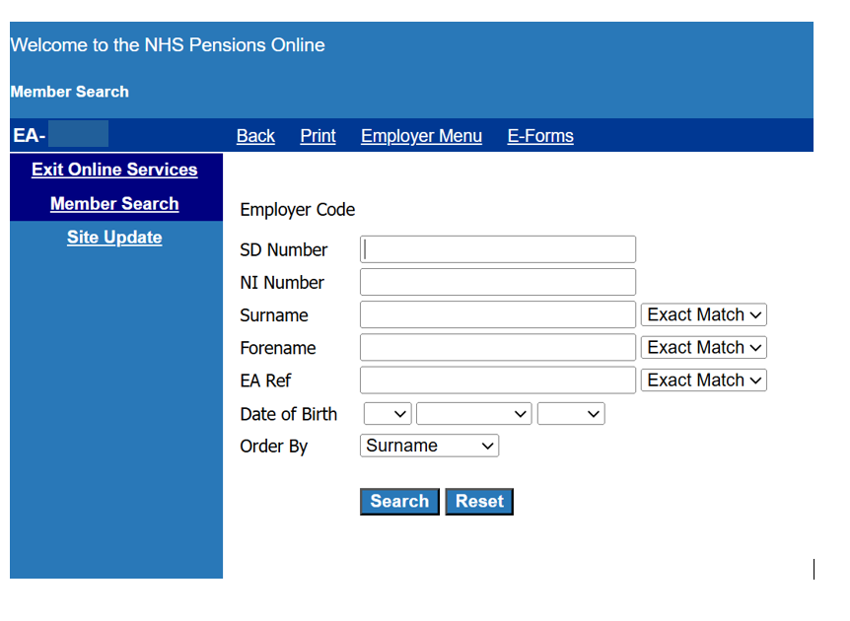

This search traced the following members:
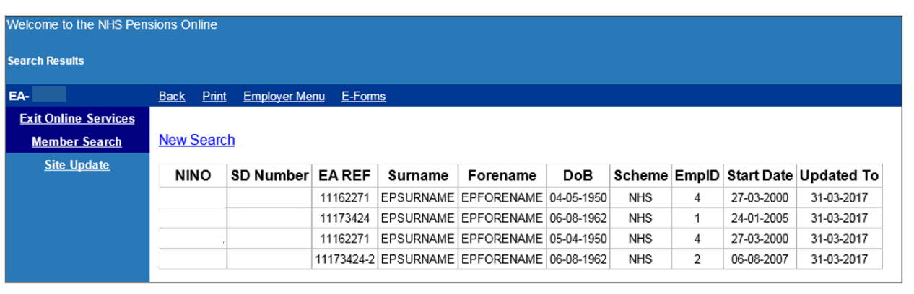

The returned data can be copied and pasted by using:

Control & C - to copy
Control & V - to paste

Where no match is found you will receive the following on screen message:

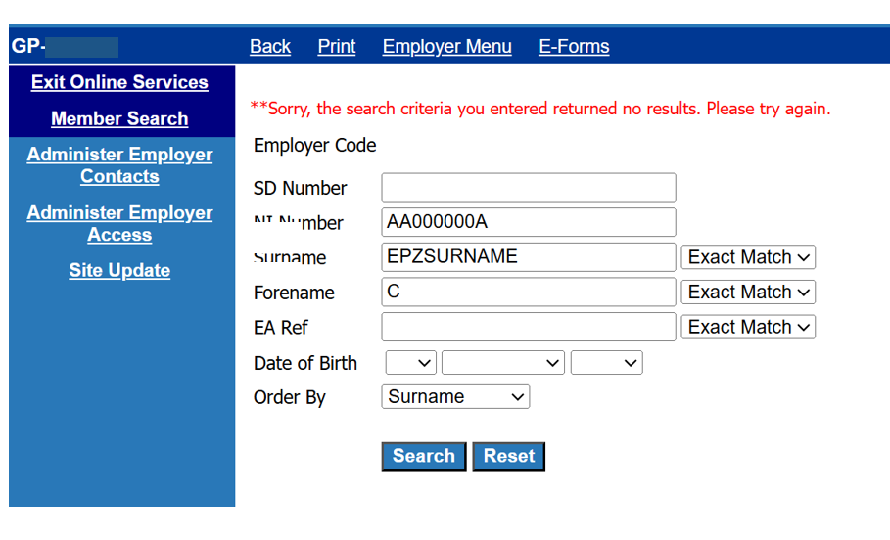

You can also search for a member if you only have a partial surname or forename by selecting the search options on the drop down menu alongside each of these fields:

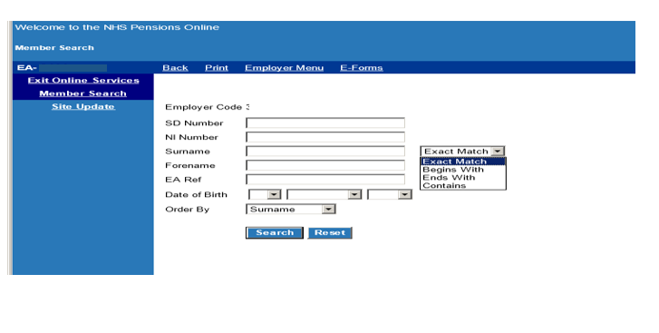

You can also choose the order that you wish the results to be returned in using the drop down menu alongside the ‘order by’ field.

How we use your information
For more information about how the NHSBSA processes your personal data, please see our Privacy Notice -
www.nhsbsa.nhs.uk/our-policies/privacy/nhs-pensions-privacy-notice

NHS Pensions

POL Guide 5. Member Search

www.nhsbsa.nhs.uk/nhs-pensions

