Wales: Guide to Understanding your Contract Monthly Pay and Monthly Superannuation Statements
Contents
Purpose 1
Background 1
Contract Monthly Pay Statement 2
Care Package Activity Statement 2
Activity Statement 3
Provider Summary 4
Clinician Monthly Statement (Monthly Superannuation Notification) 5

Purpose
The purpose of this guide is to help dental providers and clinicians in Wales understand each section of their monthly statement.
This guide will help you interpret:
- activity
- payments
- adjustments
- other key information (such as pension contributions)

Background
As NHS Wales operates its own dental contract and payment processes, this document explains how to understand:
- Contract Monthly Pay Statements, including Care Package Activity Statements, Activity Statements and Provider Statements
- Monthly Superannuation Notifications
As the statements are generic, they include information relevant to both General Dental Services (GDS) contracts and Personal Dental Services (PDS) agreements.

Contract Monthly Pay Statement
This monthly statement brings together all key information for providers such as the:
- Pay Statement
- Care Package Activity Statement
- Activity Statement
- Provider Summary
More detailed information about the Pay Statement such as Total Contract Value (TCV) and Pension Contributions, is available in the ‘A guide has been created to help you understand your monthly pay statement’ document on our website.

Care Package Activity Statement
This provides a monthly breakdown of dental care activity and the associated fees, which show’s:
- urgent and non-urgent care packages delivered during the period
- any laboratory fees – the laboratory fees listed are credited to the contract for patients who are exempt or have their fees remitted.
- a breakdown of activity completed by each clinician

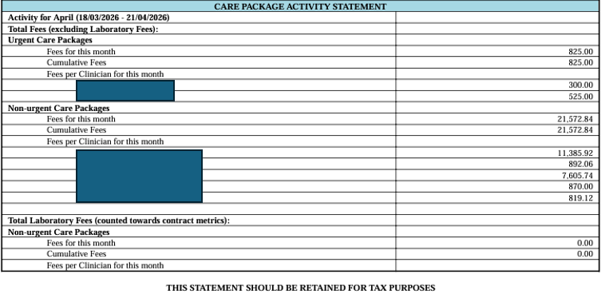
This example shows how the Care Package Activity Statement will show within a Contract Monthly Pay Statement.

Activity Statement
The Activity Statement summarises the Units of Orthodontic Activity (UOAs) provided under the contract. It shows:
- the period the activity covers
- cumulative UOAs totals
- activity completed by each clinician
UOAs continue to be reported as normal.
The statement may also include Units of Dental Activity (UDA) information from previous financial years.
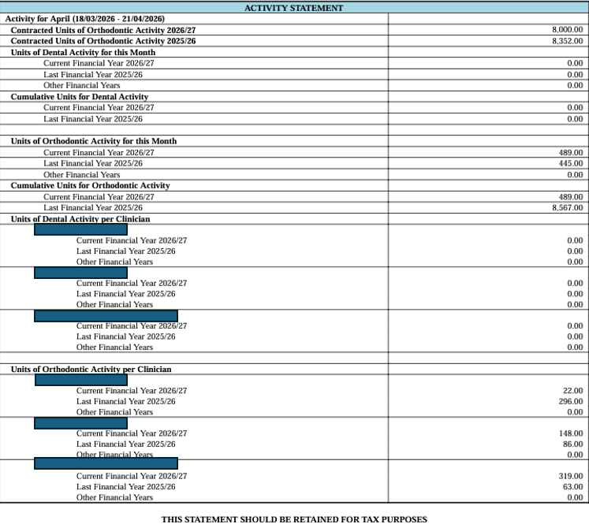
This example shows an Activity Statement with UOAs included.

Foundation Dentist (FD)
Activity completed by a FD will be included in the Activity Statement summary.

Provider Summary
The Provider Summary gives an overview of all clinical activity recorded under the contract. It shows the:
- type of treatment delivered
- number of forms submitted
- units or fees linked to each activity
Two versions of the statement are available:
- Provider Summary - Current Financial Year
- Provider Summary - Previous Financial Years

Monthly Superannuation Notification
This is the clinician’s monthly statement. It shows information specific to the individual clinician, and the treatment they delivered during the scheduling period.
It shows:
- a summary of the clinician’s payments and deductions for the period, including pension contributions for NHS Pension Scheme members
- monthly payments, patient charges, and remission totals
- levy deductions and grants
- dental activity completed such as forms processed
Statements are also generated for Dental Care Professionals (DCPs). These only include the Care Package Summary and the Clinician Activity Summary for the current and previous years.

