How to apply for a job – Check your equal opportunities in NHS Jobs quick guide
This guide gives you instructions for how to add your equal opportunities information to your application in the NHS Jobs service.
You’ll need to answer the guaranteed interview scheme and equality and diversity questions.
If you’ve previously applied for a role and saved your application information to your applicant profile, you can choose to use this saved information when completing an application.
You’ll need to complete your equality and diversity monitoring information. The information collected will be treated confidentially and used for statistical purposes only, not to identify individuals.
If you save your application information, you can use it to apply for other roles and any previous information will be replaced.

Contents
How to apply for a job – Check your equal opportunities in NHS Jobs quick guide 1
Guaranteed interview scheme 3
Have any of the following affected your ability to carry out your daily activity for more than 12 months? 4
Select any of the following that apply to you 5
Do you want to be considered for interview under the Disability Confident scheme? 6
Are you a member of the UK Armed Forces Community? 7
Do you want to be considered under the Guaranteed Interview scheme? 8
Check and save your guaranteed interview scheme answers 9
Application task list 11
Equality and diversity monitoring 13
What is your gender? 14
Is your gender the same as that assigned at birth? 15
What is your marital status? 16
Are you currently pregnant, on maternity or paternity leave or have you given birth in the last 26 weeks? 17
Which of the following options best describes how you think of yourself? 18
What is your age? 19
What is your ethnic group? 20
What is your religion? 21
Check and save your equality and diversity answers 22
Application task list 23
Your socio-economic background 25
What was the occupation of the main earner in your household when you were 14 years old? 26
What type of school did you attend for most of the time between ages 11 and 16? 28
Were you eligible for free school meals at any time? 29
Check and save your socio-economic background answers 30
Application task list 31

Guaranteed interview scheme
This page gives you instructions for how to answer the guaranteed interview scheme question.
Important: In this example, the Guaranteed interview scheme status is ‘STARTED’ and your application is incomplete as you’ve completed 5 out of 10 sections.
To answer the guaranteed interview scheme question, complete the following steps:
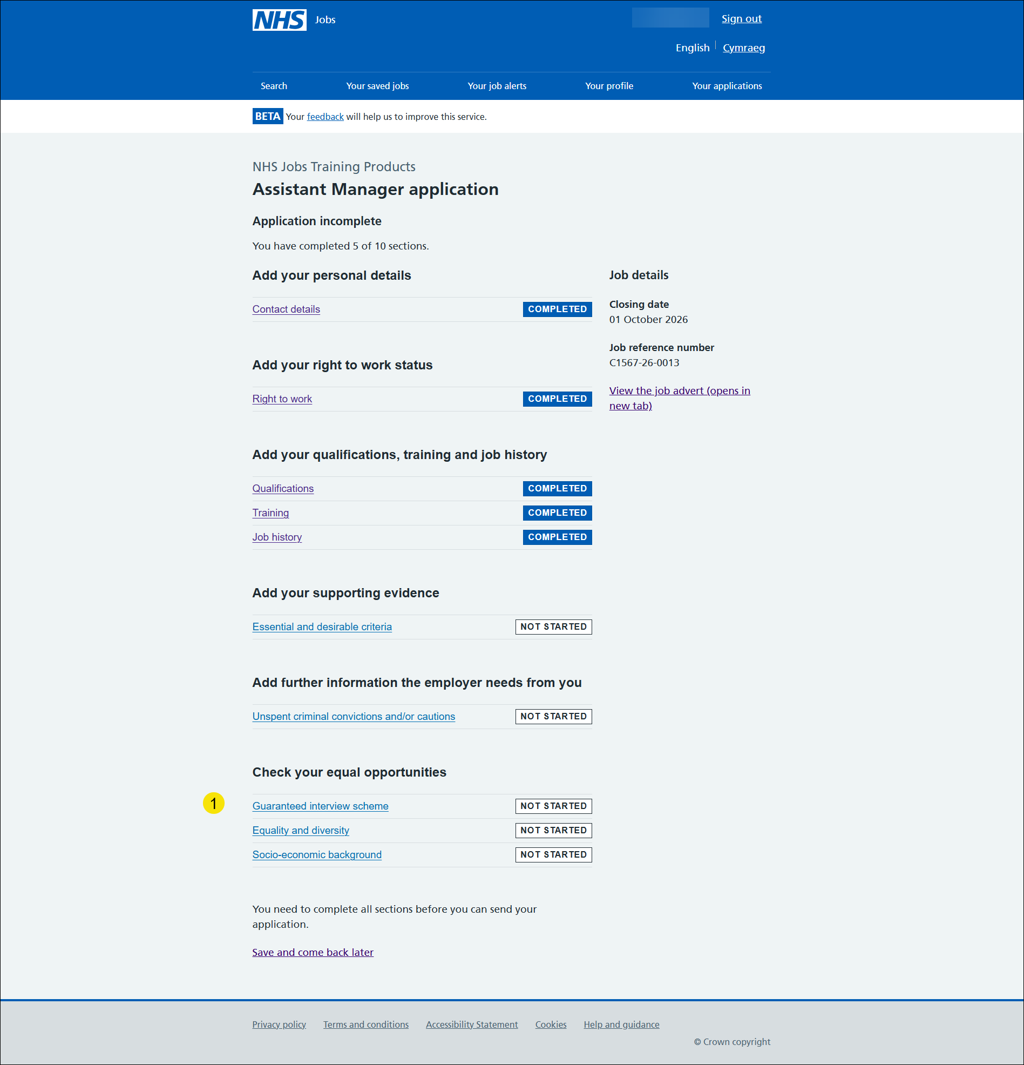
- Select the ‘Guaranteed interview scheme’ link.

Have any of the following affected your ability to carry out your daily activity for more than 12 months?

This page gives you instructions for how to confirm if any of the following affected your ability to carry out your daily activity for more than 12 months.
To confirm if any of the following affected your ability to carry out your daily activity for more than 12 months, complete the following steps:
- Select the ‘help with this question’ link for more information (optional).
- Select an answer:
- ‘Yes’
- ‘No’
- ‘Prefer not to say’
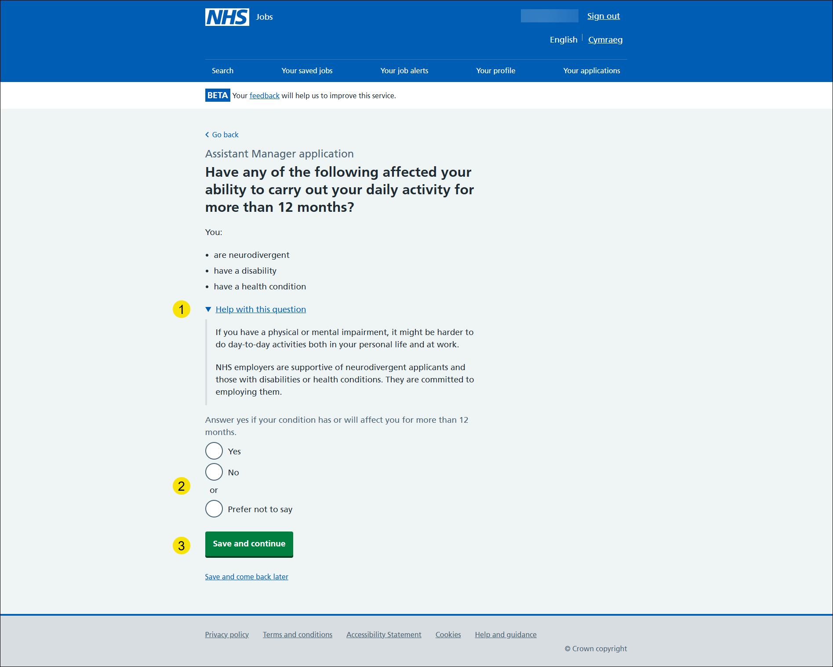
- Select the ‘Save and continue’ button.

Select any of the following that apply to you

This page gives you instructions for how to select any of the following that apply to you.
Important: This page is only shown if you’re adding an impairment.
To select any of the following that apply to you, complete the following steps:
- Select an answer.
- Select the ‘Save and continue’ button.

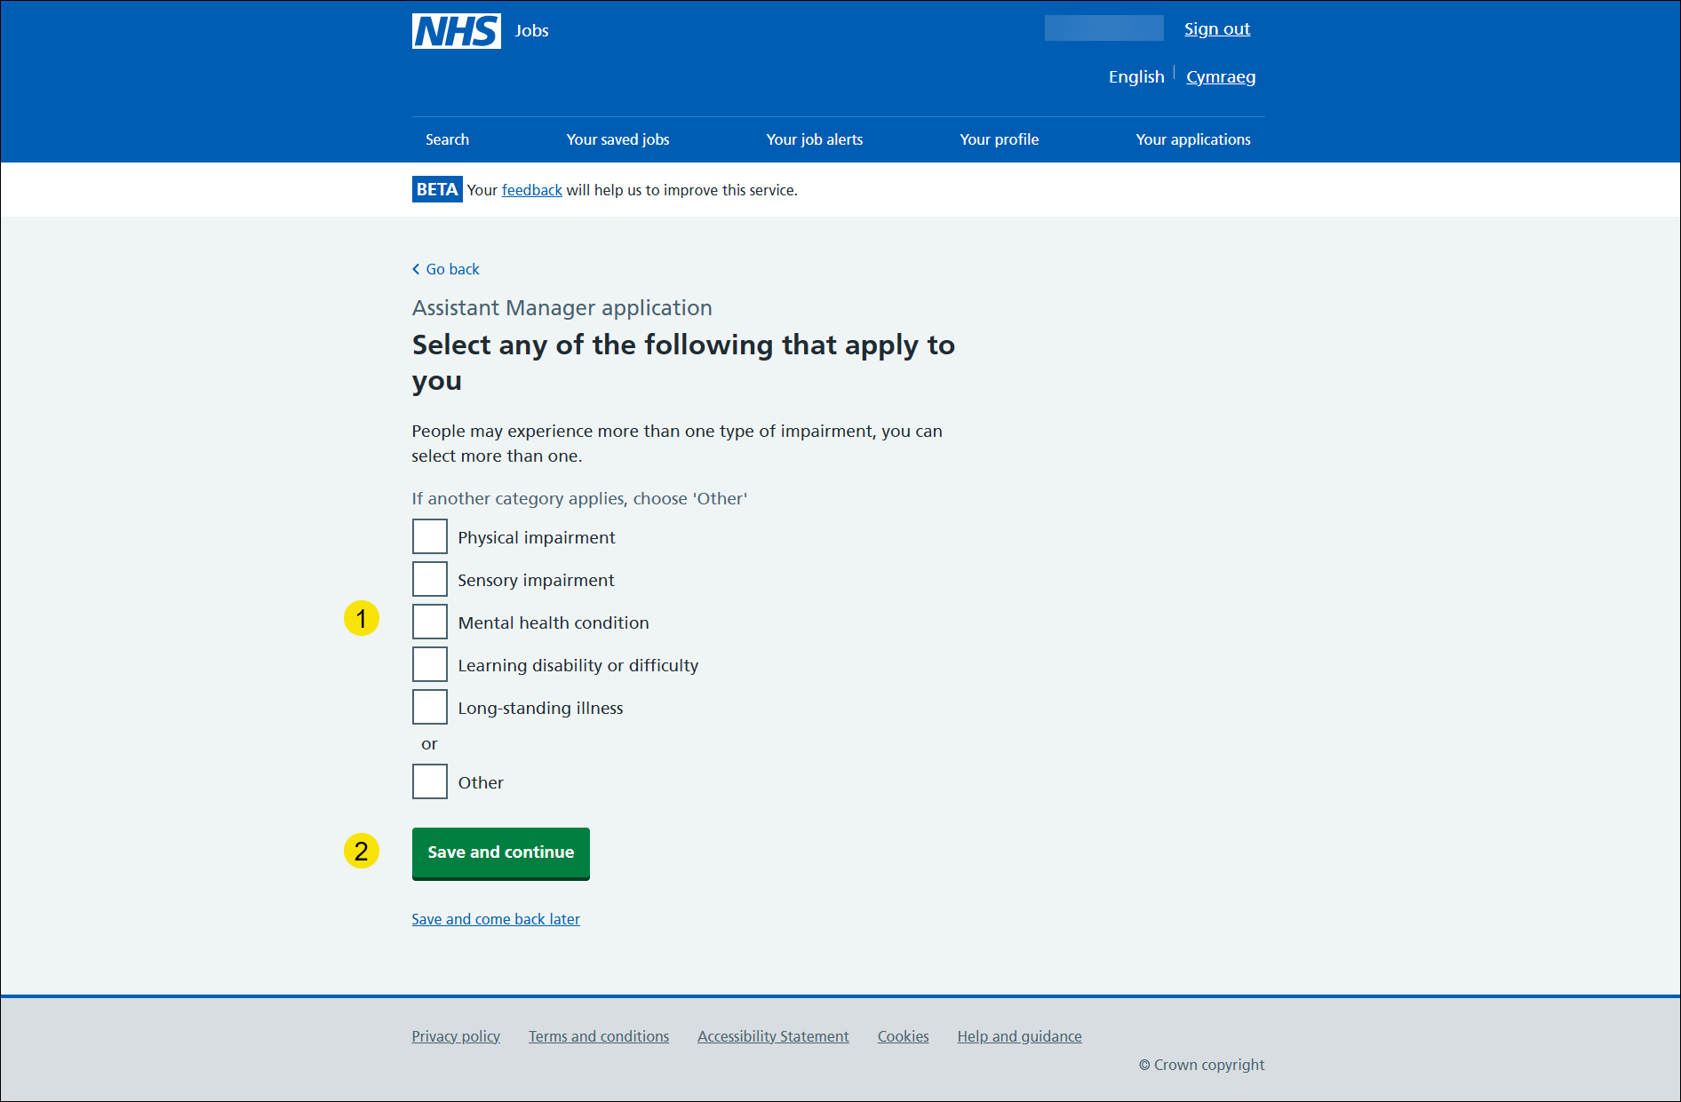

Do you want to be considered for interview under the Disability Confident scheme?
This page gives you instructions for how to confirm if you want to be considered for interview under the Disability Confident scheme.
Important: You’ll only see this page if you’ve confirmed you have an impairment.
To confirm if you want to be considered for interview under the Disability Confident scheme, complete the following steps:
- Select an answer.
- Select the ‘Save and continue’ button.

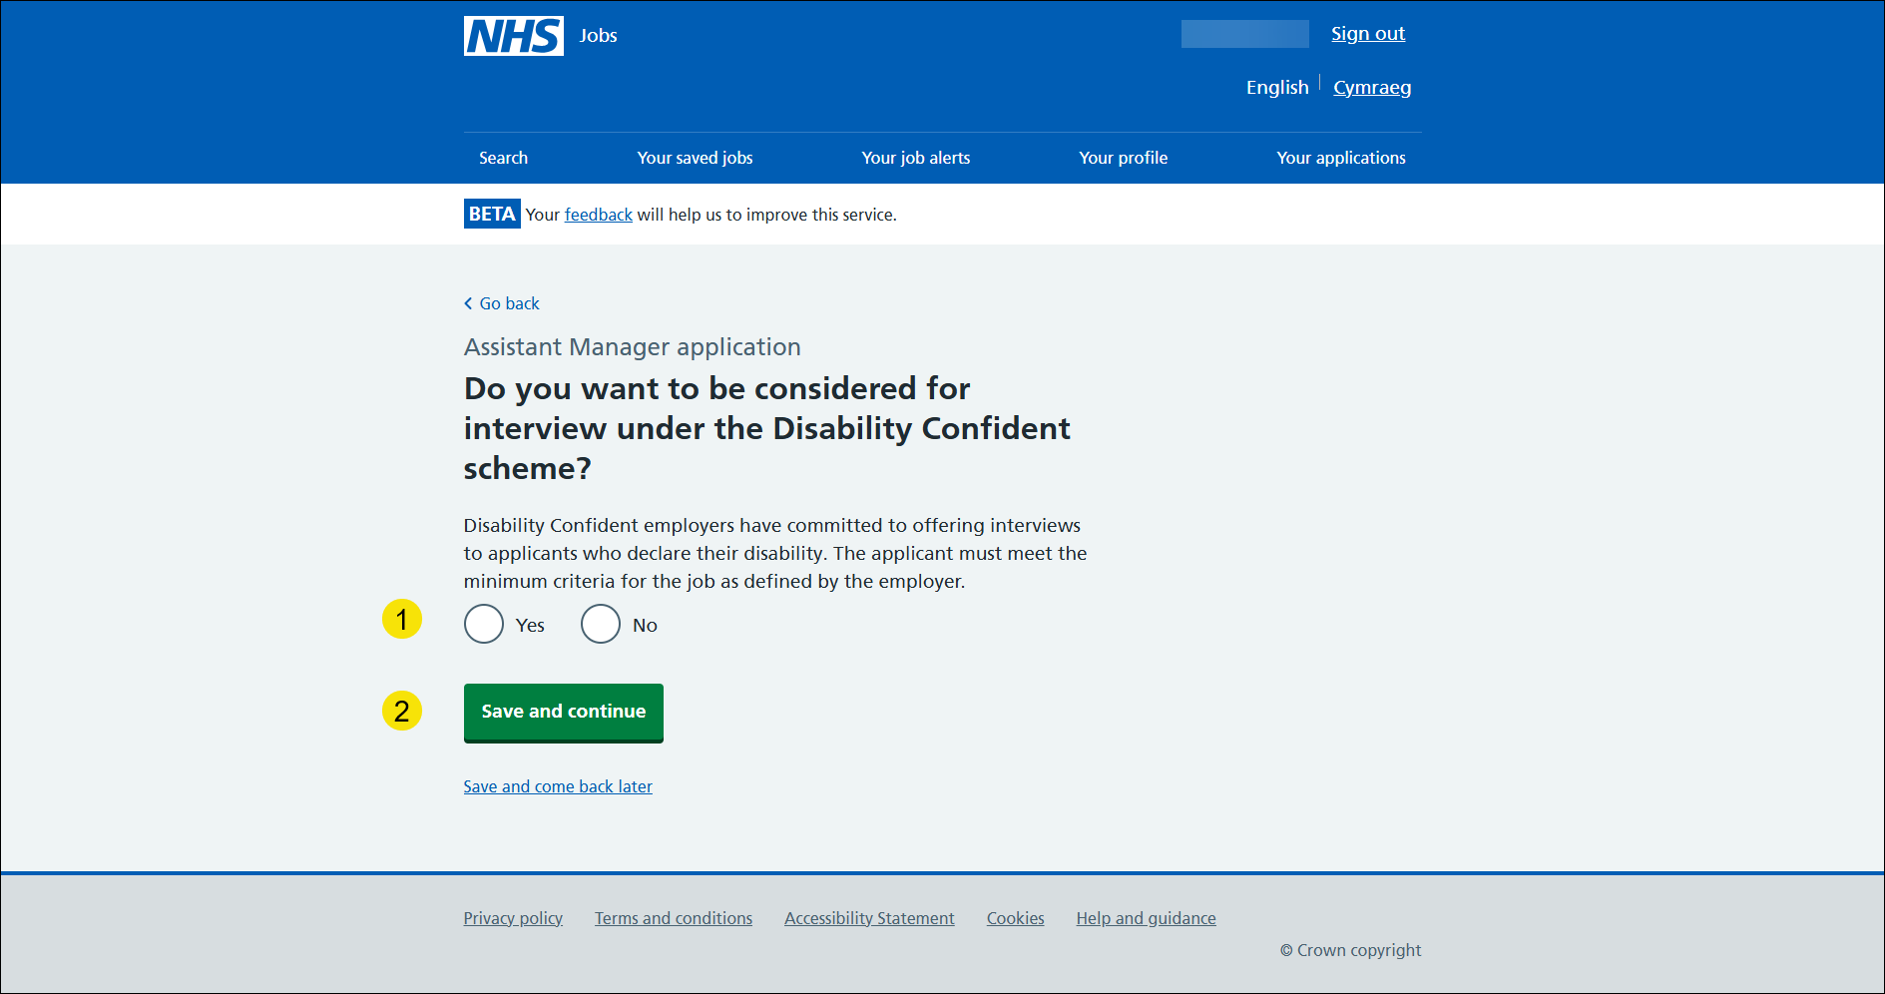

Are you a member of the UK Armed Forces Community?
This page gives you instructions for how to confirm if you’re a member of the UK Armed Forces community.
To confirm if you’re a member of the UK Armed Forces community, complete the following steps:
- Select an answer.
‘Yes’
‘No’
‘Prefer not to say’
- Select the ‘Save and continue’ button.

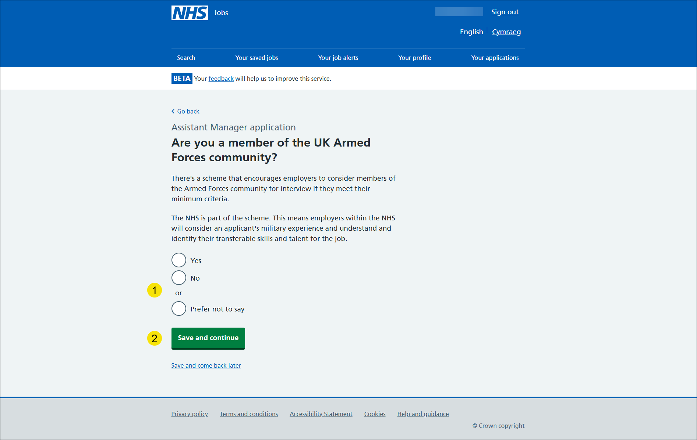

Do you want to be considered under the Guaranteed Interview scheme?
Important: You’ll only see this page if you’re a member of the UK Armed Forces community.
To confirm if you want to be considered for interview under the Guaranteed Interview scheme, complete the following steps:
- Select an answer.
- Select the ‘Save and continue’ button.

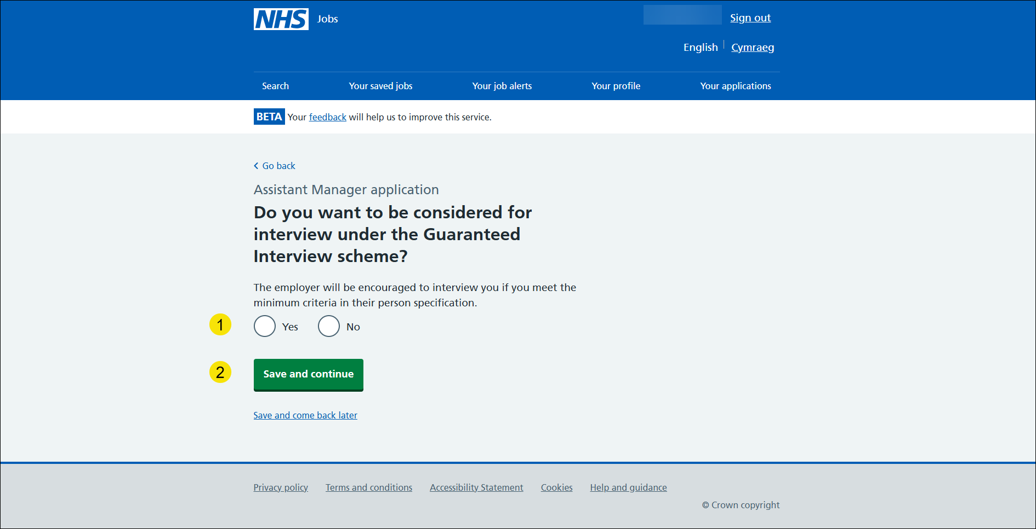

Check and save your guaranteed interview scheme answers
This page gives you instructions for how to check and save your guaranteed interview scheme answers.
To check, change and confirm your guaranteed interview scheme answers, complete the following steps:
- Select a ‘Change’ link:
- ‘Do you have a health condition or disability or are you neurodivergent and has this affected your ability to carry out your daily activities for more than 12 months?’ (optional)
- ‘Which impairment do you have?’ (optional)
- ‘Do you want to be considered for interview under the Disability Confident scheme?’ (optional)
- ‘Are you a member of the UK Armed Forces community?’ (optional)
- ‘Do you want to be considered for interview under the Guaranteed Interview scheme?’ (optional)
- Select the ‘Save and continue’ button.
Go to the next page to see the screenshot.

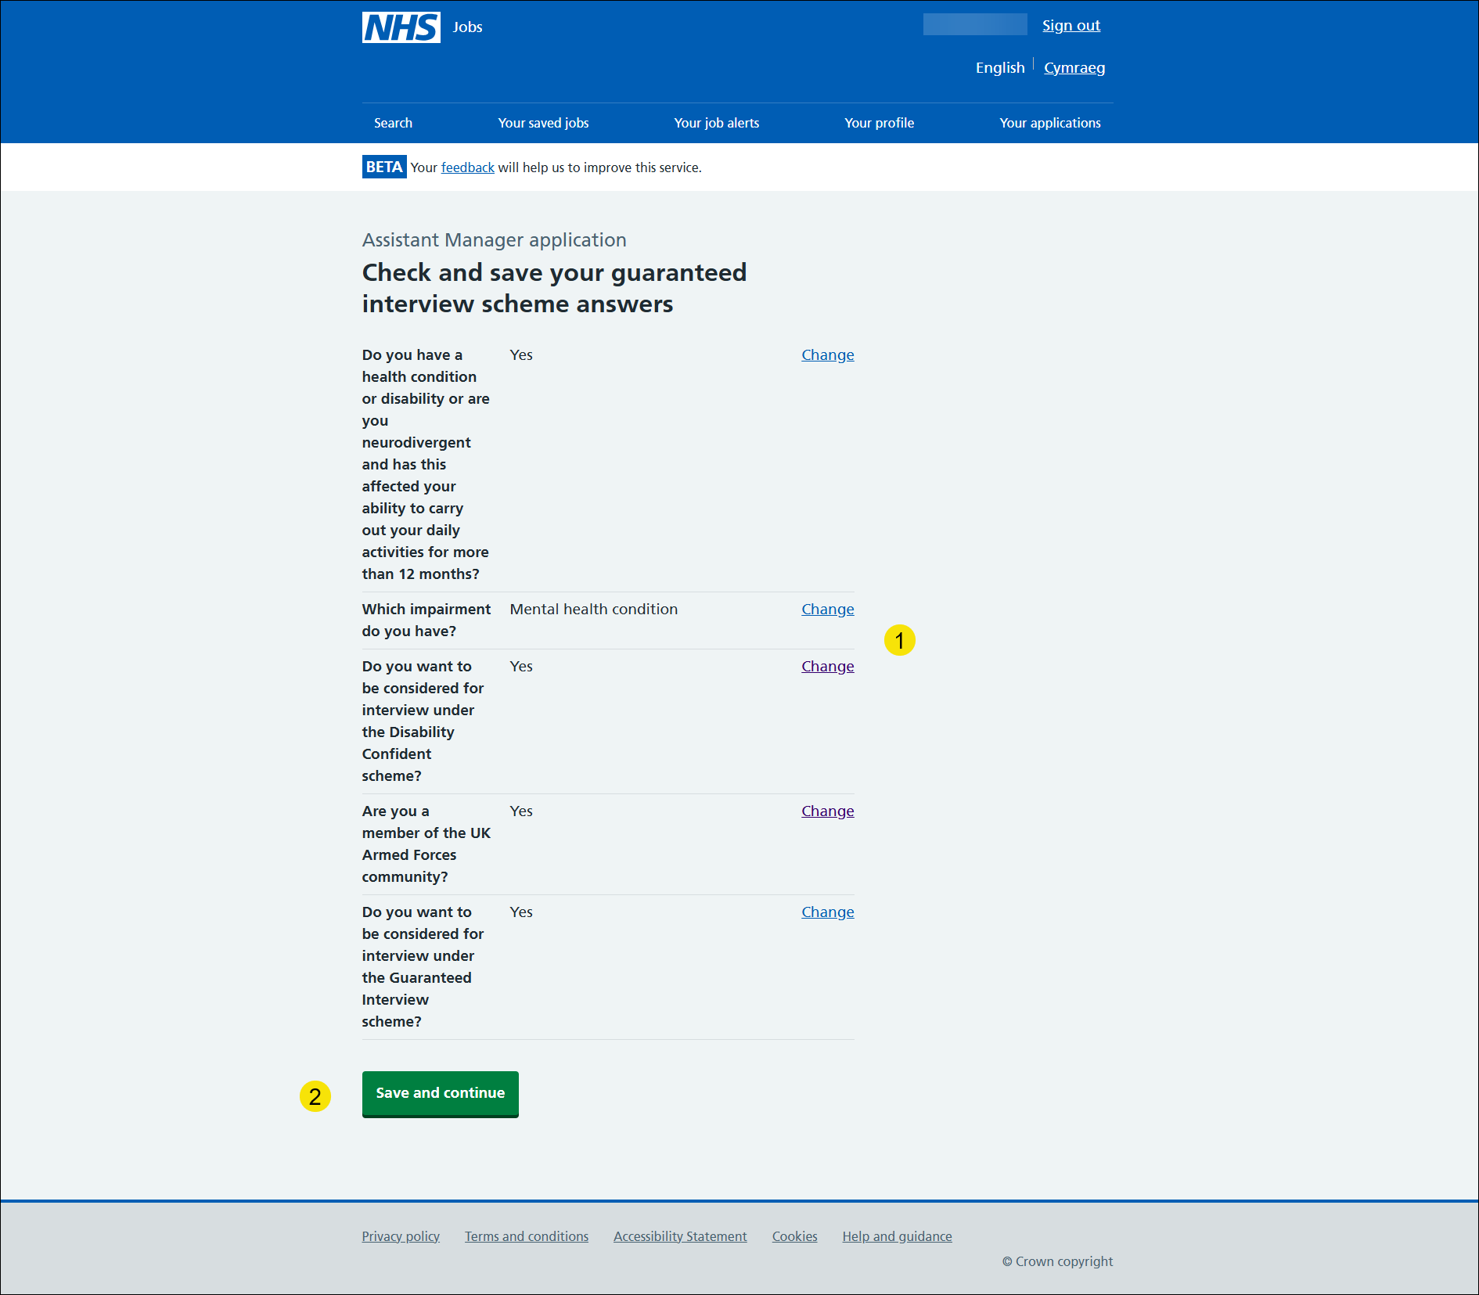

Go to the ‘Application task list’ next page.

Application task list
This page gives you instructions for how to view your application task list.
Important: In this example, the Guaranteed interview scheme status is ‘COMPLETED’ and your application is incomplete as you’ve completed 6 out of 10 sections. You need to complete all sections before you can send your application.
To start another section of your application, complete the following steps:
- Select the ‘Equality and diversity’ link.
or
- Select the ‘Save and come back later’ link (optional).
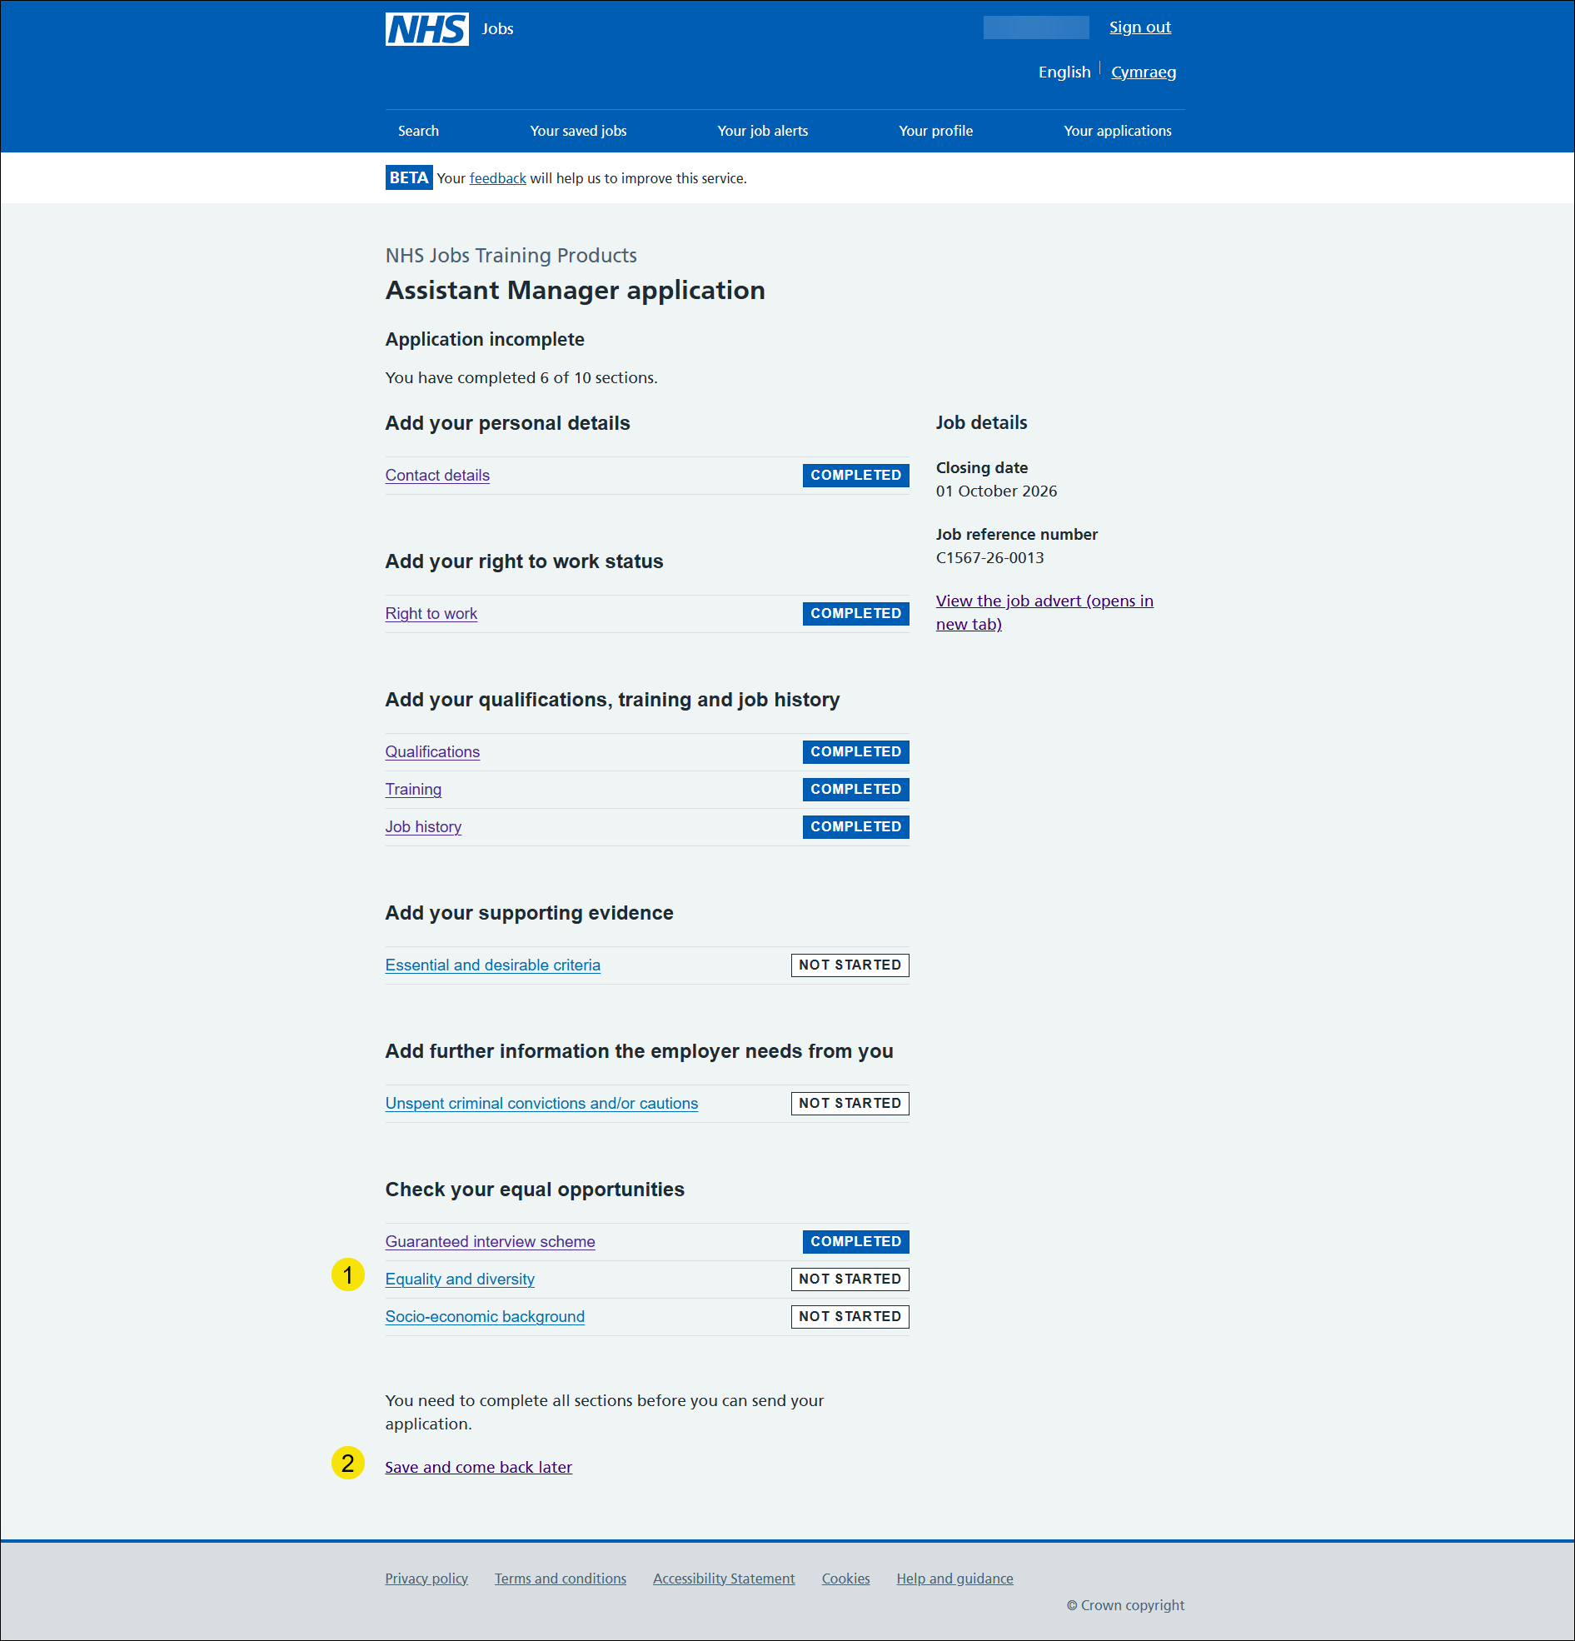

Tip: To find out how to complete your application, go to a user guide or video from the ‘Apply for a job’ section of the 'Help and support for applicants' webpage.
You’ve added your guaranteed interview scheme answers.

Equality and diversity monitoring
This page gives you instructions for how to check your equality and diversity monitoring questions.
Important: The information collected will be treated confidentially and used for statistical purposes only, not to identify individuals.
Read the information on the page and complete the following step:
- Select the ‘Continue’ button.

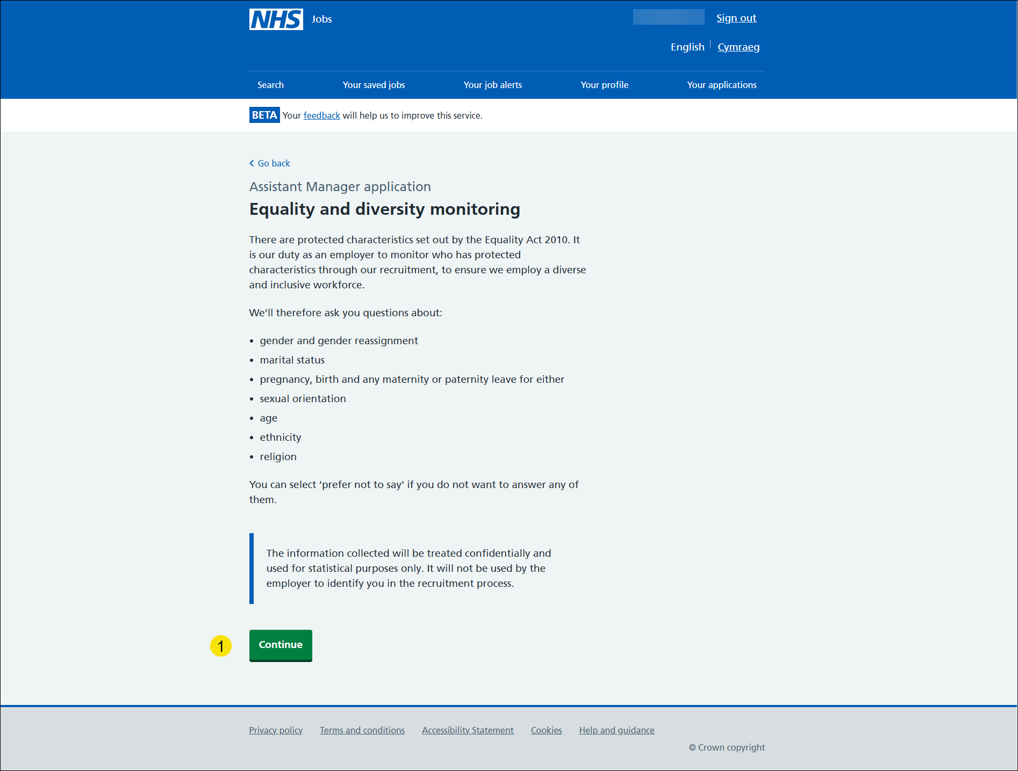

What is your gender?
This page gives you instructions for how to confirm your gender.
To confirm your gender, complete the following steps:
- Select an answer.
- Select the ‘Save and continue’ button.

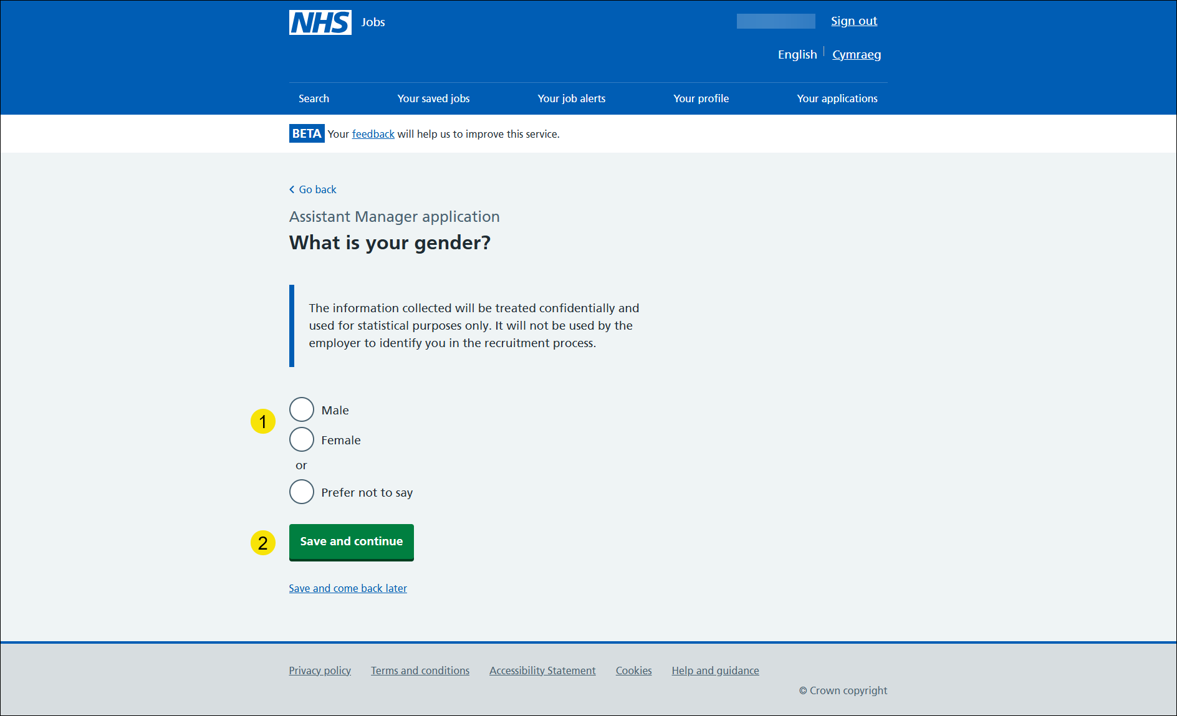

Is your gender the same as that assigned at birth?
This page gives you instructions for how to confirm if your gender is the same as that assigned at birth.
To confirm if your gender is the same as that assigned at birth, complete the following steps:
- Select an answer.
- Select the ‘Save and continue’ button.

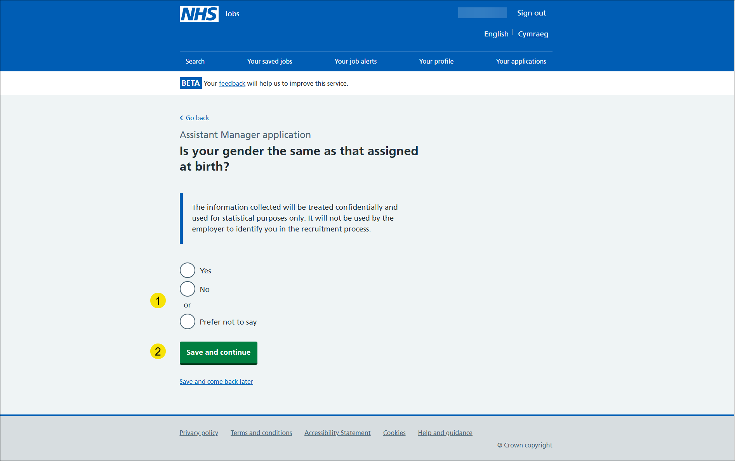

What is your marital status?
This page gives you instructions for how to confirm your marital status.
To confirm your marital status, complete the following steps:
- Select an answer.
- Select the ‘Save and continue’ button.

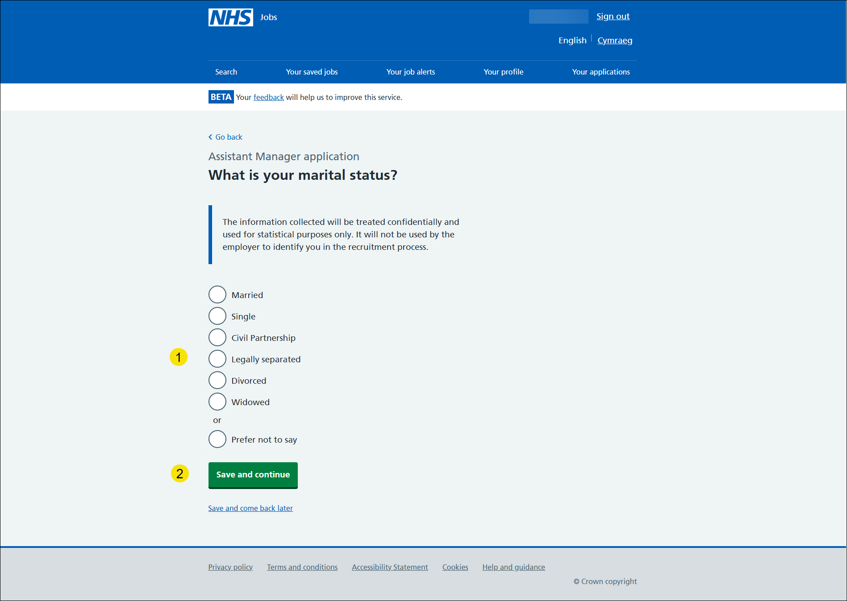

Are you currently pregnant, on maternity or paternity leave or have you given birth in the last 26 weeks?
This page gives you instructions for how to confirm if you’re currently pregnant, on maternity/paternity leave or have you given birth in the last 26 weeks.
To confirm if you’re currently pregnant, on maternity/paternity leave or have given birth in the last 26 weeks, complete the following steps:
- Select an answer.
- Select the ‘Save and continue’ button.
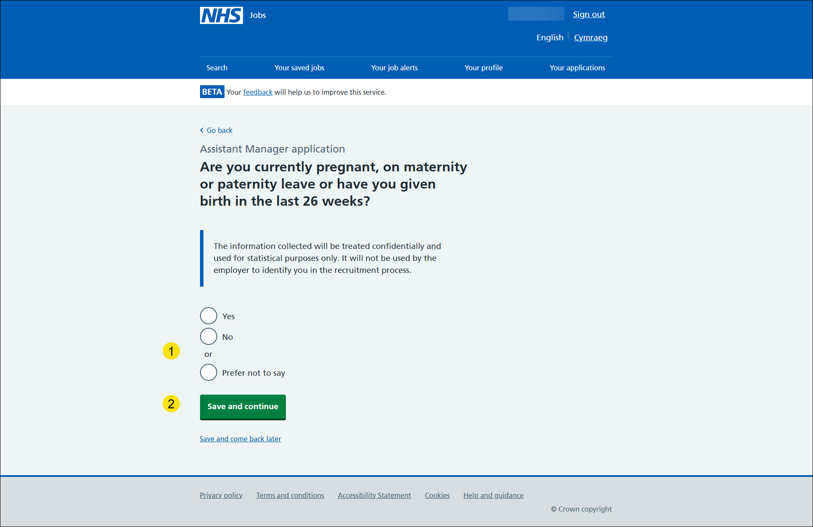

Which of the following options best describes how you think of yourself?
This page gives you instructions for how to confirm how you think of yourself.
To confirm how you think of yourself, complete the following steps:
- Select an answer.
- Select the ‘Save and continue’ button.

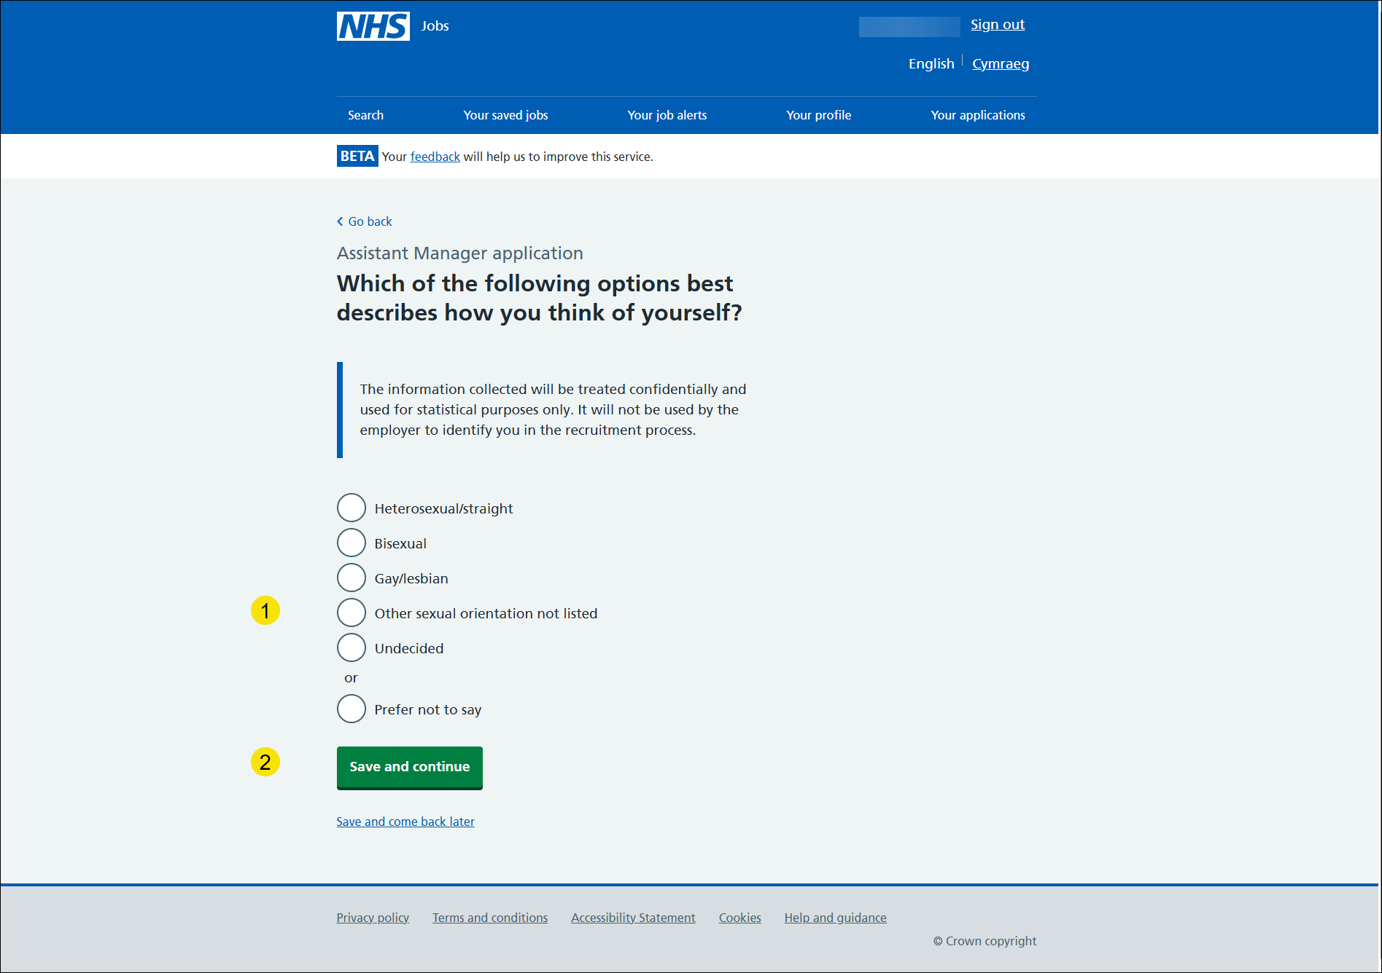

What is your age?
This page gives you instructions for how to confirm your age.
To confirm your age, complete the following steps:
- Select an answer.
- Select the ‘Save and continue’ button.

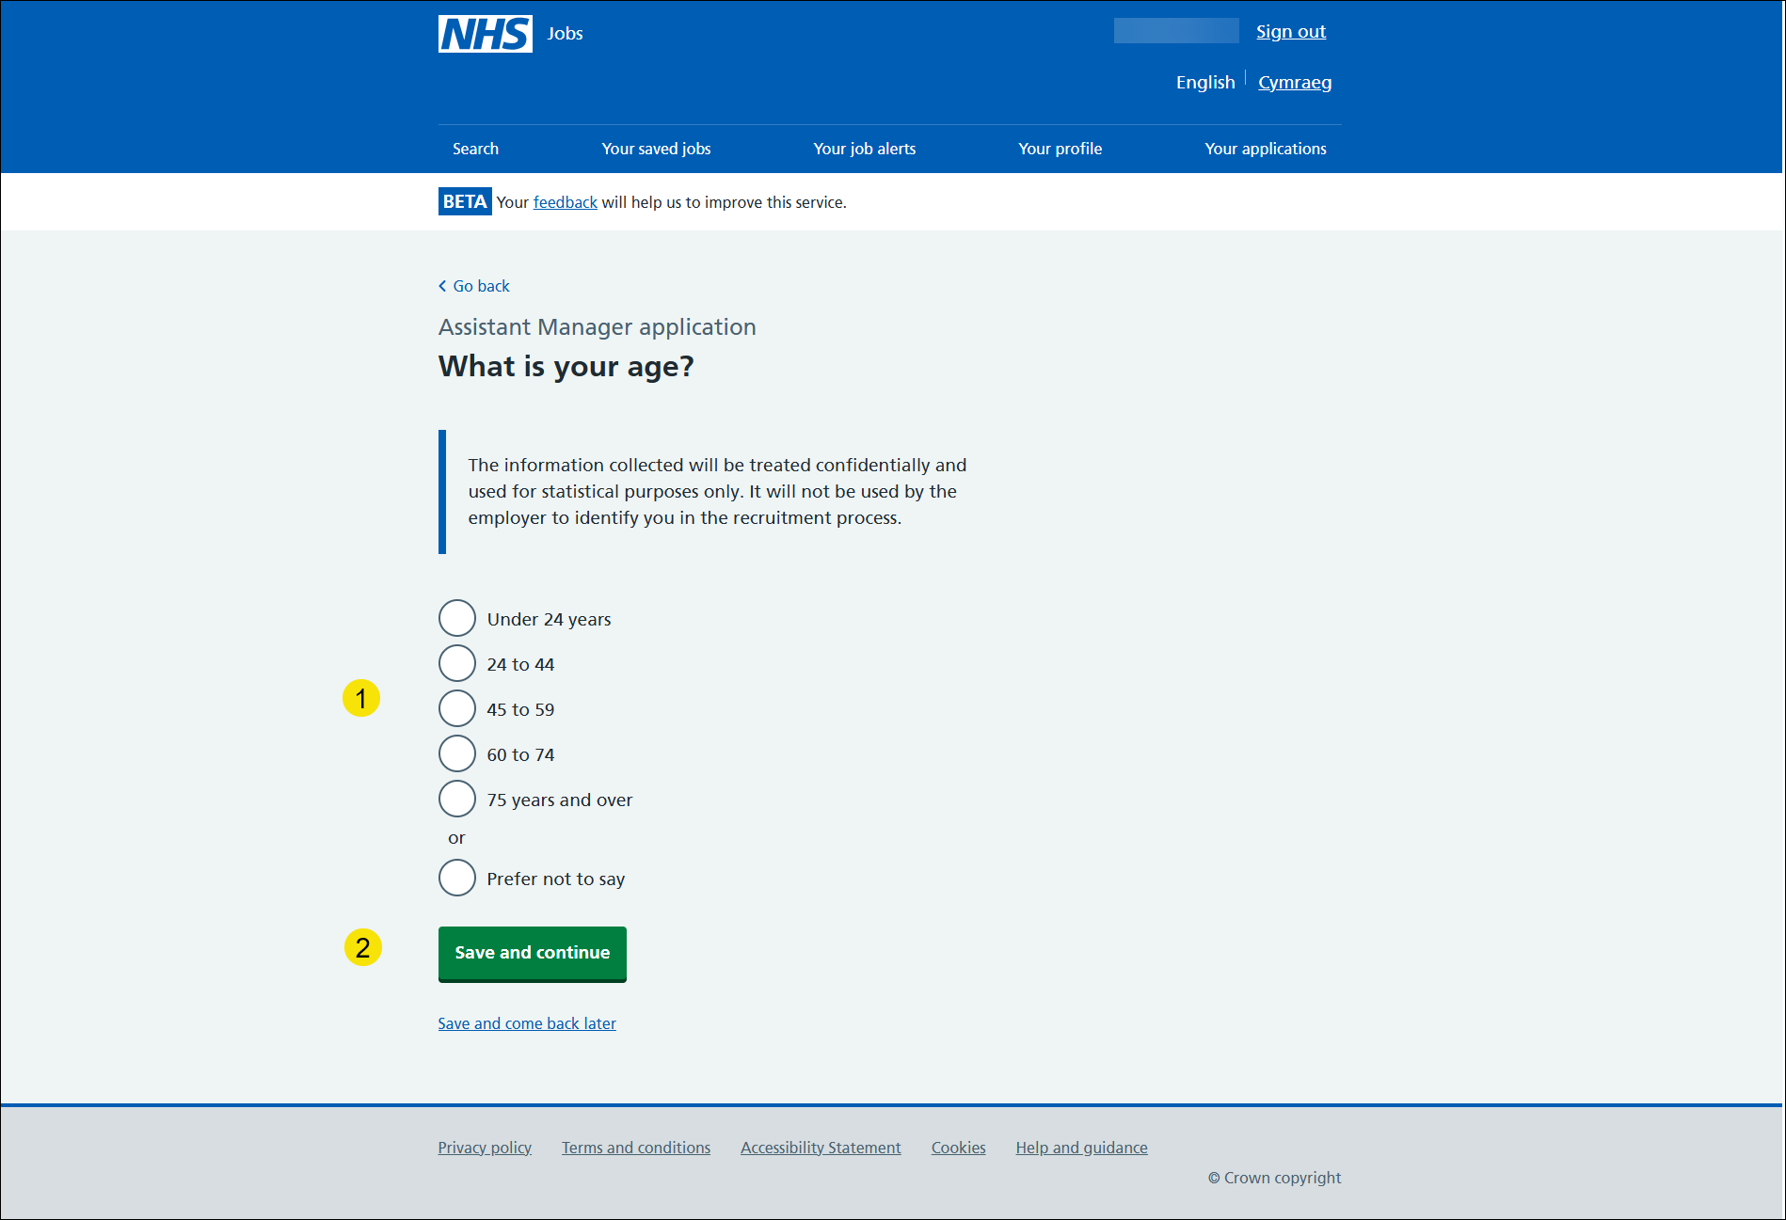

What is your ethnic group?
This page gives you instructions for how to confirm your ethnic group.
To confirm your ethnic group, complete the following steps:
- Select an answer.
- Select the ‘Save and continue’ button.

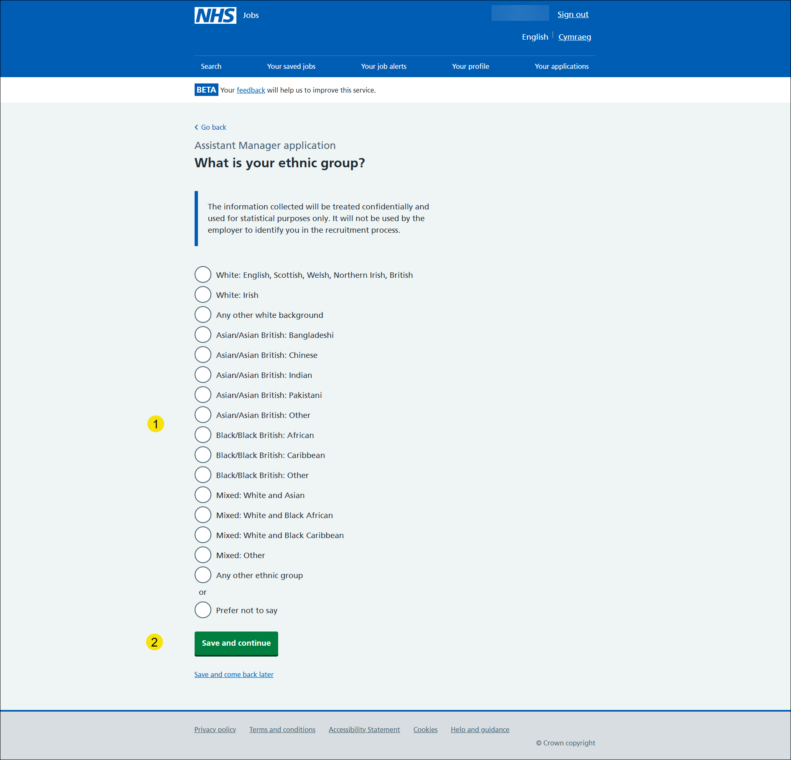

What is your religion?
This page gives you instructions for how to confirm your religion.
To confirm your religion, complete the following steps:
- Select an answer.
- Select the ‘Save and continue’ button.

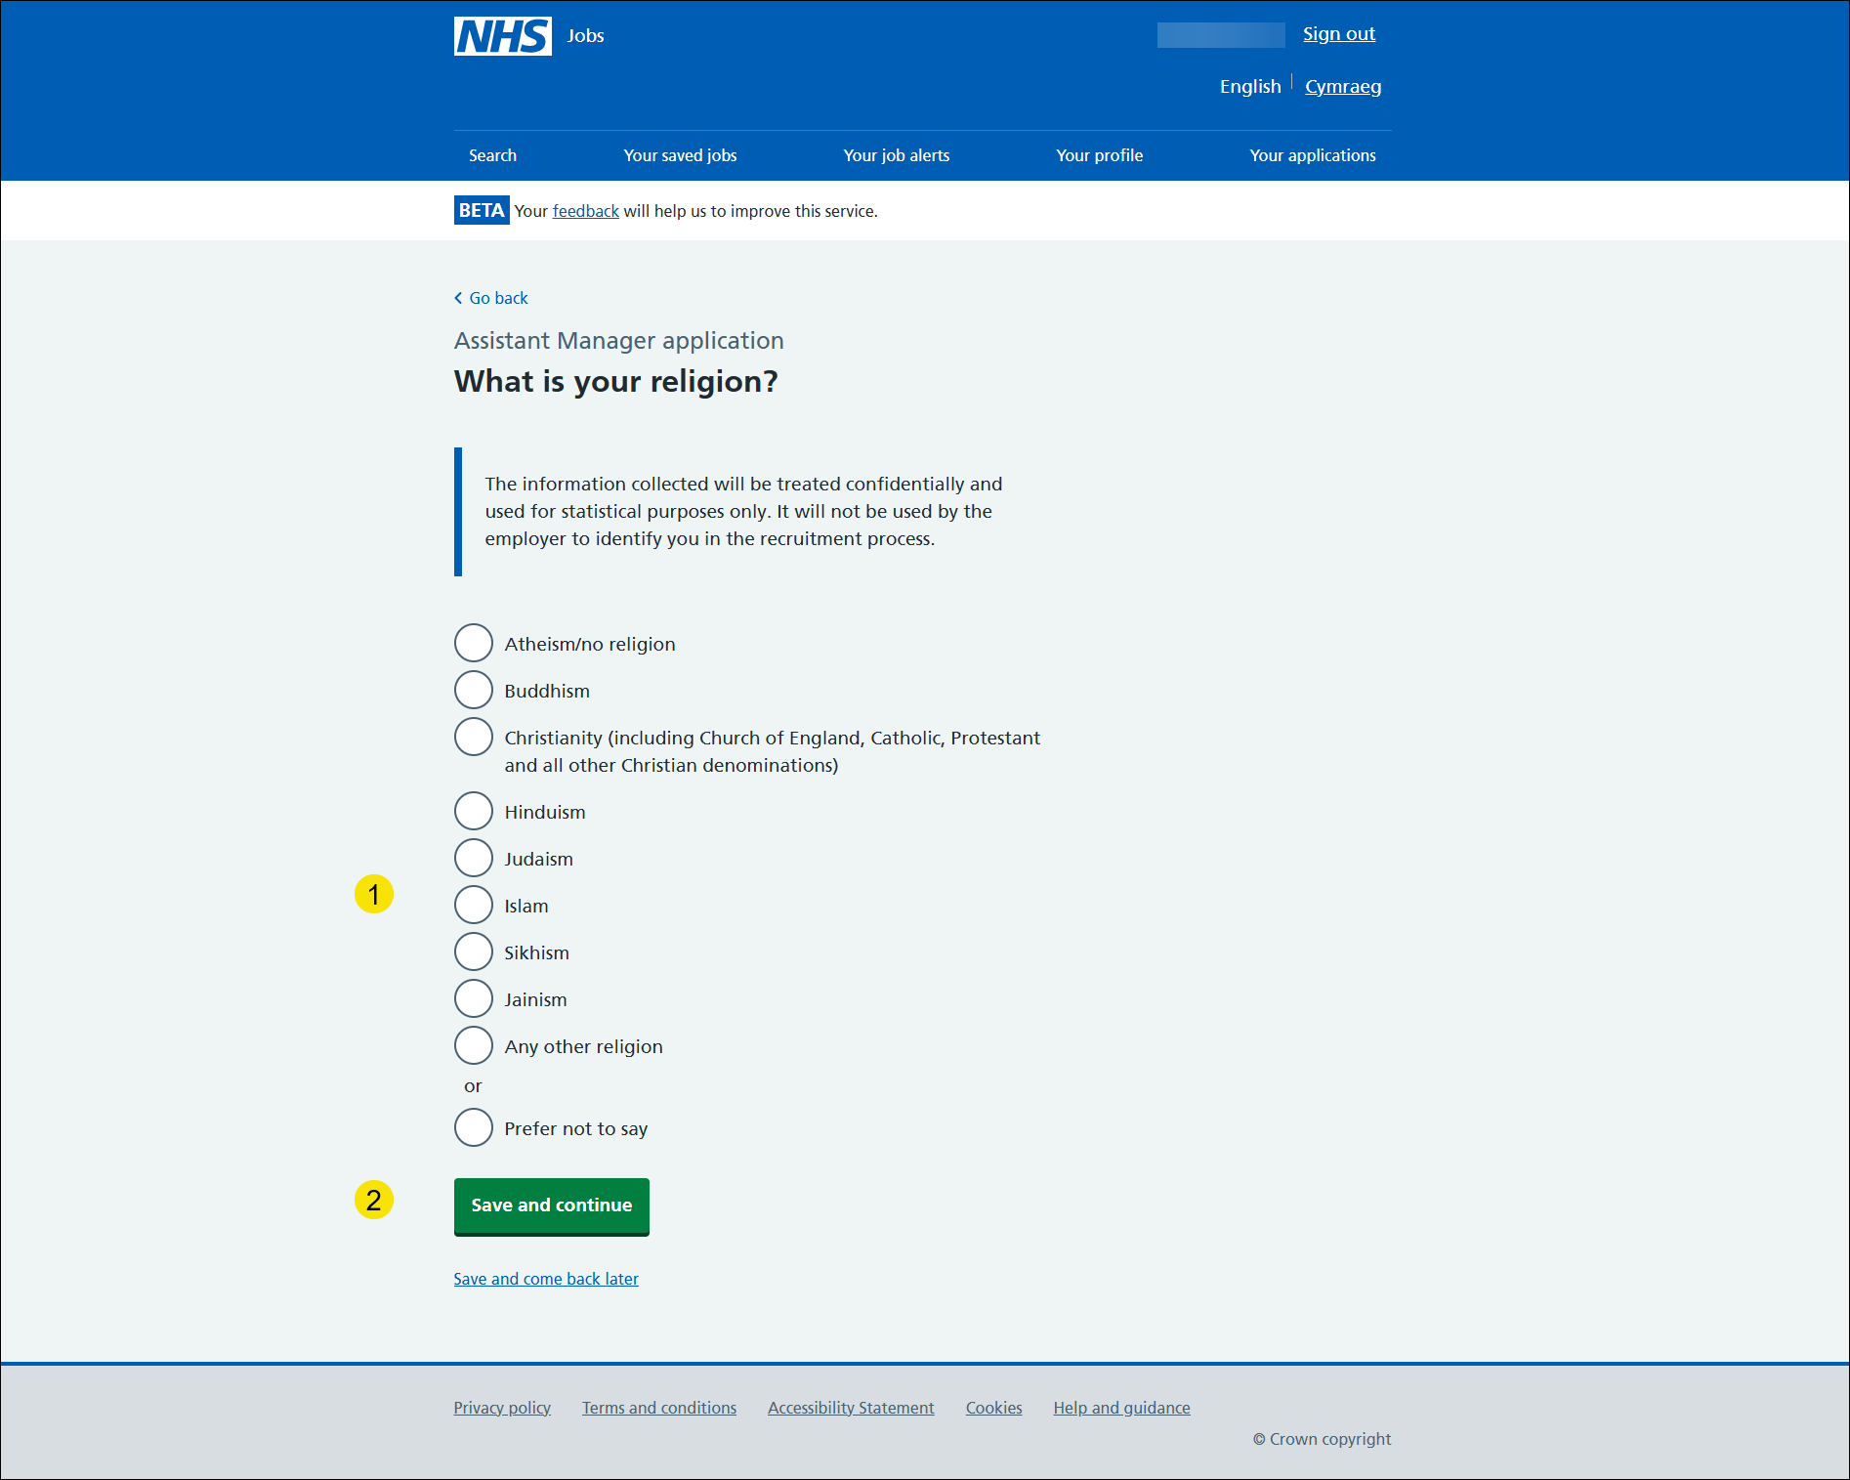

Check and save your equality and diversity answers
This page gives you instructions for how to check and save your equality and diversity answers.
To check, change and confirm your equality and diversity answers, complete the following steps:
- Select a ‘Change’ link:
- ‘Your gender’ (optional)
- ‘Gender assignment’ (optional)
- ‘Marital status’ (optional)
- ‘Pregnancy, maternity and paternity leave’ (optional)
- ‘Sexual orientation’ (optional)
- ‘Age’ (optional)
- ‘Ethnic group’ (optional)
- ‘Religion’ (optional)
- Select the ‘Save and continue’ button.

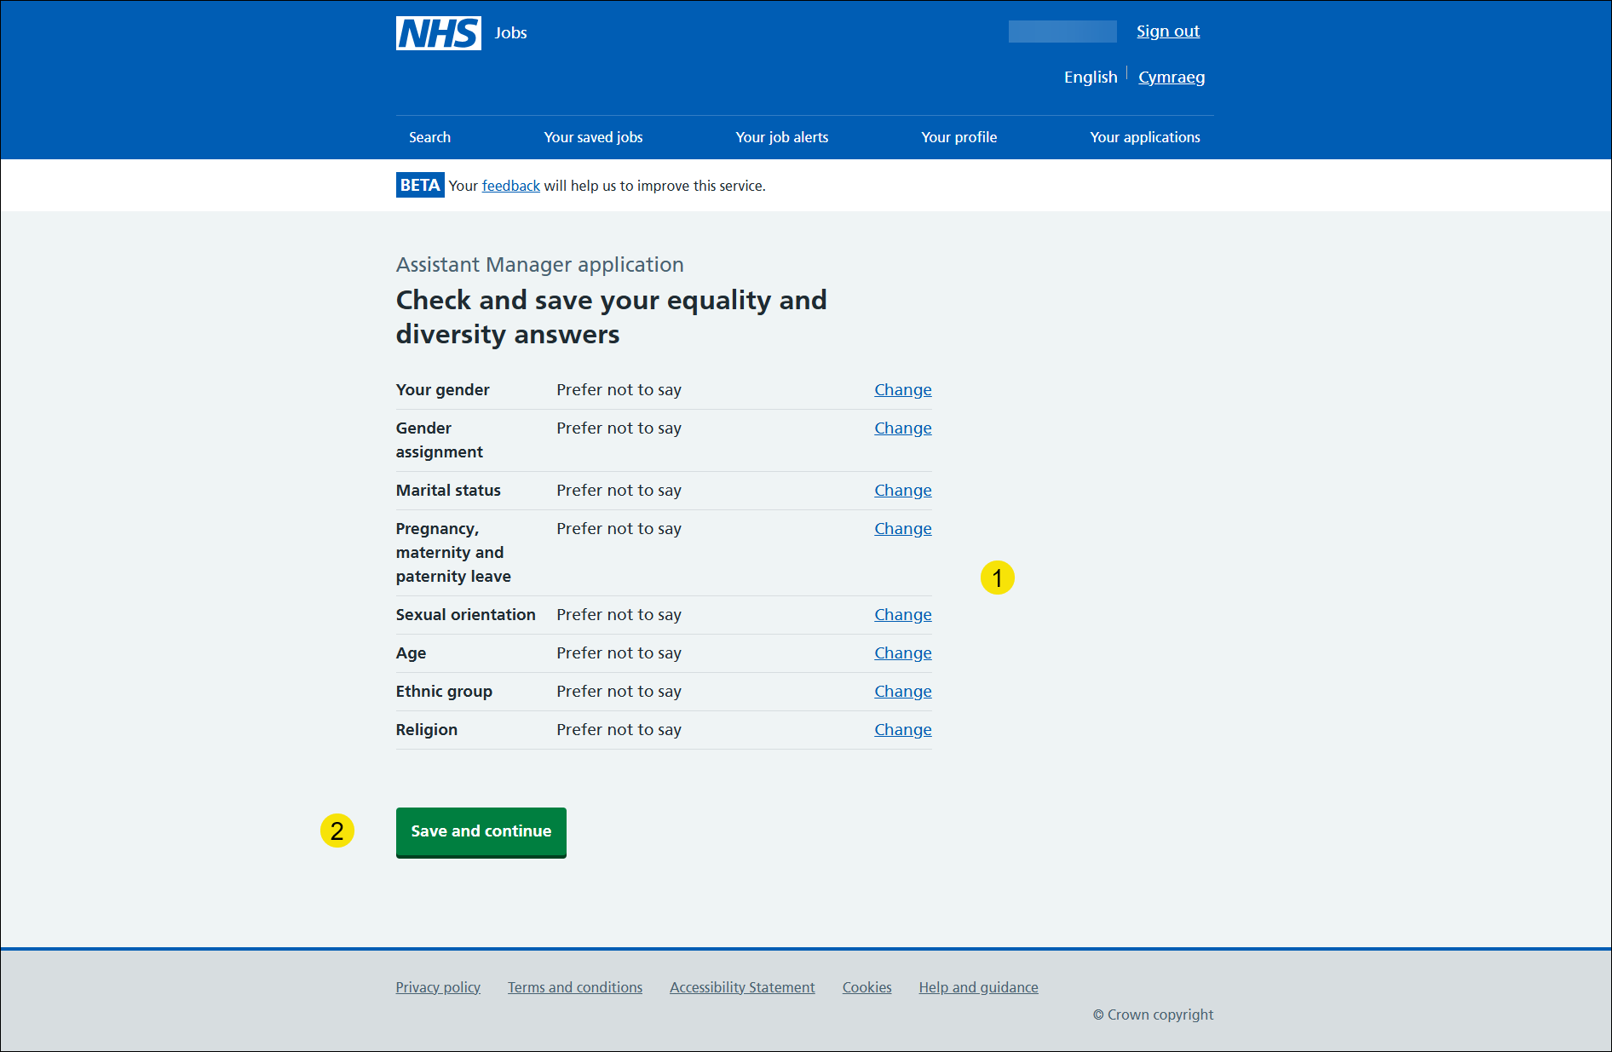

Application task list
This page gives you instructions for how to view your application task list.
Important: In this example, the Equality and diversity status is ‘COMPLETED’ and your application is incomplete as you’ve completed 9 out of 10 sections. You need to complete all sections before you can send your application.
To start another section of your application, complete the following steps:
- Select the ‘Socio-economic background’ link.
or
- Select the ‘Save and come back later’ link (optional).

Go to the next page to see the screenshot.

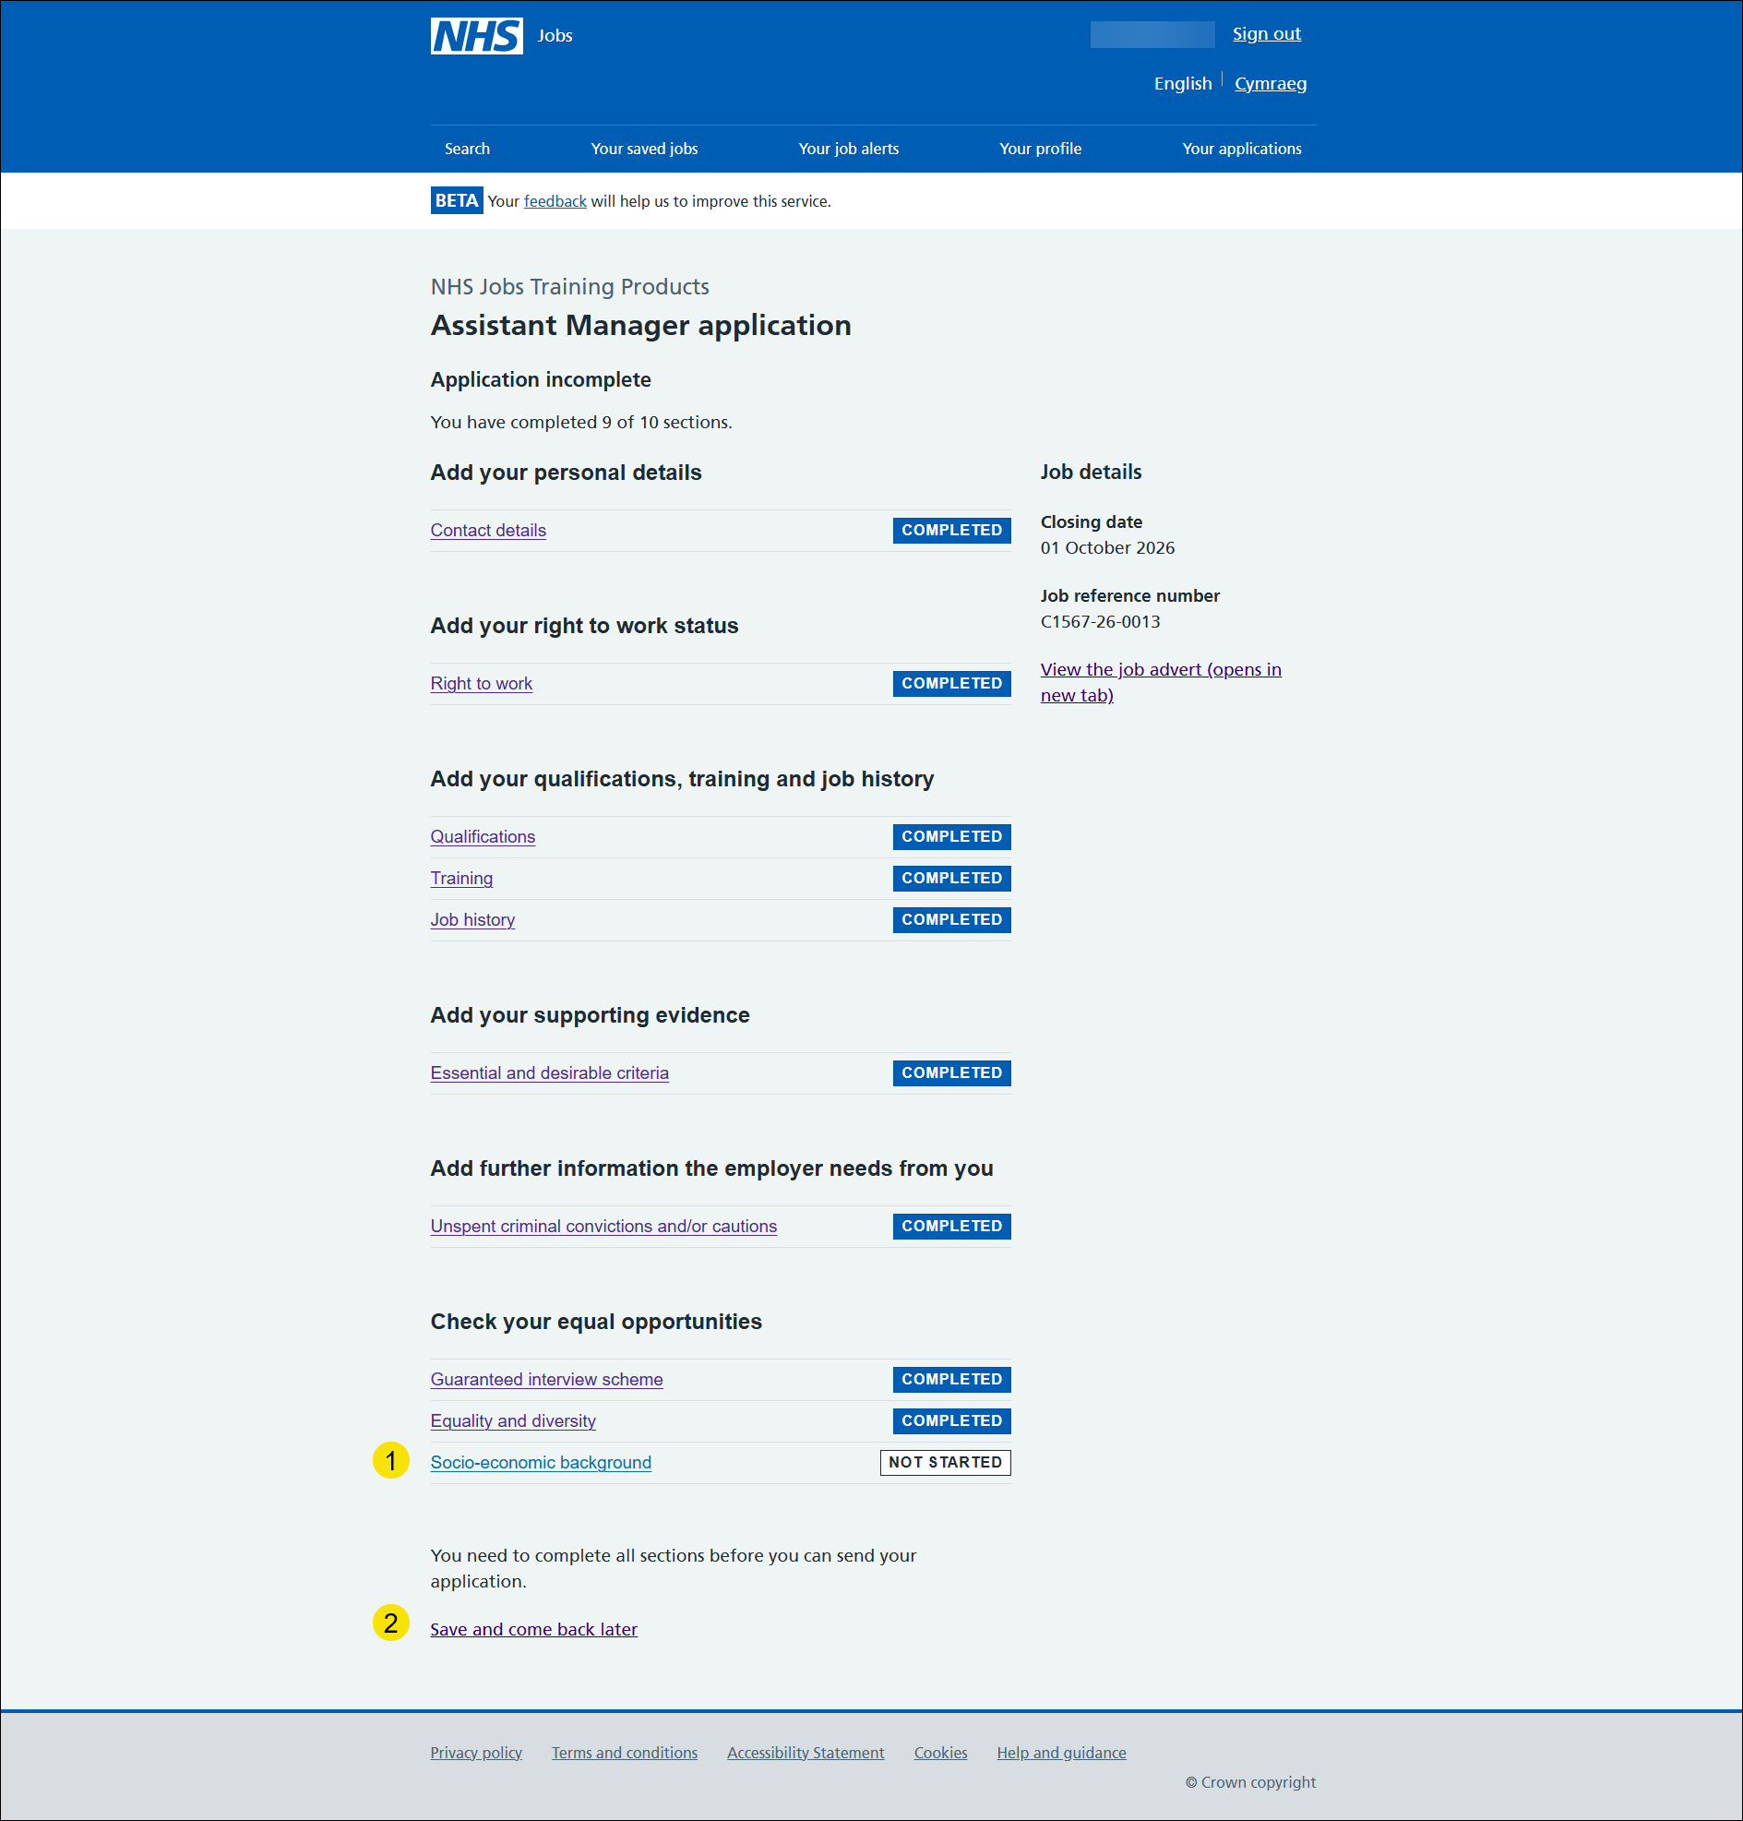

Your socio-economic background
This page gives you instructions for how to check your socio-economic background questions.
Important: The information collected will be treated confidentially and used for statistical purposes only, not to identify individuals.
Read the information on the page and complete the following step:
- Select the ‘Continue’ button.

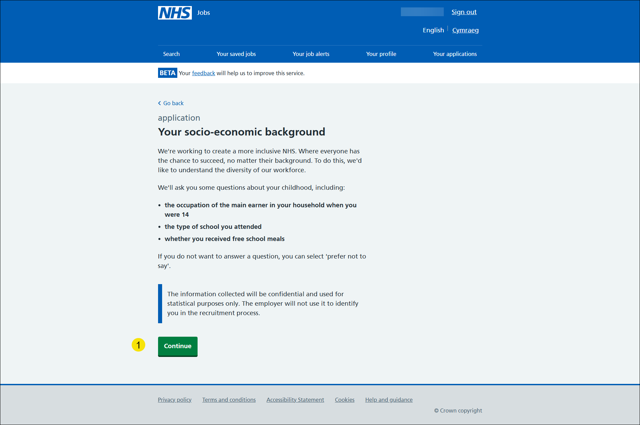

What was the occupation of the main earner in your household when you were 14 years old?
This page gives you instructions for how to confirm what was your occupation of the main earner in your household when you were 14 years old.
To confirm your choice, complete the following steps:
- Select an answer.
- Select the ‘Save and continue’ button.
- Select save and come back later.
Go to the next page to see the screenshot
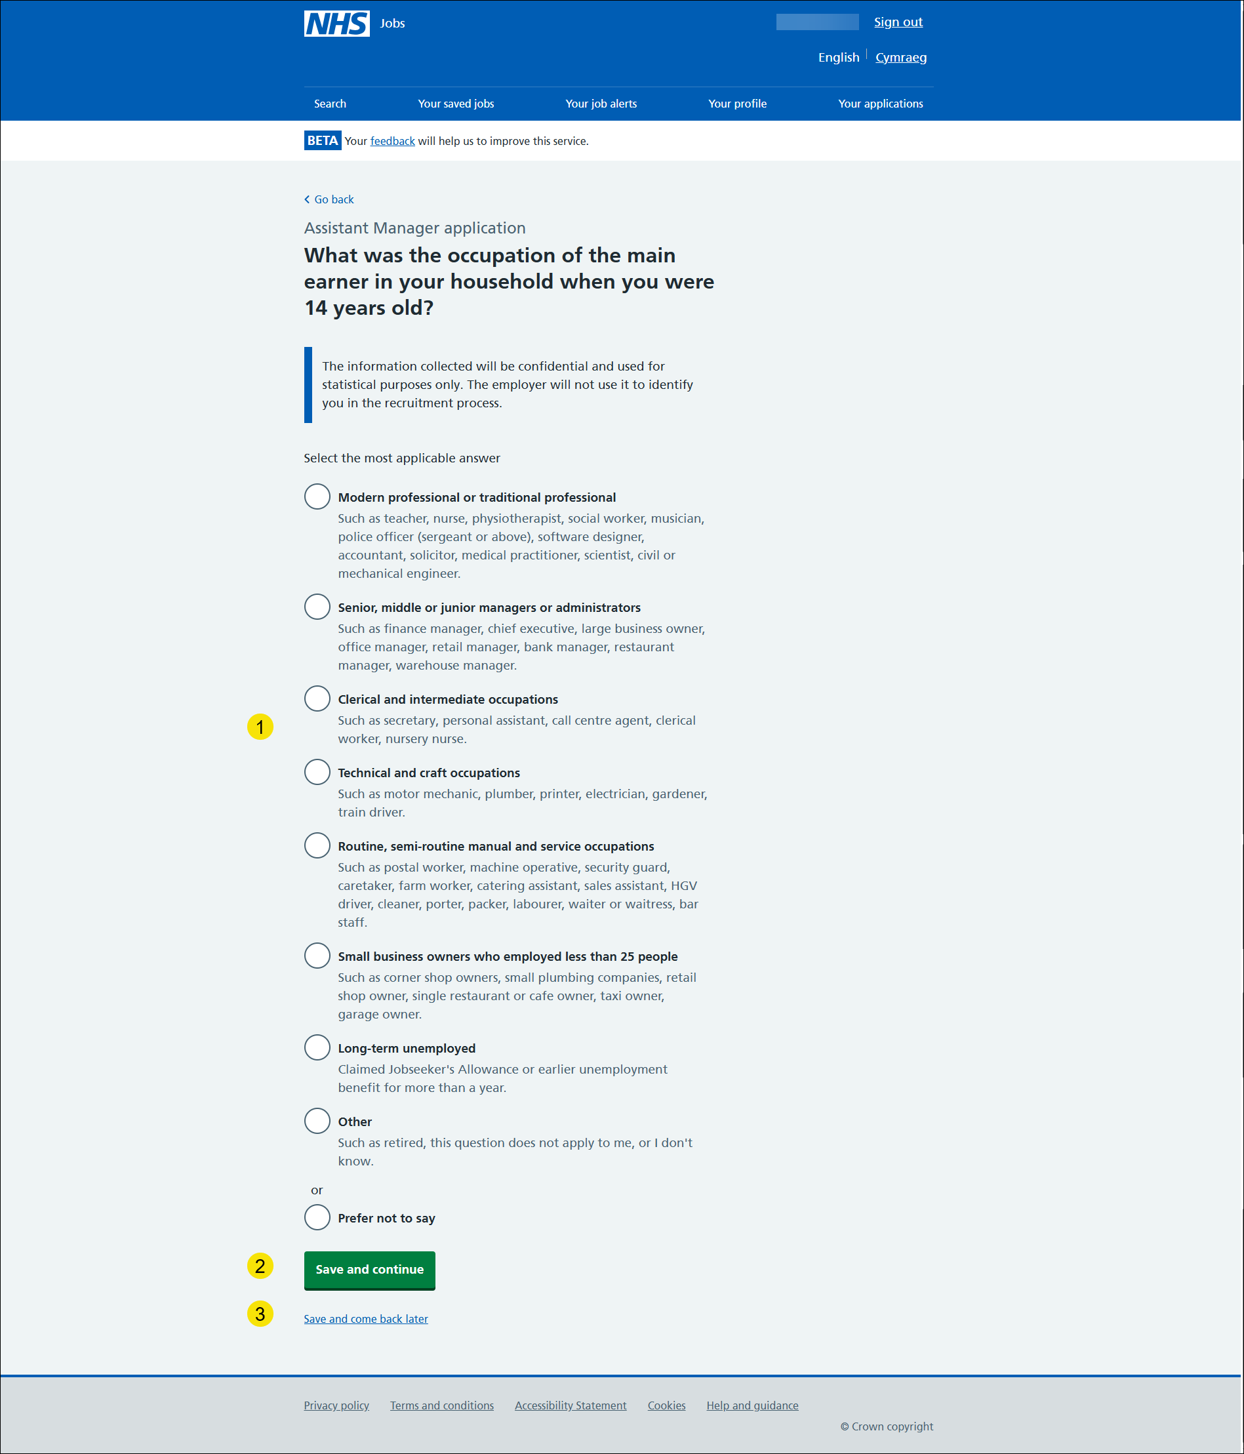

What type of school did you attend for most of the time between ages 11 and 16?
This page gives you instructions for how to confirm what type of school you attended between ages of 11 and 16.
To confirm your choice, complete the following steps:
- Select an answer.
- Select the ‘Save and continue’ button.

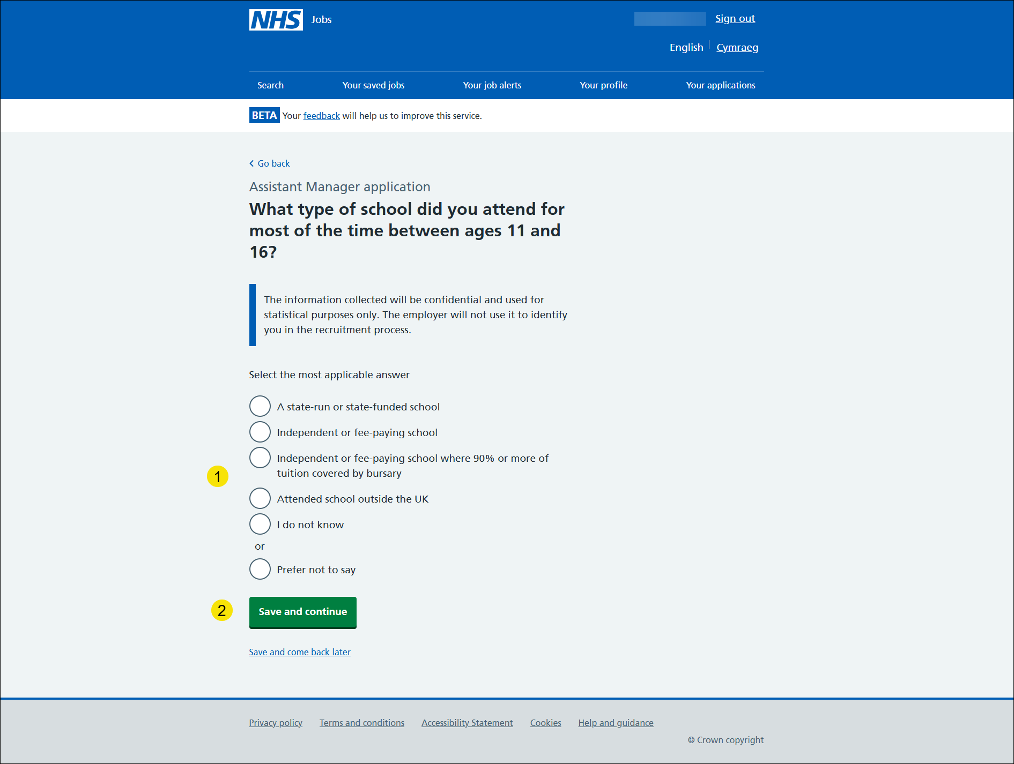

Were you eligible for free school meals at any time?
This page gives you instructions on how to confirm if you were eligible for free school meals.
To confirm your choice, complete the following steps:
- Select an answer.
- Select the ‘Save and continue’ button.

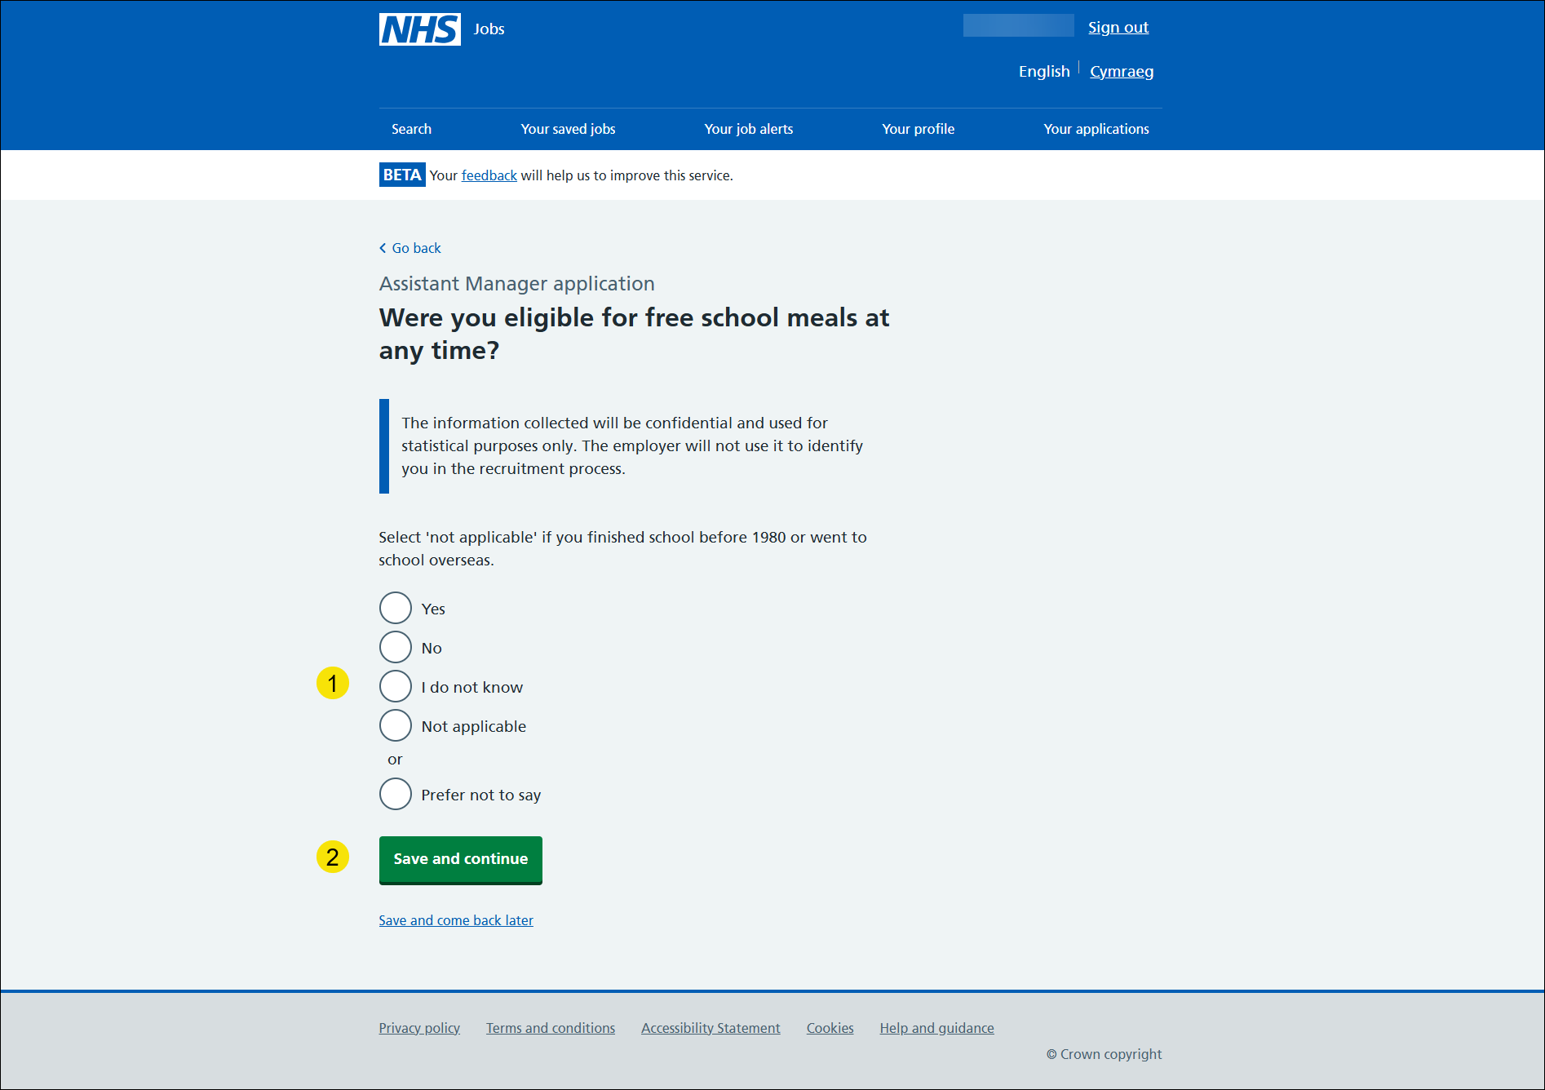

Check and save your socio-economic background answers
This page gives you instructions on how to check and save your socio-economic background answers.
To check, change and confirm your socio-economic background answers, complete the following steps:
- Select a ‘Change’ link.
- ‘What was the occupation of the main earner in your household when you were 14 years old?’ (optional)
- ‘What type of school did you attend for most of the time between ages 11 and 16?’ (optional)
- ‘Were you eligible for free school meals at any time?’ (optional)
- Select the ‘save and continue’ button.
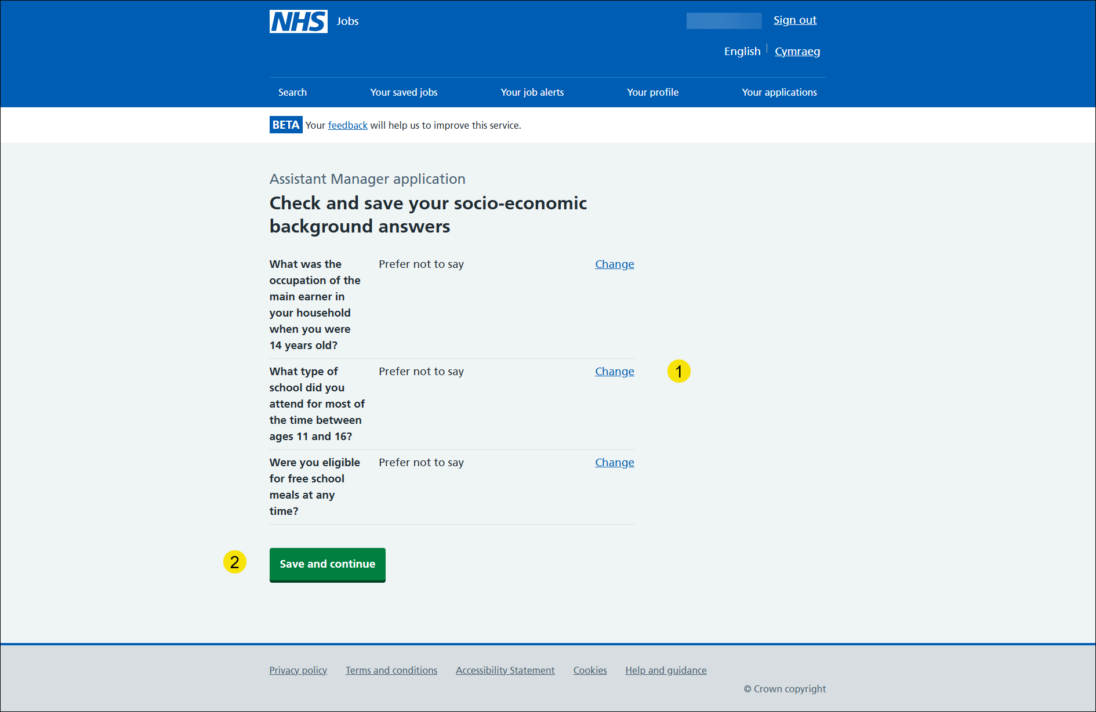

Application task list
This page gives you instructions for how to view your application task list.
Important: In this example, the Socio-economic background status is ‘COMPLETED’ and your application is complete as you’ve completed 10 out of 10 sections. You need to complete all sections before you can send your application.
To change your answers on a section of your application, complete the following steps:
- Select any of the links below.
or
- Select ‘I agree and accept the above declaration’ if you are happy with the information provided.
- Select ‘send application’ link.
or
- Select ‘save and come back later’ link.
Go to the next page to see the screenshot.

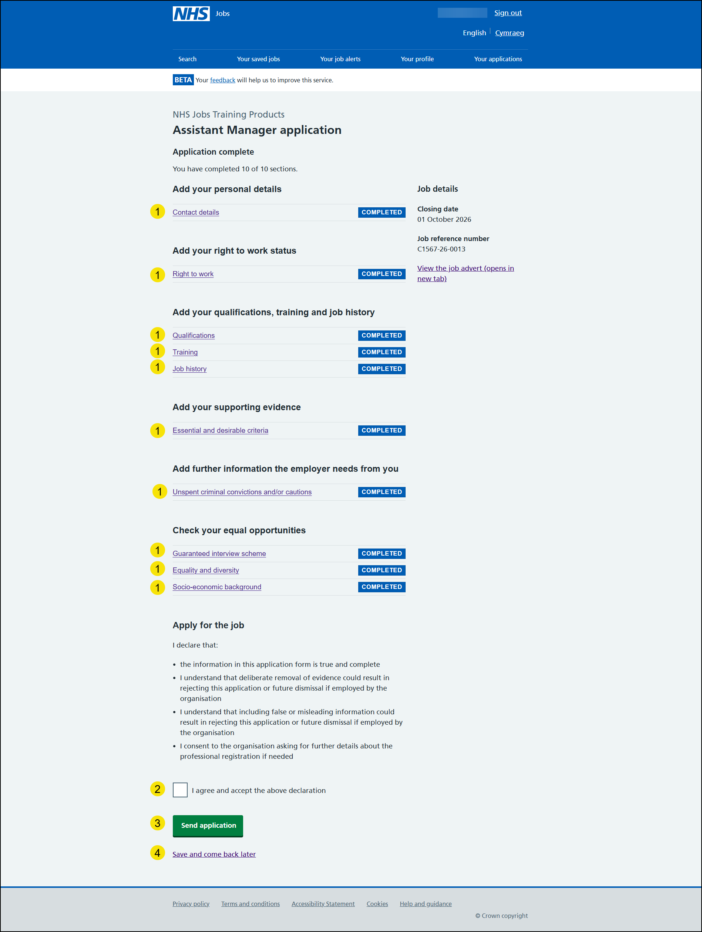

You have now reached the end of this user guide.

