Annex 5.10 Ophthalmic Contract Visit
Guidance document for Contractors

The following guidance is given to inform you of the evidence and policies that are required before a site visit can proceed. This evidence is checked for compliance by the NHSBSA caseworker assigned to your application.
Everything in a green box needs to be submitted prior to site visit. Everything in a red box is information/guidance for the contractor. Can you ensure that all policies have an author and review date.
Section 1 to 6 will be pre-populated, please check this information before proceeding and let NHSBSA know of any changes that need to be made.

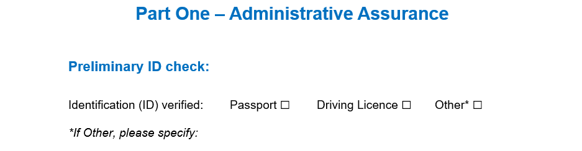
Identification to be provided at or before the virtual site visit takes place.
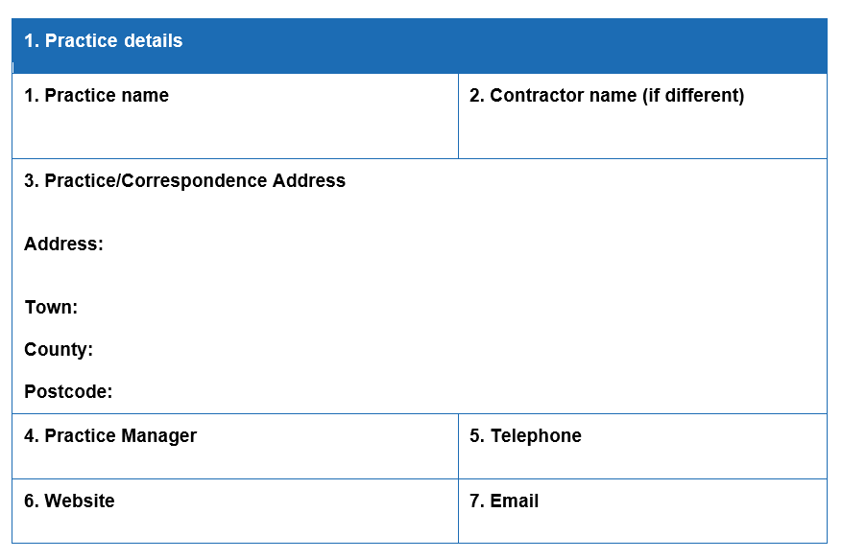
This should be the email address to be used for all correspondence relating to the ophthalmic contract visit. It may be different to emails for other purposes. If you need to enter more than one email address, please state the purpose of each.
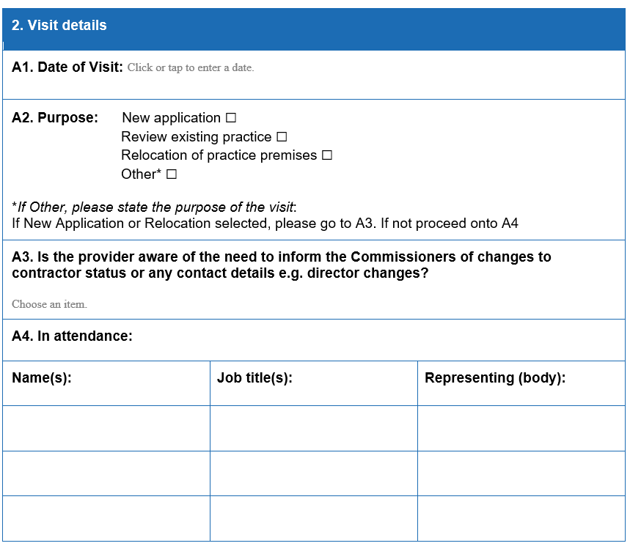

Please select the correct option from this drop down menu.

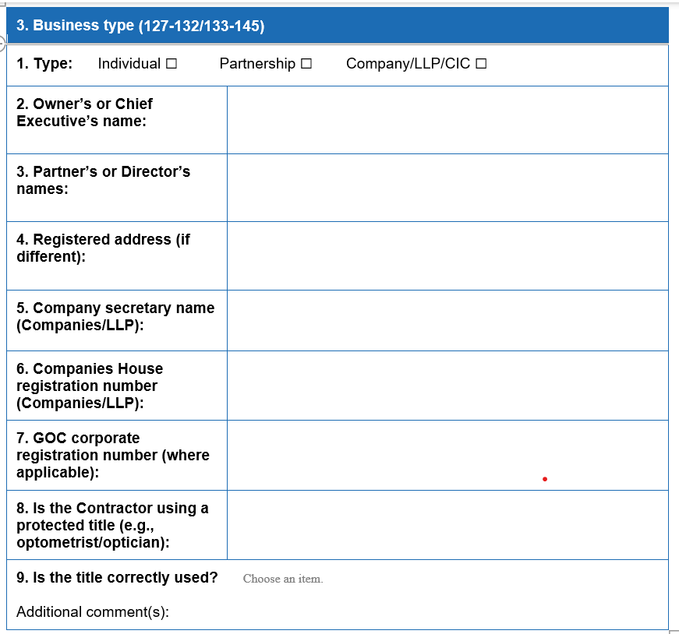


If the hours that GOS is provided within your practice are different to your practice opening hours, then this needs to be stated and differentiated from the practice opening hours.

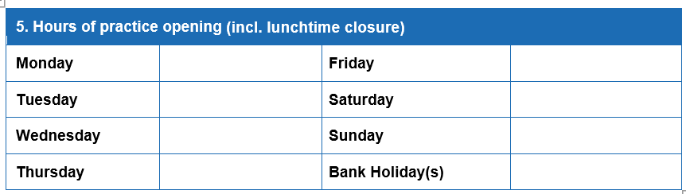

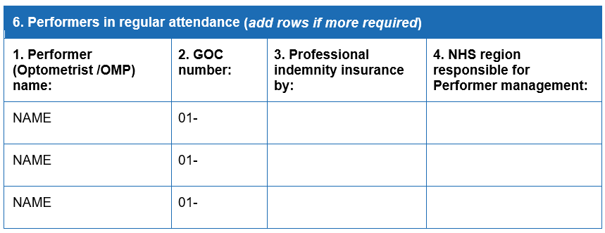
The contractor should write in this space, the relevant region responsible for each of their individual performers.

Contractors should check this on an annual basis in April/May. Select Yes or No from the drop down in the Yes/No column.

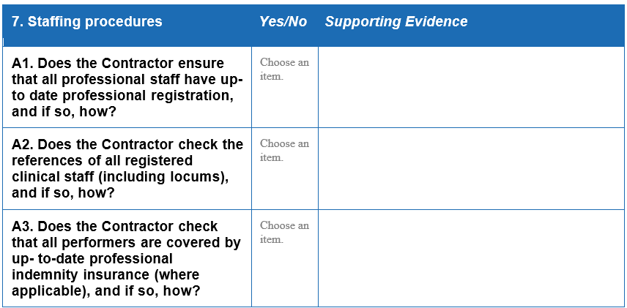
A printout/ screenshot of each performer’s GOC registration is required for each visit.

‘Where applicable’ is only relevant for instances where the contractor holds the insurance for all their performers centrally.

Copies of valid professional indemnity certificate for each performer or company policy showing professional indemnity where appropriate is required prior to the visit.
This is required prior to visit. This could be a copy of references for each performer, copy of reference template or copy of practice policy.

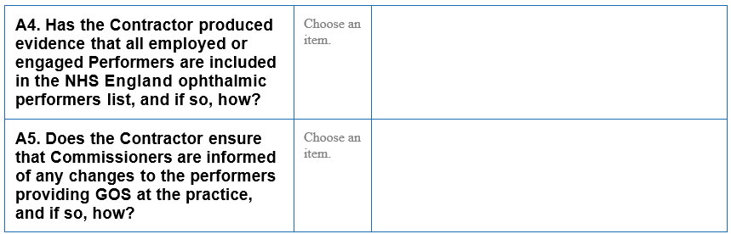
A printout/ screenshot of entry from OPL for England for each performer is required prior to the visit.
The contractor should hold documentary evidence of inclusion.

Required prior to visit. Written description of how this is done.

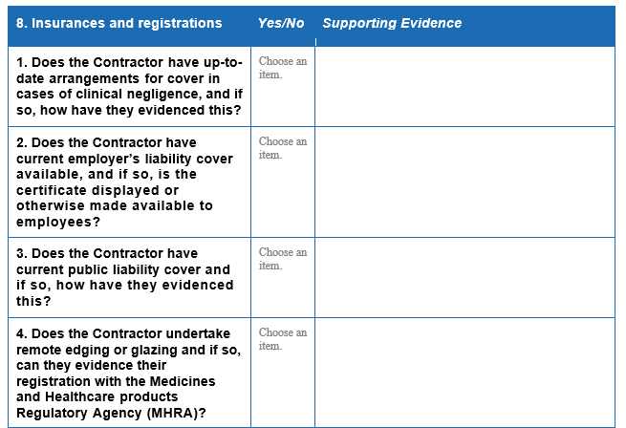

This is required prior to visit.

This copy is required prior to visit.

Copy of current policy clearly showing public liability cover is required prior to the visit.
If the contractor does not undertake remote edging/glazing, N/A can be entered.

Copy of MRA registration certificate is required prior to the visit.

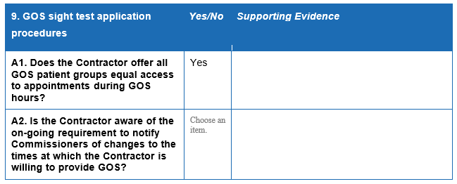

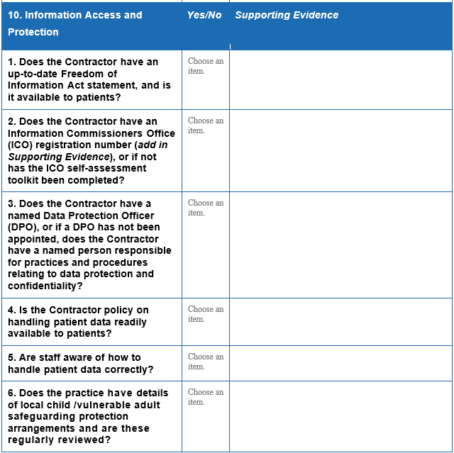
Copy of personalised Freedom of Information Act 2005 required prior to the visit.
This is for patient data held on a computer or other electronic device. Data protection (Charges and Information) Regulations 2018.

Copy of current certificate from ICO is required prior to the visit.

Submit name of DPO prior to visit.

Submit copy prior to visit.

Submit evidence of this prior to visit. Details of local contacts with contact details.

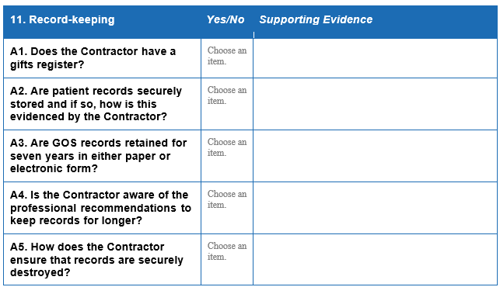
Submit copy of gifts register prior to virtual visit.
Entries need only be made if value of gift >£100.

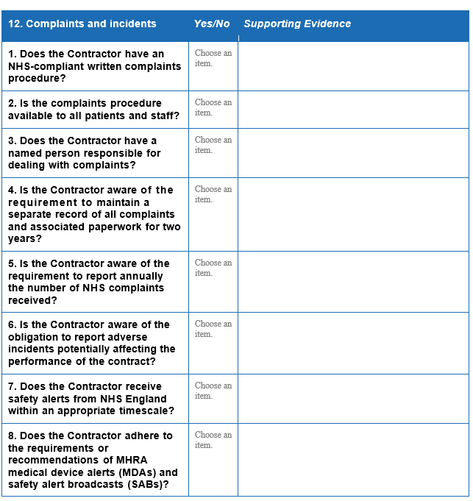
Submit copy prior to visit.

Submit copy prior to visit.
Submit name prior to visit.

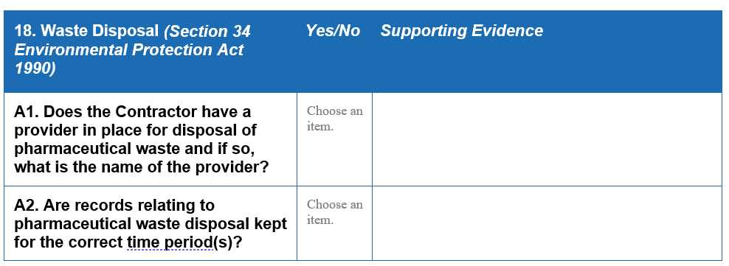

I.e., transfer notes two years, and consignment notes three years.
Documents required prior to visit.

If an existing practice, submit evidence of transfer notes from previous two years.

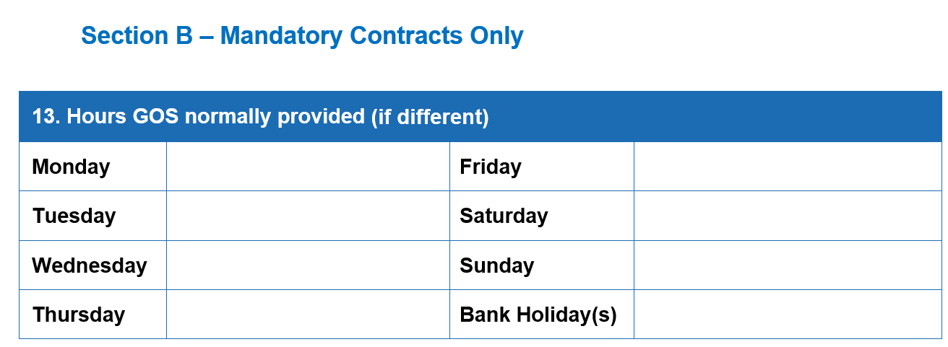

GOS hours information needed prior to visit.

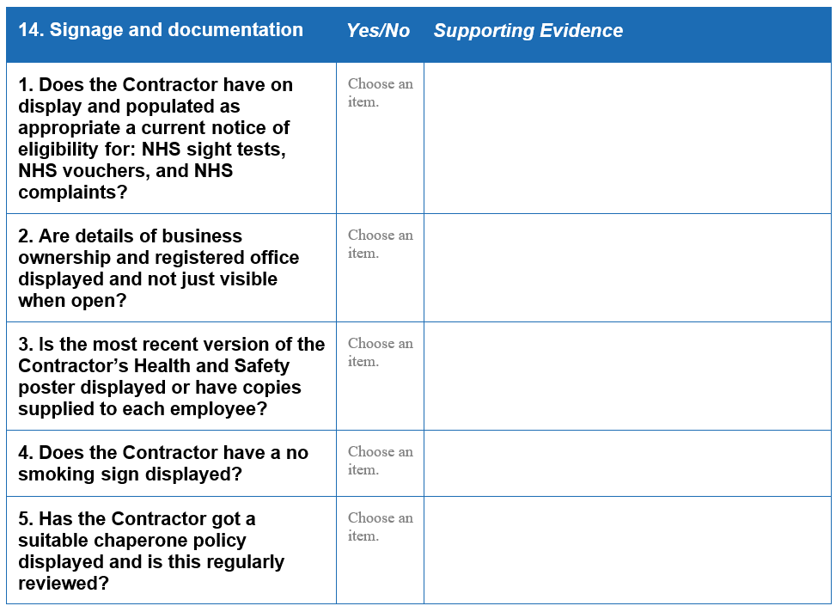

Companies Act 2006. Running a limited company: your responsibilities: Signs, stationery and promotional material - GOV.UK (www.gov.uk)

Notice should be displayed in a prominent place, so patients are aware of their right to a chaperone.

This is required prior to visit.

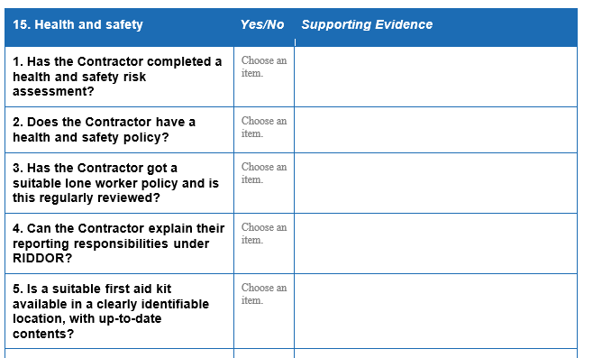
Must be completed/ documented if five or more employees or individuals are under contract to provide services within the company/ organisation.

This is required prior to visit.

This may be part of the Health and Safety Policy.

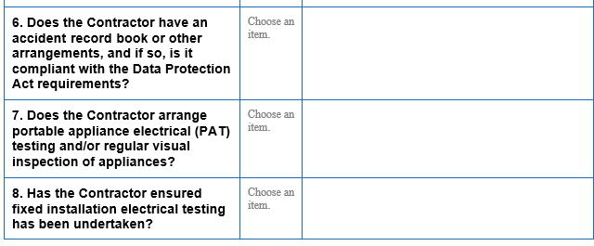

Evidence required prior to visit.

Certificate required prior to visit.

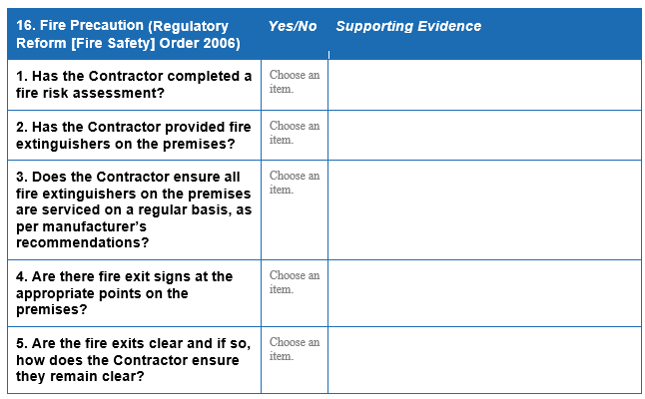

Required prior to visit.

Ensure fire extinguishers are accessible.

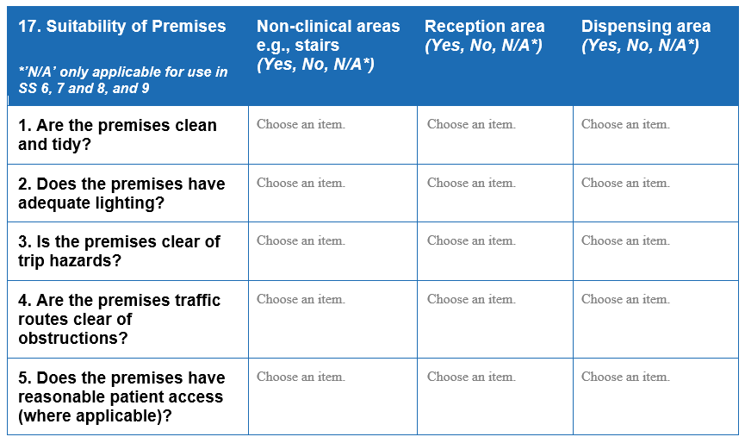

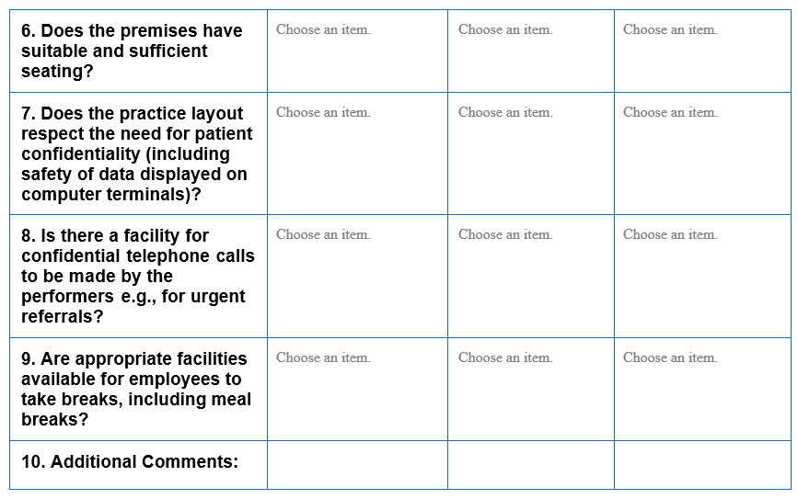

This should include adequate toilet and washing facilities. Workplace (Health and Welfare) Regulations 1992.

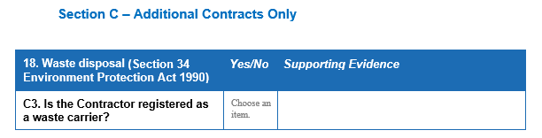

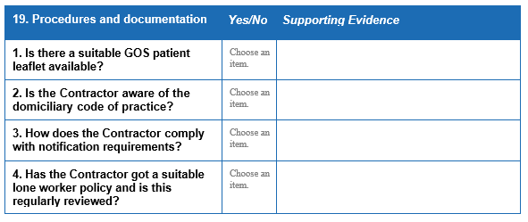
Required prior to visit.

Submit copy of current domiciliary code of conduct prior to visit.

Required prior to visit.

