

NHS Dental Services

Guidance for the completion of FP17 activity
submissions in England (June 2026)

Introduction

This guide has been created to help providers and clinicians:

- use the online FP17 form available in the NHSBSA Compass system
- understand the changes to the FP17 needed to support the contract changes from 1 April 2026.
- address some of the more common questions relating to the business rules associated with the processing of FP17s, whether they have been submitted using the online forms or submitted using a practice management system.

This guide can also be used as a training tool for individuals new to NHS dentistry.

This guide is only to be used for the submission of dental activity submissions for general courses of NHS dental treatment in England.

More information about dental activity submission for orthodontic courses of NHS dental treatment can be found on our website.

Activity Claim Creation

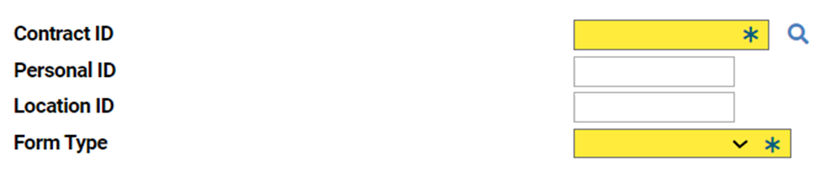

Contract ID - Enter the 10 digit contract ID of the provider.

Personal ID - Enter the 6 digit personal ID of the clinician responsible for this course of treatment. This may pre-populate following Compass log in or you can enter it manually.

Location ID - Enter the 6 digit location ID number. This may pre-populate, or you can enter it manually.

The Contract ID, Personal ID, and Location ID must be entered on all forms.

Form Type - Select FP17 from the drop-down list.

Patient Information

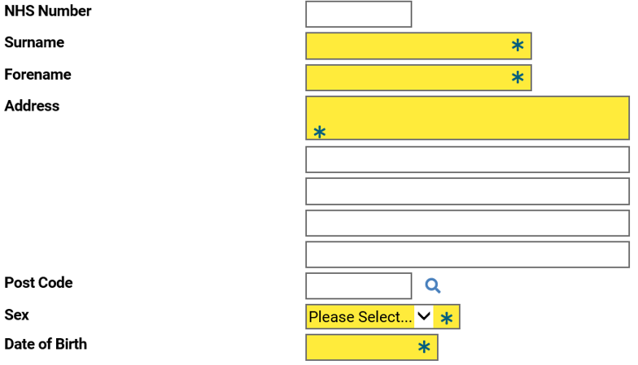

Patient’s NHS Number - Enter the patient’s 10 digit NHS number. The following codes are accepted for patients who do not have an NHS number:
- 1111111111 = Non-registered UK resident
- 2222222222 = Non UK resident
- 3333333333 = Data sharing consent not given
- 4444444444 = NHS number not found (this must not be used because the patient was not asked for their NHS number)
Surname - Enter the patient’s surname, you can use up to 14 characters.

Forename - Enter the patient’s forename, you can use up to 14 characters.

Address - Enter the patient’s house number or name, and the street name.

Postcode - Enter the patient’s postcode.

Sex – Use the drop down to select the patient’s legal sex, M for Male or F for Female..

Date of Birth – Enter the patient’s date of birth in format ddmmyyyy.

The patient’s name, address, sex, and date of birth must be included on every form.

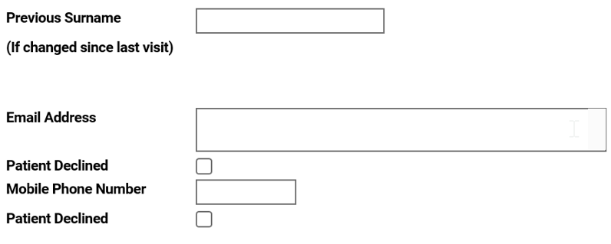

Previous Surname – Enter the patient’s previous surname if it has changed since last visit.

Email Address – Enter the patient's email address if the patient has not declined sharing their email address with the NHSBSA on their PR form

Patient Declined - Tick this box if the patient has declined sharing their email address with the NHSBSA on their PR form.

Mobile Number – Enter the patient's 11 digit mobile number if the patient has not declined sharing their mobile number with the NHSBSA on their PR form.

Patient Declined - Tick this box if the patient has declined sharing their mobile number with the NHSBSA on their PR form

Dental Care Professional

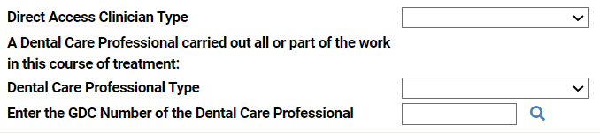

If a Dental Care Professional (DCP) is providing the full course of dental treatment as a Direct Access Clinician, select the Direct Access Clinician type from the drop down list.
The remaining fields do not need to be completed unless another DCP clinician is assisting with the course of treatment.
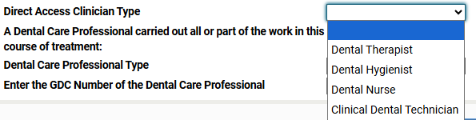

If a DCP is assisting with a course of treatment opened by a dentist or Direct Access Clinician, select one of the DCP options available from the drop down list.
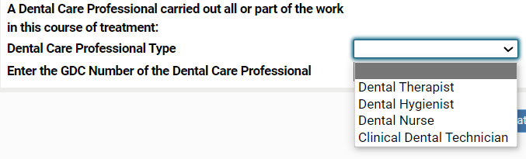

Only one box needs to be selected.
The GDC Number of the DCP must be entered, this can be completed entering the GDC number manually or by clicking on the magnifying glass icon next to the box and selecting from the list. Compass will automatically insert the mandatory leading zeroes and show the name of the DCP.
If a DCP’s GDC number is entered, one of the DCP options must be selected, otherwise the form will be rejected. Any DCP whose details are entered here must be present on the DCP GDC register and must be registered at of the Date of Acceptance entered, otherwise the form will be rejected.
If a DCP has assisted on a course of treatment for part, or all of the treatment, there must still be the personal ID number of the clinician responsible for the course of treatment entered on the form and at least one “significant” Clinical Data Set treatment item must also be entered.

The personal ID number included on the FP17 is at the discretion of the Provider, but the recommendation is that it is either the dentist or Direct Access Clinician supervising the treatment, or alternatively the personal ID number of the contract holder.

Treatment Dates/Incomplete

Incomplete treatment – For banded courses of treatment started but not completed, select 1,2, or 3 from the drop-down list to show the work that has been completed. The patient charge is calculated against whichever of these boxes is crossed. A charge band must also be present in Treatment Category, showing the treatment that has been started. The band crossed in this section must be the same as, or higher than, the band crossed in Treatment Dates/Incomplete.

Date of Acceptance – Enter date of acceptance for the course of treatment. This must be entered on every form.

Completion or Last Visit – Enter date of completion if the course was completed, or the date of last visit if it was not completed. All forms should be submitted within two months of the date of completion. If a decision is made to mark the form as incomplete, it must be submitted as soon as possible.

Completion date same as acceptance – This can be selected if the date of acceptance and date of completion are the same. There is no need to complete the Completion or Last Visit information if this is selected.

Flexible Commissioning Flag – Select an option from the drop-down menu. These indicators must only be used if the contract is participating in a flexible commissioning arrangement and the care which has been provided relates to that arrangement.

Exemptions, Remissions & Patient Charge

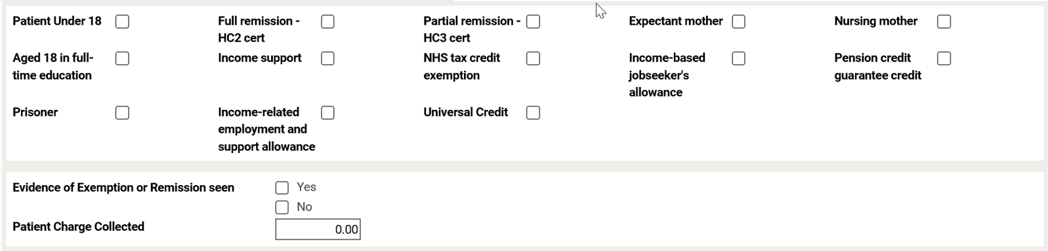
Patient Under 18 – Select this if patient is under 18.

Full Remission – HC2 cert. – Select this if patient is named on a valid HC2 certificate.

Partial Remission – HC3 cert. – Select this if patient is named on a valid HC3 certificate.

Expectant mother – Select this if the patient is pregnant.

Nursing mother – Select this if the patient has given birth in the last 12 months.

Aged 18 in full time education – Select this if the patient is aged 18 and in full time education.

Income Support – Select this if the patient or patient’s partner receives Income Support.

NHS tax credit exemption – Select this if the patient is named on an NHS Tax Credit Exemption Certificate.

Please note that Tax Credit Exemption is no longer accepted on a course of treatment with the Date of Acceptance on or after 6 April 2025.

Income-based jobseekers allowance – Select this if the patient or patient’s partner receive Income-based Jobseekers Allowance.

Pension credit guarantee credit – Select this if the patient or patient’s partner receive Pension Credit Guarantee Credit.

Prisoner – Select this if the patient is in prison or a young offender institution.

Income related employment and support allowance - Select this if the patient or patient’s partner receive Income related employment and support allowance.

Universal credit - Select this if the patient or patient’s partner receive universal credit and they meet the qualifying criteria.

Evidence of Exemption or Remission seen – Select either Yes or No to indicate whether the patient provided evidence of exemption or remission.

Patient Charge Collected – Enter any NHS patient charge that has been collected for this course of treatment.

Treatment Category

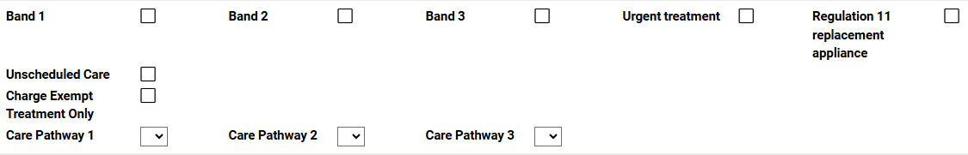

Band 1 – Select this for a band 1 course of treatment.

Band 2 – Select this for a band 2 course of treatment.

Band 3 – Select this for a band 3 course of treatment.

Urgent treatment – Select this for treatment that falls in the urgent treatment category. If an urgent treatment starts on or after 1 April 2026 Unscheduled Care must be selected.

Regulation 11 replacement appliance – Select this if a non-orthodontic replacement appliance under Regulation 11 has been provided – A patient’s charge needs to be entered, this is 30% of the band 3 charge per appliance.

Unscheduled Care – Select this for treatment that falls in the unscheduled care category. If an unscheduled care starts before 1 April 2026 Urgent Treatment must be selected.

Charge Exempt Treatment Only – Select this if only charge exempt treatment is provided

Care Pathway 1 – Use the drop down list to enter the submission number for Care Pathway 1.

Care Pathway 2 – Use the drop down list to enter the submission number for Care Pathway 2.

Care Pathway 3 – Use the drop down list to enter the submission number for Care Pathway 3.

Only one of these boxes can be selected.

Claims with a Date of Acceptance on or after 1 April 2022, unless saved as a draft claim, must conform with entries made on the Clinical Data Set tab.
It’s important that the clinical dataset accurately reflects the treatment provided, as this may affect the units of dental activity (UDA) received.
- If Band 1 is entered, only treatments appropriate to Band 1 can be selected on the Clinical Data Set tab. There must also be at least one Band 1 treatment item selected.
- If Band 2 is entered, Band 3 treatments cannot be selected on the Clinical Data Set tab. There must also be at least one Band 2 treatment item selected. Band 1 items can be selected in addition to the band 2 items.
- If Band 3 is entered, there must be at least one Band 3 treatment item selected on the Clinical Data Set tab. Band 1 and Band 2 items can be selected in addition to the band 3 items.
- If Urgent Treatment is entered, only treatments appropriate to Bands 1 and 2 can be selected on the Clinical Data Set tab.
- If Regulation 11 is entered, there must be at least one replaceable appliance treatment item selected on the Clinical Data Set tab.
- If Unscheduled Care is entered only treatments appropriate to Bands 1 and 2 can be selected on the Clinical Data Set tab
- If Charge Exempt Treatment Only is entered then there cannot be any Band 1, 2 or 3 items selected on the Clinical Data Set tab
- If Care Pathway 1 is entered and it is for the final declaration (incomplete, suspended or complete), at least one Band 2 treatment item must be selected, except for Denture Relines or Denture Additions. Band 1 items can be selected in addition to the band 2 items. Band 3 treatments cannot be selected, as they would be submitted on a concurrent claim when necessary.
- If Care Pathway 2 is entered and it is for submission number 6 or the final declaration (incomplete, suspended or complete), at least one Band 2 treatment item must be selected, except for Denture Relines or Denture Additions. Band 1 items can be selected in addition to the band 2 items. Band 3 treatments cannot be selected, as they would be submitted on a concurrent claim when necessary.
- If Care Pathway 3 is entered and it is for the final declaration (incomplete, suspended or complete), at least one Band 2 treatment item must be selected, except for Denture Relines or Denture Additions. Band 1 items can be selected in addition to the band 2 items. Band 3 treatments cannot be selected, as they would be submitted on a concurrent claim when necessary.

Clinical Data Set
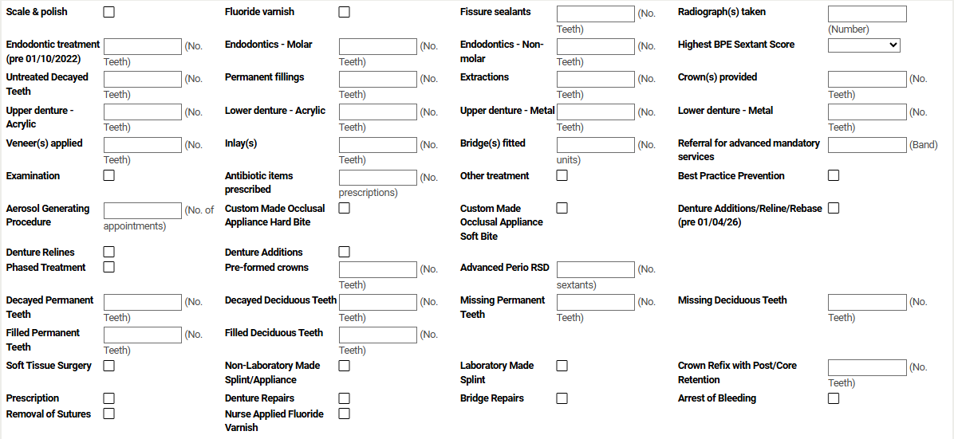

Each item on the Clinical Data Set tab relates to a Band which that treatment belongs to. If the Date of Acceptance of the claim is 1 April 2022 or later, the Band of the treatment must conform to the rules detailed in the Treatment Category tab, unless the claim is being saved as a draft.
This table indicates the treatment band associated with each item.
Treatment Item | Band
Scale and Polish | 1
Fluoride Varnish | 1
Fissure Sealants | 2
Radiographs Taken | 1
Endodontic Treatment (pre 01/10/22) | 2
Endodontics - Molar (post 01/10/22) on Permanent Teeth | 2
Endodontic – Non-molar (post 01/10/22) on Permanent Teeth | 2
Highest BPE Sextant Score | N/A
Untreated Decayed Teeth | N/A
Permanent Fillings | 2
Extractions | 2
Crowns Provided | 3
Upper Denture Acrylic | 3
Lower Denture Acrylic | 3
Upper Denture Metal | 3
Lower Denture Metal | 3
Veneers Applied | 3
Inlays | 3
Bridges Fitted | 3
Referral for Advanced Mandatory Services | N/A
Examination | 1
Antibiotic Items Prescribed | N/A
Other Treatment | 1
Best Practice Prevention | N/A
Aerosol Generating Procedure | N/A
Custom Made Occlusal Appliance Hard Bite | 3
Custom Made Occlusal Appliance Soft Bite | 3
Denture Additions/Reline/Rebase (pre 01/04/26) | 2
Denture Relines | 2
Denture Additions | 2
Phased Treatment | N/A
Preformed Crowns | 2
Advanced Perio RSD | 2
Decayed Permanent Teeth | N/A
Decayed Deciduous Teeth | N/A
Missing Permanent Teeth | N/A
Missing Deciduous Teeth | N/A
Filled Permanent Teeth | N/A
Filled Deciduous Teeth | N/A
Soft Tissue Surgery | 2
Non-Laboratory Made Splint/Appliance | 2
Laboratory Made Splint | 3
Crown Refix with Post/Core Retention | 1
Prescription | Charge Exempt
Denture Repairs | Charge Exempt
Bridge Repairs | Charge Exempt
Arrest of Bleeding | Charge Exempt
Removal of Sutures | Charge Exempt
Nurse Applied Fluoride Varnish | Charge Exempt

This check will not be carried out for claims that have either Incomplete Treatment Band set, or which have Referral for Advanced Mandatory Services present.

Scale and polish – Select this if a scale and polish is carried out.

Fluoride varnish – Select this to indicate that a topical fluoride preparation has been applied to the surfaces of any primary and permanent teeth as a primary preventive measure.

Fissure sealants – Enter the number of permanent teeth where sealant material has been applied to the pit and fissure systems as a primary preventive measure.

Radiograph(s) taken – The total number of radiographs taken must be entered in this box irrespective of the type or size. For example, 2 bite wings and 1 panoral = 3 radiographs.

Endodontic treatment (pre 01/10/2022) – The number of teeth endodontically treated (root filled) should be entered in this box. Endodontic treatment carried out on new courses of treatment starting on or after 1 October 2022 the following two Endodontics options should be used.

- Endodontics - Molar - The number of permanent Molar teeth endodontically treated (root filled) should be entered in this box. Endodontic treatment carried out prior to 1 October 2022 Endodontic treatment (pre 01/10/2022) should be used.
- Endodontic – Non-molar - The number of permanent Non-molar teeth endodontically treated (root filled) should be entered in this box. Please note for Endodontic treatment carried out prior to 1 October 2022 Endodontic treatment (pre 01/10/2022) should be used.
Highest BPE Sextant Score – Enter the Highest BPE Sextant Score for all banded courses of treatment (bands 1, 2 and 3). This is accessed by clicking on the down arrow to the right of the box which displays a drop-down list 0-4 plus – use the hyphen at the end of the drop-down list when it is not possible to carry out a BPE assessment.
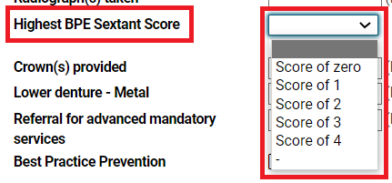
Entry of Highest BPE Sextant Score is mandatory on all adult banded claims when the Date of Acceptance is on or after 1 October 2022, but remains optional for all patients under the age of 18 at the Date of Acceptance.
Untreated Decayed Teeth - Enter the total number of Untreated Decayed Teeth at the clinical examination (check-up or start of a course of treatment). This is the total number of teeth which are decayed into dentine (excluding arrested decay) and includes teeth which have recurrent decay around fillings.
Entry of this information is mandatory on all adult banded claims (Bands 1, 2 and 3) when the Date of Acceptance is on or after 1 October 2022, but remains optional for all patients under the age of 18 at the Date of Acceptance.
Untreated Decayed Teeth is distinct from the existing options for recording of the number of decayed permanent and deciduous teeth at the start of a course of treatment.
Permanent fillings – Enter the number of teeth (not the total number of individual restorations) that have been therapeutically treated by the placement of directly applied permanent restorations, such as:

- permanent fillings in amalgam, composite resin, synthetic resin, glass ionomer, compomers, silicate or silicophosphate materials (includes any acid-etch or pin retention).
- sealant restorations involving the placement of composite resin, glass ionomer or compomer material.

Extractions – The number of teeth extracted should be entered into this box. This also includes surgical removal of a buried root, unerupted tooth, impacted tooth, or exostosed bone.

Crown(s) provided – The value entered is the number of teeth that have been provided with laboratory-fabricated permanent crowns as a finished restoration on this course of treatment.
The crowns may be full or three-quarter crowns but must be in a permanent material, in accordance with the materials listed in Schedule 3 Band 3 Charges – Provision of Appliances of the National Health Service (Dental Charges) Regulations 2005. Any post, pins or cores for retention are not counted separately.

Upper denture – Acrylic – This is completed when an acrylic or resin-based denture is provided (full or partial denture). The number of teeth present on the denture should be entered.

Lower denture – Acrylic – This is completed when an acrylic or resin-based denture is provided (full or partial denture). The number of teeth present on the denture should be entered.

Upper denture – Metal – This is completed when a metal-based denture is provided (full or partial denture). The number of teeth present on the denture should be entered.

Lower denture – Metal – This is completed when a metal-based denture is provided (full or partial denture). The number of teeth present on the denture should be entered.

Veneer(s)– This is the number of teeth that have been provided with laboratory fabricated veneers in permanent materials in accordance with the materials listed in Schedule 3 Band 3 Charges – Provision of Appliances of the National Health Service (Dental Charges) Regulations 2005. They may be on the labial or palatal surface.

Inlay(s) – The number of teeth provided with inlays, pinlays or onlays, using an indirect technique and permanent material, in accordance with the materials listed in Schedule 3 Band 3 Charges – Provision of Appliances of the National Health Service (Dental Charges) Regulations 2005.

Bridge(s) fitted – This is completed when at least one bridge is fitted. The number entered is the total number of units that the bridge or bridges span. For example, you should include the number of retainers and pontics together. Adhesive bridges are entered in a similar manner and the total number of units includes the pontic(s) and any associated ‘wings’.

Referral for advanced mandatory services – Enter the band of the treatment to be provided under advanced mandatory services. In “Treatment Category”, enter the band of the treatment provided by the clinician referring the patient. The collection of the patient charge is the responsibility of the referring clinician and is based on the charge band for the entire course of treatment.

Examination – Select this when carrying out an examination for treatment planning purposes which would normally include charting of the teeth, recording of the periodontal condition and soft tissue examination all of which would be detailed with other necessary clinical details on the clinical record.

Antibiotic Items Prescribed – This is completed when the patient is issued with a prescription containing antibiotic items. The number of antibiotic items should be entered (the number of antibiotic treatments rather than the number of pills).

Other treatment – This should be completed when treatment has been provided and there is no appropriate clinical dataset item. This item can be entered in addition to other clinical data.

Best practice prevention according to Delivering Better Oral Health offered - This should be completed prior to submitting the form. It should be selected if you have followed the guidance as detailed in Delivering better oral health.

Aerosol Generating Procedure (AGP) – This field is to be completed to record the number of AGP appointments provided as part of the course of treatment.
Submission of this information is optional.

Custom Made Occlusal Appliance Hard Bite – Select this when a Hard Bite Custom Made Occlusal Appliance has been fitted.

Custom Made Occlusal Appliance Soft Bite – Select this when a Soft Bite Custom Made Occlusal Appliance has been fitted.

Denture Additions/Reline/Rebase (pre 01/04/26) – Select this to indicate whether a denture had additions, relines or rebasing.

Denture Relines – Select this to indicate whether a denture had relines or rebasing. If a Denture Relines/Rebase treatment was carried out before 1 April 2026 Denture Additions/Reline/Rebase (pre 01/04/26) must be used.

Denture Additions – Select this to indicate whether a denture had additions. If a Denture Additions treatment was carried out before 1 April 2026, Denture Additions/Reline/Rebase (pre 01/04/26) must be used.

Phased Treatment – Select this when a course of treatment is provided as part
of Phased Treatment. Phased treatment may consist of up to three courses of treatment; all these will usually be completed within a 12-month period.

Preformed Crowns (band 2) – Enter the number of deciduous teeth that have been restored with preformed crowns, for example, Hall Technique.

Advanced Perio Root Surface Debridement (RSD) – Where Advanced Perio RSD is provided, the number of sextants involved needs to be entered.

Decayed teeth - Permanent (teeth with established caries) – Enter the number of permanent teeth that are decayed for all patients aged 6 and over. If a tooth has decay and is also restored, count the tooth as decayed.

Decayed teeth - Deciduous (teeth with established caries) – Enter the number of deciduous teeth that are decayed for all patients aged 11 and under. If a tooth has decay and is also restored, count the tooth as decayed.

Missing teeth - Permanent (Where a tooth has been extracted) – Enter the number of permanent teeth that are missing for all patients aged 12 and over. Only count a tooth as missing if you are confident that that tooth was extracted.

Missing teeth - Deciduous (Where a tooth has been extracted) – Enter the number of deciduous teeth that are missing for all patients aged 6 and under. Only count a tooth as missing if you are confident that that tooth was extracted and not exfoliated. Deciduous teeth ULA, ULB, URA, URB, LLA, LLB, LRA, LRB should be excluded from the count.

Filled teeth - Permanent – Enter the number of permanent teeth that are filled/restored for all patients aged 12 and over. Include temporary restorations.

Filled teeth - Deciduous – Enter the number of deciduous teeth that are filled/restored for all patients aged 6 and under. Include temporary restorations.

If there are no teeth in any of the Decayed, Missing or Filled categories or a category is not appropriate due to the age of the patient, enter a value of zero.

Soft Tissue Surgery - Select this when Soft Tissue Surgery has been performed.
Non-Laboratory Made Splint/Appliance - Select this when a Non-Laboratory Made Splint/Appliance has been fitted.
Laboratory Made Splint - Select this when a Laboratory Made Splint/Appliance has been fitted.
Crown Refix with Post/Core Retention - The figure you should enter is the number of crowns that have been refixed with post/core retention.
Prescription – Select this when prescription has been provided.
Denture Repairs – Select this when denture repair has been provided.
Bridge Repairs – Select this when bridge repair has been provided.
Arrest of Bleeding – Select this when arrest of bleeding has been provided.
Removal of Sutures – Select this when removal of sutures is performed.
Nurse Applied Fluoride Varnish - Select this when fluoride varnish has been provided by a Dental Nurse as Direct Access Clinician.

Other Services

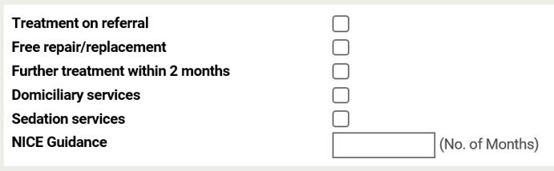

Treatment on referral – Select this if you are treating a patient that has been referred to you. If the referral is for advanced mandatory services no patient charge will be deducted. If the patient is referred for Additional Services (Sedation or Domiciliary services) a charge will be taken, as this is considered a new course of treatment. A charge band in “Treatment Category” must also be present.

Free repair/replacement – Select this box if a restoration (Permanent Filling or Sealant Restoration/endodontics, crown, inlay, veneers) has to be repaired or replaced within 12 months. The box should be selected even if a patient charge is not applicable. A charge band in “Treatment Category” must also be present and should be the band appliable to the course of treatment this should be entered in patient charge collected box in “Exemptions, Remissions & Patient Charge”, otherwise no patient charge will be deducted. A charge band in “Treatment Category” must also be present and should be the band applicable to the whole course of treatment.

If Free Repair/Replacement is selected and the Date of Acceptance is on or after 1st April 2022, unless the claim is saved as a draft claim, there must be at least one repairable/replaceable treatment item selected in the Clinical Data Set tab, these are –Permanent Filling, endodontics, crowns, inlays, veneers.

Further treatment within 2 months – Select this if this course of treatment was required within two months of the completion of a previous course of treatment and is in the same or lower band. This applies to all patients whether exempt/remitted from charges or charge payers. No patient charge will be deducted if applicable.

This does not apply if the original course of treatment was either ‘urgent’ treatment or was incomplete treatment. Additionally, if an ‘urgent’ treatment is required at any point within two months this cannot be claimed as continuation and must be claimed as a separate course of treatment. A patient charge will be deducted if applicable.

Domiciliary services – Select this if domiciliary services have been provided. If treatment has been provided, then a charge band in “Treatment Category” should be crossed and a patient charge will be deducted if applicable

Sedation services – Select this if sedation services have been provided. If treatment has been provided, then a charge band in “Treatment Category” should be crossed and a patient charge will be deducted if applicable.

NICE Guidance - Select this to show the recommended recall interval. This should be between 3 and 24 months and personalised to the patient and their level of oral health risk.
Completion of NICE guidance is mandatory on all adult FP17 claims for Bands 1, 2 and 3 where the Date of Acceptance is on or after 1 October 2022, but remains optional for patients under 18 at the Date of Acceptance.

Ethnic Origin

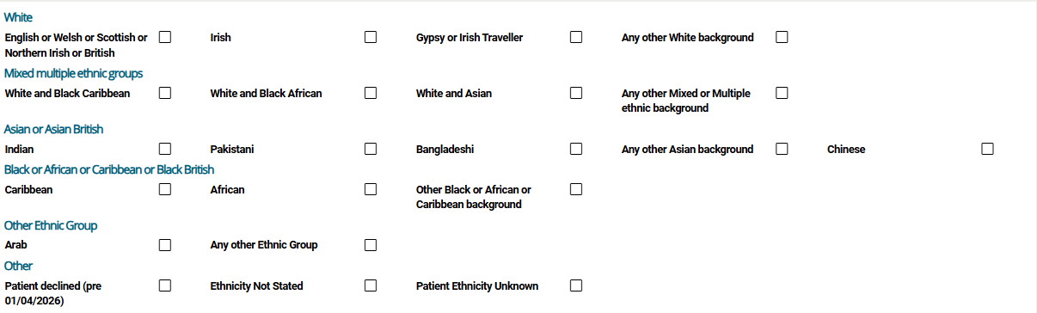

Select the patient's ethnic group.

Clinician Declaration

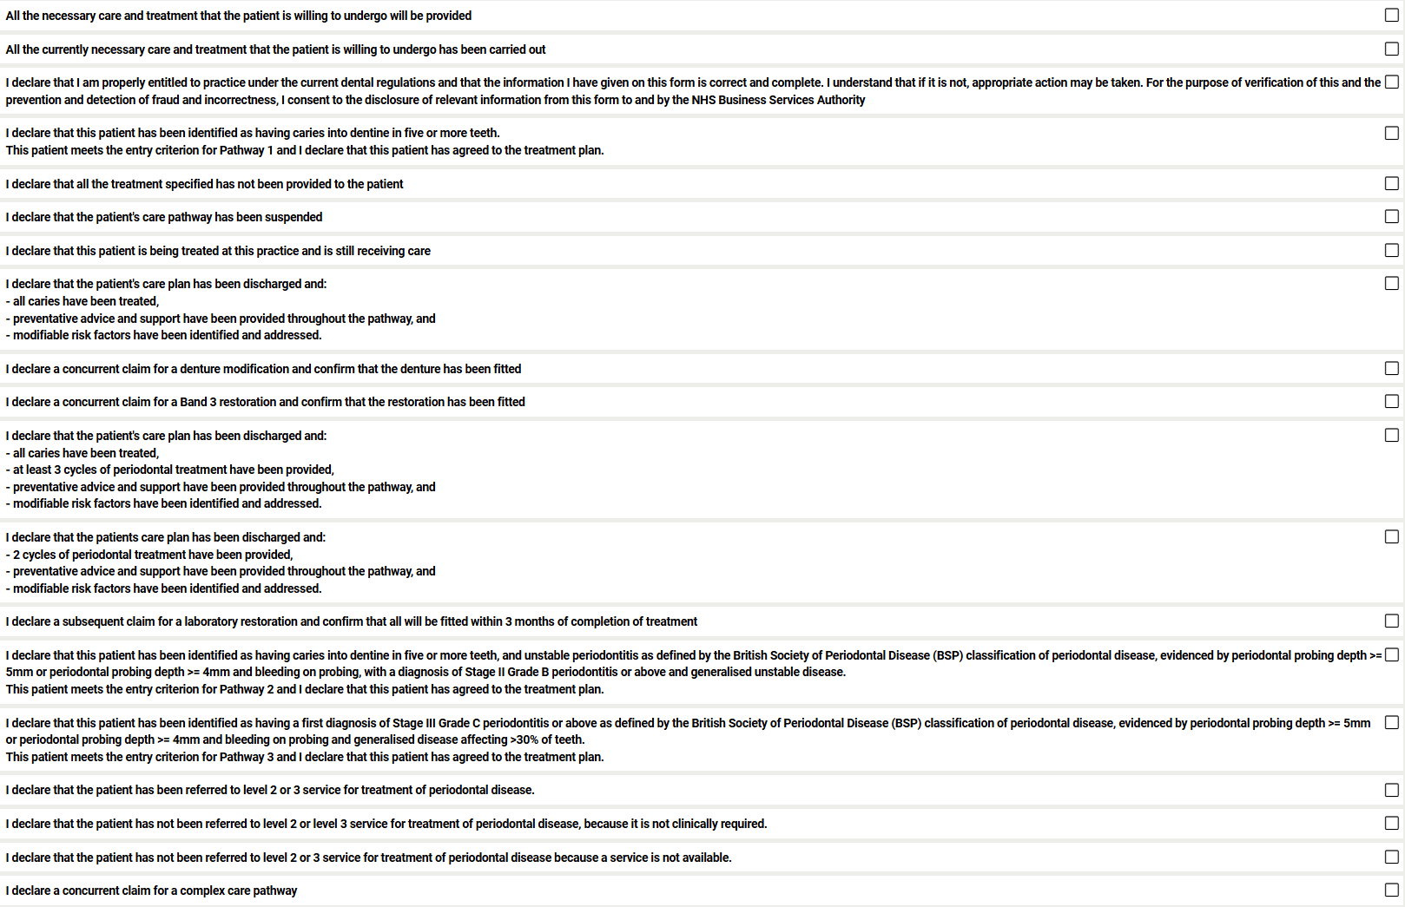

The declaration must be completed by a qualified clinician on every form. This is normally the clinician responsible for the course of treatment.

Banded or Unscheduled Care Forms
First three declarations must be selected on every form submitted, with the exception of courses of treatment where the clinician decides to discontinue treatment. In this instance, only the first and the third boxes should be selected.

Complex Care Pathway Sign-up
Declaration | Rules
I declare that I am properly entitled to practise under the current dental regulations and that the information I have given on this form is correct and complete. I understand that if it is not, appropriate action may be taken. For the purposes of verification of this and the prevention and detection of fraud and incorrectness, I consent to the disclosure of relevant information from this form to and by the NHS Business Services Authority. | Mandatory on all pathway sign-up forms
I declare that this patient has been identified as having caries into dentine in five or more teeth.  This patient meets the entry criterion for Pathway 1 and I declare that this patient has agreed to the treatment plan. | Mandatory with Pathway 1
I declare that this patient has been identified as having caries into dentine in five or more teeth and unstable periodontitis as defined by the British Society of Periodontal Disease (BSP) classification of periodontal disease, evidenced by periodontal probing depth >= 5mm or periodontal probing depth >= 4mm and bleeding on probing, with a diagnosis of Stage II Grade B periodontitis or above and generalised unstable disease.  This patient meets the entry criterion for Pathway 2 and I declare that this patient has agreed to the treatment plan. | Mandatory with Pathway 2
I declare that this patient has been identified as having a first diagnosis of Stage III Grade C periodontitis or above as defined by the British Society of Periodontal Disease (BSP) classification of periodontal disease, evidenced by periodontal probing depth >= 5mm or periodontal probing depth >= 4mm and bleeding on probing and generalised disease affecting >30% of teeth.  This patient meets the entry criterion for Pathway 3 and I declare that this patient has agreed to the treatment plan. | Mandatory with Pathway 3

Complex Care Pathway Interim Forms
Declaration | Rules
I declare that I am properly entitled to practise under the current dental regulations and that the information I have given on this form is correct and complete. I understand that if it is not, appropriate action may be taken. For the purposes of verification of this and the prevention and detection of fraud and incorrectness, I consent to the disclosure of relevant information from this form to and by the NHS Business Services Authority. | Mandatory on all pathway interim forms
I declare that this patient is being treated at this practice and is still receiving care | Mandatory on all pathway interim forms, except conclusion forms
I declare a concurrent claim for a denture modification and confirm that the denture has been fitted | Optional
I declare a concurrent claim for a Band 3 restoration and confirm that the restoration has been fitted | Optional

Complex Care Pathway Conclusion Forms
Declaration | Rules
I declare that I am properly entitled to practise under the current dental regulations and that the information I have given on this form is correct and complete. I understand that if it is not, appropriate action may be taken. For the purposes of verification of this and the prevention and detection of fraud and incorrectness, I consent to the disclosure of relevant information from this form to and by the NHS Business Services Authority | Mandatory on all pathway conclusion forms
I declare that all the treatment specified has not been provided to the patient | Mandatory with Incomplete pathway only
I declare that the patient’s care pathway has been suspended | Mandatory with Suspended pathway only
I declare that the patients care plan has been discharged and:  - all caries have been treated,  - preventative advice and support have been provided throughout the pathway, and  - modifiable risk factors have been identified and addressed | Mandatory with Completed pathway 1 only
I declare that the patients care plan has been discharged and:  - all caries have been treated,  - at least 3 cycles of periodontal treatment have been provided,  - preventative advice and support have been provided throughout the pathway, and  - modifiable risk factors have been identified and addressed | Mandatory with Completed pathway 2 only
I declare that the patients care plan has been discharged and:  - 2 cycles of periodontal treatment have been provided,  - preventative advice and support have been provided throughout the pathway, and  - modifiable risk factors have been identified and addressed | Mandatory with Completed pathway 3 only
I declare that the patient has been referred to level 2 or 3 service for treatment of periodontal disease. | Mandatory to select one, and only one with Completed pathway 3 only
I declare that the patient has not been referred to level 2 or level 3 service for treatment of periodontal disease, because it is not clinically required
I declare that the patient has not been referred to level 2 or 3 service for treatment of periodontal disease because a service is not available
I declare a concurrent claim for a denture modification and confirm that the denture has been fitted | Optional on any conclusion forms
I declare a concurrent claim for a Band 3 restoration and confirm that the restoration has been fitted | Optional on any conclusion forms
I declare a subsequent claim for a laboratory restoration and confirm that all will be fitted within 3 months of completion of treatment | Optional on Completed pathway only

Denture Modification and Band 3 Concurrent Forms
The treatment is provided while the patient is undergoing a complex care pathway. Also where Band 3 treatment is provided within three months after the completion of the Complex Care Pathway.
Declaration | Rules
I declare that I am properly entitled to practise under the current dental regulations and that the information I have given on this form is correct and complete. I understand that if it is not, appropriate action may be taken. For the purposes of verification of this and the prevention and detection of fraud and incorrectness, I consent to the disclosure of relevant information from this form to and by the NHS Business Services Authority | Mandatory
All the necessary prevention, care and treatment that the patient is willing to undergo has been carried out | Mandatory
I declare a concurrent claim for a complex care pathway | Mandatory

Charge Exempt Only Denture Repair Forms
The treatment is provided while the patient is undergoing a complex care pathway.

Declaration | Rules
I declare that I am properly entitled to practise under the current dental regulations and that the information I have given on this form is correct and complete. I understand that if it is not, appropriate action may be taken. For the purposes of verification of this and the prevention and detection of fraud and incorrectness, I consent to the disclosure of relevant information from this form to and by the NHS Business Services Authority | Mandatory
I declare a concurrent claim for a complex care pathway | Mandatory

Contact us:

Tel: 0300 330 1348

Email: nhsbsa.dentalservices@nhsbsa.nhs.uk

www.nhsbsa.nhs.uk/nhs-dental-services

